Create An IAM Role

Step 1: Login to AWS console and navigate to IAM.

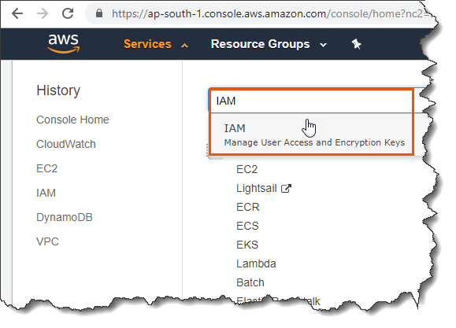

Step 2: Navigate to ‘Roles’ and click ‘Create role’.

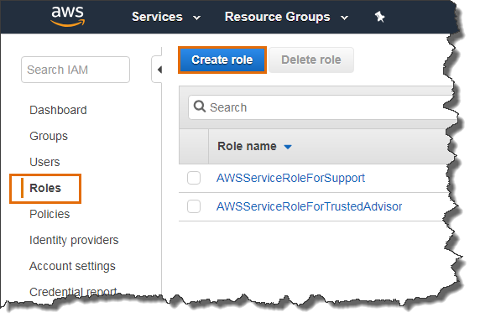

Step 3: Select ‘EC2’ service and click ‘Next: Permissions’.

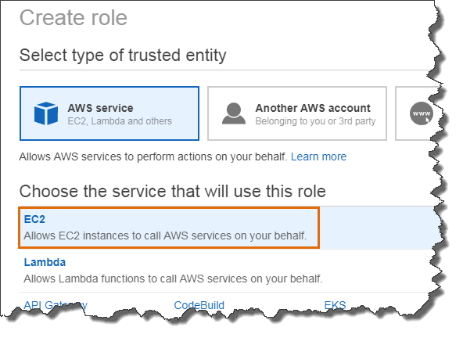

Step 4: Select the policy and click ‘Next: Add tags’.

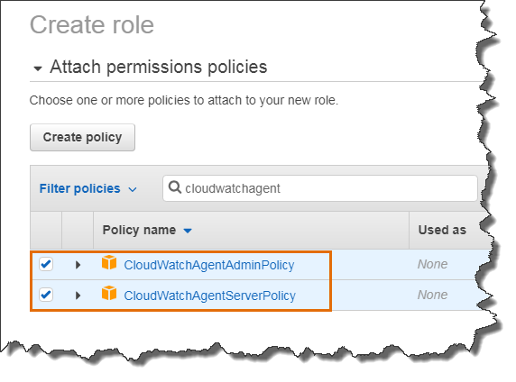

Step 5: Provide a tag (optional) and click ‘Next: Review’.

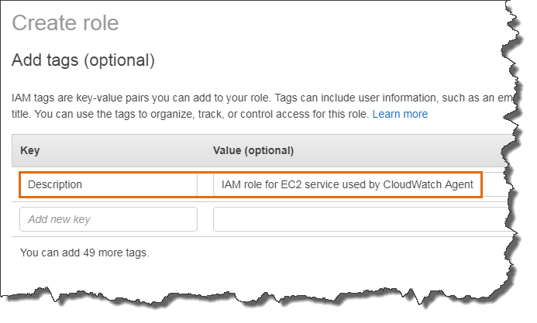

Step 6: Provide a name and click ‘Create role’.

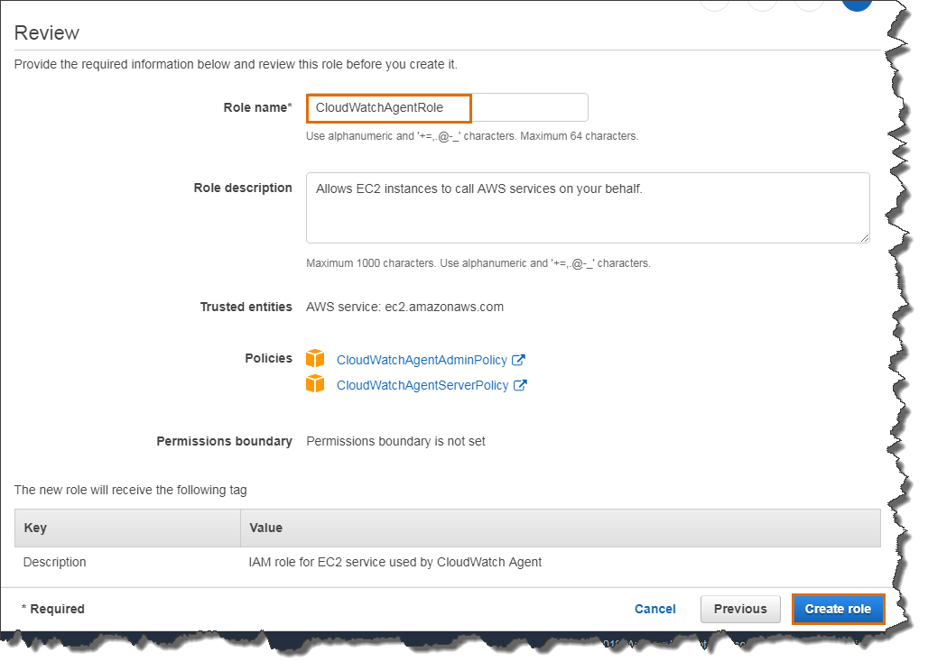

Our IAM role successfully created.

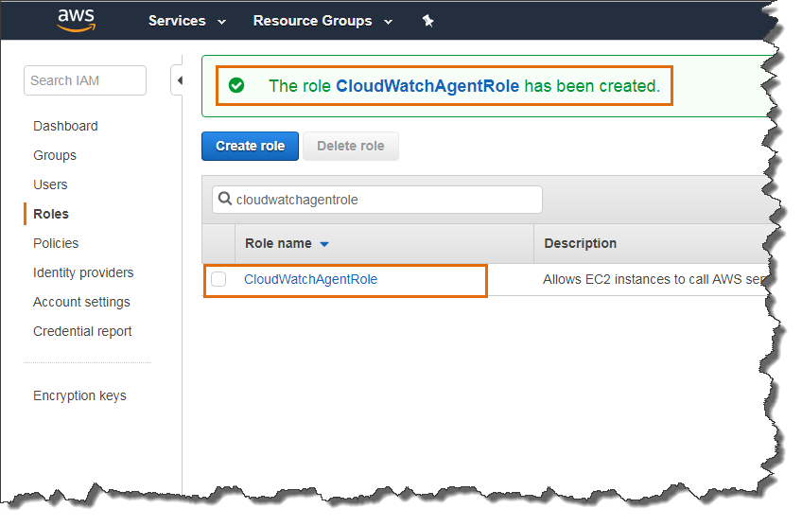

You can add

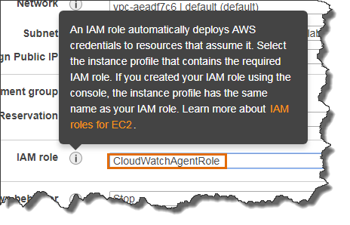

Or add to an existing EC2 instance

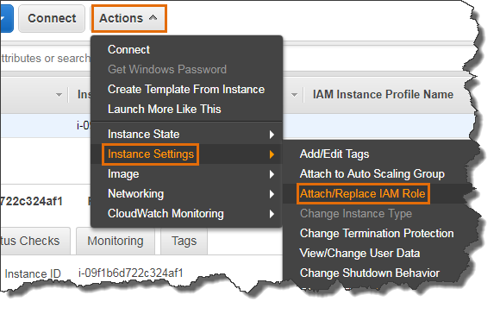

To get more details on IAM, please refer below AWS documentation

<https://docs.aws.amazon.com/iam/index.html>