Enable Multi-Factor Authentication (MFA)

Step 1: Login to AWS console and navigate to IAM.

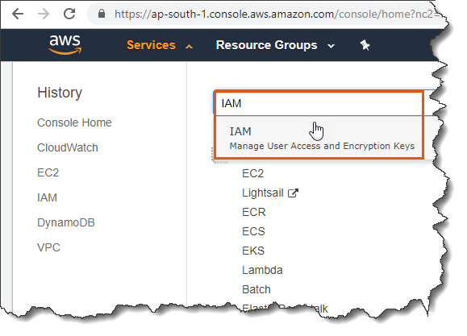

Step 2: Click ‘Manage MFA’ located under ‘Dashboard’.

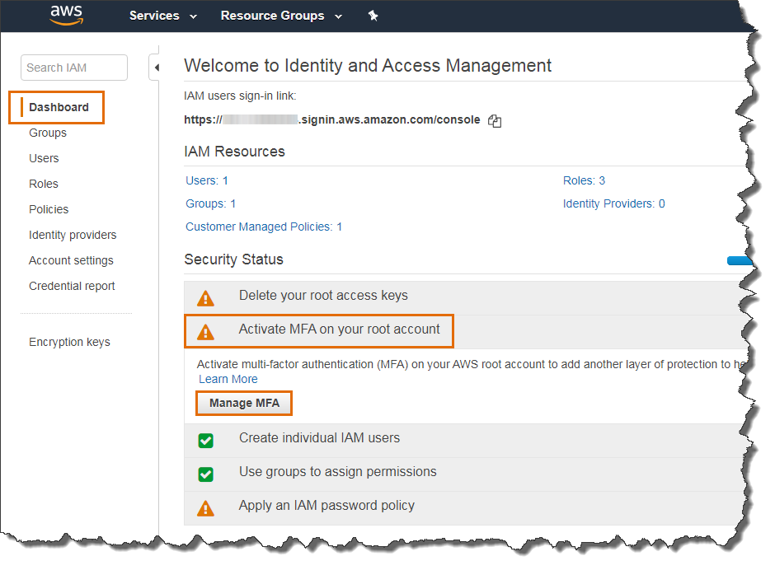

Step 3: Click ‘Activate MFA’ located under ‘Multi-factor authentication (MFA)’.

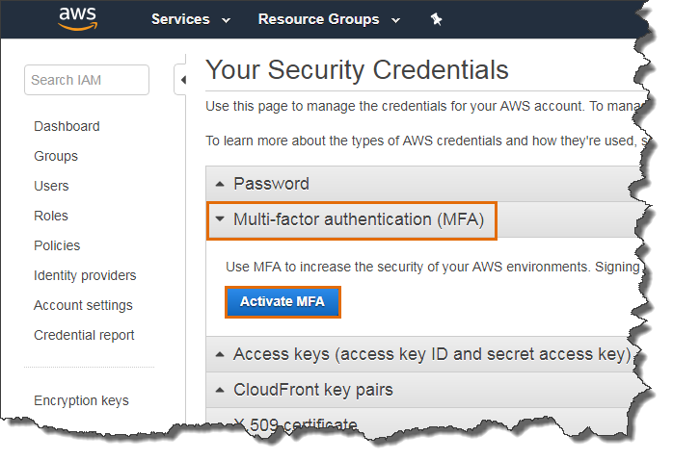

Step 4: Select ‘Virtual MFA device’ and click ‘Continue’.

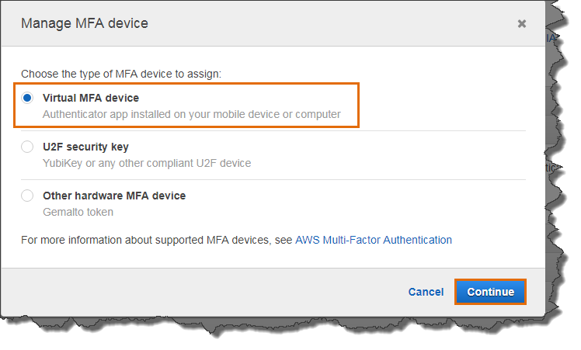

Step 5: Download and install Google Authenticator in your mobile.

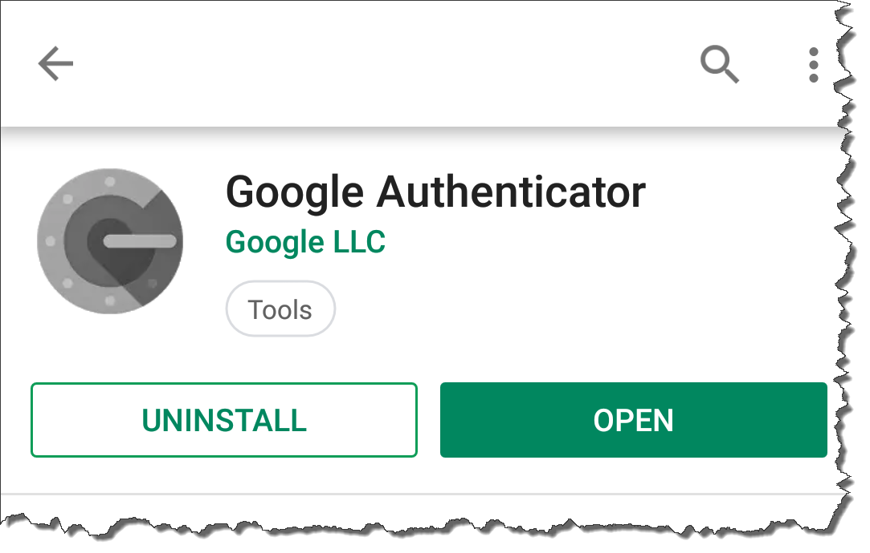

Step 6: Open the app and click ‘Scan a barcode’

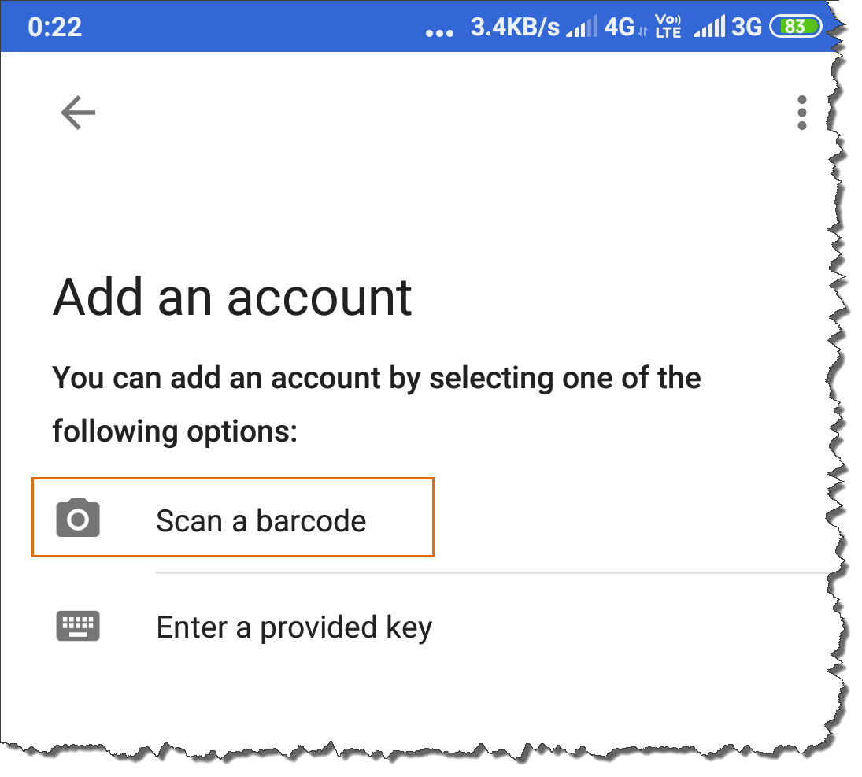

Step 7: Scan the barcode in your browser AWS console page that appeared after step 4 and from your mobile enter two consecutive MFA code. Click ‘Assign MFA’.

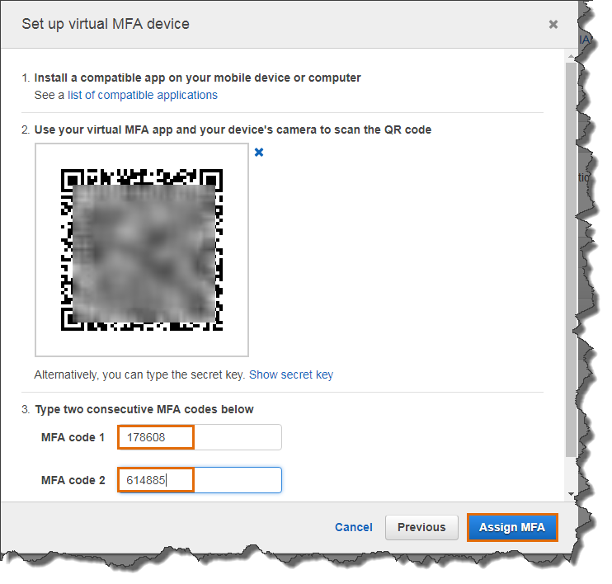

You will receive on success message.

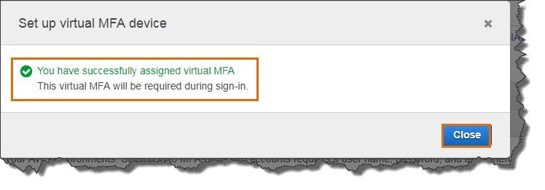

MFA successfully activated for our root account.

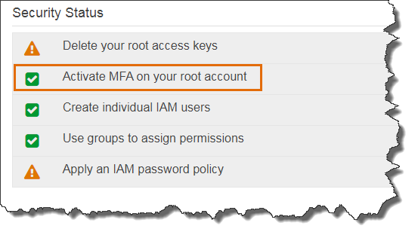

If you logoff and login again to the AWS console using your root account, you will need to enter your MFA code from your mobile apart from your root credential to login.

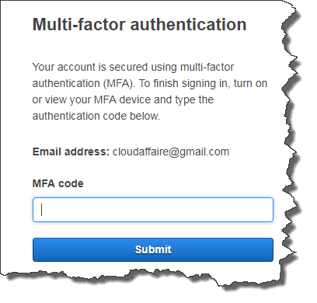

To get more details on IAM, please refer below AWS documentation

<https://docs.aws.amazon.com/iam/index.html>

To get more details on MFA supported devices, please refer below link.

<https://aws.amazon.com/iam/details/mfa/>