#### ****EXERCISE 1: Build jar artifact****

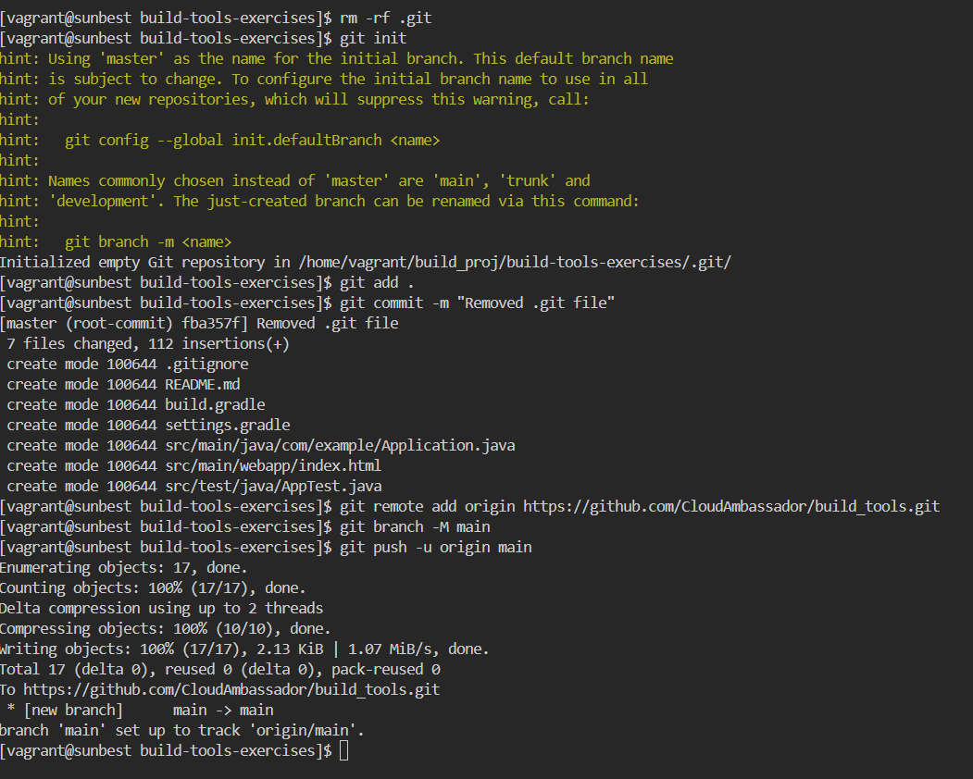

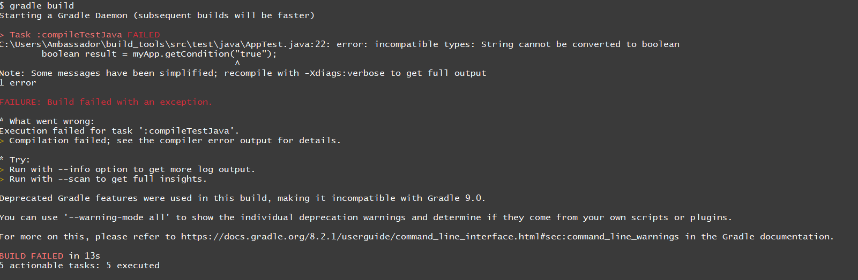

#### ****EXERCISE 2: Run tests****

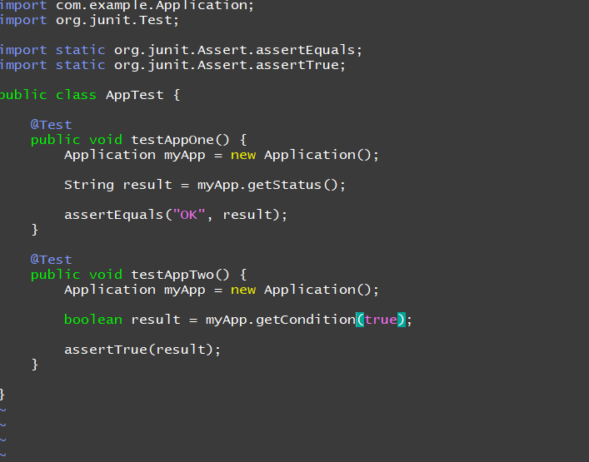

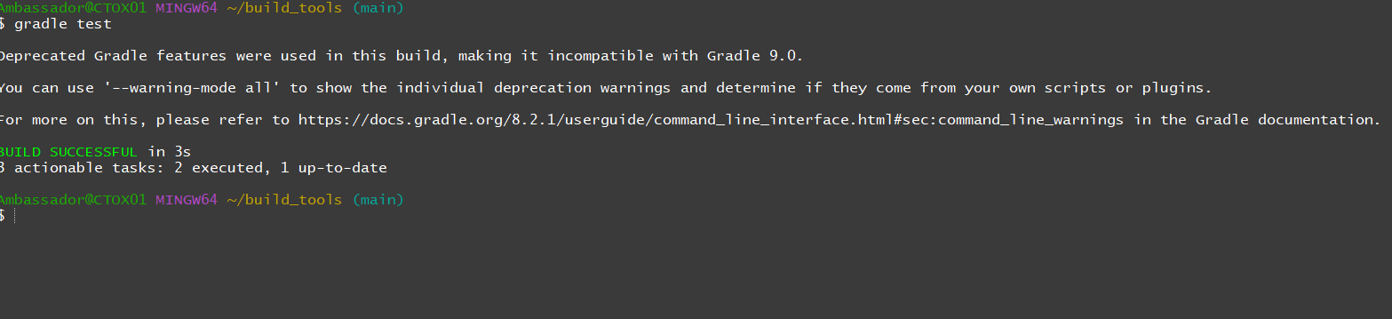

#### ****EXERCISE 3: Clean and build App****

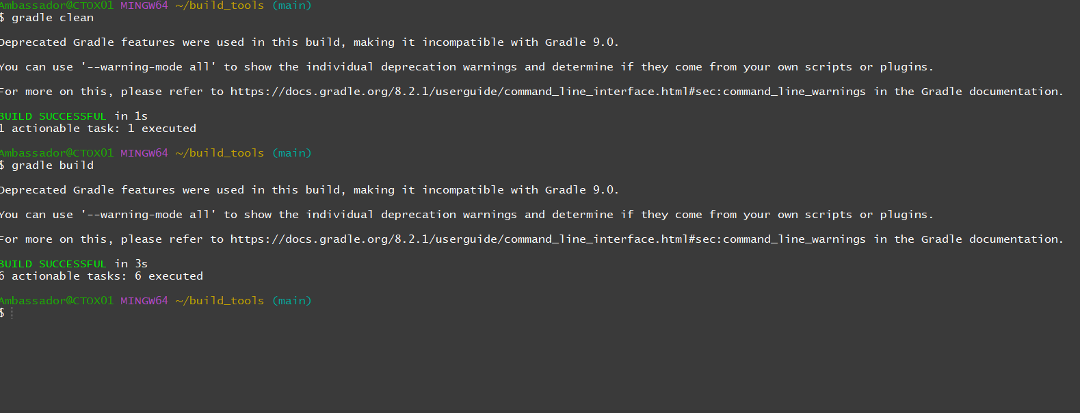

#### ****EXERCISE 4: Start application****

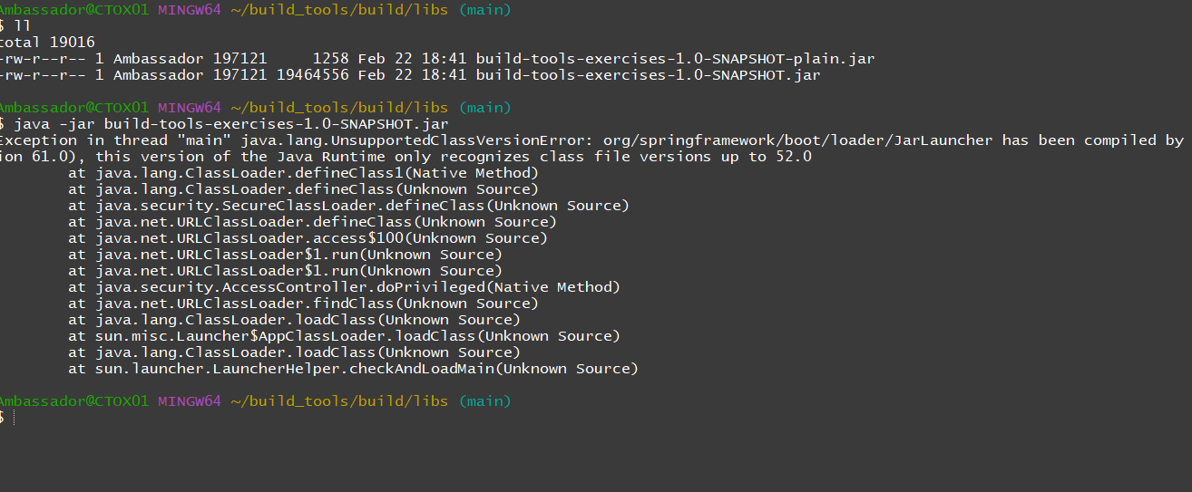

**EXERCISE 5: Start App with 2 Parameters**

