**EXERCISE 1: Package NodeJS App**

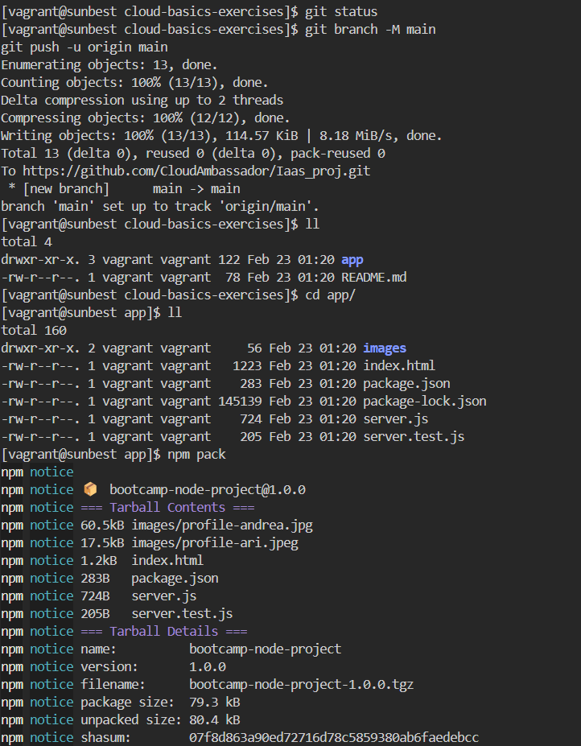

#### ****EXERCISE 2: Create a new server****

#### ****EXERCISE 3: Prepare server to run Node App****

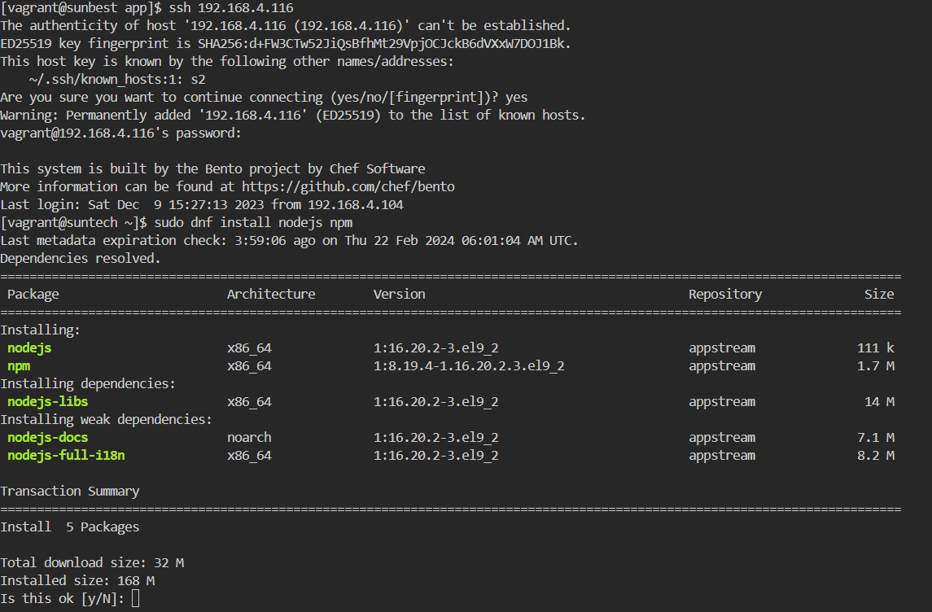

#### ****EXERCISE 4: Copy App****



#### ****EXERCISE 5: Run Node App****

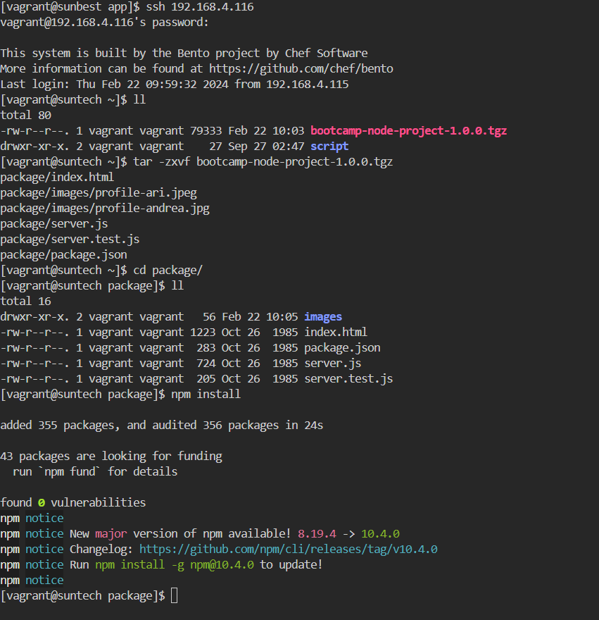

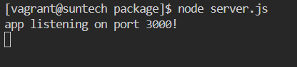

#### ****EXERCISE 6: Access from browser - configure firewall****

