Aims for BatGraph tool

Core CloudCompare functionality to keep
- Loading PLY files
- Cropping point clouds
- Aligning point clouds with Tools > Registration and point pair picking to reorientate
- Measuring distances
- Merging clouds
- Exporting clouds

New Functionality

- Node name labeller
I have an excel file with all the stations and lists platforms, platform exits, station exits, level of each platform, level of unity (where all staircases meet to follow 1 route to station exit).
I have a script which autogenerates a graph assuming a separate path from each platform exit to the level of unity. It generates a csv for nodes and edges.
It labels the nodes accordingly.
I think this functionality could live within the BatGraph tool

- Graph Viewer
I currently use a tool called Graph Commons to view my path and node csv files. I can colour code the paths depending on if they are virtual steps (distance 0) or physical real paths (distance > 0).
I would like to be able to load the path and node csv files to BatGraph and pan around the graph, click on nodes etc
- Graph Editor
I currently use Graph Commons to edit the graph. For example, adding nodes, deleting nodes and creating/deleting paths. I would like to be able to ‘Open Graph’ to add/remove nodes or edges. This saves having to flick between CloudCompare and Graph Commons to check things are consistent and make edits.

- Graph Creator
Some graphs will be easier to build from scratch rather than edit. As such it would be good to be able to make a graph by clicking points and connecting with lines. For example this could work like Inkscape where you can click from an existing node to a new node. Then specify path type (e.g. stairs, escalator, elevator, path, Path0) from a dropdown/search. Then continue adding.

- Node Stepper
A variation on Graph Editor, or maybe a feature of it. Once I have my full unlabelled graph which I created from scratch, I would want to be able to click through the nodes and assign a name from my Node Name list. The list would remove nodes which have already been used. It could show a list of ‘Available’ and ‘Used’ labels.

- Distance, Slope calculator
Currently I export my point list from Cloud Compare with labels I have meticulously aligned with the graph labels. I can then use the graph to know which nodes have a path between them and which do not. I then calculate distance, slope etc between these nodes using a python script.
I think this functionality should also sit in BatGraph
- Metadata Stepper
Similar to Node Stepper. I want to be able to cycle through the PATHS on the graph and add metadata e.g. Number of stairs, number of help points, 1-way system, seating capacity, handrail, opening times (some exits close off-peak or are 1-way).

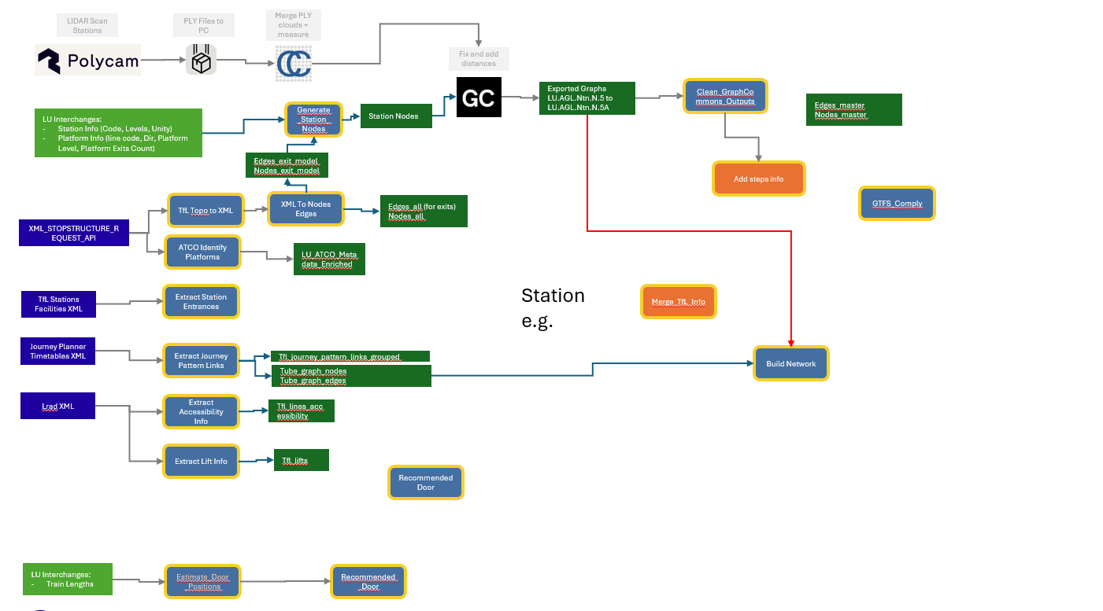

Other Cloud Compare functionality
If it helps we can effectively comment out the remaining unused functionality, but leave it in the repo for reference. In case we want that functionality in future, to realise it just needs restoring NOT reinventing.

