Foreman run report
Job: Turn these app reviews into a ranked bug backlog
Run r_76889711 · threshold 0.7 · 2,927 decisions (Jev 2,309, LLM 613, code 5) · $0.0968 · 122.5 s

Summary
We turned 1000 app reviews into a ranked bug backlog, keeping 956 items and dropping 44. The kept items included 405 praise, 185 bug, 174 other, 124 billing and 68 feature_request, and the largest theme groups were Login failures at 22, Paywall and free limits at 21, Writing feature removed at 19, Slow performance at 15 and App crashes at 14. Urgency was scored for 185 items with a mean of 63.0 and a median of 66.7. Jev made 2309 of the 2926 decisions, the LLM made 612, and code made 5, with 1 low-confidence case. The run took 120.5 seconds and cost 0.0964 USD in total.

Charts
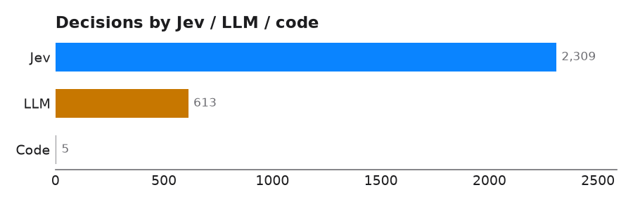
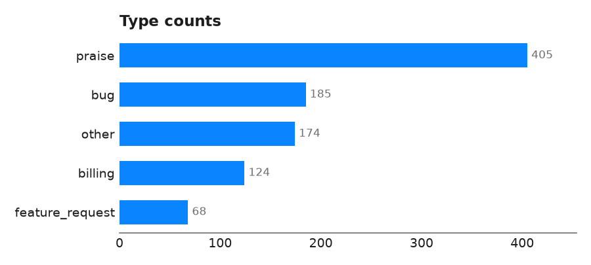
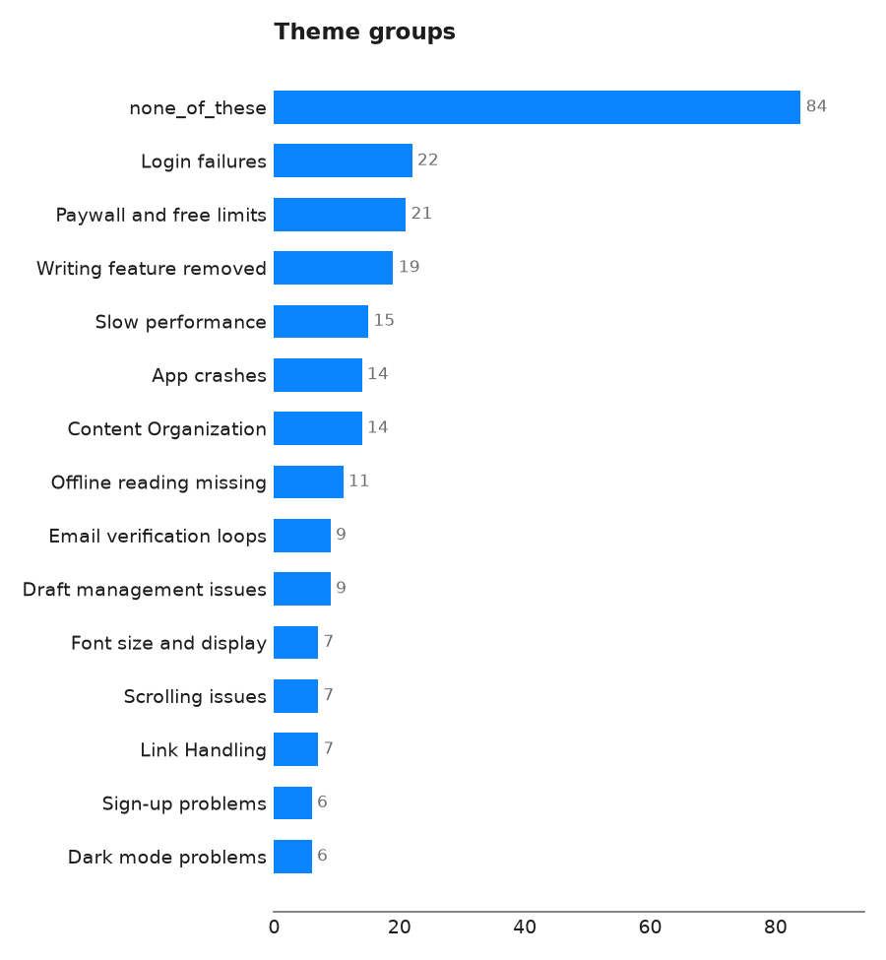

Aggregates

Type counts
key | value
praise | 405
bug | 185
other | 174
billing | 124
feature_request | 68

Theme groups
theme | description | count
Login failures | Users report being unable to sign in or log in to the app, often after updates or with various methods; not account creation issues. | 22
Paywall and free limits | Users are frustrated by paywalls, premium articles, or daily/monthly reading limits in the free version; not general content quality issues. | 21
Writing feature removed | Users complain that the ability to write or edit articles on the mobile app has been removed; not issues with reading or other features. | 19
Slow performance | The app is slow, laggy, or takes a long time to load or respond; not crashes or freezes. | 15
App crashes | The app crashes, freezes, or becomes unresponsive during use; not slow performance or loading issues. | 14
Content Organization | Requests for sorting, favorites, history, or easy access to saved articles; not draft management. | 14
Offline reading missing | Users want the ability to save articles for offline reading or find that offline mode doesn't work; not general reading issues. | 11
Email verification loops | Users get stuck in a loop where email verification links don't work or keep sending them back to sign-up; not general login failures. | 9
Draft management issues | Problems with accessing, saving, or editing drafts in the app; not issues with publishing or writing new articles. | 9
Font size and display | Users want to adjust font size or complain about text appearance, blurriness, or lack of display settings; not dark mode issues. | 7
Scrolling issues | Problems with scrolling, such as lag, jumping, or inability to scroll smoothly; not general performance or loading issues. | 7
Link Handling | Complaints about links opening in an internal browser or not opening in a native app; not general app crashes. | 7
Sign-up problems | Users report being unable to create a new account or complete the sign-up process; not login issues for existing accounts. | 6
Dark mode problems | Issues with dark mode, such as unreadable text, missing titles, or poor display; not general display or font size issues. | 6
Screen Rotation | Requests for screen rotation support or auto-rotate on tablets and e-readers; not display font size issues. | 2
none_of_these | The text fits none of the themes above | 84

Dup group clusters
group | canonical_id | conflicts
dup-1 | r-138 | []
dup-2 | r-234 | []
dup-3 | r-291 | []
dup-4 | r-384 | []
dup-5 | r-436 | []
dup-6 | r-788 | []
dup-7 | r-1142 | []
dup-8 | r-2672 | []
dup-9 | r-1376 | []
dup-10 | r-1409 | []
dup-11 | r-1555 | []
dup-12 | r-1803 | []
dup-13 | r-1828 | []
dup-14 | r-2548 | []
dup-15 | r-2586 | []
dup-16 | r-2873 | []
dup-17 | r-3306 | []
dup-18 | r-5831 | []
dup-19 | r-6270 | []
dup-20 | r-6505 | []
dup-21 | r-7086 | []
dup-22 | r-7054 | []
dup-23 | r-7328 | []
dup-24 | r-7783 | []

Urgency summary
key | value
n | 185
mean | 63.0
median | 66.7
min | 0.0
max | 100.0
per_dimension_mean | {"severity": 63.0}

Theme counts
key | value
none_of_these | 84
Login failures | 22
Paywall and free limits | 21
Writing feature removed | 19
Slow performance | 15
App crashes | 14
Content Organization | 14
Offline reading missing | 11
Draft management issues | 9
Email verification loops | 9
Font size and display | 7
Link Handling | 7
Scrolling issues | 7
Dark mode problems | 6
Sign-up problems | 6
Screen Rotation | 2

Steps
node | tool | items in | items out | Jev | LLM | code | seconds
n1 | filter | 1000 | 956 | 731 | 269 | 0 | 35.9
n2 | classify | 956 | 956 | 831 | 125 | 0 | 24.1
n3 | group | 956 | 956 | 305 | 59 | 0 | 25.8
n4 | dedupe | 956 | 956 | 248 | 134 | 2 | 22.8
n5 | score | 956 | 956 | 160 | 25 | 1 | 6.8
n6 | rank | 956 | 956 | 34 | 0 | 145 | 4.9
n7 | calculate | 956 | 956 | 0 | 0 | 4 | 0.0

