Foreman run report
Job: Turn these app reviews into a ranked bug backlog
Run r_e79c8b43 · threshold 0.7 · 2,965 decisions (Jev 2,353, LLM 607, code 5) · $0.0942 · 85.6 s

Summary
Foreman processed 1,000 items with filter, classify, group, dedupe, score, rank, calculate; 951 were kept and 49 dropped. Type counts: praise (405), bug (186), other (169). Theme groups: none_of_these (82), Missing App Features (33), Writing and Editing Broken (25). Jev made 2,353 of the 2,960 model decisions (79.5%), and the LLM made 607. The run took 85.6 s and cost $0.0942.

Charts
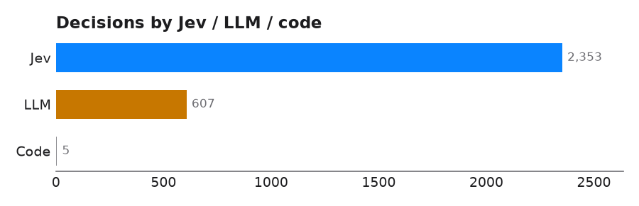
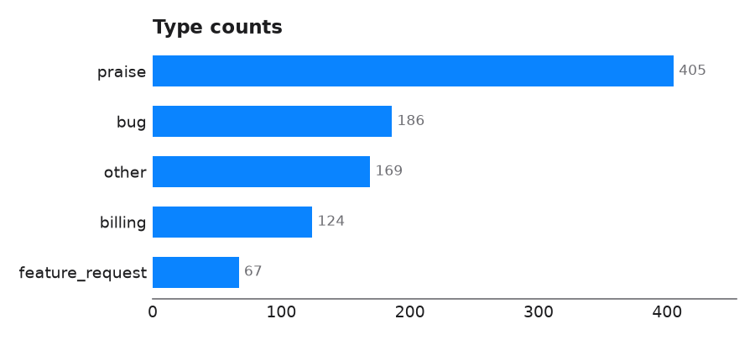
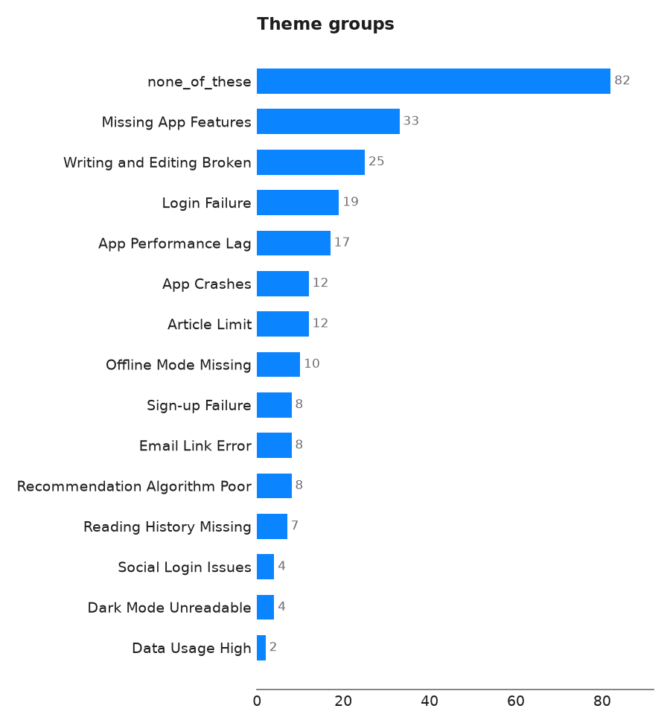
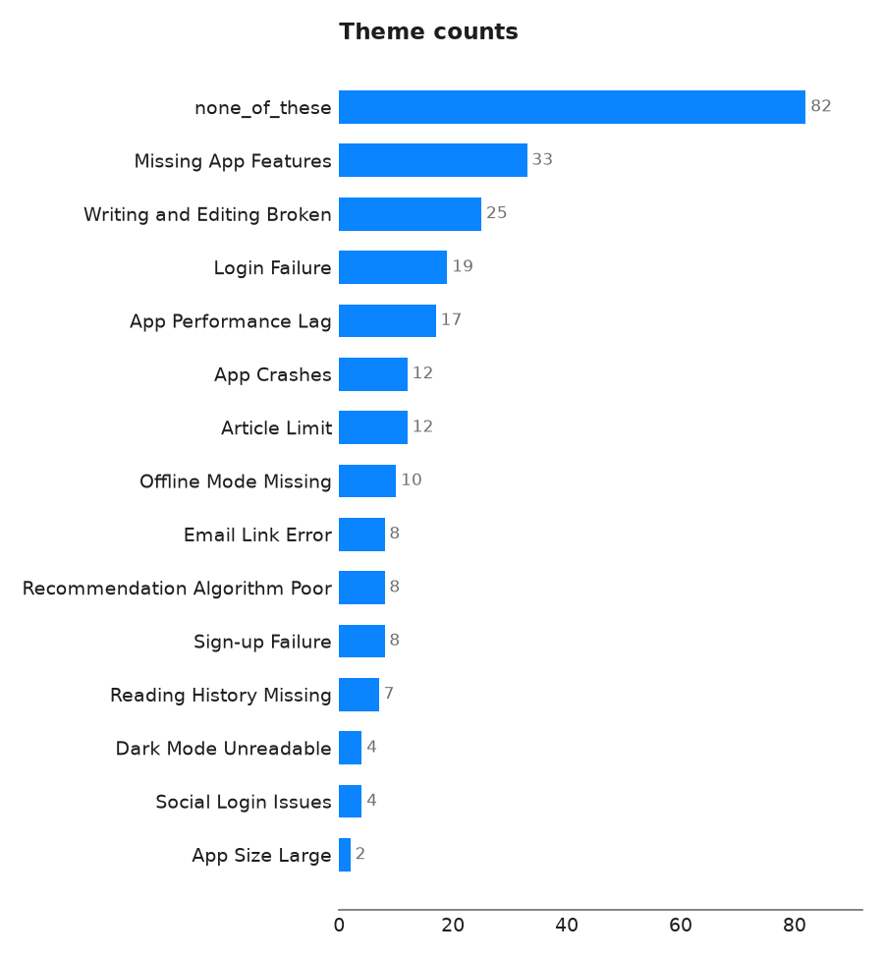

Aggregates

Type counts
key | value
praise | 405
bug | 186
other | 169
billing | 124
feature_request | 67

Theme groups
theme | description | count
Missing App Features | Features available on the website are missing in the app, such as publications, drafts, or series; not general app crashes. | 33
Writing and Editing Broken | Users cannot write, edit, or delete posts in the app; not issues with reading articles. | 25
Login Failure | Users cannot sign in or log in to the app, often after an update or with various methods; not about sign-up issues. | 19
App Performance Lag | The app is slow, laggy, or has poor scrolling performance; not about crashes or freezes. | 17
App Crashes | The app crashes or freezes frequently; not about general slowness or lag. | 12
Article Limit | Users are limited in the number of free articles they can read per month; not about subscription costs. | 12
Offline Mode Missing | Users want an offline mode to read saved articles without internet; not about other features. | 10
Sign-up Failure | Users cannot create a new account or sign up for the app; not about logging into an existing account. | 8
Email Link Error | Issues with the email verification link sent for login or sign-up, such as errors or not receiving the link; not about other login methods. | 8
Recommendation Algorithm Poor | The recommendation algorithm suggests irrelevant or repetitive articles; not about search functionality. | 8
Reading History Missing | There is no easy way to view reading history or previously liked stories; not about other missing features. | 7
Social Login Issues | Problems logging in specifically through social media accounts like Twitter, Google, or Google+; not about email or other login methods. | 4
Dark Mode Unreadable | Text or titles are unreadable or poorly displayed in dark mode; not missing dark mode. | 4
Data Usage High | The app consumes excessive mobile data; not about app size or storage. | 2
App Size Large | The app takes up a large amount of storage space; not about data usage. | 2
none_of_these | The text fits none of the themes above | 82

Dup group clusters
group | canonical_id | conflicts
dup-1 | r-5381 | []
dup-2 | r-291 | []
dup-3 | r-6618 | []
dup-4 | r-308 | []
dup-5 | r-384 | []
dup-6 | r-436 | []
dup-7 | r-788 | []
dup-8 | r-862 | []
dup-9 | r-963 | []
dup-10 | r-996 | []
dup-11 | r-1142 | []
dup-12 | r-1219 | []
dup-13 | r-1341 | []
dup-14 | r-1357 | []
dup-15 | r-1376 | []
dup-16 | r-1555 | []
dup-17 | r-1594 | []
dup-18 | r-1803 | []
dup-19 | r-1866 | []
dup-20 | r-2548 | []
dup-21 | r-2586 | []
dup-22 | r-2669 | []
dup-23 | r-9499 | []
dup-24 | r-3306 | []
dup-25 | r-7783 | []
dup-26 | r-4347 | []
dup-27 | r-5434 | []
dup-28 | r-5831 | []
dup-29 | r-6270 | []
dup-30 | r-6505 | []
… and 4 more rows (see the xlsx export).

Urgency summary
key | value
n | 186
mean | 62.9
median | 66.7
min | 0.0
max | 100.0
per_dimension_mean | {"severity": 62.9}

Theme counts
key | value
none_of_these | 82
Missing App Features | 33
Writing and Editing Broken | 25
Login Failure | 19
App Performance Lag | 17
App Crashes | 12
Article Limit | 12
Offline Mode Missing | 10
Email Link Error | 8
Recommendation Algorithm Poor | 8
Sign-up Failure | 8
Reading History Missing | 7
Dark Mode Unreadable | 4
Social Login Issues | 4
App Size Large | 2
Data Usage High | 2

Steps
node | tool | items in | items out | Jev | LLM | code | seconds
n1 | filter | 1000 | 951 | 736 | 264 | 0 | 23.7
n2 | classify | 951 | 951 | 823 | 128 | 0 | 23.5
n3 | group | 951 | 951 | 348 | 59 | 0 | 16.0
n4 | dedupe | 951 | 951 | 253 | 131 | 2 | 14.8
n5 | score | 951 | 951 | 161 | 25 | 1 | 3.4
n6 | rank | 951 | 951 | 32 | 0 | 132 | 4.1
n7 | calculate | 951 | 951 | 0 | 0 | 4 | 0.0

