
TAX INVOICE

Invoice number: TEQIT-RNINVOICE-00242
Date: 7 Sept 2026

SOLD BY
Rev0365 Global Private Limited (TEQIT)
Phone Number: +91 7567386365
GST Number: 23ASDFM0125PAZ1
OD Acc: 00000044015545872
IFSC: SBIN0013241
Branch: SBI Egmore

BILLING TO.
Prodian Technologies
Hyderabad, Hyderabad, Andhra Pradesh, 530001
Phone Number: +91 9876654389
GST: 33ABCDE1234F1Z5
SHIPPING TO
Prodian Technologies
Hyderabad, Hyderabad, Andhra Pradesh, 530001
Phone Number: +91 9876654389
GST: 33ABCDE1234F1Z5

PRODUCT INVOICE

SNO | DESCRIPTION | HSN CODE | QTY | TAXABLE AMOUNT | TAX (%) | TAX AMOUNT | SUB TOTAL | TOTAL AMOUNT
1 | Lenovo Thinkpad |  | 1 | 10000 | 18 | 1800 | 10000 | 11800

Authorized By
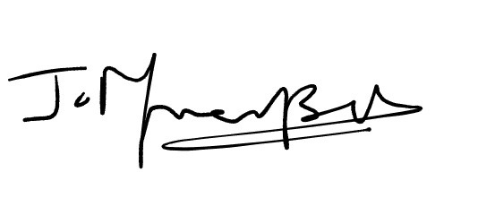
Sub Total:10000
Tax:1800
Total amount Paid:11800

