
TAX INVOICE

Invoice number: TEQIT-RNINVOICE-00244
Date: 7 Sept 2026

SOLD BY
Rev0365 Global Private Limited (TEQIT)
Phone Number: +91 7567386365
GST Number: 23ASDFM0125PAZ1
OD Acc: 00000044015545872
IFSC: SBIN0013241
Branch: SBI Egmore

BILLING TO.
Harish Raja
SRR mens pg
sholinganallur, Chennai, Tamil Nadu, 600119
Phone Number: +91 8523697410
GST: 33ABCDE1234F1Z5
SHIPPING TO
vinith
SRR mens pg
sholinganallur, Chennai, Tamil Nadu, 600119
Phone Number: +91 8523697410
GST: 33ABCDE1234F1Z5

PRODUCT INVOICE

SNO | DESCRIPTION | HSN CODE | QTY | TAXABLE AMOUNT | TAX (%) | TAX AMOUNT | SUB TOTAL | TOTAL AMOUNT
1 | Acer Laptop |  | 1 | 8000 | 18 | 1440 | 8000 | 9440

Authorized By
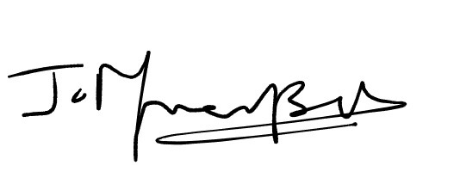
Sub Total:8000
Tax:1440
Total amount Paid:9440

