
TAX INVOICE

Invoice number: TEQIT-RNINVOICE-00263
Date: 1 Aug 2026

SOLD BY
Rev0365 Global Private Limited (TEQIT)
Phone Number: +91 7567386365
GST Number: 23ASDFM0125PAZ1
OD Acc: 00000044015545872
IFSC: SBIN0013241
Branch: SBI Egmore

BILLING TO.
Harish Raja
SRR mens pg
sholinganallur, Chennai, Tamil Nadu, 600119
Phone Number: +91 8523697410
GST: 33ABCDE1234F1Z5
SHIPPING TO
Harish Raja
SRR mens pg
sholinganallur, Chennai, Tamil Nadu, 600119
Phone Number: +91 8523697410
GST: 33ABCDE1234F1Z5

PRODUCT INVOICE

SNO | DESCRIPTION | HSN CODE | QTY | TAXABLE AMOUNT | TAX (%) | TAX AMOUNT | SUB TOTAL | TOTAL AMOUNT
1 | Acer-i9 |  | 1 | 30000 | 18 | 5400 | 30000 | 35400

Authorized By
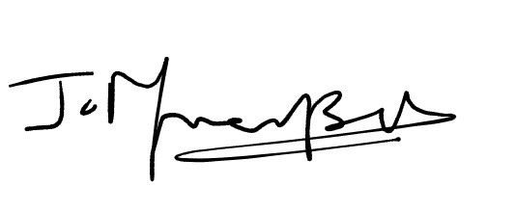
Sub Total:30000
Tax:5400
Total amount Paid:35400

