
TAX INVOICE

Invoice number: TEQIT-RNINVOICE-00233
Date: 8 Apr 2026
Order ID: TEQIT-0000000734

SOLD BY
Rev0365 Global Private Limited (TEQIT)
Phone Number: +91 7567386365
GST Number: 23ASDFM0125PAZ1
OD Acc: 00000044015545872
IFSC: SBIN0013241
Branch: SBI Egmore

BILLING TO.
Cloud Desk Technology
2, shollinganallur, Kanchipuram, Tamil Nadu, 600119
Phone Number: +91 9876543672
GST: 33BZYPS9373N1ZZ
SHIPPING TO
Cloud Desk Technology
2, shollinganallur, Kanchipuram, Tamil Nadu, 600119
Phone Number: +91 9876543672
GST: 33BZYPS9373N1ZZ

PRODUCT INVOICE

SNO | DESCRIPTION | HSN CODE | QTY | TAXABLE AMOUNT | TAX (%) | TAX AMOUNT | SUB TOTAL | TOTAL AMOUNT
1 | Lenovo Thinkpad |  | 1 | 5000 | 18 | 900 | 5000 | 5900

Authorized By
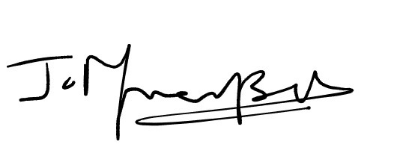
Sub Total:5000
Tax:900
Total amount Paid:5900

