Folder and Files details

Folder Name : **SRE_Assignment**

Terraform files

1. Api.tf – Creates Api gateway resources and method
2. DiceRoll_GetData_lambda.py – Code to create lambda function for retrieving results from DynamoDB
3. DiceRoll_Simulation_lambda.py – Code for create lambda function for creating dice simulations and store it to DynamoDB
4. dynamodb.tf – Creates DynamoDB resources
5. iam.tf. – Create Iam roles and policies used for lambda function
6. main.tf. – Creates Lambda resources
7. outputs.tf. – Gives APIGateway URLs for creating simulation and get results of the simulation
8. variables.tf – defined variables , please pass your region , by default resources will create at “ap-southeast-1”

Terraform initialization

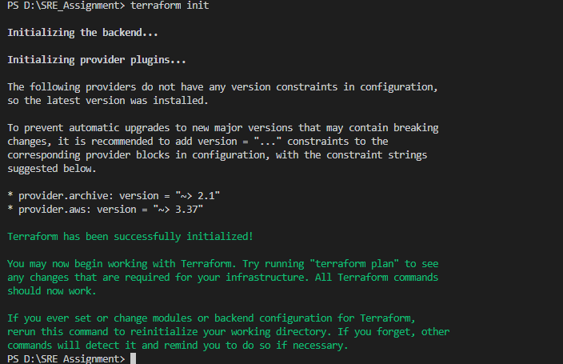

Terraform Plan

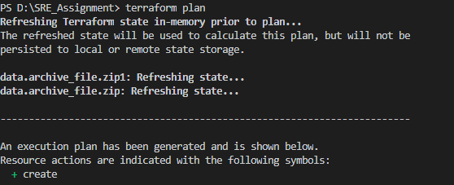



Terraform Apply





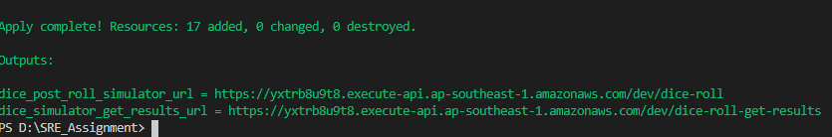

dice_post_roll_simulator_url = [This](https://yxtrb8u9t8.execute-api.ap-southeast-1.amazonaws.com/dev/dice-roll) API will perform the simulation as per parameters passed

dice_simulator_get_results_url = [Thi](https://yxtrb8u9t8.execute-api.ap-southeast-1.amazonaws.com/dev/dice-roll-get-results)s API will provide you the simulation details

**Note : Please use POST type method for both the API calls from the client**

1. As mentioned in the assignment , number of dice, the sides of the dice and the total number of rolls configurable through query parameters.   
   * 1. dice_sides = sides of the dice
     2. no_of_dices. = number of dice,
     3. no_of_simulations = total number of rolls
2. Please take the dice_post_roll_simulator_url API URLS from the output screen and append the parameters like below example
   1. https://ijnpoilx86.execute-api.ap-southeast-1.amazonaws.com/dev/dice-roll?dice_sides=6&no_of_dices=3&no_of_simulations=25

API creation screen shots

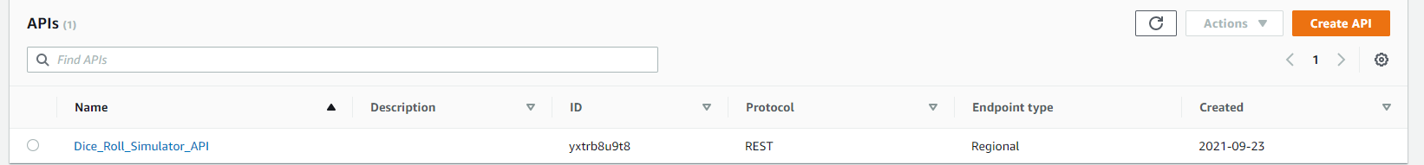

API Resources screen shots

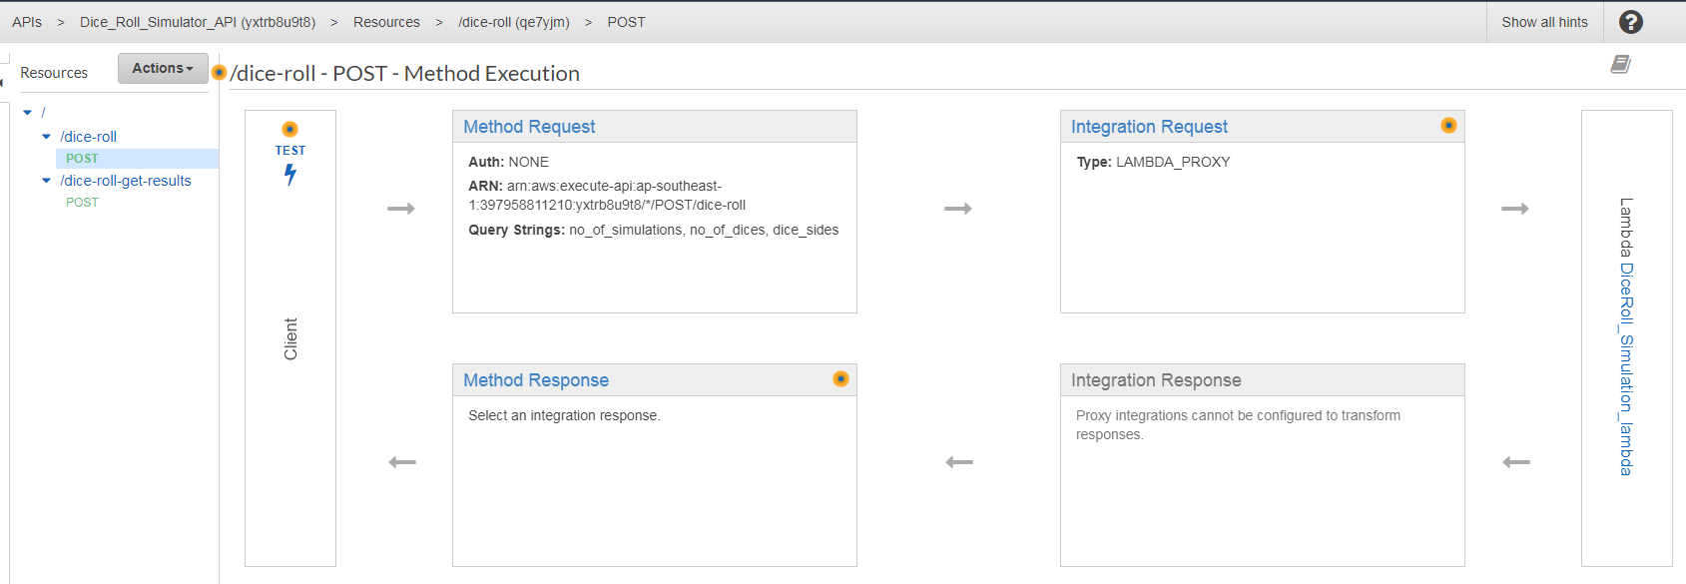

Lambda function screen shots

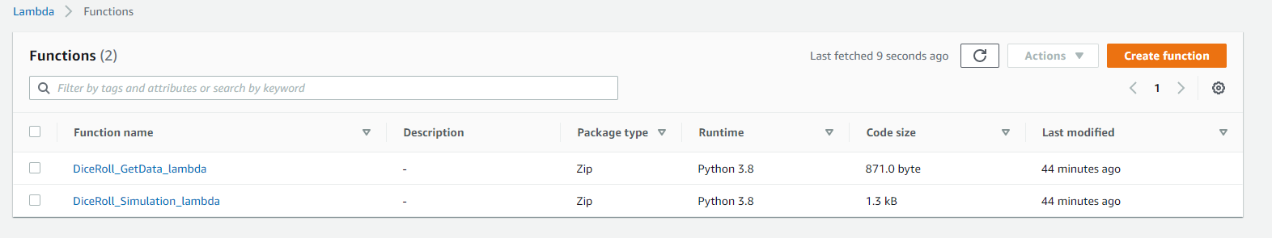

DynamoDB Scan results screenshots

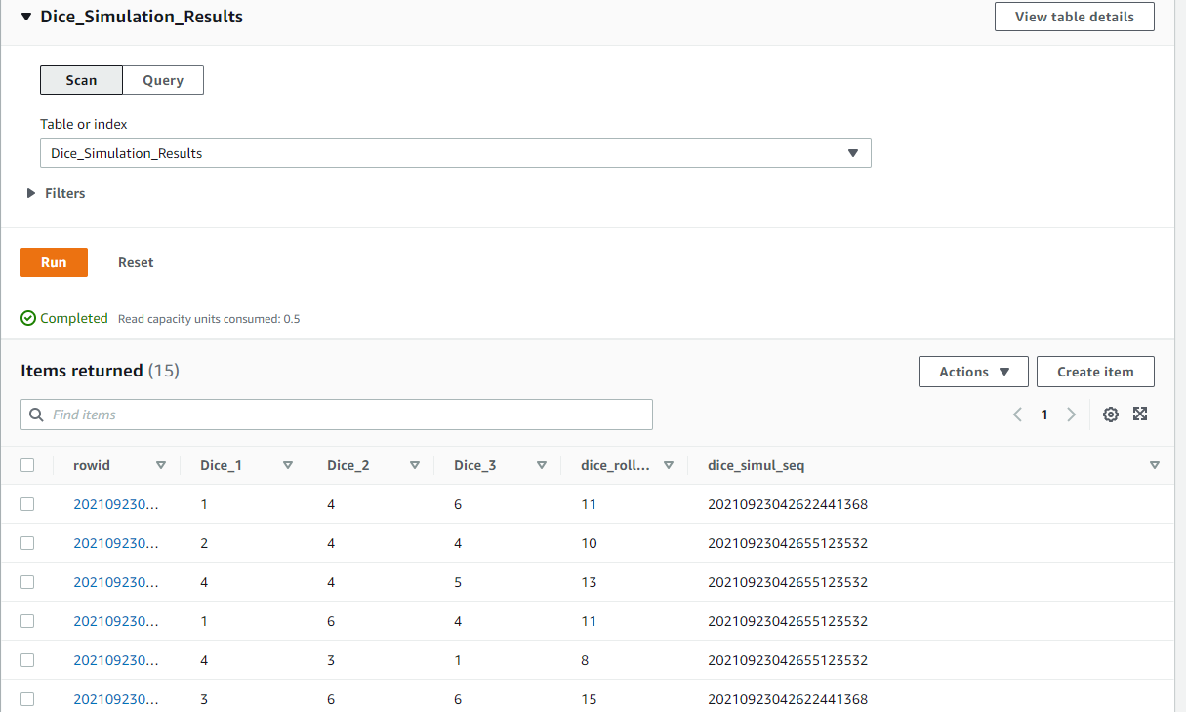

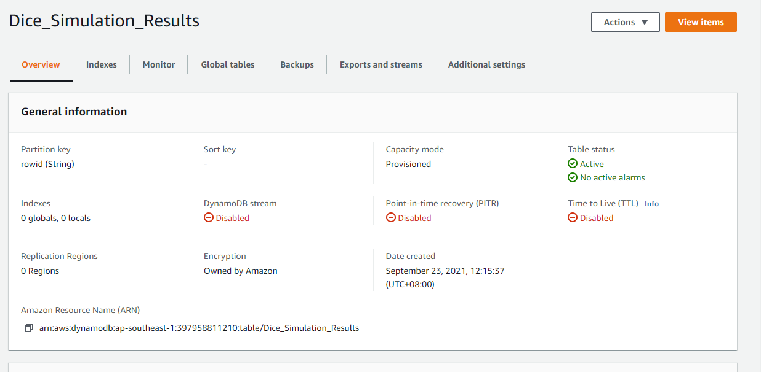

PostMan app -- POST rest api called Screen shot with arguments passed with results below

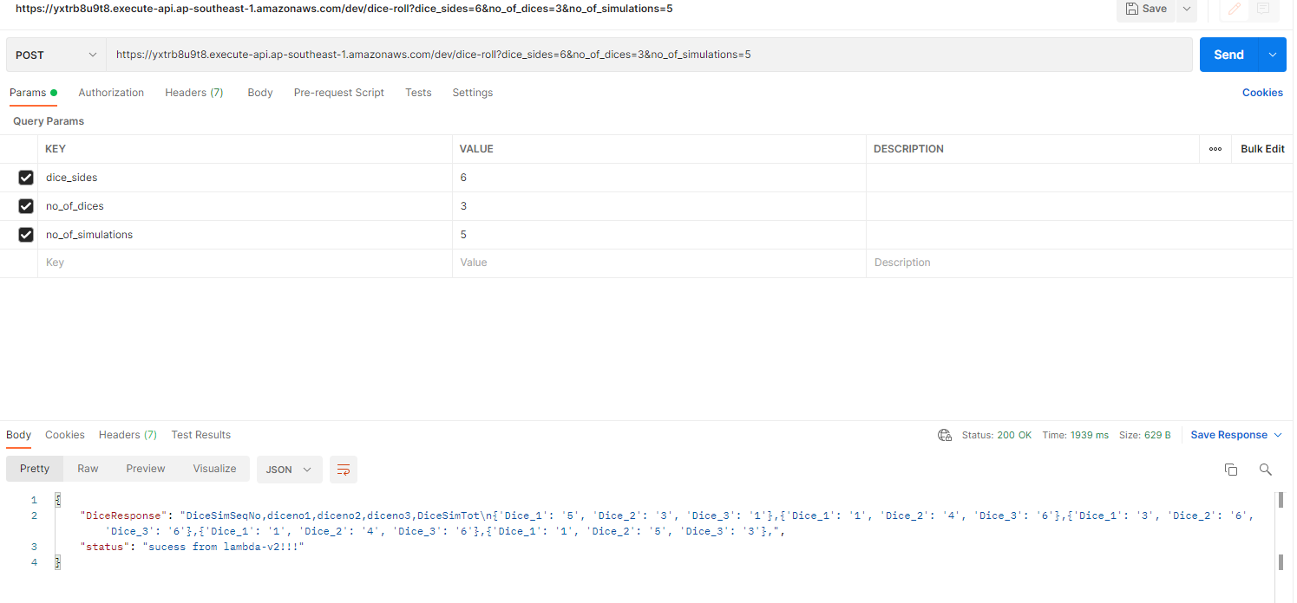

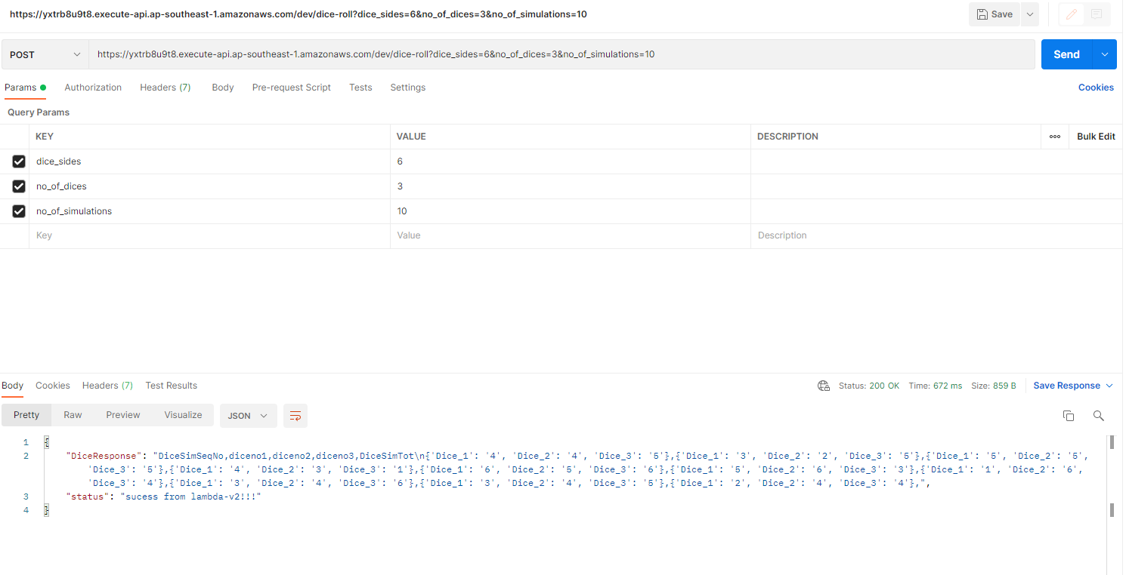

POSTMAN - retrive api results from DynamoDB screenshot

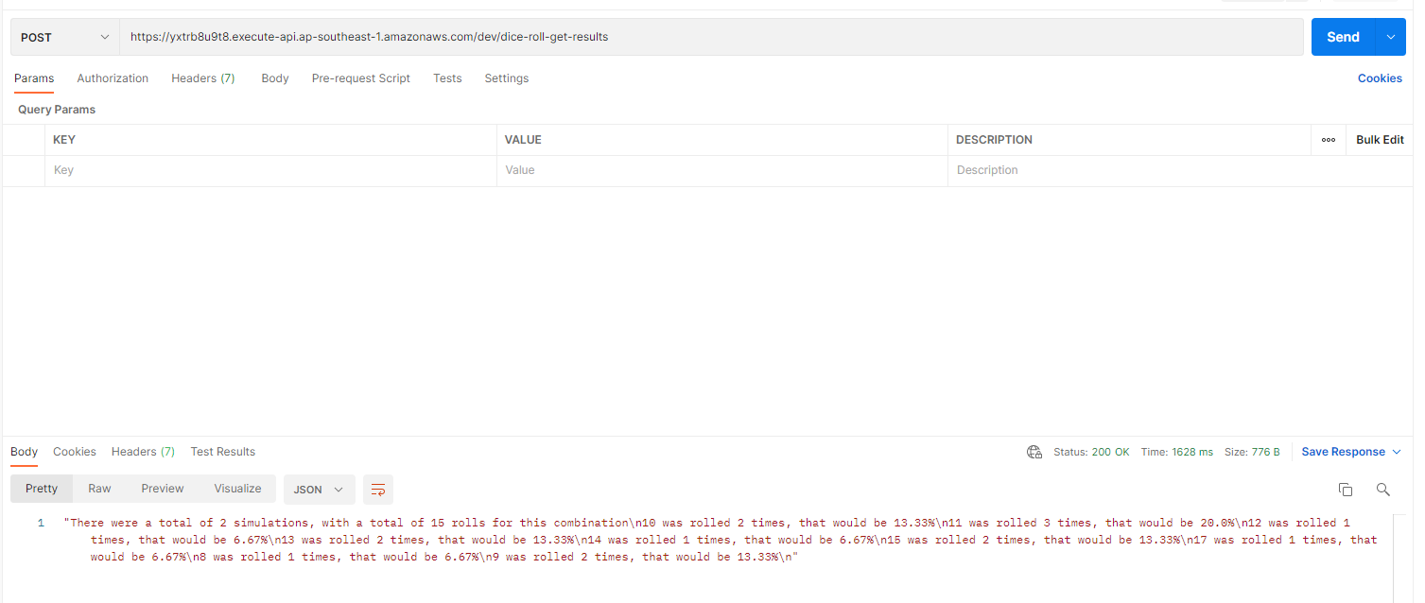

**Notes**

* Due to lack of time, only one role with read/write permissions used in lambda for dynamodb table.
* API Security and Deployment methods are not updated