Terraform Training Notes
28-09-2026 — Introduction to Terraform & Infrastructure as Code
1. What is Infrastructure as Code (IaC)?
Infrastructure as Code (IaC) is the practice of creating, configuring, and managing infrastructure using code or configuration files instead of manually creating resources through a cloud portal.
With IaC, infrastructure can be:
- Automated
- Reused
- Version controlled
- Consistently deployed
- Easily modified
- Shared across teams
- Recreated whenever required
Example
Instead of manually creating an Azure Virtual Machine through the Azure Portal, we can define it in Terraform:
resource "azurerm_linux_virtual_machine" "rg" {
name = "my-vm"
}
Terraform reads this configuration and creates the required infrastructure.

2. What is Terraform?
Terraform is an Infrastructure as Code (IaC) tool developed by HashiCorp.
Terraform allows us to define, create, modify, and manage infrastructure using human-readable configuration files.
Terraform can manage infrastructure across:
- Azure
- AWS
- Google Cloud Platform (GCP)
Definition
Terraform allows us to define and manage infrastructure in a consistent and repeatable way using human-readable configuration files that can be versioned, reused, and shared.

3. Azure Services
Terraform can be used to provision and manage many Azure services, such as:
- Virtual Machines (VMs)
- Virtual Networks (VNets)
- Subnets
- Network Security Groups (NSGs)
- Storage Accounts
- Databases
- Load Balancers
- Public IPs
- App Services
- Azure Kubernetes Service (AKS)

4. AWS Services
Terraform can also manage AWS services such as:
- EC2
- VPC
- Subnets
- Security Groups
- S3
- RDS
- IAM
- Load Balancers
- Route 53
- EKS

5. Basic Azure Infrastructure Flow
When working with Azure, a typical infrastructure flow is:
Azure Account
↓
Subscription
↓
Resource Group
↓
Virtual Network
↓
Subnet
↓
Network Security Group
↓
Virtual Machine
↓
Storage / Database / Other Services
Basic Azure Portal Activities
- Log in to the Azure Portal
- Select or create an Azure Subscription
- Create a Resource Group
- Create required resources
- Configure networking
- Deploy applications/workloads
Terraform can automate these activities instead of creating everything manually through the portal.

6. Infrastructure Components
Terraform can manage different types of infrastructure components.
1. Compute
Examples:
- Azure VM
- AWS EC2
- GCP Compute Engine
2. Storage
Examples:
- Azure Storage Account
- AWS S3
- GCP Cloud Storage
3. Networking
Examples:
- VNet
- VPC
- Subnet
- NSG
- Security Group
4. DNS
Used to manage domain names and DNS records.
Examples:
- Azure DNS
- AWS Route 53
- Google Cloud DNS
5. SaaS
Terraform can also manage certain Software-as-a-Service resources and services through supported providers.

7. Cloud Providers Supported by Terraform
Terraform supports many cloud platforms.
The major cloud providers are:
Terraform
|
-----------------------
| | |
Azure AWS GCP
| | |
Azure EC2 Compute
VM VPC Engine
VNet S3 VPC
Storage RDS Storage

8. How Does Terraform Work?
Terraform follows a workflow where we define the desired infrastructure in configuration files and Terraform determines what needs to be created, changed, or removed.
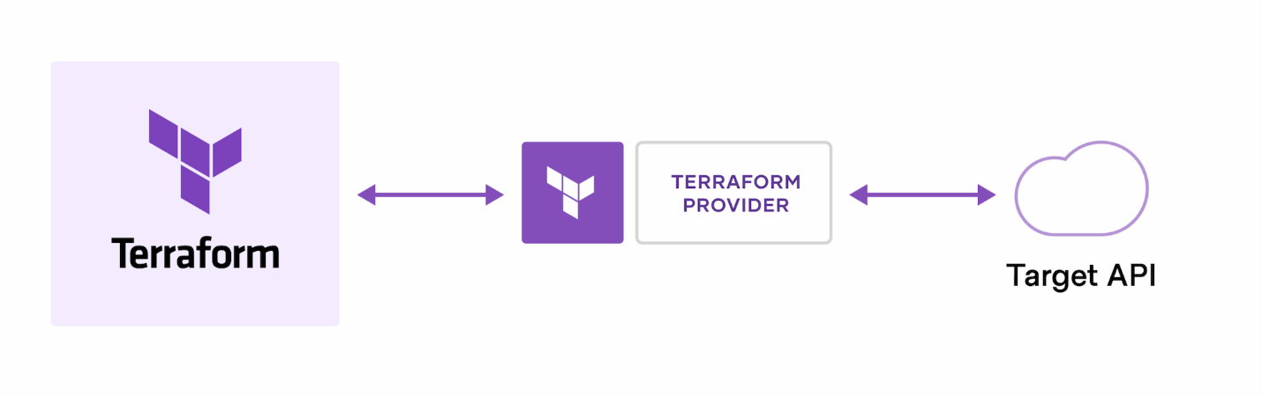

Wrire, plan and apply flow
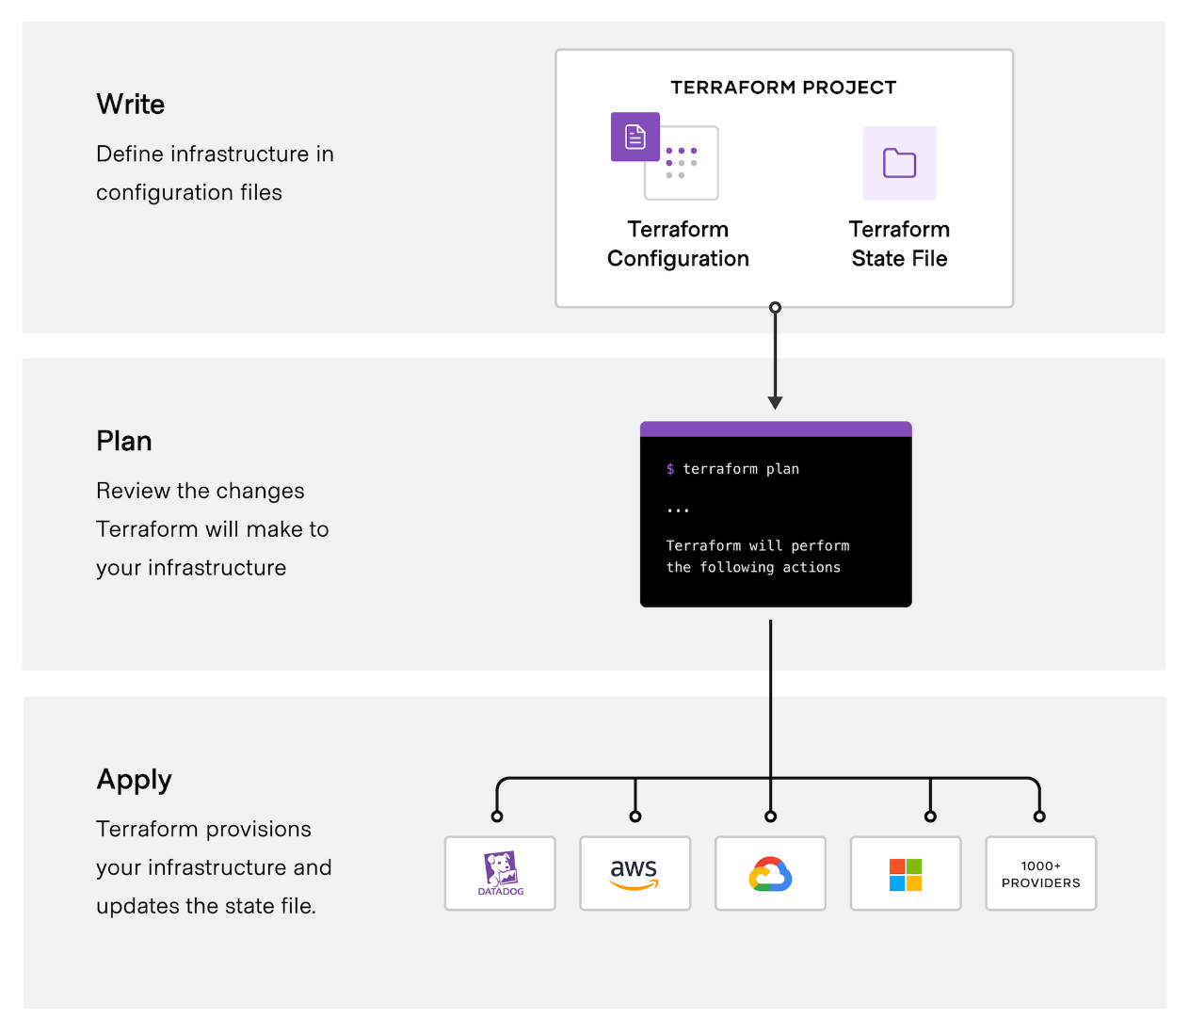

Basic Workflow
Write Terraform Code
↓
terraform init
↓
terraform plan
↓
terraform apply
↓
Infrastructure Created
↓
Terraform State Updated

9. Why Terraform?
Terraform helps organizations manage infrastructure in a consistent, repeatable, and automated way.
Major benefits
- Automation
- Consistency
- Reusability
- Version control
- Infrastructure standardization
- Multi-cloud support
- Collaboration
- Faster deployments
- Reduced manual errors
Simple Example
Without Terraform:
Engineer
↓
Azure Portal
↓
Create VM
↓
Create VNet
↓
Create Subnet
↓
Create NSG

With Terraform:
Terraform Code
↓
terraform plan
↓
terraform apply
↓
Azure Infrastructure

11. Terraform Concepts
The important Terraform concepts you will learn are:
- Provider
- Resource
- Variables
- Outputs
- Locals
- Data Sources
- Modules
- Meta-Arguments
- Backends
- Search and Import
- State Management
- CRUD Operations
- Provisioners

12. Provider
A provider allows Terraform to communicate with an external platform or service.
Examples:
Terraform
↓
Azure Provider
↓
Microsoft Azure
Terraform
↓
AWS Provider
↓
Amazon Web Services
For Azure, we commonly use the azurerm provider.
Example:
terraform {
required_providers {
azurerm = {
source = "hashicorp/azurerm"
version = "~> 4.0"
}
}
}

provider "azurerm" {
features {}
}

13. Resource
A resource block defines an infrastructure object that Terraform should create or manage.
Example:
resource "azurerm_resource_group" "example" {
name = "my-resource-group"
location = "East US"
}
Here:
- resource → Terraform resource block
- azurerm_resource_group → Resource type
- example → Local name
- name → Resource Group name
- location → Azure region

30-09-2026 — Variables and Outputs
14. What is a Variable?
A variable in Terraform is a way to define an input value that can be changed without modifying the main Terraform configuration.
Example
Instead of hardcoding:
location = "East US"
we can use:
location = var.location
and define the variable separately.

15. Why Do We Use Variables?
Variables provide several benefits:
1. Avoid Hardcoding
Values do not have to be directly written into the resource configuration.
2. Reuse Terraform Code
The same Terraform code can be used for multiple environments.
3. Customize Infrastructure
Different values can be supplied for Dev, QA, and Production.
4. Easier Maintenance
Configuration becomes easier to manage and update.
5. Pass Values from Outside
Values can be provided through variable files, command-line options, environment variables, or other mechanisms.

16. variables.tf
The variables.tf file is commonly used to define Terraform variables.
Example:
variable "location" {
description = "Azure region"
type = string
}

variable "resource_group_name" {
description = "Resource group name"
type = string
}
This defines what values are required.

17. terraform.tfvars
The terraform.tfvars file is commonly used to provide the actual values for Terraform variables.
Example:
location = "East US"
resource_group_name = "dev-rg"

=========================
variables.tf
↓
Defines WHAT values are needed
====================================
terraform.tfvars
↓
Provides the ACTUAL values
========================================
main.tf
↓
Uses those values
==========================================
For example:
variables.tf
variable "location" {
type = string
}
terraform.tfvars
location = "East US"
main.tf
resource "azurerm_resource_group" "rg" {
name = "my-rg"
location = var.location
}

18. Outputs
What is an Output?
An output is used to display or expose useful information after Terraform creates or manages infrastructure.
For example, we may want Terraform to display:
- VM name
- VM public IP address
- Resource ID
- Resource Group name
- Storage Account name
Example
output "resource_group_name" {
description = "Name of the Resource Group"
value = azurerm_resource_group.example.name
}
After:
terraform apply
Terraform can display:
resource_group_name = "my-rg"

19. Terraform Project Structure
For your hands-on Azure project, you can use this structure:
terraform-azure-project/
│
├── provider.tf
├── main.tf
├── variables.tf
├── terraform.tfvars
└── outputs.tf
Purpose of each file
File | Purpose
provider.tf | Configure Terraform provider
main.tf | Define resources
variables.tf | Define input variables
terraform.tfvars | Provide variable values
outputs.tf | Display useful information

20. Terraform Setup — 29-09-2026
Step 1 — Install Terraform
Download and install Terraform on your laptop.
After installation, open PowerShell or VS Code Terminal:
terraform --version
Example:
Terraform v1.x.x
Step 2 — Install Azure CLI
Check Azure CLI:
az version
Step 3 — Login to Azure
az login
A browser window will open for authentication.
If you have multiple subscriptions, you can check them with:
az account list --output table
Select the required subscription:
az account set --subscription "<subscription-id>"
Verify:
az account show --output table

21. Create Terraform Project in VS Code
Open your project folder in VS Code.
Create:
- main.tf
- provider.tf
- variables.tf
- terraform.tfvars
- outputs.tf
Then run:
terraform init
Validate:
terraform validate
Format:
terraform fmt
Preview the changes:
terraform plan
Create the resources:
terraform apply
Delete the resources when they are no longer required:
terraform destroy

22. Terraform + GitHub
Your overall learning workflow can be:
VS Code
↓
Terraform Code
↓
Git
↓
GitHub
↓
Terraform Plan
↓
Terraform Apply
↓
Azure / AWS / GCP

