Uday training notes:

25/10/2026:

DevOps/Azure DevOps with Multi cloud:

Job roles:
- DevOps engineer
- Cloud DevOps engineer
- Platform engineer
- Infrastructure engineer
- SRE

DevOps Role and Responsibilities:
Application Deployment:
- Java application
- .net application
- Python
- Sale force application

Developer- java/.net
Manually Deployment by developer
Jar/war/ear----------on deployment in tomcat

Environment:
- Dev
- Stage
- Prod

DevOps Engineer: Application deployment for using below stacks
Source code: Write code we can create docker file –docker image
- Source tools --Git/Github
- Build tools -- Maven/Gradle
- CI/CD ----Jenkins/Azure DevOps
- Storage—ACR/jfrog
- Container—Docker
- Orchestration – Kubernates (yaml)
- Monitoring tools---- Prometheus and Grafana
===========================================================================
- Dev
- QA
- PreProd
- Prod

Infrastructure Deployments:
Cloud –Azure/AWS/GCP
Source tools: Git/Github
CI/CD : Azure DevOps/ADO
IAC : Terraform
Monitoring tools: Prometheus and Grafana

Azure Portal
Account
Subscription
Resource Group
Resource
- Vm -------------1 machine from portal
- Vnet
- Storage account
- App service
- Function
- Logic app

1. Source tools --Git/Github
2. Build tools -- Maven/Gradle
3. CI/CD ----Jenkins/Azure DevOps
4. Storage—ACR/jfrog
5. Container—Docker
6. Orchestration – Kubernates (yaml)
7. Monitoring tools---- Prometheus and Grafana
8. Terraform
9. cloud - azure, AWS and GCP

Road Map:
- DevOps fundamentals
- Linux basic
- Git/GitHub
- Azure cloud
- Terraform and ansible
- Azure DevOps –CI/CD
- Monitoring
- Docker
- Kubernates –AKS/EKS/GKE
- Real time project

- Aws
- Azure
- GCP

Configuration –Ansible/puppet /chef
Ansible -Vms—apache, tomcat and java –100 servers
Provison.sh
Patching –big fix
Base line
20 servers
Kernal rules, Security
- AIops
- MLops
- LLM Ops
Resume prepares
10 years
Relative 5+years
======================================
Dev team
Infras team
Ops team

===============================================

27/10/2026:
DevOps fundamentals

What is DevOps?

What is a combination of development and operation. it is a culture methodology and set of practice that enable development and operation team to work
Together to deliver software faster, more reliably and high quality

Traditional Approach:

- Poor communication
- Manual deployments
- Slow release
- Frequent failure
- Long recovery time

DevOps Approach:
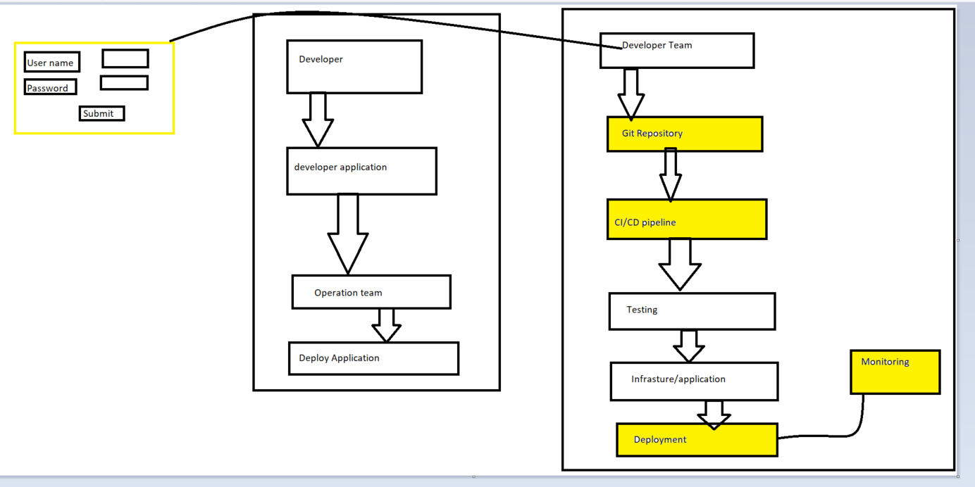

DevOps Goal:
- Automation
- Faster software delivery
- High-quality
- Reduce deployment failure
- Better collaboration
- Continue feedback
- Improved customer satisfaction

Why DevOps?
Without DevOps:
- Release every 3 months
- Deployment takes 8 hours
- Manual testing
- Manual rollback
With DevOps:
- Release every day
- Deployment in minutes
- Automated testing
- Automated rollback

SDLC
DevOps with Cloud—Cloud DevOps engineer
Git/Github
Maven
CI/CD
Jenkins
ADO
Docker
Kubenrates
Cloud

SDLC: Software development life cycle
- Planning
- Analysis
- Design
- Implementation
- Test & Integration
- Maintained

SDLC Models:
- Waterfall
- Agile
- Spiral
- Iterative
- Incremental
- V-model

Agile:
Agile Workflow
Requirements
│
▼
Sprint Planning
│
▼
Development
│
▼
Testing
│
▼
Review
│
▼
Release
│
▼
Next Sprint

Benifies:
- Faster
- Higher quality
- Flexibility

- Development –from scratch to development/ or midle development
- Maintainance – any features implementation
- Support------------DevOps pipeline, docker, nodes
- Migration ---- gitlab,github, ---github action

DevOps Tools Overview
Category | Examples
Source Control | Git, GitHub, Azure Repos
Project Management | Azure Boards, Jira
CI/CD | Azure DevOps, Jenkins, GitHub Actions
Build | Maven, Gradle, MSBuild
Artifact Repository | Azure Artifacts, Nexus, JFrog Artifactory
Infrastructure as Code | Terraform, ARM, Bicep
Configuration Management | Ansible
Containers | Docker
Orchestration | Kubernetes (AKS, EKS, GKE)
Monitoring | Azure Monitor, Prometheus, Grafana
Security | SonarQube, Trivy

28/10/2026:

Git/Github:

Version control:
What is version control?
Version control is a system that tracks changes to source code over time

Its help developers:
- Save every change
- Track who made change
- Restore previous
- Collaborator safely
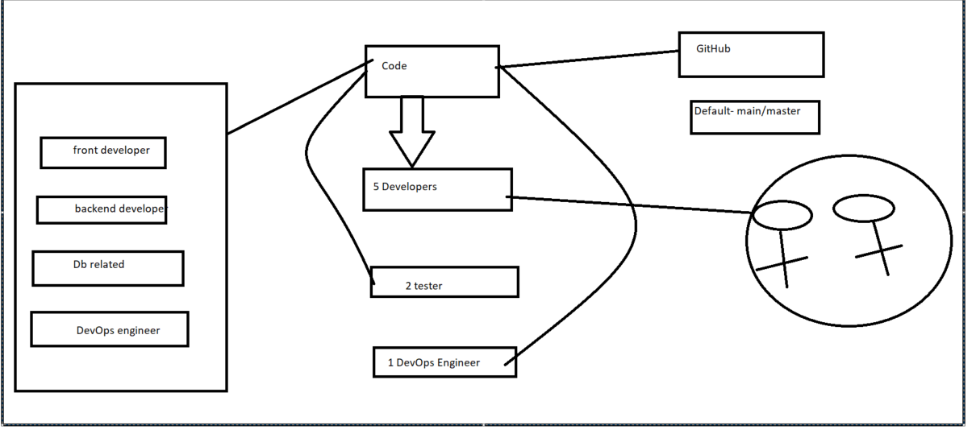

With out version control:
Project
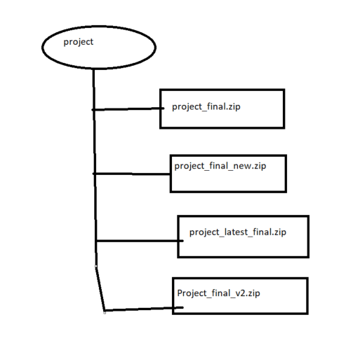
Problems:
- Confusing file names
- No history
- Difficult to collaborate
- Risk of losing work

With Git:
Download link: https://git-scm.com/install/windows
path set: in environment
cmd : git version
git version 2.37.2.windows.2

project - git repository History

Github url: https://github.com/

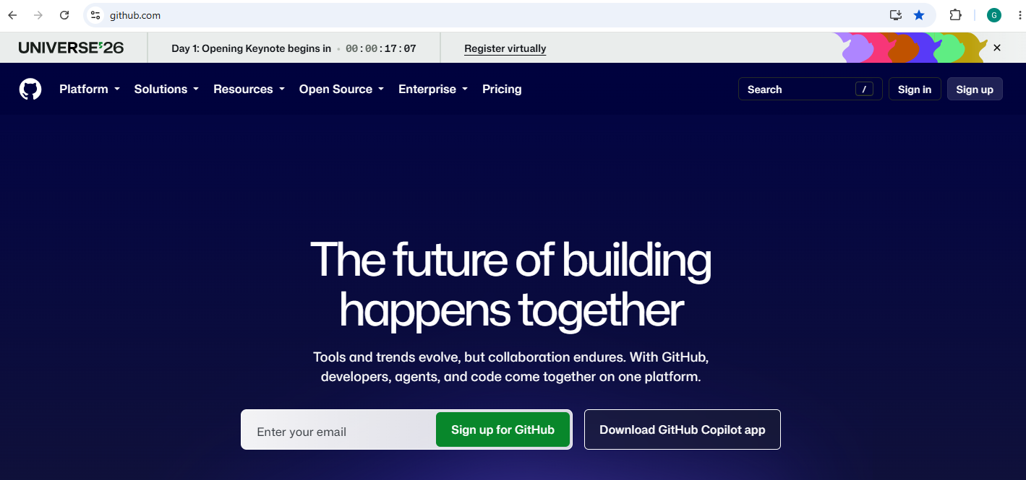

You need to sign up

29/10/2026:

Git/Github:
Github url: https://github.com/

Git commands

File creation
Touch

git commands

git clone
git branch --which branch we curretly showing
git branch -r repo branch list
git add .
git commit -m ""
git push

follow this order for commit
git pull
git status

git add .
git status
git commit -m ""
git push

31/10/2026:

Git Architecture:
What is Git?
Git is a distributed version control system
Every developer has a complete copy of the repository

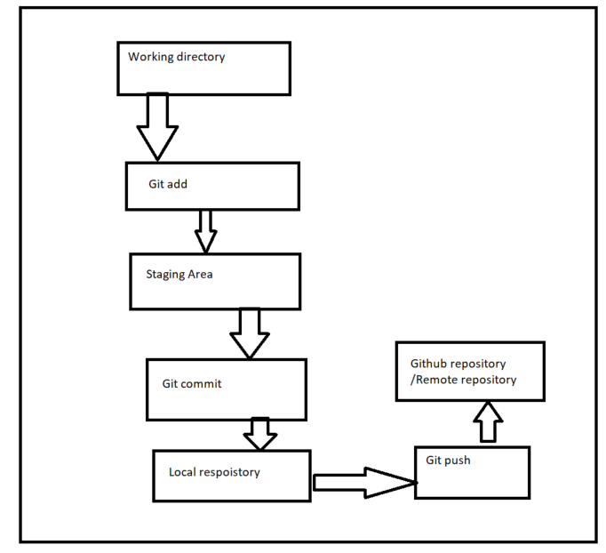

Send a parcel
- Working directory your item
- Staging areapecked box
- Commit sealed parcel
- Push courier deliver to destination

Topic 3: Repository
- Local Repository
- Remote repository

What is local repository?
Stored on your laptop or computer
What remote repository?
Stored on githuh
Shared with your team

Laptop GitpushGithub repository

Topic 4: branching
What is a branch?
A branch is an independent line of development
Developer can work on new feature without affecting main code

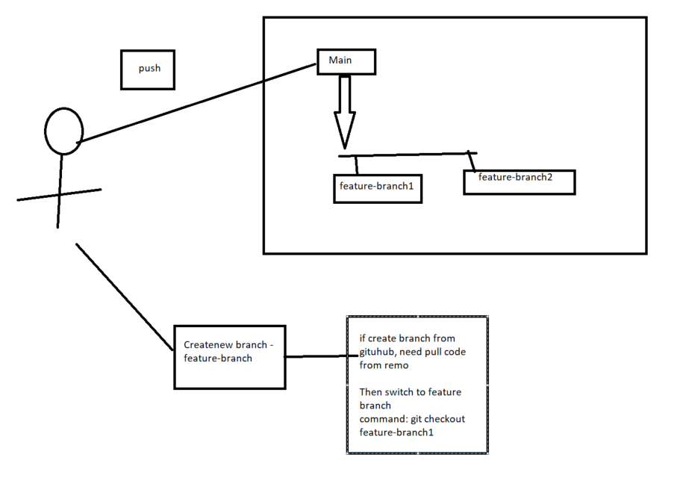
Commands:
Create branch
Git branch feature-branch1
Switch
Git checkout feature-branch1

