**Creative Brief:**

Cloud Guo

3/28/2023

**Title: Berserk Website**

1. Project Overview:

The goal of this website is to be informative about Berserk and its legacy. There will also be analyze of this manga to show people why it is good.

1. Resources:

Copy under: <https://en.wikipedia.org/wiki/Berserk_(manga)>

1. Audience:

Pretty much fans to this manga. However, if you are a new reader and not afraid of spoiler, you are welcome to read the pages.

1. Message:

I will focus on the comic itself. The comic is considered as a masterwork because of its struggling plot and characters and the artistic value created by Kentaro Miura.

1. Tone

The tone will be neutral and be informative as possible.

1. Visual Style:

The general color tone would be dark and grim like the manga. The comic work will be shown at some point as the background of the page.

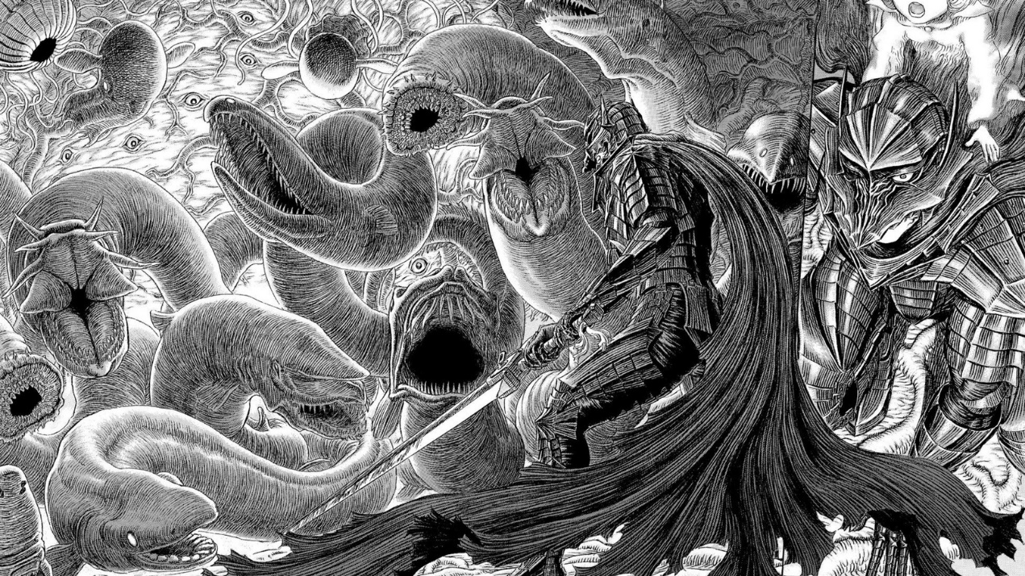

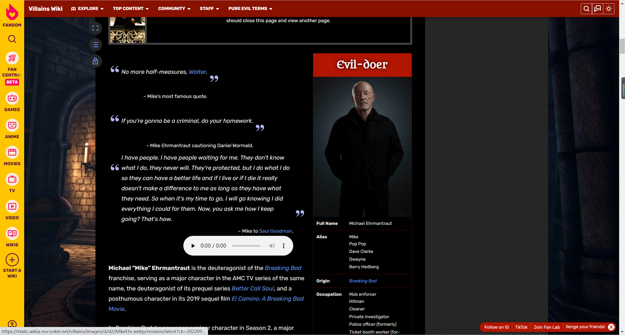

(Probably consider page be like this.)