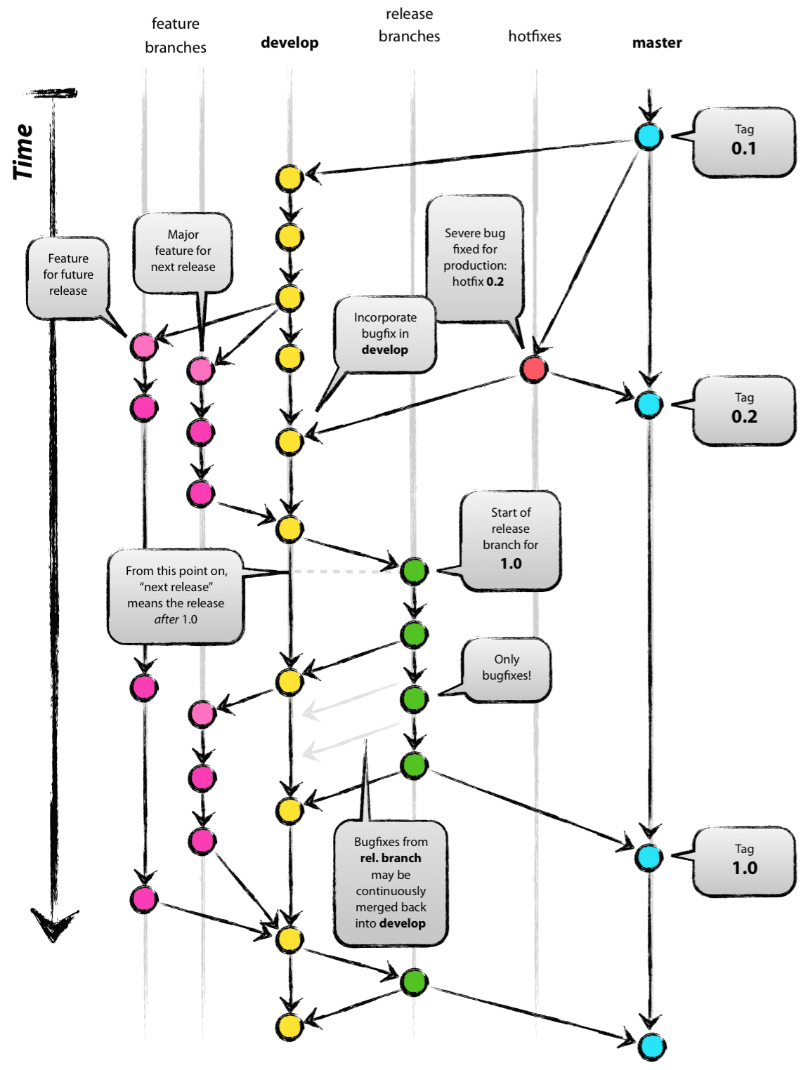

Commits to a feature branch triggers a personal deploy to DEV. This means that it will only be available to the developer that deployed.

QA deploys come from develop branch. PR into here triggers an approval-based auto-release to QA. It will also trigger a deploy to INT which is not approval based

Prod deploys come from release branch. PR into here triggers an approval-based auto-release to ALPHA (QA), BETA, RC, PROD