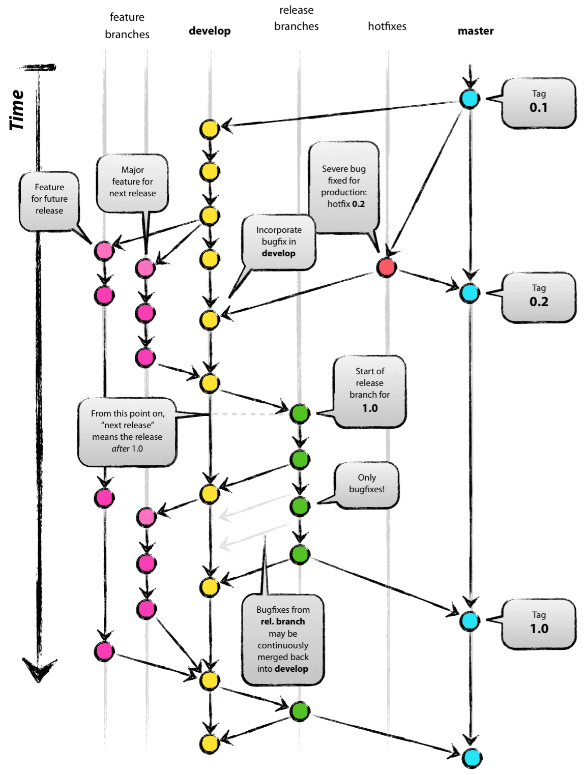

PR into here first triggers a deploy to INT which is not approval based. QA deploys come from develop branch as well, so then it triggers an approval-based deploy to QA.

Commits to a feature branch triggers a personal deploy to DEV. This means that it will only be available to the developer that deployed.

Prod deploys come from release branch. PR into here triggers an approval-based auto-release to ALPHA (QA), BETA, RC, PROD