





TechMSpire 2.0: Data and Analytics Hackathon

Speaker:

Ziggy Zulueta

Scenario

AI-Powered Healthcare Analytics

Problem Statement:
Long wait times in healthcare facilities diminish patient satisfaction and hinder operational efficiency. With limited resources and increasing patient volumes, identifying the root causes of bottlenecks and optimizing scheduling becomes a complex challenge. This initiative aims to harness data-driven insights to analyze patient appointment trends, uncover inefficiencies in patient flow, and implement strategies to reduce wait times—ultimately improving both patient care and hospital management.

Objectives



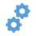

Leverage AI for Operational Insights – Use AI-driven analytics to optimize patient scheduling and
reduce wait times.
Deploy Data-Driven Dashboards – Visualize patient flow and inefficiencies using Power BI for real-
time decision-making.
Integrate Azure AI & Automation – Utilize Azure SQL, Machine Learning, and Functions to
automate patient flow predictions.
Optimize Healthcare with Predictive Analytics – Analyze historical patient data to detect
bottlenecks and improve resource allocation.
Hackathon Challenge: AI for Patient Care – Solve real-world healthcare challenges by streamlining
operations and enhancing patient experience.

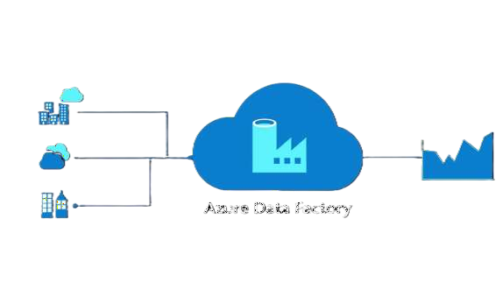
Technology Stack

Azure Data Factory

Overview:
Azure Data Factory is a cloud-based data integration service that allows you to create, schedule, and orchestrate data workflows (pipelines) across various data sources. It enables the movement and transformation of data, facilitating data-driven workflows for analytics and operational processes.

Key Features:
Azure data Factory
- Data Transformation: Utilizes Mapping Data Flows to perform code-free data transformations at scale, enabling complex data processing tasks without the need for manual coding.
- Orchestration: Provides a unified platform to schedule and manage data pipelines, ensuring seamless data flow between various services and on-premises data sources.


Technology Stack

Azure Machine Learning

Overview:
Azure Machine Learning is a comprehensive cloud platform that enables data scientists and developers to build, train, and deploy machine learning models. It supports the entire machine learning lifecycle, from data preparation to model deployment, facilitating scalable and reproducible AI solutions.

Key Features:
- Collaborative Notebooks: Provides Jupyter notebooks for collaborative development, supporting popular
frameworks like TensorFlow and PyTorch.
- Automated Machine Learning: Simplifies the process of building predictive models by automating algorithm
selection and hyperparameter tuning.
- Model Deployment: Enables seamless deployment of models as web services, allowing integration with applications and real-time scoring.
- MLOps Integration: Supports continuous integration and continuous delivery (CI/CD) for machine learning
models, ensuring consistent and reliable deployments.

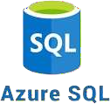
Technology Stack

Azure SQL Database

Overview:
Azure SQL Database is a fully managed relational database service based on the latest stable version of Microsoft SQL Server. It offers high availability, scalability, and intelligent performance features, making it suitable for modern cloud applications.

Key Features:
- Managed Service: Handles routine database management tasks such as backups, patching, and monitoring,
allowing developers to focus on application development.
- Scalability: Offers dynamic scaling options to adjust resources based on workload demands, ensuring optimal
performance.
- Advanced Security: Provides built-in security features like data encryption, threat detection, and advanced auditing to protect sensitive data.
- Global Distribution: Supports geo-replication, enabling data distribution across multiple regions for enhanced
availability and disaster recovery.

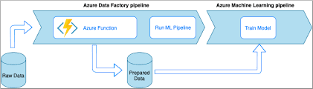
Technology Stack

Azure Functions

Overview:
Azure Functions is a serverless compute service that allows you to run event-driven code without managing infrastructure. It enables the execution of small pieces of code, or "functions," in response to events, providing a scalable and cost-effective solution for building applications.

Key Features:
- Event-Driven Execution: Triggers functions based on various events, such as HTTP requests, database changes, or
messages from queues, facilitating reactive programming.
- Integration: Seamlessly integrates with other Azure services, such as Azure Data Factory, Azure Event Grid, and
Azure Logic Apps, enabling the creation of comprehensive workflows.
- Flexible Development: Supports multiple programming languages, including C#, JavaScript, Python, and Java, allowing developers to use familiar tools and frameworks.

Thank you!

