**TASK-1**

**Sub-Task-1:**

1. Installed aws cli on ubuntu and credentials were configured

2. Created s3 bucket for terraform state file using s3api and enabled versioning

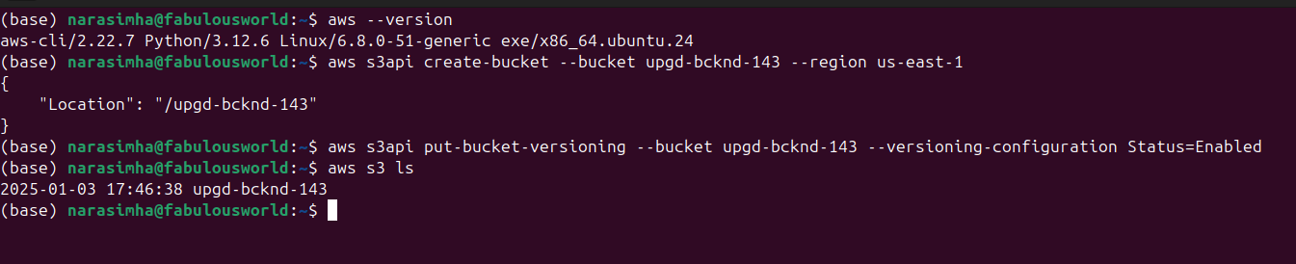

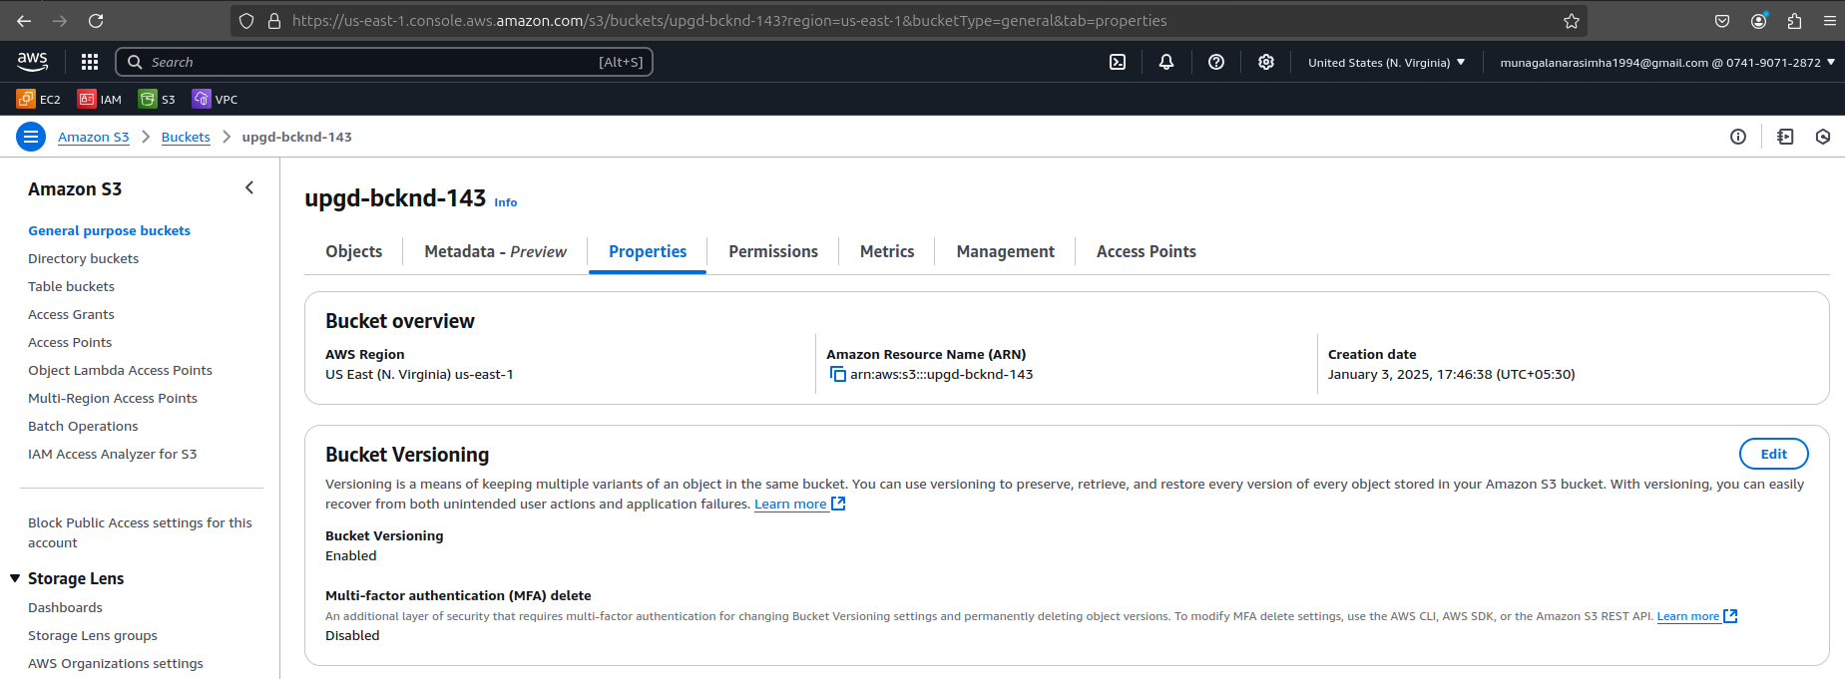

**Sub-Task-2 & Sub-Task-3:**

1. Installed terraform on ubuntu machine

2. Created VPC, NAT Gateway, Internet Gateway, 1 Public Subnet, 2 Private Subnets, Public and Private Route tables and their association with respective subnets.

3. Created Security Groups for Public, Private and bastion, 3 Ec2 instances were created for Bastion, Jenkins and App respectively.

4. Created Key-Pair and Application Load Balancer and its respective output file is attached and shared via google drive.

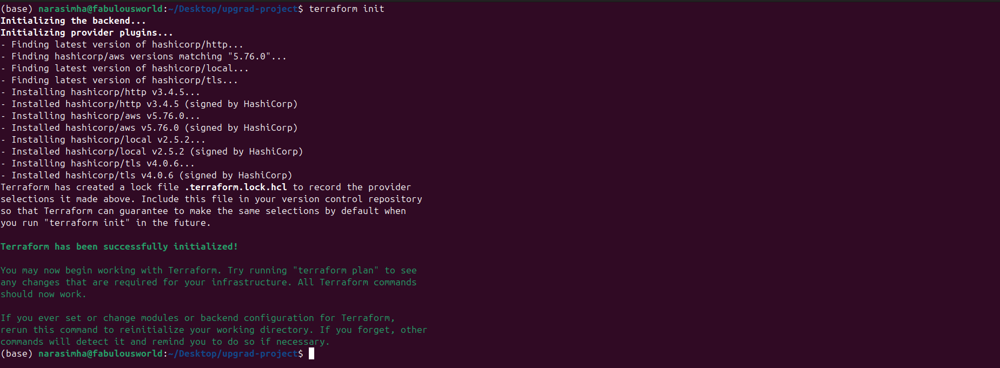

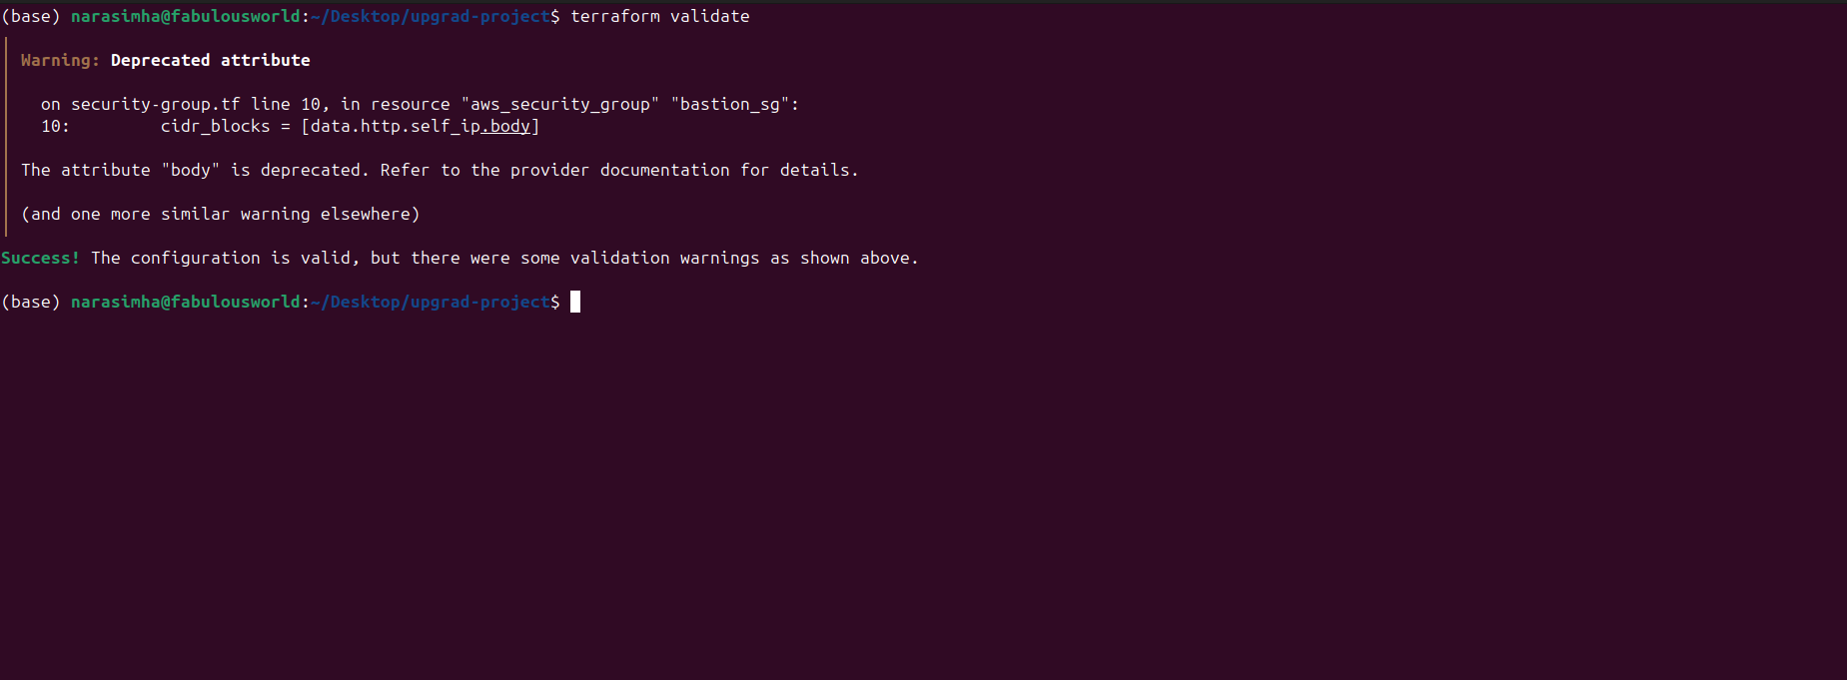

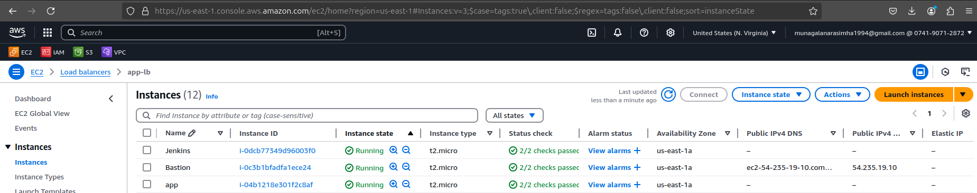

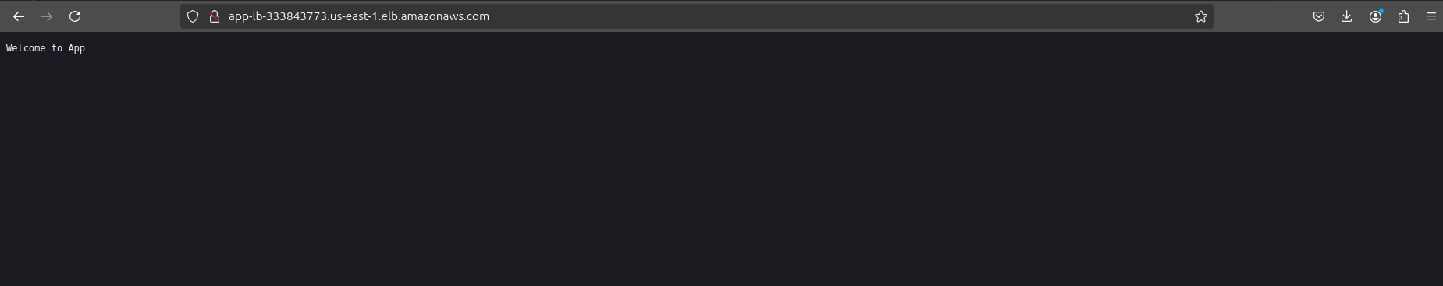

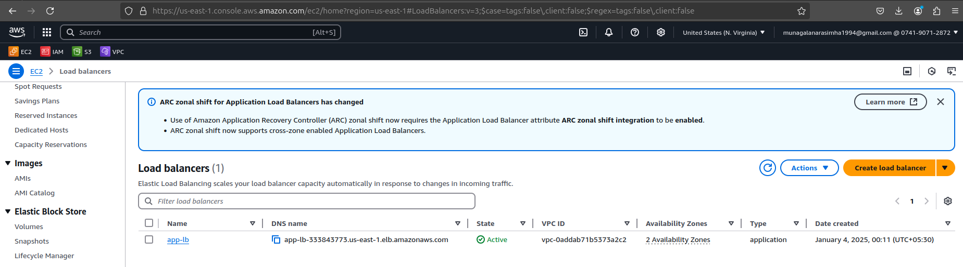

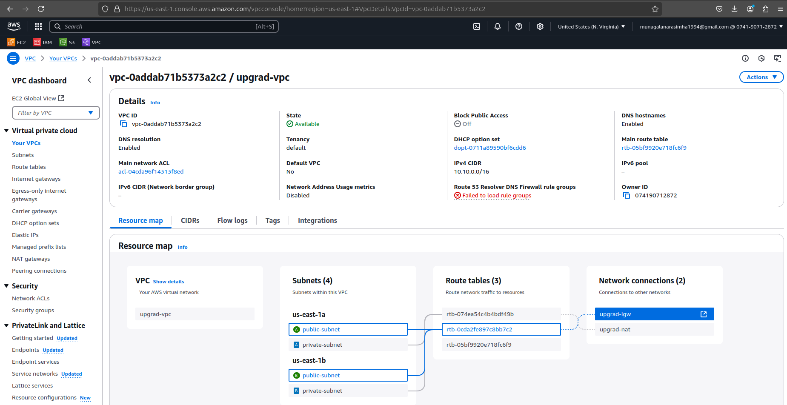

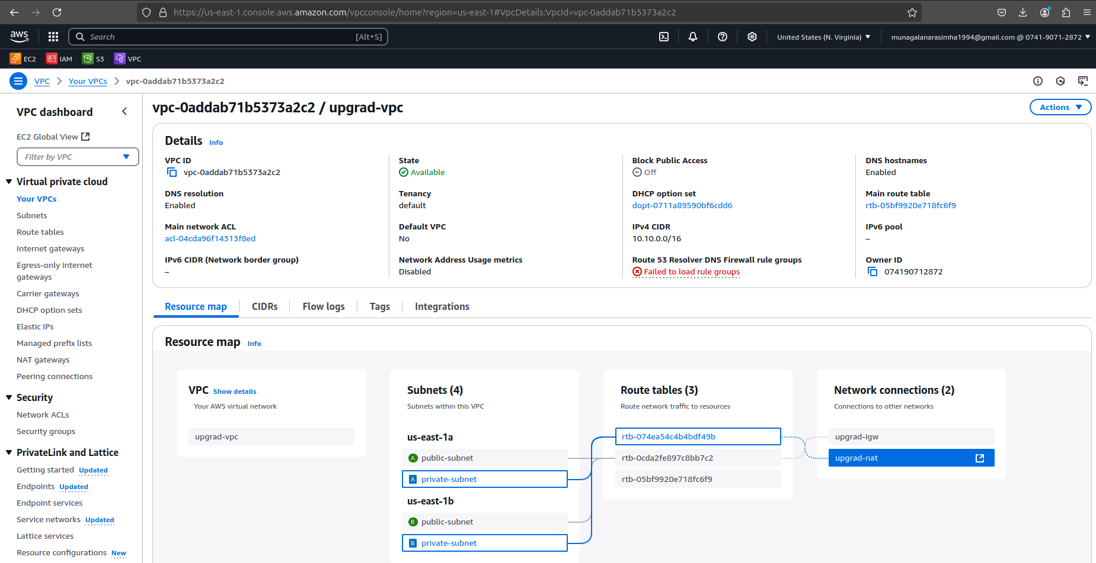

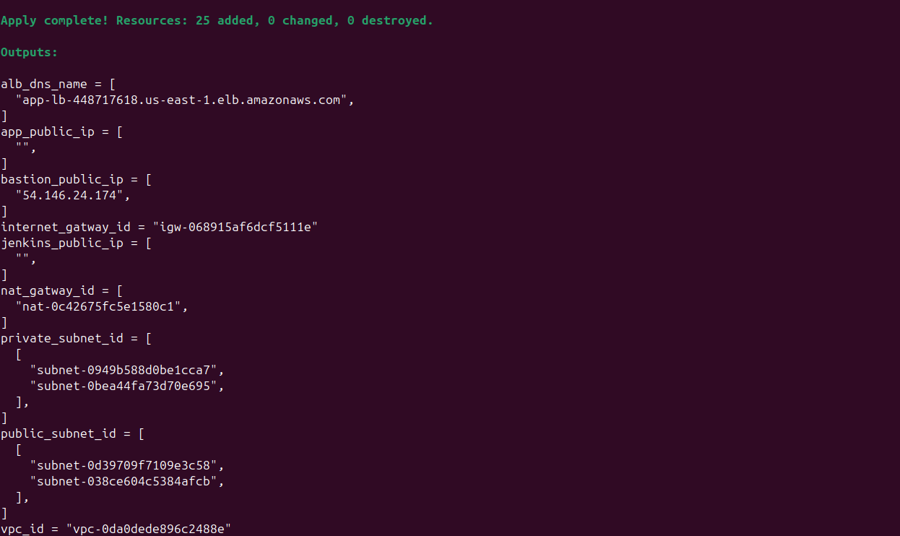

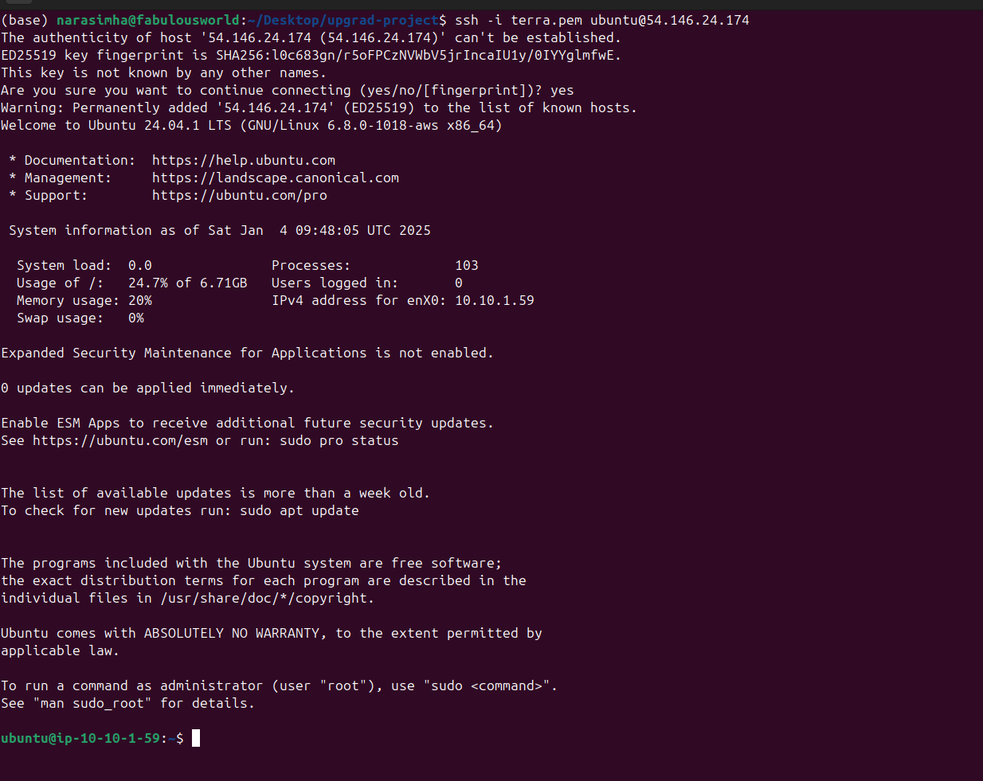

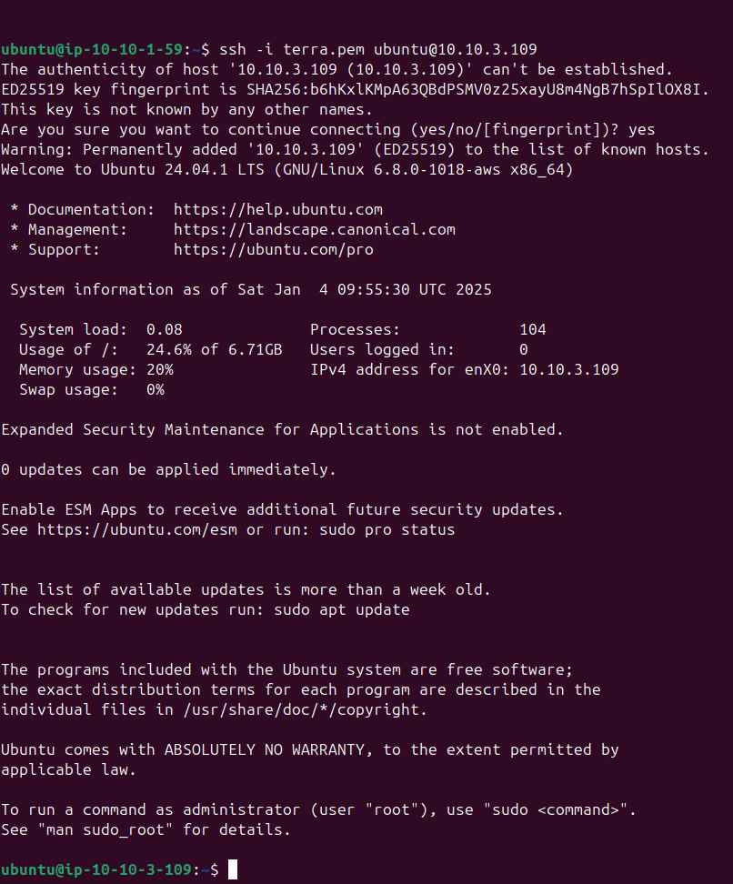

**Attached Files :** All Terraform files and output file