**TASK-1**

**Sub-Task-1 :**

1. Created private github repository <https://github.com/CloudLearner143/docker-node-app.git> as suggested in the task

2. Cloned <https://github.com/samaronybarros/movies-app.git> and dockerized node applications

3. Pushed Dockerfiles to the newly created github repository

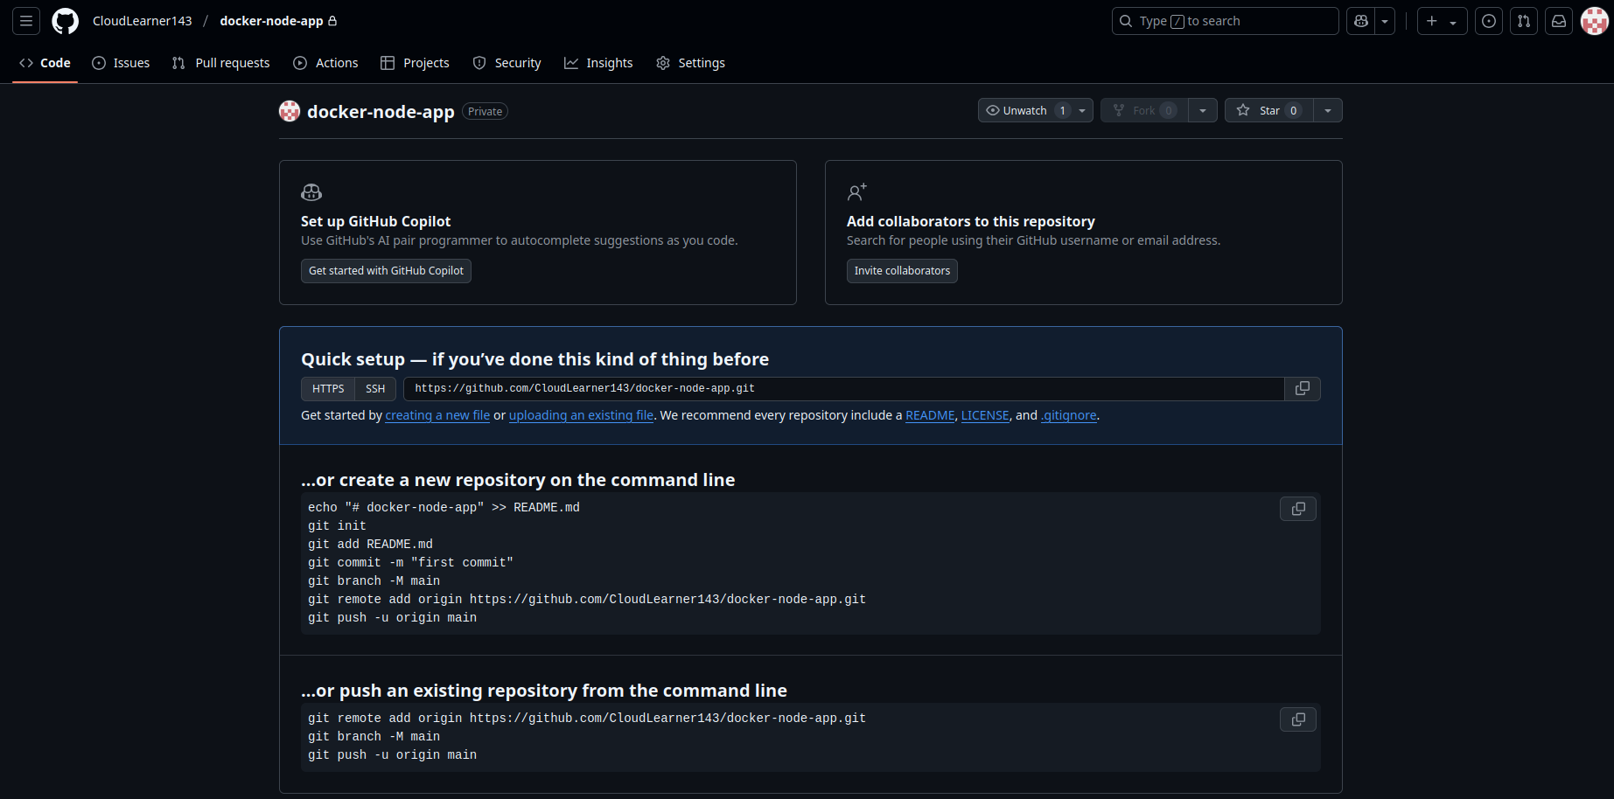

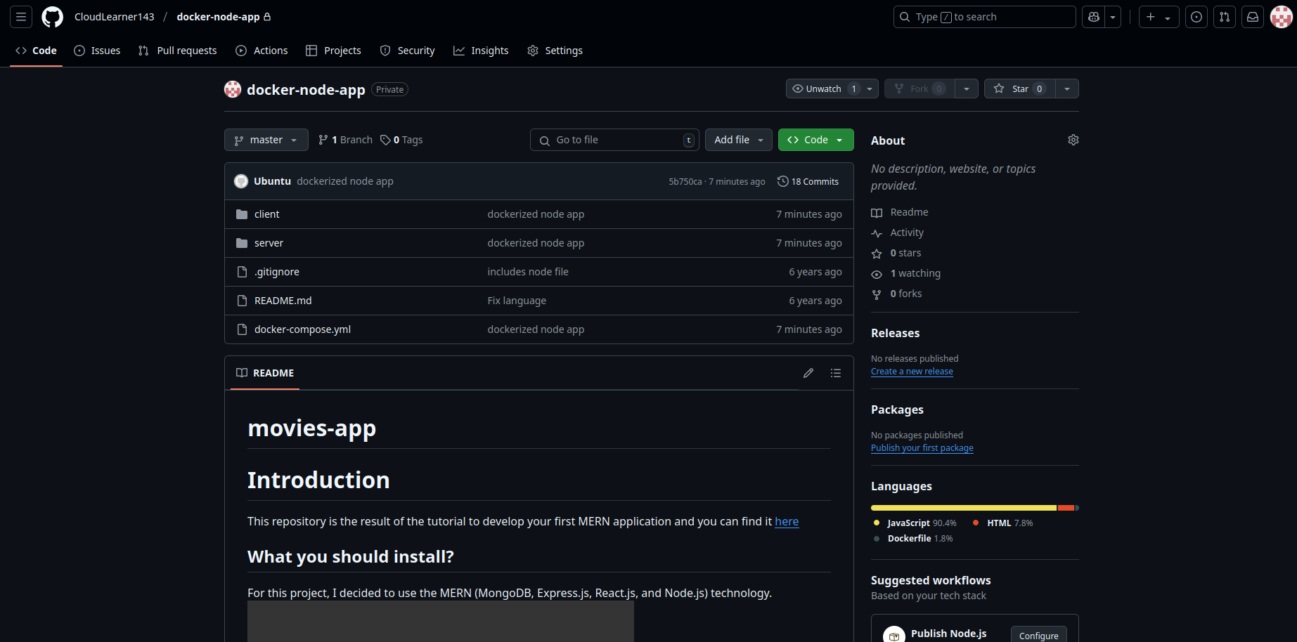

**Sub-Task-2 :**

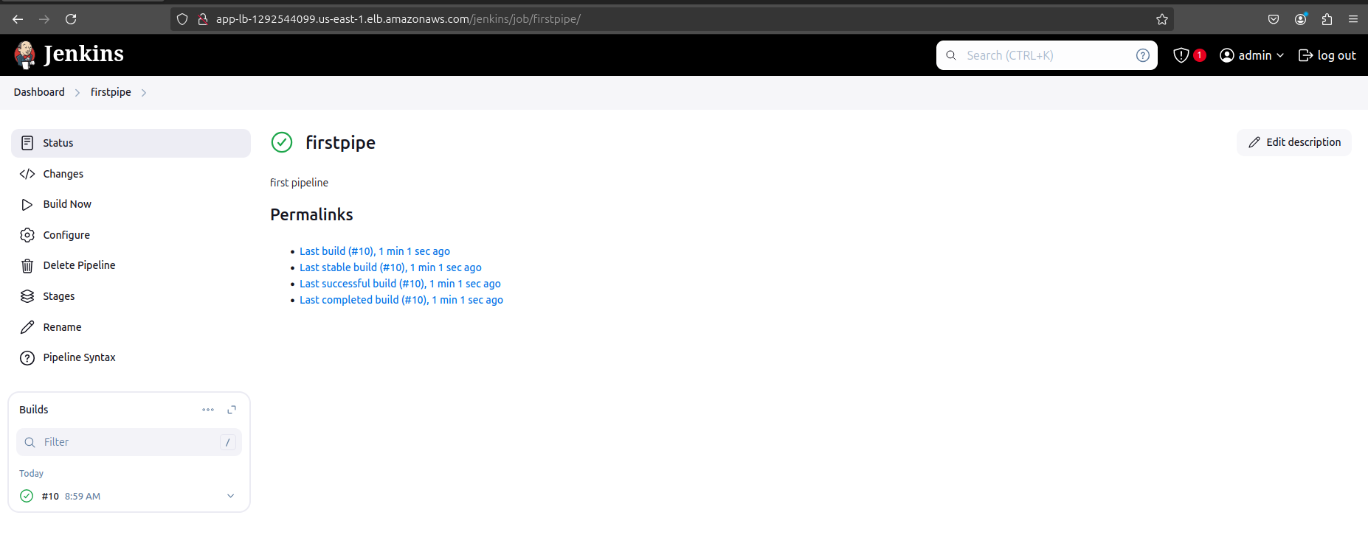

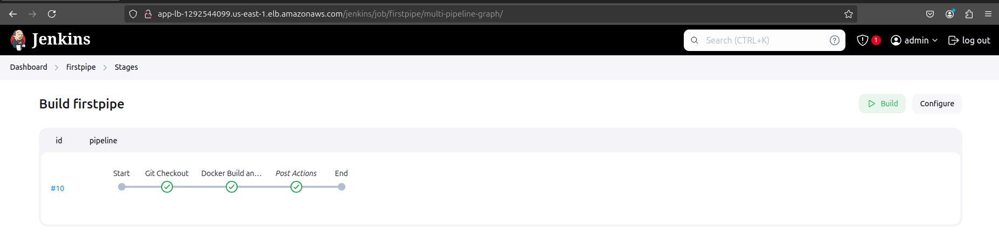

**Sub-Task-3:**

