*SIMULATION OF ATM QUEUEING SYSTEM IN CITIBANK, MAKATI CITY*

C. Arnigo C.N. Del Rosario  
College of Science, Technological University College of Science, Technological University  
 of the Philippines of the Philippines

A.I. Revilla J.P. Velasco  
College of Science, Technological University College of Science, Technological University  
 of the Philippines of the Philippines

***Abstract* - Improving service quality in the region is essential for the customers' required satisfaction. Quick transactions are especially concerned about the duration that the customers will have to wait prior to them receiving the service they need. To stay relevant, atm machines have been trying to improve their system UI and among other things for the customer to use their machines quickly and efficiently. This is an expository case study, showing the usefulness and practicality of the proposed simulation approach.**

Keywords - ***Quality of service, ATM transaction, simulation modeling***

I. Introduction

Automated teller machines can provide significant advantages to both banks and depositors. Depositors may be able to withdraw cash at more convenient times and locations than during branch banking hours. Simultaneously, by automating services that were previously performed manually, ATMs can reduce the costs of servicing some depositor demands. During this study, we used various tools to help us understand and evaluate the data that we have gathered. We used Microsoft Excel to organize our data. After we are done with the data, we used Simio to execute and interpret with real life 3D models.

Simulation is one method for comprehending and explaining the underlying processes of a specific pattern in a system, as well as the prospective patterns associated with processes in a system. While some critics regard simulation as just recording existing information, the capacity of a simulation to draw together facts and theory about many system components allows it to produce superior explanations. Simulations of the global climate system or transportation networks, for example, incorporate research and data from several scientific and policy fields to provide a better understanding of how these systems function.

By applying the theory of queueing, we can shorten the line of people waiting by using appropriate performance indicators, such as average queue length, average waiting time in queue, and utilization factor. In this paper, data from an ATM are collected and in-depth analysis is carried out using Little's hypothesis and the M/M/1 queuing model. We then compare the collected data to the simulated data.

We can determine the predicted length of the queue, the average time spent in the system, and the statuses of the system, such as empty or full, by applying the queueing theory. There are six basic characteristics of a queuing measure: [1] client arrival pattern; [2] server service pattern; [3] queue discipline; [4] system capacity; [5] number of administration channels; and [6] number of administration stages.

**Types of simulation techniques**

This section discusses the many available simulation approaches.

**Process emulation -** Software process simulation may be used to alter and supplement empirical investigations, such as evaluating changing circumstances and analyzing process [9]. It offers two types of simulation models: continuous and discrete-event models, as well as hybrid models that combine the two. Furthermore, this chapter covers a systematic process for creating simulation models as well as an existing collection of simulation model components that may be readily reused. Finally, it describes how process simulation may be used in conjunction with empirical investigations to speed process knowledge and improvement.

**Discrete-event simulation -** A discrete-event simulation model depicts such a system as a network of linked, attributed entities that execute and communicate through events and activities [8]. Common applications vary from communications to transportation, with a focus on the modeling of technological systems in general. It is less appropriate in fields such as astronomy, meteorology, or materials science, but social scientists frequently use agent-based modeling for simulation studies. While discrete-event simulation is simple to grasp, it is also expressive and powerful. To examine their behavior, single researchers, students, or practitioners might develop high-validity models. There are three worldviews in discrete-event simulation: activity-oriented, process-oriented, and event-oriented simulation.

**Rare-event simulation** - rare events are occurrences that are projected to occur seldom or, more precisely, have low odds of occurring (say, order of 10-3 or fewer) according to a probability model [7]. In the context of uncertainty quantification, unusual occurrences frequently correlate to system failures built for high dependability, implying that system performance fails to fulfill certain design or operating standards. As shown in this section, computing such rare-event probability is difficult. Nontrivial problems seldom have analytical solutions, and typical Monte Carlo simulation is computationally wasteful. As a result, the substantial academic effort has gone into designing more efficient advanced stochastic simulation approaches. In this section, we address the problem of estimating rare-event probabilities by Monte Carlo simulation, importance sampling, and subset simulation for highly reliable dynamic systems.

II. Methodology

One automated teller machine will be present inside the room. The bank account holder will arrive at the ATM booth and continue to the ATM if no one is using it. It will be necessary for the next user to wait until the ATM is available to use if someone else is already using it. The bank account holder will now insert the card into the ATM and enter the pin then will choose what type of transaction to occur. Once the transaction is completed, the ATM network will send it to the card issuer to determine whether the transaction is approved. After completing the transaction with the ATM, the bank account holder will now move to the exit.

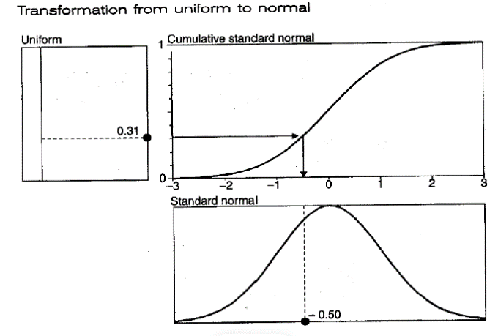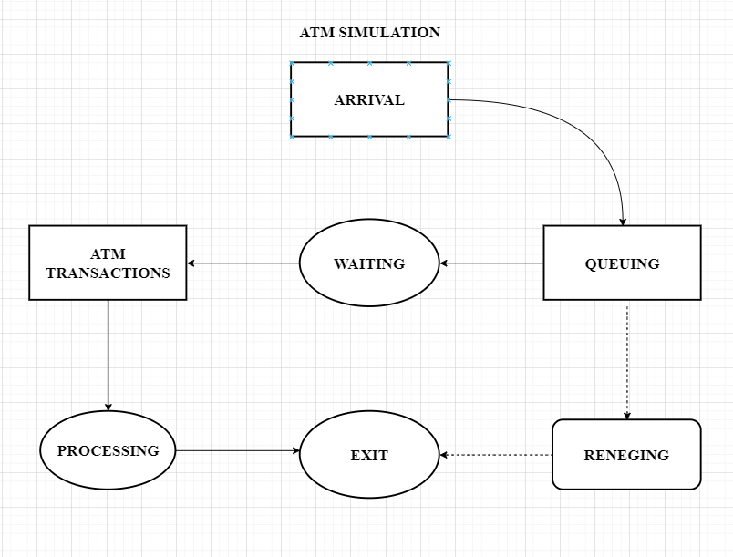*Fig.1 Use Case Diagram*

The atm algorithm we made is reality-based. All individuals start at arriving and if there is someone who came first, they will need to wait which will go down to queue. If someone saw the line was too crowded, they have the option to call out, but those who are willing to wait can proceed to the atm transaction phase. In this phase, they can now process what they want to do inside the atm booth. Afterward, they can now exit because they are done with their objective.

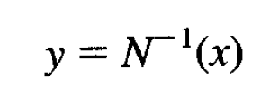***Monte Carlo Analysis***  
 Monte Carlo simulations are based on random draws & from a variable with the desired probability distribution. The numerical analysis usually proceeds in twosteps. The first building block for a random-number generator is a uniform distribution over the interval [0,1] that produces a random variable x.

*Fig 2. Formula for random number*

Moro (1995) demonstrates how to fast track computing by using approximations to the function N^ (-1). In a broader sense, any distribution function can be created provided that N () can be inverted. The inverse transformation method is the process that is depicted in the following figure.

*Fig.3 Inverse transformation method*

***Little’ Law Theory***  
 In queueing theory, a discipline within the mathematical theory of probability, Little's result, theorem, law, or formula[10][11] is a theorem by John Little which states that the long-term average number L of customers in a stationary system is equal to the long-term average effective arrival rate λ multiplied by the average time W that a customer spends in the system. Written algebraically the law is L = λW. Although it looks intuitively easy, it is quite a remarkable result, as the relationship is "not influenced by the arrival process distribution, the service distribution, the service order, or practically anything else.[12]"

The result applies to any system, and particularly, it applies to systems within systems [13]. So, in a bank, the customer line might be one subsystem, and each of the tellers another subsystem, and Little's result could be applied to each one, as well as the whole thing. The only requirements are that the system be stable and non-preemptive; this rules out transition states such as initial startup or shutdown.

***Simuation model using Simio***

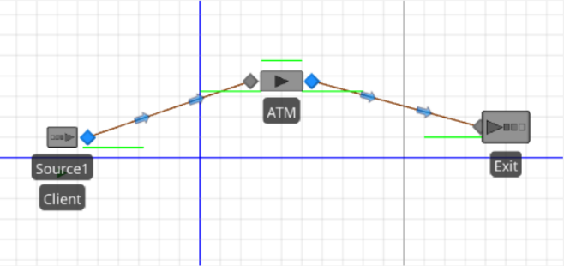Simio keeps the connections between objects intact as you move the object around the model. Note that you can move individual object input and output in addition to moving objects nodes. This type of entity transfer was supported by the Simio Connector object. This is clearly not the case with our ATM model, in which customers walk from the entrance to the ATM and from the ATM to the exit .The majority of "real" system models involve some kind of similar entity movement. Simio, includes several objects from the Standard Library to help. The following are the function and definition of Simio model

*Figure 4. ATM model in simio*

*Connector -* Transfers entities between objects in zero simulation time (i.e., instantly, at infinite speed);  
*Path -* Transfers entities between objects using the distance between objects and entity speed to determine the movement time;  
*TimePath* — Transfers entities between objects using a user-specified movement-time expression  
*Conveyor* — Models physical conveyors.

The path length and the entity-movement time along a Path object determine the entity-movement time. Entity velocity Simio models are by default drawn to scale, so when we added a path between two nodes, the path length was determined by the distance between the two nodes whenever you enter lengths or other properties in units, the + button will expand a field where you can specify them in the input devices

III. Results and Analysis

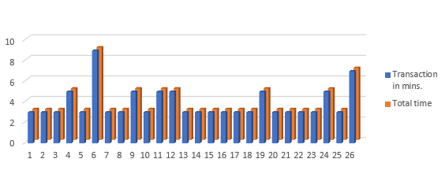 Figure 5 shows the average transaction time of each individual client with numerous factor that may affect the transaction and waiting time of each client. It is most likely due to the characteristics of the exponential distribution that it is unsuitable for simulating transaction or processing time at an ATM in particular, the exponential distribution is distinguished by many relatively small values and a few extremely large values. Because its density function's mode is zero Given that all customers are required to insert their ATM card, enter their personal identification number (PIN) correctly, and select their transaction, because the number of ATM transaction types is limited, a bounded distribution is appropriate most likely a better option.

*Figure 5. Average Total and Waiting Time*

In figure 6, shows the comparison of the average clients that uses the ATM within the 6-hour duration. More specifically, we've reduced the variation in processing times, so we'd expect the number of entities in the system and in the queue, as well as the time spent in the system, to decrease, but we've also increased the entity-transfer times, so we'd expect the number of entities in the system and the time spent in the system to increase. The number of entities in the queue and their time in the system have both decreased, as expected.

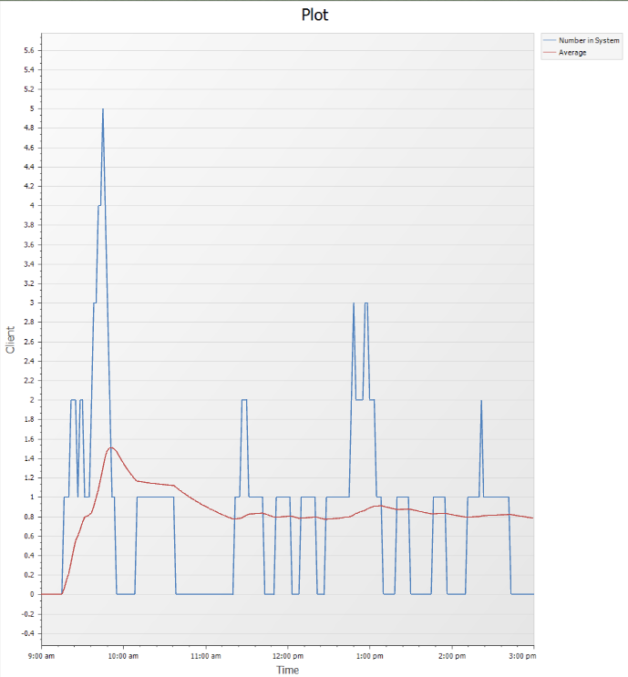 *Figure 6. Total Clients in Simio*

***Paired T-Test***

We used paired t-test to see the difference between the data we collected and our simulated data. Frequently, there is a time gap between the two variables. A significance level of 0.05 usually yields good results. A 0.05 significance level shows a 5% chance of determining there is a difference when there isn't one. The null hypothesis is to be rejected if the p-value is less than or equal to the significance level.

*Fig.7 Paired T-Test*

In figure 7, we can see that the result of our p-value is 0.02. The statistical significance of the difference that was found increases with decreasing p-value. It means that our queueing system is valid and can happen in real life because the data gathered only has a 5-client difference from the simulated data.

IV. Conclusion

In this project, the students were able to make an ATM simulation with proper queueing time and accurate transaction time. The purpose of this study is to investigate ATM service optimization in banks using queuing modeling approach. The practical analysis of queuing system in the banking sector is that they may be very efficient in terms of resources utilization. Queues form and customers wait are a direct consequence of the variability of the arrival and service processes. The general objective of this project is to create a simulation of an ATM queueing system with the proper tools to evaluate the data that was carefully recorded. The study uncovered the applicability and extent of usage of queuing models in achieving customer satisfaction at the lowest cost and striking a balance between the provision of a satisfactory and reasonable quick service and minimizing the cost of such service. They were also able to total the average clients that would come and use the atm machine in a day. The researchers were able to collect and interpret the data that they gathered. The data that was then used to further understand and gain deeper knowledge regarding the project. We hope that our research can help to contribute to the betterment of a bank in terms of its service and functioning through the ATM.

**Terminology Defined**

* Arrival time: This is the time at which each client arrives at the service station and thereby joins the waiting line from the rear. The arrival time is documented from the moment a customer enters the service station to the time he or she joins the waiting line.
* Queue Theory - The mathematical study of waiting lines or queues is referred to as queuing theory. The theory allows for the mathematical study of a number of connected processes, such as arriving at the queue, waiting in the queue, and getting serviced at the front of the queue. The theory allows for the development and calculation of several performance measures, such as the average waiting time in the queue or system, the expected number of people waiting or receiving service, and the likelihood of having an available server or having to wait a certain amount of time to be served.
* Waiting time: The amount of time it takes for each client to go from the point of arrival to the point when they are about to be served.
* Reneging: Reneging is a phenomenon that occurs when a consumer in a waiting line or queue decides to forego the services because he or she cannot wait any longer.
* Automated Teller Machine (ATM) service: An ATM is an electromechanical machine that is used to reduce a bank's costs and increase its reach by meeting the demands of its customers. Customers utilize Automated Teller Machine (ATM) capabilities to withdraw money without having to fill out any paperwork, as well as to save time and money while visiting banking halls.

REFERENCES

[1] Hamdy A. Taha, Operations research an introduction, Person Education, Edition- 9, ISBN 978-81-317-8594Retracted -2, 2011.

[2] Dr. R. Ramakrishna, Mr. KedirMohamedhusien, Simulation Technique for Queuing Theory: A Case Study, International Journal of Research and Applications.

[3] D. Devikanniga, A. Ramu, and A. Haldorai, Efficient Diagnosis of Liver Disease using Support Vector Machine Optimized with Crows Search Algorithm, EAI Endorsed Transactions on Energy Web, p. 164177, Jul. 2018. doi:10.4108/eai.13-7 2018.164177

[4] H. Anandakumar and K. Umamaheswari, Supervised machine learning techniques in cognitive radio networks during cooperative spectrum handovers, Cluster Computing, vol. 20, no. 2, pp. 1505–1515, Mar. 2017.

[5] Mathias Dharmawirya, Erwin Adi, Case Study for Restaurant Queuing Model, 2011 International Conference on Management and Artificial Intelligence IPEDR vol.6 (2011) © (2011) IACSIT Press, Bali, Indonesia

[6] P.V. Ushakumari, S. Devi Krishna, OPTIMAL SERVERTIME MANAGEMENT IN A SINGLE SERVER QUEUE, International Journal of Advanced Research in Engineering and Technology, Vol. 11, Issue 6, pp. 50-58-2020.

[7] Beck J.L., Zuev K.M., (2015). *Handbook of Uncertainty Quantification*, DOI 10.1007/978-3-319-11259-6_24-1

[8] (Ullrich O., Daniel K., 2017). *An Introduction to Discrete-Event Modeling and Simulation -*  
http://dx.doi.org/10.11128/sne.27.on.10362

[9] Ove A., Munch J., Kowalczyk M., & Soto M. (2012). [*Software Process Definition and Management (pp.187-210)*](https://www.researchgate.net/publication/258865356_Software_Process_Definition_and_Management)  
http://dx.doi.org/10.1007/978-3-642-24291-5_7

[10]  Alberto Leon-Garcia (2008). Probability, statistics, and random processes for electrical engineering (3rd ed.). Prentice Hall. ISBN 978-0-13-147122-1.

[11] Allen, Arnold A. (1990). Probability, Statistics, and Queueing Theory: With Computer Science Applications. Gulf Professional Publishing. p. 259. ISBN 0120510510.

[12] Simchi-Levi, D.; Trick, M. A. (2013). "Introduction to "Little's Law as Viewed on Its 50th Anniversary"". Operations Research. 59 (3): 535. doi:10.1287/opre.1110.0941.

[13] Serfozo, R. (1999). "Little Laws". Introduction to Stochastic Networks. pp. 135–154. doi:10.1007/978-1-4612-1482-3_5. ISBN 978-1-4612-7160-4.