Model and Simulation of Flow of Customers in 7/11: A Convenience Store

Superales, Franz Daniel

*Technological University*

*of the Philippines*

Rosario, Nichole Andrea *Technological University*

*of the Philippines*

Doria, Mark Cedrick T.

*Technological University*

*of the Philippines*

Rojo, Romeo S.

*Technological University*

*of the Philippines*

***Abstract*** **– As the many sari sari store owners had to cease their operations, it is clearly evident that the franchise owners whom has the means to sustain their businesses. Consumers had no any other choice where to buy some of their necessities. Public Markets, Supermarkets, and Convenience Stores. Our group had decided to tap the Convenience Store to make a study regarding the flow and number of people who refers to go on this type of mart. This paper presents the scenarios and occurrences inside the convenience store that uses simulation and modeling to monitor the randomness of the customers in the establishment. The Discrete Event Simulation has advantages and downsides, and researchers must understand the issue in order to choose the appropriate model.**

1. **INTRODUCTION**

**BACKGROUND OF THE STUDY**

In today’s world, with the preferred fast-paced daily lives of the people and the

technology that allows people to live in convenience and comfort. Most people

nowadays prefer convenience in every situation they are in. Whether in workplaces or at the comfort of their own home. Due to this, convenience store chains' popularity grew exponentially starting in the early 90’s according to NikkeiAsia in 2014. Convenience stores are convenient due to the reason that most of these are vastly located into areas where people can quickly purchase a vast number of products such as grocery items, food, and gasoline, etc.

One of the popular convenience stores that is thriving today is 7-11. It is arguably the most popular convenience store locally as it has 2978 branches in the Philippines as stated in Esquire Magazine in 2021. In global perspective, there are 77,711 active branches worldwide in January 2022 according to QSR Magazine in 2022. The popularity growth of 7-11 Convenience

Stores are also backed up by the increase of market share by 17% in the last 5 years according to Google Finance. WIth the rapid growth of its popularity, the high number of customers that visit an individual 7-11 Convenience Store could disrupt the business flow of the certain store considering also that most 7-11 Convenience stores only consist of 2-3 working clerks per shift.

A pair of researchers (Kehinde and Adewale, 2020) created a model for customer flow analysis in a commercial bank in Nigeria. The Methodology of the study is composed of problem formulation and analysis; project planning; formulation of the conceptual model; macro-information and data collection; model translation; verification and validation; experimental design; comparison of systems and identification of the best solutions; documentation and presentation of results and implementation.

simulation of this scenario, it was possible to observe that the number of customers in the conventional executive cashier queue, service time and cash occupancy rate decreased. And in the preferred cash register, despite having undergone changes, its impact was minimal.

**OBJECTIVE OF THE STUDY**

The objective of the study Model and Simulation of Flow of Customers in 7/11: A Convenience Store Business is to model and simulate the average number of customers who enter the store per time, as well as to determine the cause and solution that the researchers may propose to improve the efficiency on the queuing system. As the model and simulation may not accurately reflect real-time events inside the store premises, it is safe to presume that the researchers' recommendations may help the franchise to ease and improve the system inside the store.

**BOUNDARIES OF THE STUDY**

The Model and Simulation of Flow of Customers in 7/11: A Convenience Store Business may not be totally accurate with to all branches aside of the facilities are all completely different,  the number of customers going in the premises may vary  too depends on the population on the vicinity and area of a certain branch, but the researchers will attempt to create a model and simulation in line with the known business in order to accurately compare and analyze the likely problems and solutions that the researchers may propose.

**INPUT AND OUTPUT DATA REQUIREMENTS**

In the needed input requirements of the Model and Simulation of Flow of Customers in 7/11: A Convenience Store Business, the number of customers that entered the store per time is specified, as this information will be used to develop the model and form the basis for the simulation. In addition, other factors may affect the situation such as the ready to cook foods are available, it may cause a little amount of duration on waiting time.

**ANIMATION REQUIREMENTS**

Using the software application SIMIO, the researchers will model and simulate the Flow of Customers in 7/11: A Convenience Store Business. The application requires a Pentium or higher processor at minimum. 4GB or more RAM, 500MB for minimum installation or more as resource downloading is extensive, 128MB DirectX 9-compatible integrated graphics.

**PROJECT TIMELINE**

One of the researchers mentioned that he prefers to go to convenience stores rather than supermarkets or public markets. During the months of April and May, the researchers collected the  data for the purpose in simulating and modeling the flow. In June, the researchers began to construct the appropriate model and to simulate it in order to compare the input data to the output data.

|  |  |  |  |  |  |
| --- | --- | --- | --- | --- | --- |
|  | March | April | May | June | July |
| Planning |  |  |  |  |  |
| Collecting Data |  |  |  |  |  |
| Building Model |  |  |  |  |  |
| Simulate the Model |  |  |  |  |  |
| Verify, Validate and Analysis |  |  |  |  |  |
| Submit |  |  |  |  |  |

TABLE 1

**PROJECT TIMELINE OF THE PROPOSED STUDY**

1. **SIMULATION MODELING METHODS**

The researchers develop a convenience store queuing simulation model in order to determine the typical number customers in a convenience store.  Following is a description of how simulation inputs were utilized to comprehend the model.

1. *Input analysis*

Data were collected from a 1 Branch of 7/11 Store with 2 Cashiers. The average number of customers who arrived every 1 hour is also included in the data collected by the researchers. The average queue time and the average roaming time of customers are optionally collected data.

|  |  |  |  |  |  |
| --- | --- | --- | --- | --- | --- |
|  |  | |  |  |  |
|  | **Time** | | **# of Customers** | |  |
|  | **12:00AM-1:00AM** | | **17** | |  |
|  | **1:00AM-2:00AM** | | **13** | |  |
|  | **2:00AM-3:00AM** | | **11** | |  |
|  | **3:00AM-4:00AM** | | **32** | |  |
|  | **4:00AM-5:00AM** | | **30** | |  |
|  | **5:00AM-6:00AM** | | **51** | |  |
|  | **6:00AM-7:00AM** | | **57** | |  |
|  | **7:00AM-8:00AM** | | **57** | |  |
|  | **8:00AM-9:00AM** | | **54** | |  |
|  | **9:00AM-10:00AM** | | **38** | |  |
|  | **10:00AM-11:00AM** | | **35** | |  |
|  | **11:00AM-12:00NN** | | **44** | |  |
|  | **12:00NN-1:00PM** | | **30** | |  |
|  | **1:00PM-2:00PM** | | **31** | |  |
|  | **2:00PM-3:00PM** | | **84** | |  |
|  | **3:00PM-4:00PM** | | **79** | |  |
|  | **4:00PM-5:00PM** | | **76** | |  |
|  | **5:00PM-6:00PM** | | **72** | |  |
|  | **6:00PM-7:00PM** | | **46** | |  |
|  | **7:00PM-8:00PM** | | **25** | |  |
|  | **8:00PM-9:00PM** | | **19** | |  |
|  | **9:00PM-10:00PM** | | **27** | |  |
|  | **10:00PM-11:00PM** | | **22** | |  |
|  | **11:00PM-12:00AM** | | **32** | |  |
|  | **TOTAL** | | **982** | |  |
|  |  |  |  |  |  |

TABLE 2

**TIME AND AVERAGE NUMBER OF**

**CUSTOMERS PER HOUR**

In the Table 2 shown above is the average number of customers per hours, according to the table, there is an average of 5 to 6 customers who arrived in the store premises per 6 hours. The average time of looking for an item is less than 2 minutes according to the cashier based on CCTVs. And the average waiting for the ready to eat food is 3 to 5 minutes.

1. *DES model conceptualization*

*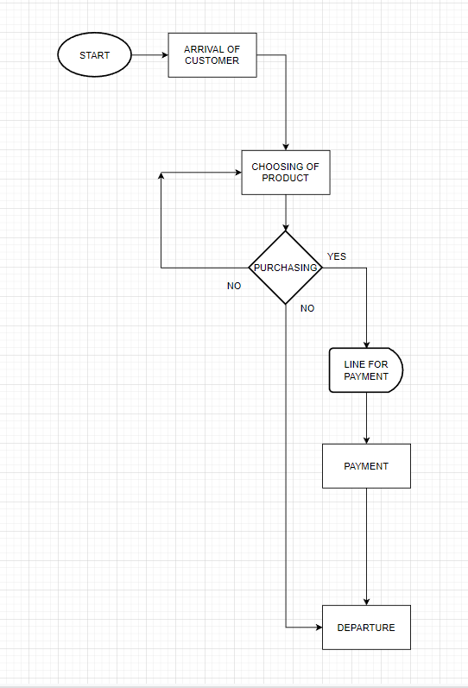Figure 1. Flow of Customers in the Convenience Store on a Daily Basis*

Using the personal edition simulation software SIMIO, a DES model based on the typical number of consumers entering the 7/11 was constructed. The system's scope and patient flow are discussed in the following. Customer arriving on the store, It’s either start to roam around the store to look for their needs, or look for a ready to eat food and queue to the cashier for it to put in the microwave, after they got their item to buy, they will stop to cashier and start to queue if there are other customers too, after their payment, they depart the store.

1. *Model Validation*

The model's validity was evaluated utilizing the 7/11 shop data collected by the researchers. The collected data in TABLE 2 was utilized to compare the with the DES model's output.

1. *Comparative Analysis*

The researchers developed 3 scenarios with 10 replications to evaluate the assumptions regarding the arrival time of each customer. The goal was to estimate and simulate the average amount of customers entering the store every hour, as well as to determine the potential cause and solution that researchers may offer for the business's improvement. The degree of confidence is 95%, with the Upper Percentile at 75% and the Lower Percentile at 25%. The 1st scenario correspond with the CustomerArrival_InputBufferCapacity into 3, the ProductChoosing_InputBufferCapacity into 3, and the LinePayment_InputBufferCapacity into 3. The 1st scenario means that in the CustomerArrival_InputBufferCapacity they are set to roam around 3 aisle then in ProductChoosing_InputBufferCapacity and then they are set to take 3 products and directly set to LinePayment_InputBufferCapacity to pay for their items. The 2nd scenario correspond also with the CustomerArrival_InputBufferCapacity into 1, means that they are set to roam for 2 aisle then, ProductChoosing_InputBufferCapacity into 2 then they are set to LinePayment_InputBufferCapacity. The 3rd Scenario corresponds also with the CustomerArrival_InputBufferCapacity into 1, and set to go only 1 aisle and then ProductChoosing_InputBufferCapacity and set to take only 1 item, and lastly with the LinePayment_InputBufferCapacity wherein they pay for their items purchased.

For the simulation of customer arrival, the daily average number of customers per hour was considered.

1. **RESULTS**
2. Validation results

The researchers ran the model for 10 replications for the simulation to ensure a narrow confidence interval. The researchers use the gathered data from a 7/11 branch from Pulang Lupa. The data consist of the number of the customers that enter the convenience store. According to the data gathered, the average number of customers who arrive in the store per day is 886.8. According to Figure 3, The simulation yielded an average of 844.9. The average customer per day on the data and the simulation yielded a P-Value of 0.050768. It is determined that the model can support the system. The researchers validate that the average number of the arriving customers in the 7/11 Pulang Lupa branch conform to the real data.

1. Simulation results

After the simulator is run 10 times, the researchers have collected the output data yielded by the model. The results varied in range per day from 804 and 899 per day with a daily customer average of 844.9. This is considerably lower than the actual data result from the actual 7-11 store due to the reason that the model has only been run 10 times. Which led the model to have fewer data to train to and therefore resulting in a slight difference in both data. However, the P-Value of the model data and actual data suggest that model would still maintain high accuracy.

1. **CONCLUSION**
2. Limitations and future work

The researchers come to the conclusion that there might not be a problem with the average arriving customers in the 7/11 Pulang Lupa Branch because as time goes on, many customers will start visiting this establishment to buy and order food. However, as time goes on, the establishment's facilities might not be able to properly serve the customers because it lacks the workers it needs to support larger numbers of customers. As a new food business, this might not be a concern at initially, but as long as there are patrons eating there, the typical number of customers arriving may rise.

In order to manage serving huge numbers of customers and provide more tables and chairs for them, the researchers propose that the company may need to grow the number of their employees.

Businesses can use the information from this simulation model to identify potential issues with their systems or company operations. The projection of the typical number of arriving consumers can be examined beforehand by incorporating the DES model. This study enables us to provide a lead time for corporate financial error mitigation.

1. **REFFERENCE**

[1] “Seven-Eleven Japan Leading the Way for Retail Empire.” *Nikkei Asia*, asia.nikkei.com/Business/Seven-Eleven-Japan-leading-the-way-for-retail-empire. Accessed 6 July 2022.

[2] Apr 19, Paul John Caña |, and 2021. “5 Facts You Need to Know about 7-Eleven in the Philippines.” *Esquiremag.ph*, 19 Apr. 2021, www.esquiremag.ph/money/industry/7-eleven-in-the-philippines-facts-a00289-20210419. Accessed 6 July 2022.