**SIMULATION AND ANALYSIS OF GETTING A NATIONAL ID IN MUNICIPAL OFFICE USING ARENA AND SIMIO SIMULATION**

Ezekiel Guevarra

Laille Aldrich Rodil

Dylan Jabla

Sean Carlo Quinones

Technological University of the Philippines

BSCS-3AB

# ABSTRACT

The purpose of this study is to discuss a discrete event simulation model that was designed to identify and understand the impact of varying numbers of individuals traveling in and out of the municipal office on a daily basis. In this paper, we developed a simulation approach, with a system dynamic model to predict the waiting time of the applicants in different circumstances and a discrete-event simulation to evaluate different large numbers entering the municipal office. Both of these models are included in the simulation approach. These findings provide a fascinating new perspective on the predicament at hand, giving those in charge of making decisions a potent new resource with which to devise an intelligent solution to the problem at hand.

# INTRODUCTION

A national identity document (also called a "ID" or "identity card") is a photo ID card that can be used as an ID card at least inside the country and is given out by a government agency. Regional governments give out driver's licenses and other cards that show permission to do certain things. These are not included in this list of national identity cards. So, by this rule, a U.S. driver's license isn't acceptable because it's issued by a local (state) government (although these or the state ID are all-but required as nation wide identification). The Philippine Identification System, or PhilSys, will give each person who signs up for it a unique and permanent PhilSys number and a physical ID card called a PhilID that can be used to prove who they are when they need to. Most countries in the world, like Singapore, Thailand, China, South Korea, France, Italy, and Spain, give their own citizens national ID cards. Before the new law was signed, the Philippines was one of only nine countries in the world that didn't have a system for a national ID.

There are three significant reasons why an individual needs to register for a Philippine National ID, the Philippine Statistics Authority (PSA) said.

First, the National ID which is the main component of the Philippine Identification System (PhilSys) paves the way for streamlined information of an individual including among others, his address, telephone number, driving records, loans, and others. Second, there is no need to present other valid IDs when transacting with government and private entities such as GSIS, SSS, PhilHealth, Pag-IBIG or voter’s registration, if one has a PhilID. Third, National ID verification is speedy. The PhilSys Act guarantees a fool-proof and highly secured process of identification once the system is put in place, PSA said. The PSA also reiterated registration for Philippine ID is free of charge, however, an individual needs to pay in case the PhilID is lost and needs replacement, destroyed, or some entries are to be added or changed. Signed into law by President Rodrigo R. Duterte in August 2018, Republic Act 11055, or the Philippine Identification System Act, aims to establish a single national ID for all Filipinos.

# PROCESS OVERVIEW

The operations of getting a national id can be subdivided into following main steps. Note the combination of discrete (batch) and continuous processing steps.

1. Contact Tracing
2. Fill up Application Form
3. Checking of requirements
4. ID Verification
5. Facial and Fingerprint Recognition
6. Form Submission

The first stage of the process involve the collection of health information for the purpose of facilitating contact tracing by the government; this is done so that, once an applicant has received a covid, it is simple to perform contact tracing. After the submitting the Health form, it is collected by the barangay officials. The next thing that you need to do is fill out the application form, which contains all of your personal information. After that, the employee will validate your id by checking both your primary and secondary id to make sure that they are legitimate. And last but not least, once all of the validation has been completed, the encoder will now process all of the information that you have entered and will add your face and fingerprints to the details of your identification. After successfully completing the various recognition requirements, you will be given a piece of paper to present to the members of the delivery staff when they bring your identification into your home.

# DES MODEL FOR GETTING A NATIONAL ID

In this section, we present the simulation model developed for the getting a National ID in Municipal Office

## DES Simulation Model

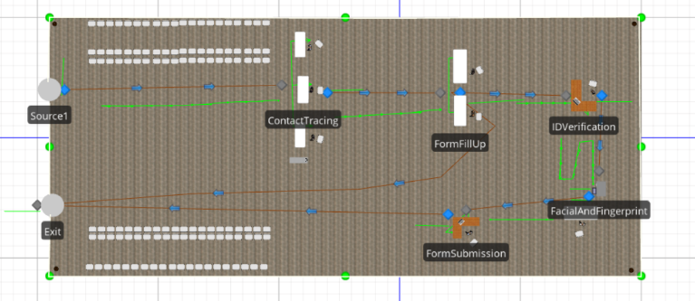

Figure 1. Simulation Model for Getting a National ID

Figure 1 shows the model the researchers used in making the simulation. The SIMIO® simulation tool provides the software for simulation, process planning, and process time manipulation alongside providing real time data. This allows planning and management of uncertainty, enabling failures to be mitigated and targets met. The information required for running the simulation model was stored in the integrated databases in Simio Simulation®. The input required for the running the simulation model can be classified in the following categories:

1. Simulation parameters: Simulation run length, number of replications.
2. Station Information: Station average process time, station success rate.
3. Probability: Random probability of process failure, Overall success rate.

For the model verification and validation, the number of completed processes were checked.

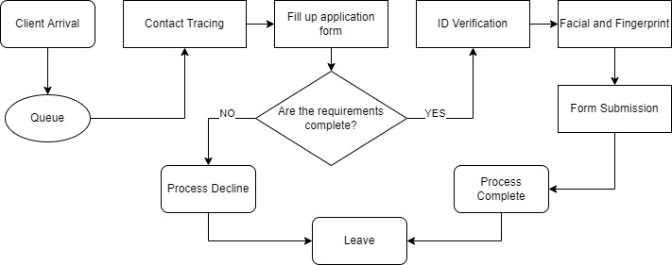

Figure 2: Process Flowchart

Figure 2 shows how the process runs in both the simulation and generally in real-life. The process starts with a client queue right at the entrance leading to the Contract Tracing station. After that, clients are given submission forms to fill-up. After filling up the forms, clients are to take them to a table where their requirements such as identification and paper works are checked. That is where clients’ process can be rejected if they do not have sufficient or valid requirements. If the clients are accepted, they will proceed to do ID Verification, Facial and Fingerprint, and Form Submission respectively for the process to be completed.

## Data

|  |  |
| --- | --- |
| Simulation Data | |
| Day | Success |
| 1 | 84 |
| 2 | 79 |
| 3 | 81 |
| 4 | 85 |
| 5 | 86 |
| 6 | 80 |
| 7 | 83 |
| 8 | 82 |
| 9 | 79 |
| 10 | 83 |
| Avg | 82.2 |

|  |  |
| --- | --- |
| Real Life Data | |
| Day | Success |
| 1 | 97 |
| 2 | 101 |
| 3 | 76 |
| 4 | 92 |
| 5 | 88 |
| 6 | 90 |
| 7 | 75 |
| 8 | 86 |
| 9 | 90 |
| 10 | 83 |
| Avg | 87.8 |

Figure 3. Real Life Data Figure 4. Simulation Data

Figure 3 shows the data that has been gathered from a real-life National ID application site. It shows the number of completed processes in a singular day for a span of 10 days. So to attempt to replicate the process, the simulation is run 10 times to produce 10 days’ worth of data, which is shown in Figure 4.

# DISCUSSION

The main contribution of this paper is the conception of a model for getting a national ID, able to adequately mimic the behavior of our partner Municipality. We believe that our model can be a valuable decision-helping tool to estimate the resources needed for day-to-day operations and to assess the need for a special policy in the case of unpredicted events as we did in different scenarios.

Although the results of the simulation are promising, we believe this model can be improved, in particular the place capacities and waiting queues. Indeed, the relations between the queue can be more accurately described. For instance, a user could be rerouted to the first in line if they are PWD, Senior citizen, or Frontline workers.

Moreover, additional work should be done to clean the database and correct the problems posed by in the model. Indeed, we noticed that the entrance highly demanded for short stays (less than 3 minutes in average) are not well modelled by our simulation, causing a long queue that can also cause no social distancing. We believe that obtaining more precise data should help improve the model.

Response policies have been designed and tested to test our model. We believe that studying the real-time setting in Carmona municipality with covid restrictions, with precise data on users, would improve this model. In addition, implementing dynamic surge policies, like allowing an extra assistance for PWD, senior citizen, and frontliners under certain conditions would greatly improve the model.

# SUMMARY AND FUTURE WORK

A discrete event simulation model was developed to identify and understand the impact of different component failures on the overall production capabilities in a municipal office providing national id service. The model will be used to not only identify misinformation/ computer error but also will be used to see the impact of the whole process to avoid long queue to avoid any covid-19 transmission. Currently, we are in the process of gathering information required for full model validation. Our preliminary results on available information provide some key insights into failure properties of different computer for the database and impact of failures on the whole process day. Once the critical components are identified, the next step will involve understanding the impact of having multiple option to avoid any conflicts and resolved the problem immediately. The present work shows the potential of discrete event simulation for such applications. The use of a systematic approach to investigate the system hierarchy from the outside in is an efficient method for complex models.

# REFERENCES

Esq, J. J. (n.d.). LAW, ICT AND HUMAN RIGHTS: Pros and cons of national ID system. GMA News Online. Retrieved July 13, 2022, from <http://www.gmanetwork.com/news/opinion/content/644837/pros-and-cons-of-national-id-system/story/>‌

Malasig, J. (2018, May 29). Weighing the national ID system for Filipinos: The good, the bad and the ugly. Interaksyon. https://interaksyon.philstar.com/breaking-news/2018/05/29/127618/national-id-system-philippines-advantages-disadvantages/‌

PSA cites benefits of nat’l ID. Www.pna.gov.ph. Retrieved July 13, 2022, from https://www.pna.gov.ph/articles/1157391#:~:text=The%20national%20ID%20shall%20be‌

‌