Queueing Simulation Model of McDonalds Vito Cruz, Manila

Matthew Perry B. Bustarde  
*College of Science*  
Technological University of the PhilippinesManila, Philippines  
matthewperry.bustarde@tup.edu.ph

Kyle Chistian O. De Castro  
*College of Science*  
Technological University of the PhilippinesManila, Philippines  
kylechristian.decastro@tup.edu.ph

Ian Sisante  
*College of Science*  
Technological University of the PhilippinesManila, Philippines  
ian.sisante@tup.edu.ph

Kimberley V. Delgado  
*College of Science*  
Technological University of the PhilippinesManila, Philippines  
kimberley.delgado@tup.edu.ph

*Abstract*— One issue with food restaurants are the long lines at the pay register. It occurs frequently in local company operations. Because of an imbalance between people serviced and the services provided, lines form. In fast-food establishments like McDonald's, lines typically form during lunch or dinner. The goal of this study is to identify the queuing model that exists in the McDonald's cashier area and assess if it is acceptable and effective by contrasting the results of simulations performed with the aid of SIMIO software with the previous model.

# Introduction

Queues in the cashier area of fast-food restaurant is one of the problems that often occur in business processes in the community. Queues happen because of an imbalance between those served and their services. In fast food restaurants like McDonalds, queues generally occur during peak hours. The purpose of this study is to determine the queuing model that occurs in the McDonalds cashier area and analyze whether the queuing model is appropriate and efficient by comparing the previous model with the simulation results that have been carried out with the help of SIMIO software.

Increased public interest in consuming fast food can cause its own problems for fast food businesses. The problem that can be investigated from the increased interest of the community lies in its queuing system. The process of queuing into something is less favored by a lot of people. This is also an obstacle experienced at McDonalds fast food restaurant. The number of fast-food enthusiasts cause long queues. This condition causes productivity of the fast-food restaurant decrease. In the McDonalds fast food store queue system, there are 3 queue lines with a total of 3 service counters.

Repairing the queuing system is done by identifying the type of arrival time distribution and also the length of service. With known types of arrival time distribution and length of service, we can determine the optimal queuing system model by simulating it with available simulation software.

# Methodology

The research conducted at McDonald’s Vito Cruz; Manila are as follows:

## Data Collection

Data collection is used to identify the type of distribution that exists in the queuing system at the McDonalds food restaurant that are used as important data so that it can be simulated in SIMIO Software. The data used is the arrival of customers, the length of time of service, and also the length of time the customer that moves to the service. Data was collected by direct observation at McDonalds during lunch time from 11:00AM to 1:00PM.

## Queueing Simulation Model

The queuing system simulation is made using SIMIO Software according to the type of arrival time distribution and customer service length obtained.

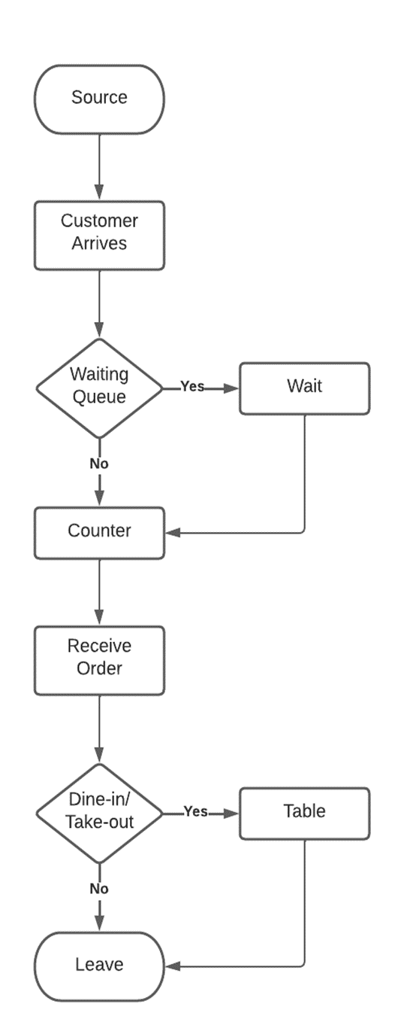

1. Base flowshart of the model

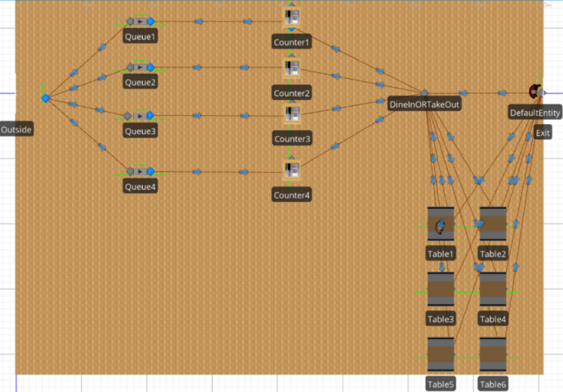

1. 2D flowshart of the model using SIMIO

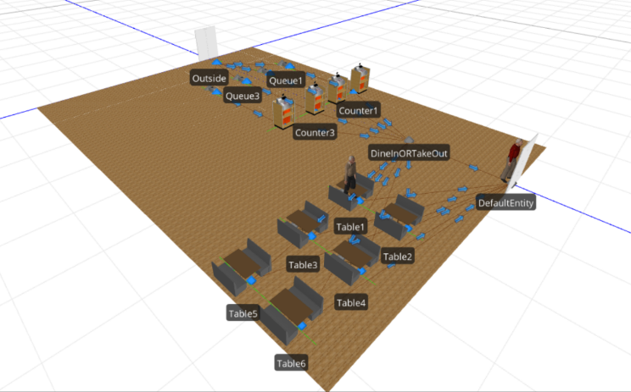

1. 3D flowshart of the model using SIMIO

# Result and Discussion

We used the random exponential distribution on the interarrival time then triangular distribution on each counter and for validation, we used the hypothesis method then tested our result by using the P test.

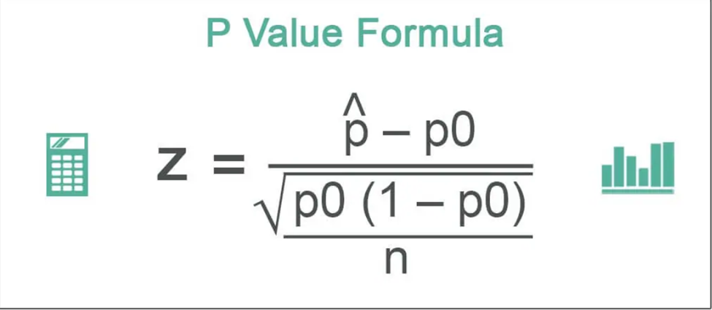

1. P value formula

*For our average waiting time in the queue, we recorded the values of counter 1, 2, and 3 of the said restaurants and it’s SIMIO result and it’s as follows:*

1. Average Waiting Time in Queue

|  | DATA | SIMIO | P VALUE |  |
| --- | --- | --- | --- | --- |
| Counter 1 | 52 sec | 26 sec | 0.38 | Accepted |
| Counter 2 | 75 sec | 60.84 sec | 0.70 | Accepted |
| Counter 3 | 42 sec | 56.16 sec | 0.75 | Accepted |

*Now for its average time that the customer orders and its SIMIO result:*

1. Average Time that Customer’s Order

|  | DATA | SIMIO | P VALUE |  |
| --- | --- | --- | --- | --- |
| Counter 1 | 77.2 sec | 94.8 sec | 0.56 | Accepted |
| Counter 2 | 183.2 sec | 173.88 sec | 0.50 | Accepted |
| Counter 3 | 72 sec | 66.24 sec | 0.57 | Accepted |

*For receiving orders:*

1. Receiving Orders

| DATA | SIMIO | P VALUE |  |
| --- | --- | --- | --- |
| 151.6 sec | 157.32 sec | 0.57 | Accepted |

*For our verification, we have a 20 repetition, and 100 repetition:*

1. Average Waiting Time

|  | 20 Repetition | 100 Repetition | P Value |  |
| --- | --- | --- | --- | --- |
| Counter 1 | 24.12 sec | 27.36 sec | 0.32 | Accepted |
| Counter 2 | 60.84 sec | 56.52 sec | 0.43 | Accepted |
| Counter 3 | 47.16 sec | 57 sec | 0.51 | Accepted |

1. Average Ordering Time

|  | 20 Repetition | 100 Repetition | P Value |  |
| --- | --- | --- | --- | --- |
| Counter 1 | 94.8 sec | 102.04 sec | 0.36 | Accepted |
| Counter 2 | 177.48 sec | 176.04 sec | 0.14 | Accepted |
| Counter 3 | 66.9 sec | 68.78 sec | 0.18 | Accepted |

1. Average of Getting the Orders

| 20 Repetition | 100 Repetition | P Value |  |
| --- | --- | --- | --- |
| 178.2 sec | 177.48 sec | 0.17 | Accepted |

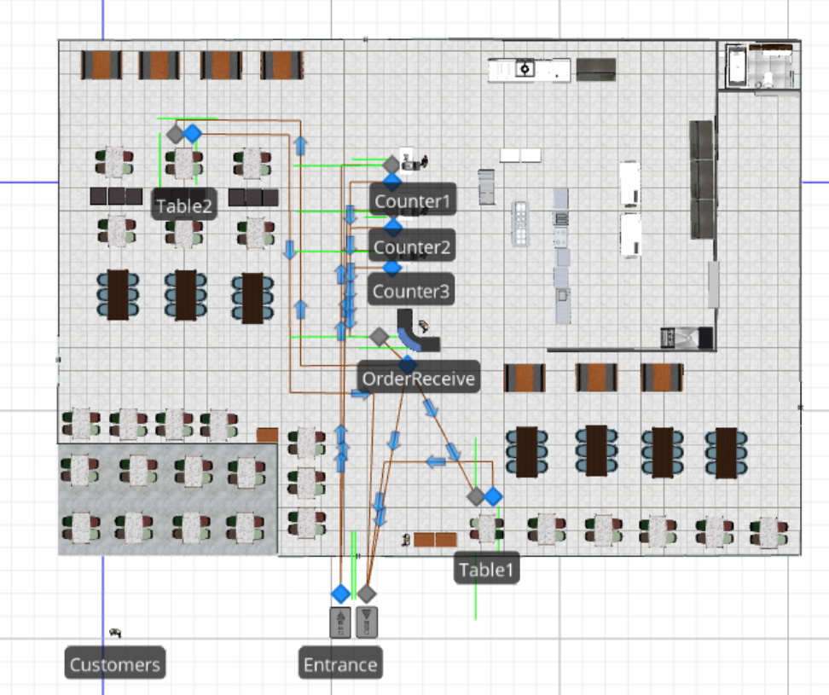

1. Final 2D version of the model

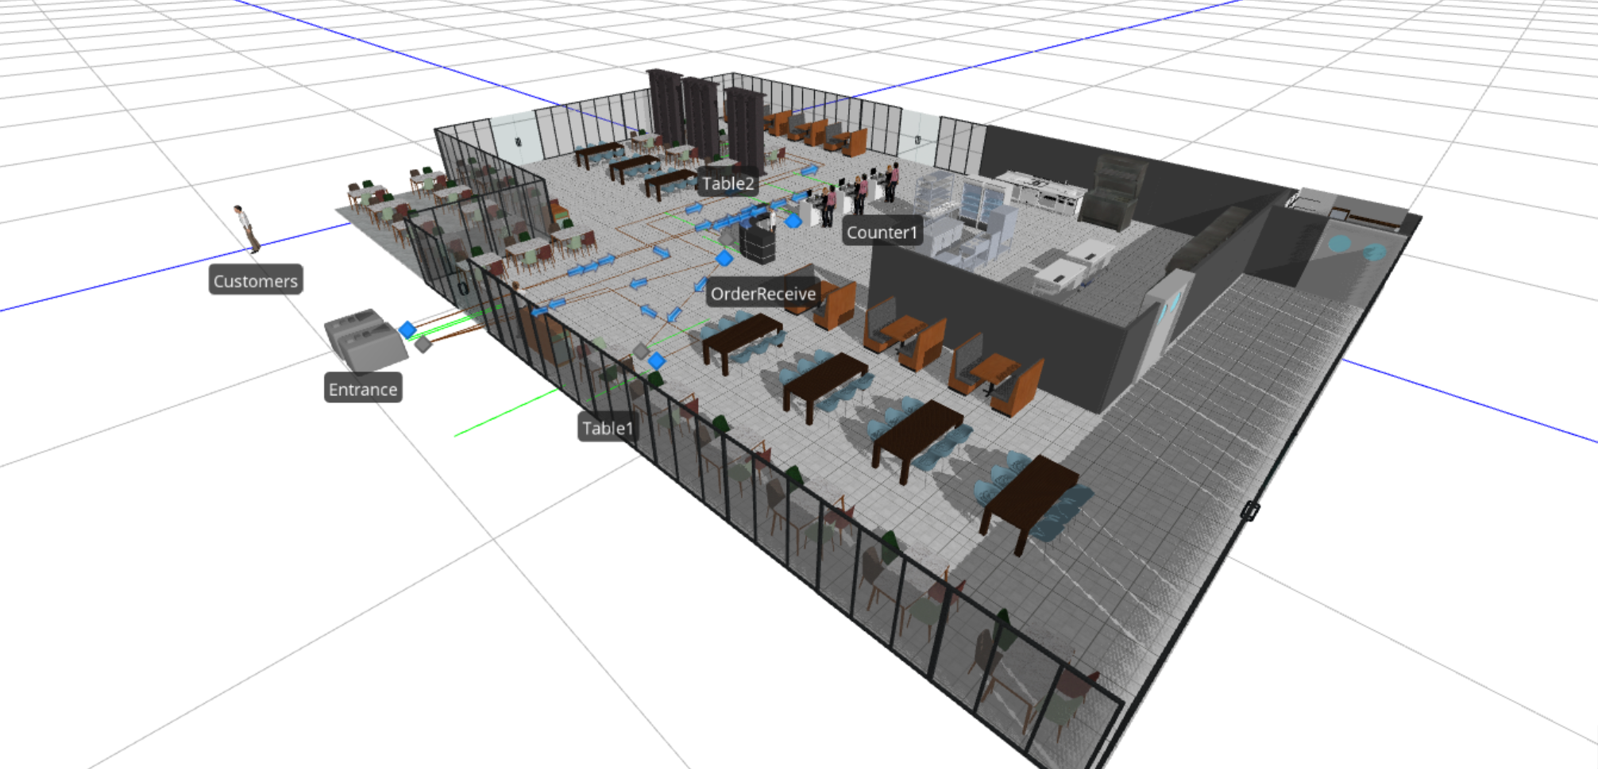

1. Final 3D version of the model

# What If Analysis

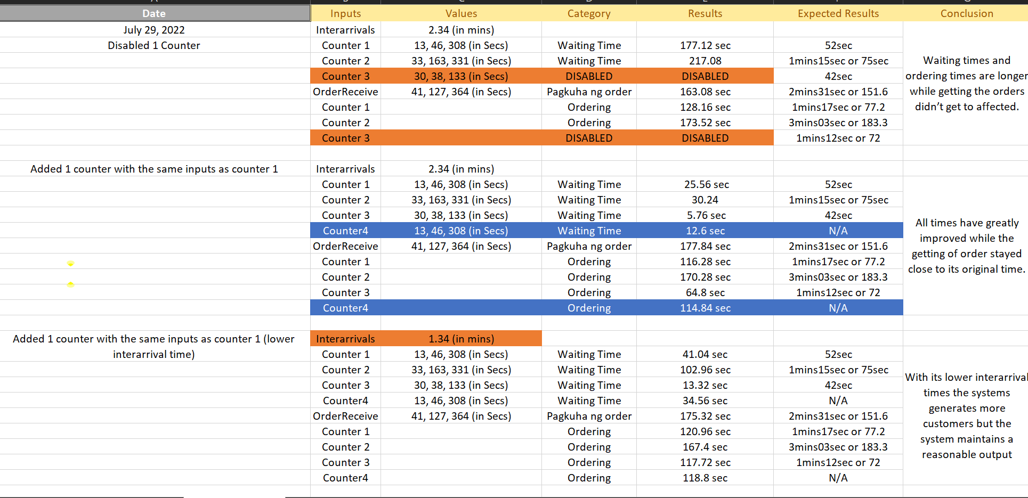

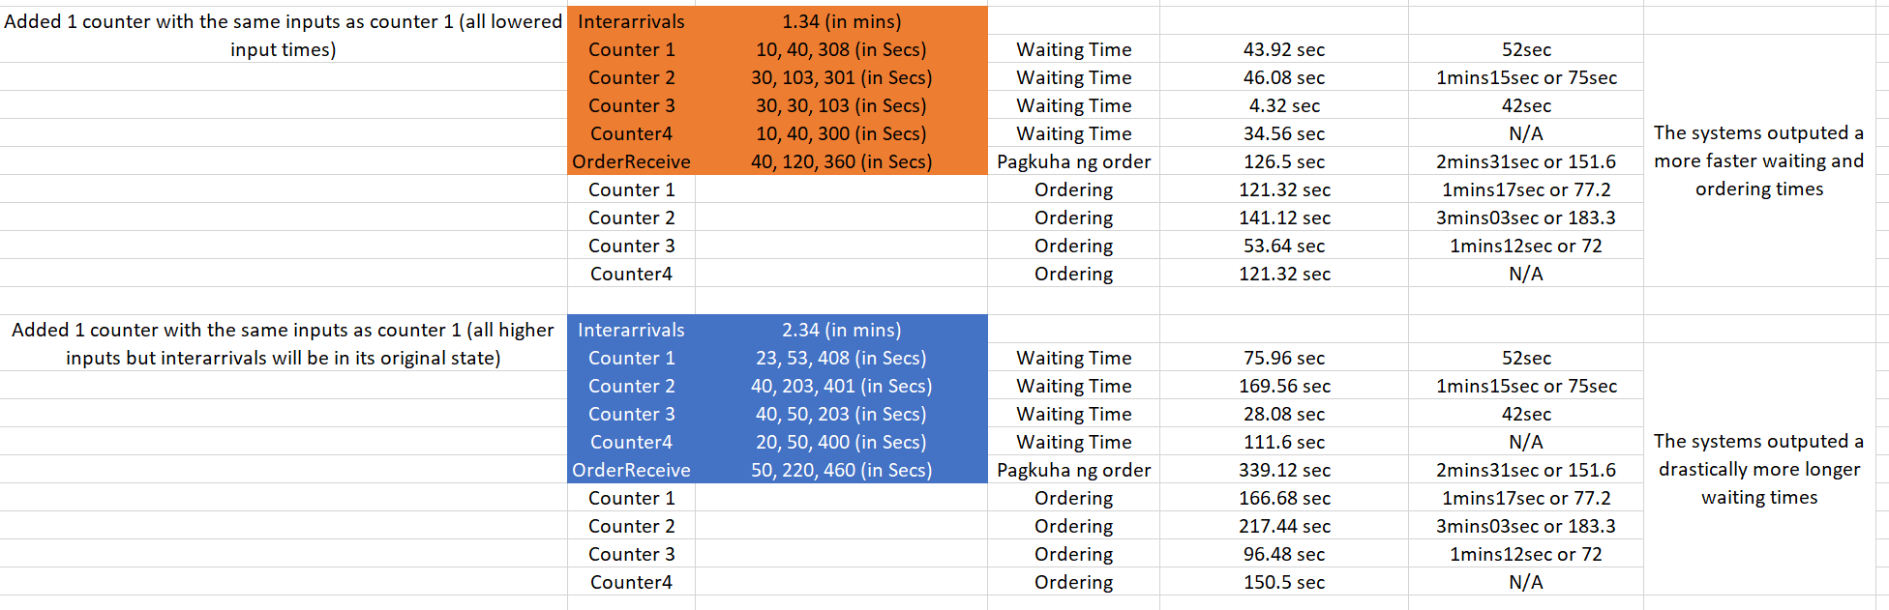

# Conclusion

*Cost Savings:*

The company can evaluate its sources to see what needs optimizing if it is too much then they would have to cut it down to save money.

*Cost Avoidance:*

The company could regularly maintain its hardware to avoid large cost in the future and also evaluate its sources to avoid overspending.

##### References

1. Ivo Andika Hasugian et al. (2020). IOP Conf. Ser.: Mater. Sci. Eng. 851 012028. Retrieved from: [Analysis Of Queuing Models Of Fast Food Restaurant with Simulation Approach - IOPscience](https://iopscience.iop.org/article/10.1088/1757-899X/851/1/012028/meta)
2. Ivo Andika Hasugian et al. (2020). IOP Conf. Ser.: Mater. Sci. Eng. 851 012028. Retrieved from: [(PDF) Analysis Of Queuing Models Of Fast Food Restaurant with Simulation Approach (researchgate.net)](https://www.researchgate.net/publication/341765787_Analysis_Of_Queuing_Models_Of_Fast_Food_Restaurant_with_Simulation_Approach)
3. Sarah Ritchey Jordan. (n.d.). A Computer Simulation Model of the Service Component of a Fast Food Operation: Development, Validation, and Use. Retrieved from: [A Computer Simulation Model of the Service Component of a Fast Food Operation: Development, Validation, and Use (tennessee.edu)](https://trace.tennessee.edu/cgi/viewcontent.cgi?&article=5526&context=utk_graddiss)
4. [Simulation, Production Planning and Scheduling Software | Simio](https://www.simio.com/)