**Assignment M1**

**Abstract**

The primary goal of this project is to redesign the Yelp app interface of searching restaurants in U.S. The current searching restaurant interface will be optimized, and a few modules with surging demands from the users will be implemented to bridge the gulf of execution and evaluation.

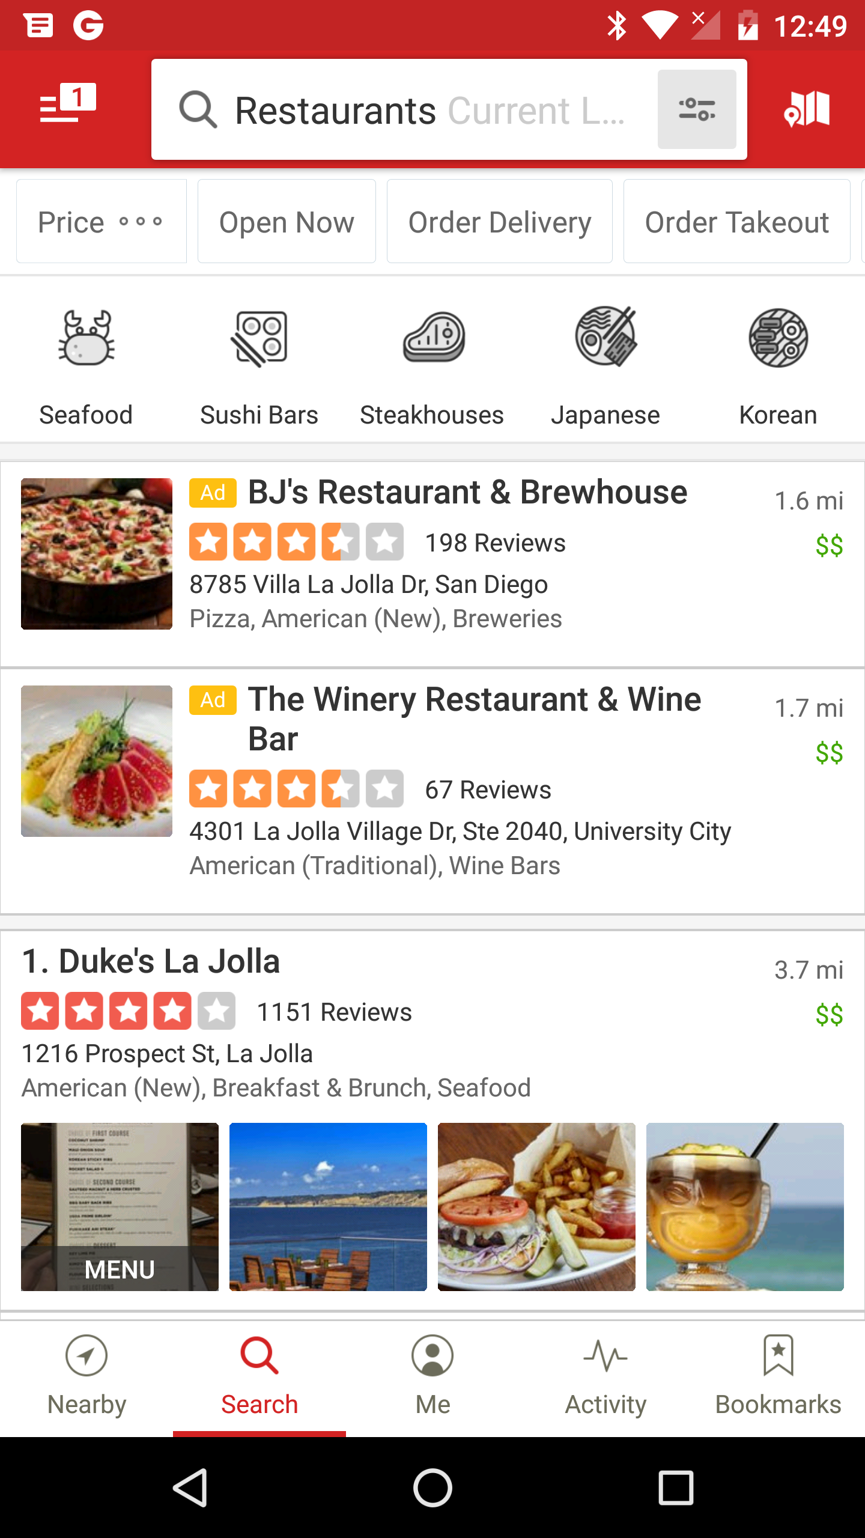

Figure 1. The screenshot of Yelp app interface for searching restaurants.

**Problem Space**

From my perspective, the current restaurant searching interface of Yelp app is based on an assumption that users always set restaurant style (Asian, American, Italian, Mediterranean etc.) high priorities in making their decisions (see Figure 1), which is susceptible. Other key factors of searching users’ destinating restaurants are neglected in the interface. For instance, if I am starving, I might not care about the restaurant style but really care about when I could arrive at the restaurant, by walking, driving, taking bus etc. in real-time. Also a lot of users are deal-lover, their only criteria of chosing restaurants is if coupons from Groupon / Living Social or direct discounts could be redeemed in a restaurant. Another huge problem is that the rank of default recommended restaurants on the first page of Yelp’s interface is mysterious. Were they ranked by name? Distance? Reviews? No one knows. Ideally the users should find their favorite restaurants or those fulfilling their on-demand on the first page, which is not the scenario of the current Yelp restaurant searching interface.

**User Types**

I am interested in redesigning the Yelp’s interface for any people who loves gourmet! Since the task is to search restaurants in U.S., it might require the users could write or speak English. And they should have a smartphone / touchscreen tablet PC to install the app and know how to input English letters and words into the interface. For people with physical disabilities, the interface should be compatible for them using assistive technologies to input information. Also the users may allow the app to obtain their current locations, thus it could estimate how many minutes the users gonna take to arrive at the restaurants based on real-time traffic data.

**Needfinding Method 1: Participant observation**

As a user of the Yelp app to search the restaurant, I will first check the recommend restaurant list on the first page to see if I could find out my favorite one or the restaurants fulfill my stardand(s). Here my standard is to start eating meals within 30 mins after I finish my searching from home via Yelp app. Having discount/coupons will be a bonus if two restaurants have similar distance from the current location. Yelp app does offer a filter to help users chosing restaurants by distance. So I will first select one restaurant on the option “driving(5 miles)” and drive to there. Since currently Yelp app could not support real-time map. I might use Google map to estimate how many minutes I gonna take to arrive at the restaurant. Meanwhile I gonna record the exact time I spent on the route. I might also record the waiting time in the restaurant, including but not limited to the time waiting in the queue, time between ordering food and receiving food. Second, I will select one restaurant on the option “biking(2 miles)” and bike to there. Again, the mintues on the way as well as on the restaurant will be recorded accordingly. Third, I will select one restaurant on the option “walking(1 mile)” and perform the same procesure metioned above. Lastly, instead of stopping by the restaurant, I will ask these three restaurant to deliever the meal and record the delievery time. All these tests will be repeated on different time period, say, lunch time, dinner time and rush hours after work. The goal is to gather data as much as possible to optimize the searching restaurant fucntion in Yelp app. And the disadvantage of this needfinding method is obvious: lack of context. For instance my current location is fixed (from my home) and it could not really reflect other users’ waiting time between searching restaurants and receiving the meal.

**Needfinding Method 2: Think Aloud**

The spirit of thinking aloud is to interview users while they working with the Yelp’s app, and ask them what they are thinking and wondering at each action. The first step of thing-aloud protocal is to select representatives. I could select a restaurant and ask the customers how they find this place. If the answer is using Yelp, then I could recruit them into the protocal. Or I may visit some online forums reviewing restaurants and make a post to ask for participates of the protocal. The second step is to give the users task to finish. Here the task is to search the restaurant via Yelp’s app. Such task could be divided into few sub-tasks, such as searching restaurants by distance, by features and by price. The participates will be asked to describe whatever pop-up in their minds while they performing their tasks and/or sub-tasks. And as an observer, I should take notes for all users’ feedbacks including but not limited to thinking, talking and feeling, espcially the moment that users encounted difficulties in using the interface. Such notes could be pencil-paper record, audio-record and/or video-record. Also I should be prepared to anwser participates’ questions and recognize if it comes from the gulf of execuations. All the records should be fully transcribed and analyzed. The downside of this method is that participates are exposed to an unnatrual senario. For instance, some people may feel a little bit nervious when he/she was recored by a video-recorder, and it may have unneglectable impect on their responses/feelings/things while they performing their tasks.

**Needfinding Method 3: Survey**

The first step of survey is to set the goals and in this project, I want to collect users’ opinions, preferences and statisfactions while they using Yelp’s interface to search restaurants. The second step is to recruit participates and I could use the same stragies strategies mentioned in think-aloud protocal. And unlike think-aloud protocal, face-to-face talking is not necessary in survey thus I could enlarge the sample size to be more representative of the underlying population within a certain budget. The third step is to design questions based on the pricinples mentioned in class video 3.3: be clear, be concise, be specific, be expressive, be unbiased and be usable. Three common question formats: multiple choice, numeric open-end and text open-end should be introduced into the survey to avoid any user response biases. The fourth step is to test surve questions. I could either carry out the survey by myself, or ask my friends/family members to finish the survey and take note of their feedbacks. Do they think the survey questions written in plain-text? Are questions clear and unambiguous? Is the length of survey fine and not making them boring? How do they think the difficulties of the questions? After receiveing all feedbacks from pre-testing users, I will improve the survey and standardize the final version of it. The fifth step is to conduct the survey for all participates. It could be done by pencil-paper mode, email or on-line forms. And the final step is to collect the survey data and pre-process the results to identify valid data, followed by some statistical methods such as one-way ANOVA, linear regression, logistical regression etc. The weak point of this method is that the survey data may not fully reveal the true thinkings/feelings/logics of users while they performing the task.