CS7637 Fall 2018 Assignment 3

Zheng Fu  
zfu66@gatech.edu

# Question 1

Figure 1 shows the simple models of human brain system and ant hills system. According to the lecture materials of lesson 18, the process of analogical reasoning could be performed as following steps:

1. Analogical Retrieval.

According to Figure 1, the deep similarities between these two models include

(1) Something does simple job. (2) Something forms something else. (3) An information flow exists between two objects. (4) Two objects communicate each other.

1. Analogical Mapping.

According to Figure 1, I map the human brain system to the ant hills system as following: (1) Neuron -> Ant. (2) Brain regions -> Sub-colonies. (3) Brain -> Colony.

1. Analogical Transfer.

Based on the representations in Figure 1, the following items could be transferred from human brain system into ant hills model. (1) Neurons form brain regions. (2) Brain regions form brain. (3) Brain makes decision.

And Figure 2 exhibits the analogical transfer results (Colony makes decision) and the analogical transfer occurs at a functional level.

**Is an anthill conscious?**

Brain in a vat is one of my favorite philosophy questions. It proposes that a brain was suspended in a vat of life-sustaining liquid, and a supercomputer offers all [electrical impulses](https://en.wikipedia.org/wiki/Action_potential) identical to those the brain normally receives (thinking about “Matrix” movie  series) [1].

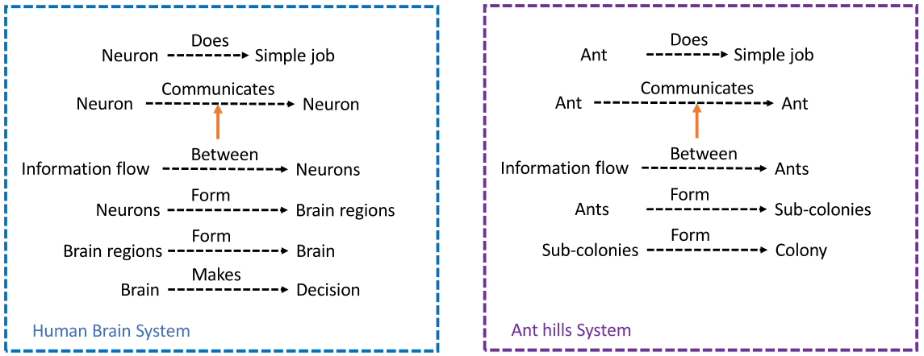

**Figure 1.** Models of human brain system and ant hills system.

So in this scenario, will the brain know itself is suspended in a vat and all it received are virtual? My answer is if a brain could think about questions like “Brain in a vat”, it is not a “Brain in a vat”. In other word, if a brain could suspect the reality of its existence, it is in a real world and it has real consciousness. So according to this definition, the ant hills system has something called “collective consciousness”. It will make some decisions as an entire entity while the surrounding environment changing, yet it never questions the reality of its existence. So it does not have the human consciousness as we have.

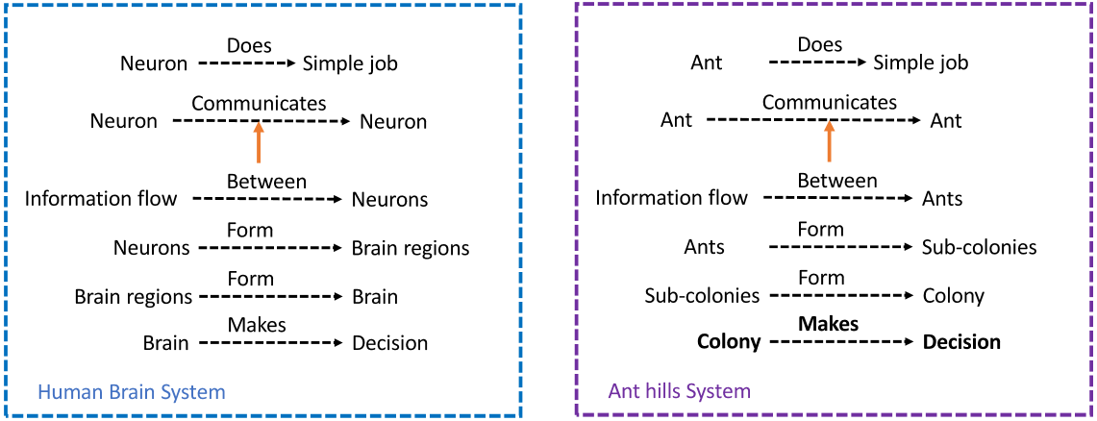 **Figure 2.** Models of human brain system and ant hills system after analogical transfer.

# Question 2

## Paper 1

“What’s up with Privacy? User Preferences and Privacy Concerns in Intelligent Personal Assistants [2]”.

## Summary

Motivation: The Intelligent Personal Assistant (IPA), such as Echo by Amazon and Home by Google, plays more and more important role in our daily life, along with increasing concerns about privacy and ethical implications. Thus in this paper the authors try to investigate the following research challenges:

1. Features that attract clients to use the IPA.
2. The relationship between IPA usage and privacy concerns, and
3. Actions to address the privacy concerns while using IPA.

## Methodology

1. Collecting IPA online reviews from Google Search, Amazon.com and Bestbuy.com to build an IPA review database.
2. Applying the psycholinguistic lexicon LIWC (http://liwc.wpengine.com/) on the review texts to detect clients’ emotions. Extracting the topic information from both positive and negative reviews to determine the top 4 latent topics using Latent Dirichlet Allocation algorithm.
3. Extracted latent topics were conducted by 2 human encoders to summarize the topics. Detecting co-occurring words with the phrase “privacy issues” using Word2vec model.
4. Conducted a survey of open-ended questions to understand the usability patterns and privacy concerns associated with the usage of IPA, 51 participants were recruited.

## Conclusions

1. Overall the clients are comfortable and positive of using IPA.
2. Multiple privacy issues do exist while using IPA. Once the clients found privacy issues, they would take actions such as return IPA or mute the microphone.
3. Even technically savvy users are not completely aware of the privacy issues while using IPA.
4. Social media news is the main source to trigger clients being aware of IPA privacy issues.

## My opinions

I agree all the conclusions since even technically savvy users could not be aware of that the microphone of their IPA are always open. Such security hole might cause serious privacy issues, and most clients did not notice it until they read corresponding reports on social media.

## Future work

The follow-up ethic question should be: “How to help users to notice that their privacies might be invaded while using IPA”. Methodologies that might be used to explore this question could be conducting a user survey. Based on the feedback of the survey, the authors may find few technical ways to address this issue.

## Paper 2

“Socialbots supporting human rights [3]”.

## Summary

Socialbot is defined as non-human/algorithmic social media user and it potentially manipulates, deceives, and distracts human users in discussions of specific trending topics. In this paper the authors investigate the impacts of socialbots on “Tanhuato” human rights abuse report in Spanish-speaking tweeter.

## Methodology

1. Socialbot identification and data preparation: BotOrNot was employed to distinguish socialbots from humans account. Pairwise combinations of the Friend, Network, and Temporal classifiers forming BotOrNot were estimated by bivariate kernel decomposition.
2. Network Analysis: Socialbots and human tweeter networks were analyzed in terms of the betweenness centrality in the retweet network.
3. Text Analysis: Basic sentiment analyses were carried on both socialbots and human tweeter networks via LabMT.

## Conclusion

The socialbots ensure that the “Tanhuato” human rights abuse report could be reached by public and the information was not stifled.

## My opinions

## I partially agree the conclusion since the public could reach the report does not mean their opinions were not manipulated or induced on purpose.

## Future work

The follow-up ethic question should be: “How to help users to make their own judgement and avoid the disturbance from Socialbots?” Methodologies that might be used to explore this question, is to build several algorithms that the human users could identify Socialbots and investigate the effects of these algorithms.

# Question 3

## Paper 1

"Visualizing Reviews Summaries as a Tool for Restaurants Recommendation [4]”.

## Summary

This work developed a generic framework to analyze the restaurants reviews and visualize the results based on comparative sentences.

## Major contributions

The authors implemented a framework to offer a quick and visual overview of a large body of restaurant reviews. Its major functions including:

1. Identifying a comparison sentence in restaurant reviews. Extracting a comparison relation from a comparison sentence in restaurant reviews.
2. Finding the direction of the comparison relations.
3. Visualizing an integrated set of comparison sentences about features of interest extracted from reviews. Clients could use such features to search for their dine-in places.

## What I found interesting about the paper

I use Yelp app a lot and I believe customers often do not have time and patience to read every review of a restaurant. Also the clients intend to examine reviews of similar restaurants, and get a comprehensive picture of how different aspects of these restaurants compare. Suppose that a family want to choose a restaurant from 10 candidates and each candidate has more than 500 reviews in Yelp app. Although Yelp app offers a few criteria to filter out the searching results, it is still a challenge to make the final decision. And this work ensures that the clients could understand the differences between a set of restaurants in an easy and direct way. Thus there is no need for clients to waste time on comparing reviews manually and it largely simplified the process of making decisions.

## Weakness

The authors claim their framework “is not limited to restaurants review, but can be applied in any domain where comparisons of features are used in reviews”. Yet by doing so, new attribute lists should be compiled for new domains, which makes the system quite difficult to adapt.

## Hypothesize what should come next from that research

1. Create a more global framework that does not relay on a specific domain.
2. Explore the sentiments and emotions in the reviews to support the decision making.
3. Better visualization to present comparative sentences in a more intuitive way.

## Paper 2

"Constructing Knowledge Graphs of Depression [5]”.

## Summary

The authors constructed knowledge-based graphs focusing on major depression disease from various knowledge sources. It facilitates doctors to answer realistic clinical queries in major depression treatments.

## Major contributions

1. The authors built a common information exchange reference model to ensure the content of the information exchange requests are un-ambiguously defined.
2. Semantic relations from unstructured text of drug knowledge were extracted using natural language processing tool with medical terminologies.

## What I found interesting about the paper

Major depression is a severe mental health issue and might cause the patients to commit suicide. Currently the knowledge of anti-depression drugs was stored in different kinds of databases dispersedly. For instance, the recorded adverse effects of anti-depression drugs were saved in SIDER database, yet their detailed chemical and biological information were saved in DrugBank database. Here the authors built bridges between several major drug databases, and visualized the semantic relations that cover multiple knowledge resources of antidepressants.

## Weakness

In the online version of knowledge graphs, the authors used semantic queries with regular expressions to integrate different knowledge resources so as to reduce the query time. Such actions could not exclude false positive relationships between two entities from two antidepressants knowledge resources.

## Hypothesize what should come next from that research

1. Developing methods to deal with the partiality, inconsistency, and incorrectness of antidepressants knowledge resources.
2. The formal language of knowledge graphs could not fully express the medical knowledge representation. Such challenges should be resolved in the future work.

# Question 4

## Homework question 1

Referring the example in lecture material of lesson 16 - Scripts, construct an initial script of a hair salon. Then construct another script that the AI agent could generate expectations when the customer sits on the barber chair.

## Homework question 2

Recently Facebook faces an [Employment Discrimination Lawsuit](https://www.vox.com/policy-and-politics/2018/5/31/17408884/facebook-amazon-job-ads-age-discrimination-lawsuit) [6] that its users are suing them for age discrimination. Do some researches online about this lawsuit and try to finish the following action items.

1. Briefly summarize the lawsuit and describe the role AI played in the employment process according to the lawsuit.
2. Briefly summarize the arguments of both plaintiffs and defendant sides in this lawsuit, mainly focus on the AI usage in employment process. Determine your stance on this lawsuit and explain the reasons.

## Homework question 3

P vs. NP is a major [unsolved problem in computer science](https://en.wikipedia.org/wiki/List_of_unsolved_problems_in_computer_science) [7]. Do some researches online and summarize at least two Turing Award recipients’ opinions on this problem. Then brainstorm if this problem is solved in the future, how it will change the development of artificial intelligence, and its potential impacts on human society.

## Project

Speech recognition is a hot-spot research area and widely used in our daily life, such as Amazon Echo, Google Home and self-driving vehicle. In this project the students will use TensorFlow Speech Commands Dataset [8] to build an AI agent that could understand simple spoken commands. This dataset contains 65,000 one-second long utterances of 30 short words, by thousands of different people. The labels of these 65,000 utterances could be classified into 12 categories: “yes”, “no”, “up”, “down”, “left”, “right”, “on”, “off”, “stop”, “go”, “silence” and “unknown”.

## Track 1

Both training and test set only include utterances with labels “yes”, “no” and “unknown”. Compute the RMSE, accuracy, ROC curve and AUC of both training and test set. Write a reflection to describe the design of the AI agent and evaluate its performance.

## Track 2

Both training and test set only include utterances with labels “yes”, “no”, “up”, “down”, “left”, “right” and “unknown”. Compute the RMSE, accuracy, ROC curve and AUC of both training and test set. Write a reflection to describe the design of the AI agent and evaluate its performance.

## Track 3

Both training and test set include utterances with all 12 labels. Compute the RMSE, accuracy, ROC curve and AUC of both training and test set. Write a reflection to describe the design of the AI agent and evaluate its performance.

# References

1. https://en.wikipedia.org/wiki/Brain_in_a_vat
2. Lydia M., Aditya D. and Subbarao K. (2018). What’s upwith Privacy? : User Preferences and Privacy Concerns in Intelligent Personal Assistants. In *Proceedings of the* [*first conference on AI, Ethics, and Society*](http://www.aies-conference.com/2018/). New Orleans, Louisiana.
3. Eduardo R., Mehrdad Y. and Pablo S.-S. (2018). Socialbots supporting human rights**.** In *Proceedings of the* [*first conference on AI, Ethics, and Society*](http://www.aies-conference.com/2018/). New Orleans, Louisiana.
4. Yaakov D., Tsvi K. and Osnat M. (2018). Visualizing Reviews Summaries as a Tool for Restaurants Recommendation**.** In *Proceedings of the 23rd International Conference on Intelligent User Interfaces*. Tokyo, Japan.
5. Zhisheng H., Jie Y., Frank H. and Qing H. (2017). Constructing Knowledge Graphs of Depression**.** In *Proceedings of the 16th. Conference on Artificial Intelligence in Medicine*. Vienna, Austria.
6. <https://www.bloomberg.com/news/articles/2018-05-29/facebook-tools-are-used-to-screen-out-older-job-seekers-lawsuit-claims>
7. <https://en.wikipedia.org/wiki/P_versus_NP_problem>
8. https://ai.googleblog.com/2017/08/launching-speech-commands-dataset.html