**CS 7641 Problem Set 2**

**ZHENG FU: ZFU66@GATECH.EDU**

1. ​You have to communicate a signal in a language that has 3 symbols A, B and C. The probability of observing A is 50% while that of observing B and C is 25% each. Design an appropriate encoding for this language. What is the entropy of this signal in bits?

**Answer:**

The probability of observing A / The probability of observing B = P(A) / P(B) = 50% / 25% = 2

The probability of observing A / The probability of observing C = P(A) / P(C) = 50% / 25% = 2

Therefore we could encode symbol A with 1 bit, symbol B with 2 bits and symbol C with 2 bits. The entropy of this signal in bits is:

Entropy = 1bit x P(A) + 2bits x P(B) + 2bits x P(C) = 1bit x 0.5 + 2bits x 0.25 + 2bits x 0.25 = 1.5bits

2. Show that the K-means procedure can be viewed as a special case of the EM algorithm applied to an appropriate mixture of Gaussian densities model.

**Answer:**

For clustering problem, the probability of a data point belonging to a certain cluster is unknown. So in the E step, the EM algorithm builds a model with estimated parameters and computes the ownership probability of each data point. Then in the M step, the estimated parameters (mean, variances and mixing weights for GMM) are updated to maximize likelihood function with the given ownership probabilities.

According to the K-means procedure, the E step is to assign each data point to a cluster, and the M step is to recompute the mean of each cluster. Therefore comparing with GMM, the E step of K-means is a hard assignment without ownership probability information, and the M step of K-means doesn’t consider the variances between samples as well as the mixing weights. So the K-means procedure can be viewed as a special case of the EM algorithm applied to an appropriate mixture of Gaussian densities model.

3. ​Plot the direction of the first and second PCA components in the figures given​.

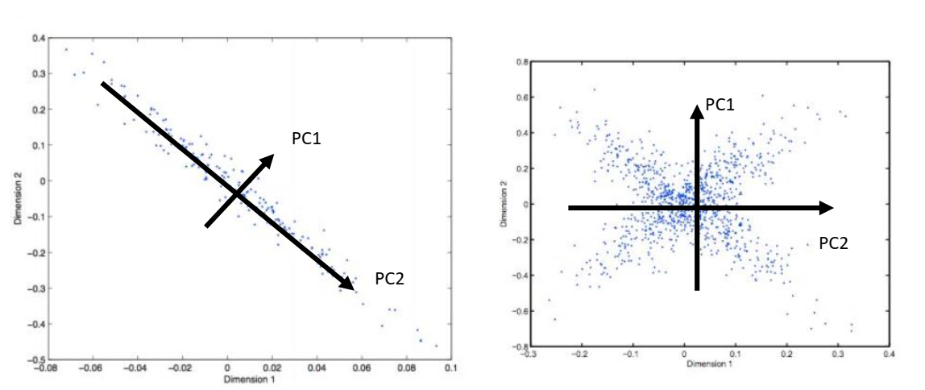

6. ​Use the Bellman equation to calculate Q(s, a1) and Q(s, a2) for the scenario shown in the figure. Consider two different policies:

● Total exploration: All actions are chosen with equal probability.

● Greedy exploitation: The agent always chooses the best action.

Note that the rewards/next states are stochastic for the actions a1’, a2’ and a3’. Assume that the probabilities for the outcome of these actions are all equal. Assume that reward gathering / decision making stops at the empty circles at the bottom.

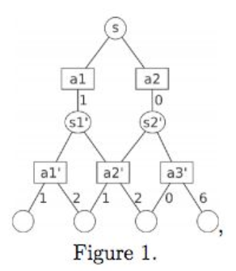

**Answer:**

From Figure 1 we could have the following information:

Q(S1’, a1’) = 1 x 0.5 + 2 x 0.5 = 1.5

Q(S1’, a2’) = 1 x 0.5 + 2 x 0.5 = 1.5

Q(S2’, a2’) = 1 x 0.5 + 2 x 0.5 = 1.5

Q(S2’, a3’) = 0 x 0.5 + 6 x 0.5 = 3

**For Total exploration:**

Q(S, a1) = R(S, a1, S1’) + 0.5 x Q(S1’, a1’) + 0.5 x Q(S1’, a2’) = 1 + 1.5 x 0.5 + 1.5 x 0.5 = 2.5

Q(S, a2) = R(S, a2, S2’) + 0.5 x Q(S2’, a2’) + 0.5 x Q(S2’, a3’) = 0 + 1.5 x 0.5 + 3 x 0.5 = 2.25

**For Greedy exploration:**

Q(S, a1) = R(S, a1, S1’) + 0 x Q(S1’, a1’) + 1 x Q(S1’, a2’) = 1 + 1.5 x 0 + 1.5 x 1 = 2.5

Q(S, a2) = R(S, a2, S2’) + 0 x Q(S2’, a2’) + 1 x Q(S2’, a3’) = 0 + 1.5 x 0 + 3 x 1 = 3