**Manual Strategy Project**

ZHENG FU(zfu66@gatech.edu)

**Part 1: Technical Indicators (20 points)**

In this part I developed four technical indicators and their details are described as following.

**1. Simple Moving Average (SMA)**

Simple Moving Average is a common indicator used in technical analysis. SMA is an arithmetic moving average and in this project it is defined as the average of the daily adjusted close price values of the security over a specific number of periods. Here a specific number of periods could be 20 days, 50 days and 200 days etc. It smooths the volatility and provides an easier view of the price trend of the security. Figure 1 shows the JPM stock daily adjusted close price values between 2008-01-01 and 2009-12-31, along with its 20-days SMA and 50-days SMA.

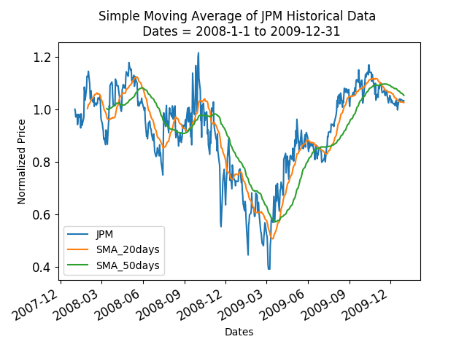

Figure 1. JPM stock’s historical adjusted close price (normalized) with 20-days SMA and 50-days SMA.

**2. Exponential Moving Average (EMA)**

Comparing with SMA, EMA setups a higher weighting on recent data than the older data. There are three steps to calculate the EMA values:

(1). Computing the SMA at a given time point as the initial EMA value.

(2). Computing the weighting multiplier = 2 / (1+N) where N is the number of days.

(3). Computing the Current EMA = (Current adjusted close price of the security - Previous EMA) * weighting multiplier + Previous EMA

As SMA, it smooths the volatility and provides an easier view of the price trend of the security. Figure 2 shows the JPM stock daily adjusted close price values between 2008-01-01 and 2009-12-31, along with its 20-days EMA and 50-days EMA.

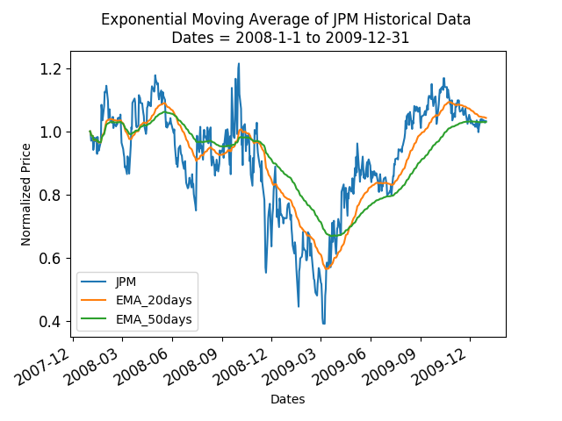

Figure 2. JPM stock’s historical adjusted close price (normalized) with 20-days EMA and 50-days EMA.

**3. Bollinger Band®**

In this project Bollinger Band® is a set of lines plotted *n* standard deviations away from a *m*-days simple moving average of the security's adjusted close price. It often has three bands:

(1). Middle band: *m*-days simple moving average

(2). Upper band: *m*-days simple moving average + (*m*-days standard deviation of adjusted close price) * *n*

(3). Lower band: *m*-days simple moving average - (*m*-days standard deviation of adjusted close price) * *n*

Bollinger Band® provides a way to measure the volatility of the market. If the width of the Bollinger Bands becomes widen, the market becomes more volatility. Otherwise if the width of the Bollinger Bands becomes narrow, the market become less volatility. Figure 3 shows the JPM stock daily adjusted close price values between 2008-01-01 and 2009-12-31, along with Bollinger Band® where *m* = 20 and *n* = 2.

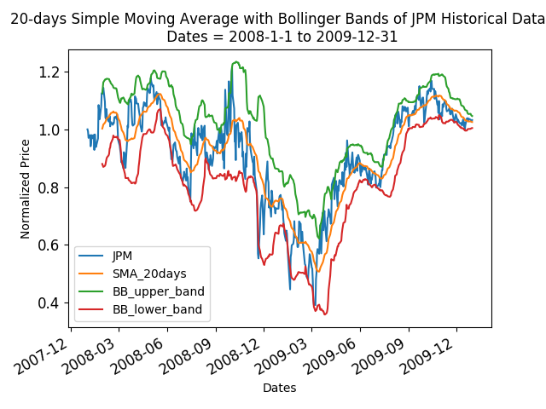

Figure 3. JPM stock’s historical adjusted close price (normalized) with Bollinger Band®.

**4. Momentum**

Momentum often was applied to portrait the rate of acceleration of the security's price. In this project it was defined as:

Momentum = [(Current adjusted close price of the security - Adjusted close price of the security at *m*-days ago) / Current adjusted close price of the security] - 1

Here *m* could be 20, 50 and 200 etc. Figure 4 shows JPM stock daily adjusted close price values between 2008-01-01 and 2009-12-31, along with momentum where *m* = 20.

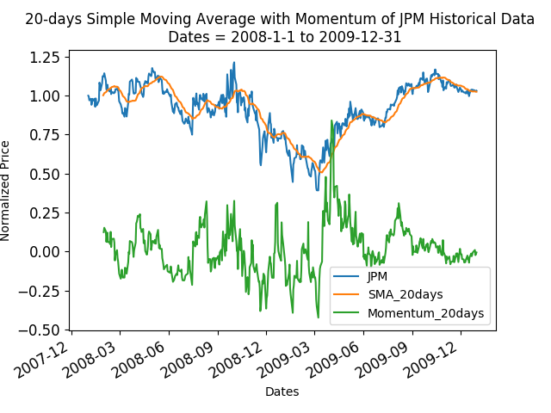

Figure 4. JPM stock’s historical adjusted close price (normalized) with 20-days SMA and Momentum (20-days) indicator.

## 

## 

## **Part 2: Theoretically Optimal Strategy (20 points)**

The idea of theoretically optimal strategy is the trader has the ability to ‘foresee’ the security price changing tendency. In other word the trader knows the exact price of the security in the future, thus he/she could buy/sell the security at present accordingly to maximize the return. To implement such strategy, I took the following steps:

(1). Computing the difference between the adjusted close price of the security at a given date and that of the following day.

(2). Normalizing the adjusted close price difference calculated in step (1) to 1 or -1, representing price increasing and decreasing, respectively.

(3). The normalized price difference at a given date will be compared with that of the previous day. If the sign of the normalized price difference is changed, it indicates the price changing tendency turns and an order should be made.

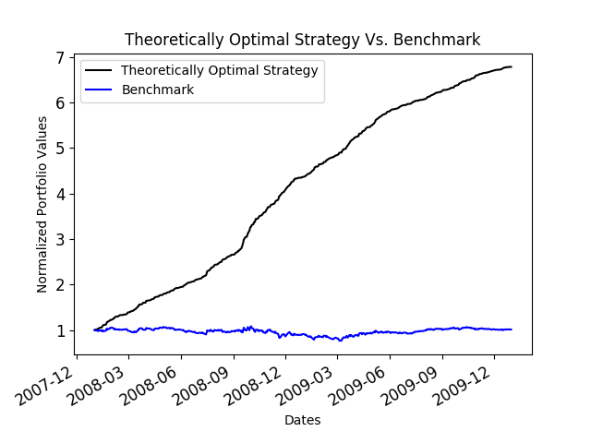

Figure 5. Comparing theoretical optimal strategy and benchmark strategy over in-sample time period.

(4). If the normalized price difference at a given date is 1 and the normalized price difference of the previous day is -1, a short order should be made.

(5). If the normalized price difference at a given date is -1 and the normalized price difference of the previous day is 1, a long order should be made.

(6). The normalized price difference at the first day determines the initial order. If it equals to 1, the trader will long 1000 shares of the security. If it equals to -1, the trader will short 1000 shares of the security.

(7). Since the project has constraints on shares holding (Allowable positions are: 1000 shares long, 1000 shares short, 0 shares), after first day the trader could only long / short 2000 shares when an order is made according to the sign changing of normalized price differences between successive days.

Further a benchmark strategy is also introduced that the trader will buy and hold 1000 share of the security throughout the in-sample period. Figure 5 shows the comparison between theoretical optimal strategy and benchmark strategy in terms of normalized portfolio values over in-sample time period. Table 1 summarizes the statistics of portfolio values while using these two different strategies over in-sample time period, respectively.

|  |  |  |
| --- | --- | --- |
|  | Theoretically Optimal Strategy | Benchmark |
| Sharpe Ratio | 13.3228 | 0.1569 |
| Cumulative Return | 5.7861 | 0.0123 |
| Average Daily Returns | 3.8168E-03 | 1.6809E-04 |
| Standard Deviation of Daily Returns | 4.5478E-03 | 1.7004E-02 |

Table 1. Statistics of portfolio values using theoretically optimal strategy and benchmark.

## 

## **Part 3: Manual Rule-Based Trader (50 points)**

For manual rule-based trader, I applied three technical indicators to determine the trading signal of the system.

**1. SMA:**

(1). Buy signal (Golden Cross): when the security’s 20-days simple moving average crosses above its 50-days simple moving average, it is a buy signal. In other word, if the security’s 20-days SMA is no less than its 50-days SMA at current date, and the security’s 20-days SMA is no more than its 50-days SMA at previous date, an order should be made to long shares of the security.

(2). Sell signal (Death Cross): when the security’s 20-days simple moving average crosses below its 50-days simple moving average, it is a sell signal. In other word, if the security’s 20-days SMA is no more than its 50-days SMA at current date, and the security’s 20-days SMA is no less than its 50-days SMA at previous date, an order should be made to short shares of the security.

**2. EMA:**

(1). Buy signal (Golden Cross): when the security’s 20-days exponential moving average crosses above its 50-days exponential moving average, it is a buy signal. In other word, if the security’s 20-days EMA is no less than its 50-days EMA at current date, and the security’s 20-days EMA is no more than its 50-days EMA at previous date, an order should be made to long shares of the security.

(2). Sell signal (Death Cross): when the security’s 20-days exponential moving average crosses below its 50-days exponential moving average, it is a sell signal. In other word, if the security’s 20-days EMA is no more than its 50-days EMA at current date, and the security’s 20-days EMA is no less than its 50-days EMA at previous date, an order should be made to short shares of the security.

**3. Bollinger Band®:**

(1). Buy signal: when the security’s adjusted close price crosses above its 20-days lower Bollinger band, it is a buy signal. In other word, if the security’s adjusted close price is no less than its 20-days lower Bollinger band at current date, and the security’s adjusted close price is no more than its 20-days lower Bollinger band at previous date, an order should be made to long shares of the security.

(2). Sell signal: when the security’s adjusted close price crosses below its 20-days upper Bollinger band, it is a sell signal. In other word, if the security’s adjusted close price is no more than its 20-days upper Bollinger band at current date, and the security’s adjusted close price is no less than its 20-days upper Bollinger band at previous date, an order should be made to short shares of the security.

A screenshot of a cell phone

Description generated with very high confidence

Figure 6. Comparing manual rule-based strategy and benchmark strategy over in-sample time period.

If at least one of the three buy signals mentioned above (SMA, EMA and Bollinger Band®) appears, and no signal conflict (say, SMA gives a buy signal yet EMA gives a sell signal at a given date) occurs, the system buy signal is set to TRUE and the trader will make an order to long shares of the security.

If at least one of the three sell signals mentioned above (SMA, EMA and Bollinger Band®) appears, and no signal conflict (say, SMA gives a buy signal yet EMA gives a sell signal at a given date) occurs, the system sell signal is set to TRUE and the trader will make an order to short shares of the security.

If both system buy and sell signals are FALSE, the trader just does nothing and holds the positions. Meanwhile the manual rule-based trader was constrained on shares holding (Allowable positions are: 1000 shares long, 1000 shares short, 0 shares), so the following scenarios should be considered while making orders:

A. Positions are zero shares:

If the system buy signal is TRUE, the trader will make an order to long 1000 shares of the security. If the system sell signal is TRUE, the trader will make an order to short 1000 shares of the security.

B. Positions are 1000 shares long:

If the system buy signal is TRUE, the trader will do nothing. If the system sell signal is TRUE, the trader will make an order to short 2000 shares of the security.

C. Positions are 1000 shares short:

If the system buy signal is TRUE, the trader will make an order to long 2000 shares of the security. If the system sell signal is TRUE, the trader will do nothing.

The benchmark strategy is as same as the one in Part 2 and Figure 6 shows the comparison between manual strategy and benchmark strategy in terms of normalized portfolio values over in-sample time period. Table 2 summarizes the statistics of portfolio values while using these two different strategies over in-sample time period, respectively. From Table 2 we could see the manual trading system provide higher cumulative return than the benchmark over the in-sample time period.

|  |  |  |
| --- | --- | --- |
|  | Manual Strategy | Benchmark |
| Sharpe Ratio | 0.2002 | 0.1534 |
| Cumulative Return | 0.0384 | 0.0123 |
| Average Daily Returns | 1.9789E-04 | 1.6809E-04 |
| Standard Deviation of Daily Returns | 1.5688E-02 | 1.7004E-02 |

Table 2. Statistics of portfolio values using manual strategy and benchmark.

## 

## **Part 4: Comparative Analysis (10 points)**

Figure 7 shows the comparison between manual strategy and benchmark strategy in terms of normalized portfolio values over out-of-sample time period. Table 3 summarizes the statistics of portfolio values while using theoretical optimal strategy, manual strategy and benchmark strategy over out-of-sample time period, respectively. From Table 3 we could see the manual trading system provide lower cumulative return than the benchmark over the out-of-sample time period.

A close up of a logo

Description generated with high confidence

Figure 7. Comparing manual rule-based strategy and benchmark strategy over out-of-sample time period.

So there are few reasons that the manual trading system performs worse in out-of-sample time period:

**1. Lookahead bias**

All the technical indicators were calculated based on adjusted close price and traded based on such information. Therefore it allows the strategy ‘foresee’ the future a little bit as the theoretically optimal strategy did. Such lookahead bias may make a fascinating return over in-sample time period yet worse performance over out-sample time period.

**2. Ignoring market impact**

The historical data did not include the trades that strategy trader made, thus it could not actually represent the price the strategy trader would get if the strategy trader were trading.

And using such data to train the strategy trader may cause bias while using it on real-world data.

|  |  |  |  |
| --- | --- | --- | --- |
|  | Theoretically Optimal Strategy | Manual Strategy | Benchmark |
| Sharpe Ratio | 16.3897 | -1.0382 | -0.2568 |
| Cumulative Return | 3.1202 | -0.2756 | -0.0834 |
| Average Daily Returns | 2.8226E-03 | -5.9897E-04 | -1.3720E-04 |
| Standard Deviation of Daily Returns | 2.7338E-03 | 9.1586E-03 | 8.4810E-03 |

Table 3. Statistics of portfolio values using theoretically optimal strategy, manual strategy and benchmark.