**OMSCS CS7646 2018 Fall Project 2 Report**

Zheng Fu

[zfu66@gatech.edu](mailto:zfu66@gatech.edu)

The following chart compares the optimal portfolio with SPY using the following parameters:

Start Date: 2008-06-01, End Date: 2009-06-01, Symbols: ['IBM', 'X', 'GLD', 'JPM']

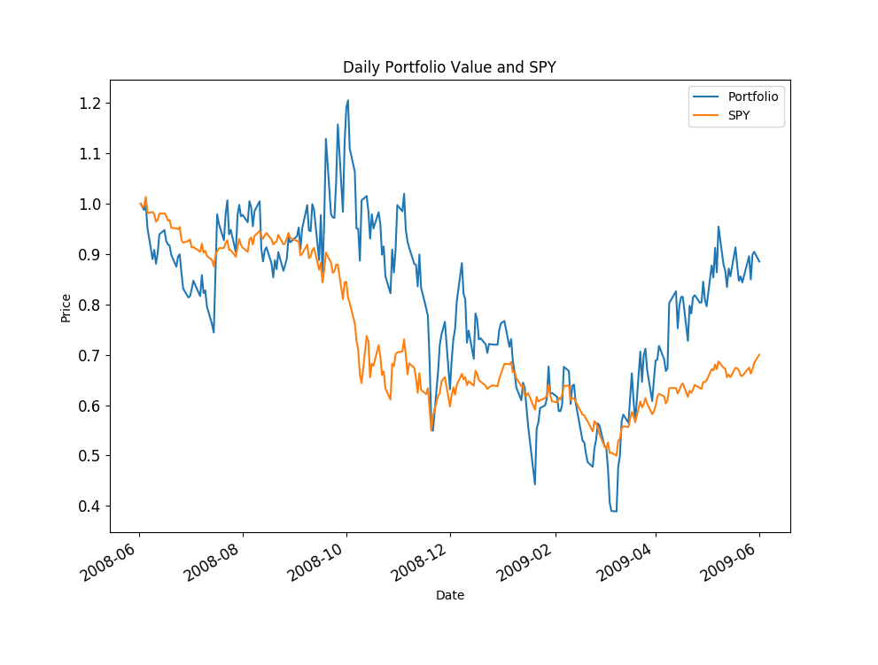* This chart was made by plot_data() function in util.py.