

Energy Management in Low   
Power Wireless Sensor Networks

Requirements Analysis

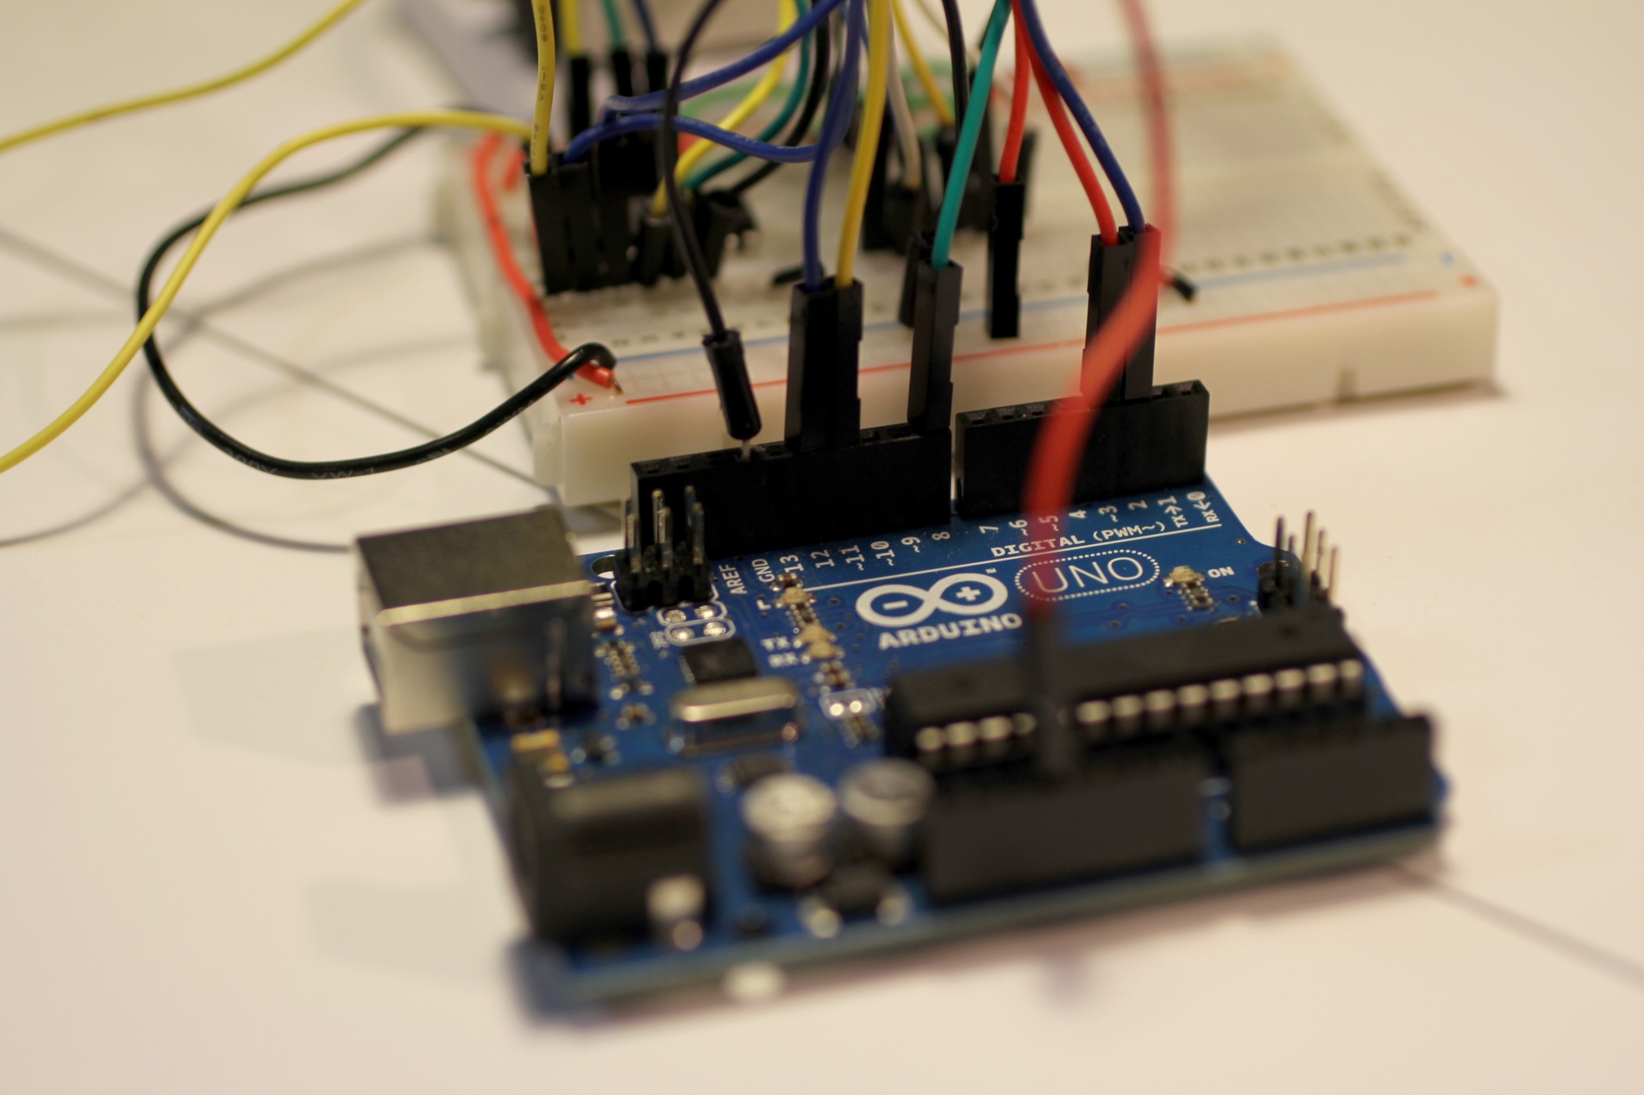

Energy Management in Low   
Power Wireless Sensor Networks   
Team 14

Authors

Peter Bouvy(21299044)

Yung Ren Chin(21247413)

Aaron Hurst(21325887)

Khanh Tan (Jamie) Phan(21326604)

Matthew Ramanah(21317297)   
Jake Sacino(21132001)

Andy Ta(21317377)

Requirements Analysis

Project Partner:

Mr Mark Callaghan, ATAMO

Supervisor:

Mr Marcus Pham

Unit Coordinator:

Dr Sally Male

Group Meeting Day and Time:

Thursday 4pm

Word Count:

9993

Word Limit:  
10,000

Version 4.4

[1]

**Revision History**

| **Date** | **Version2** | **Description** | **Author** |
| --- | --- | --- | --- |
| 11/08/2017 | 0.1 | Initial template created. | Jake Sacino |
| 12/08/2017 | 1.0 | Significant updates to template. Personalised document while maintaining standardised format. | Jake Sacino |
| 19/08/2017 | 1.1 | Overview, Purpose, and Structure & Contributions | Jake Sacino |
| 20/08/2017 | 1.2 | Project Stakeholders, Appendix B – Stakeholder Analysis and formatted Table of Contents | Aaron Hurst |
| 20/08/2017 | 1.3 | Front End Key Technologies regarding User Interface | Jake Sacino |
| 20/08/2017 | 1.4 | Power Management | Aaron Hurst |
| 22/08/2017 | 1.5 | Project Overview | Jamie Phan |
| 22/08/2017 | 1.6 | Front End Key Technologies regarding Cloud Computing | Andy Ta |
| 22/08/2017 | 1.7 | Assumptions Table | Andy Ta |
| 22/08/2017 | 1.8 | A04 tables entries, discussion | Jamie Phan |
| 22/08/2017 | 1.9 | Networking Literature Review (Still needs references) | Peter Bouvy |
| 22/08/2017 | 1.10 | Modified M05, M08, A02, A04, and Project Overview | Jamie Phan |
| 22/08/2017 | 2.0 | Completed Power Management, partial work on Similar Projects | Aaron Hurst |
| 22/08/2017 | 2.1 | Front End Standards regarding User Interface | Jake Sacino |
| 22/08/2017 | 2.2 | Hardware Lit Review | Yung Chin |
| 23/08/2017 | 3.0 | Mandatory Requirements Matrix | Matthew Ramanah, Jake Sacino |
| 23/08/2017 | 3.1 | Network Literature Review; reorder acronyms table | Jamie Phan |
| 23/08/2017 | 3.2 | Acceptance Criteria and Requirement A10 Data Scalability | Andy Ta |
| 24/08/2017 | 3.3 | Requirements A03 and A09; Power Management editing | Aaron Hurst |
| 24/08/2017 | 3.4 | Requirements A05 and A08; Mandatory Requirements Matrix editing | Jake Sacino |
| 24/08/2017 | 3.5 | Requirement A05 and Hardware Literature Review | Yung Chin |
| 25/08/2017 | 3.6 | Addition of preambles for the Requirements Sections and Assumptions | Andy Ta |
| 25/08/2017 | 3.7 | Preliminary edit of the document | Andy Ta, Jake Sacino |
| 25/08/2017 | 3.8 | Modified hardware and network literature review; added section on Dusty Hardware | Jamie Phan |
| 25/08/2017 | 4.0 | TCP/IP literature review; updated glossary | Jamie Phan |
| 25/08/2017 | 4.1 | Case Study; referencing edits | Aaron Hurst |
| 25/08/2017 | 4.2 | Project Constrains | Jake Sacino, Yung Chin |
| 25/08/2017 | 4.3 | Conclusion | Matthew Ramanah |
| 25/08/2017 | 4.4 | Final proof read and editing on miscellaneous items | Aaron Hurst, Jake Sacino, Jamie Phan, Matthew Ramanah |

2*Incrementing the version by 0.1 denotes a minor change; incrementing by 1.0 denotes a significant change*

**Contents**

1 Introduction 1

1.1 Overview 1

1.2 Purpose 1

1.3 Structure & Contributions 1

1.4 Definitions, Acronyms, and Abbreviations 2

2 Project Overview 3

3 Project Stakeholders 4

4 Relevant Literature 6

4.1 Background & Case Study 6

4.2 Hardware 6

4.3 Network 7

4.4 Power Management 9

4.5 Front End 12

5 Project Design Requirements 14

5.1 Mandatory Design Requirements Matrix 14

5.2 Aspirational Design Requirements Matrix 16

5.3 Requirements Acceptance Criteria 18

5.4 Description of Requirements 21

5.5 List of Assumptions 23

6 Project Constraints 24

7 Conclusion 25

8 References 26

9 Appendices 29

9.1 Appendix A – Stakeholder Analysis 29

**List of Figures**

Figure 1. Proposed system architecture 3

Figure 2: A Simple Network 8

Figure 3. Example 6LoWPAN mesh network communicating with IPv6 Network 9

Figure 4: Dust Network LTC5800-IPM (Mote) State Transition Diagram 11

Figure 5: Comparison of CSP Delivery Models 12

Figure 6: GUI complexity and control 13

**List of Tables**

Table 1: Project Stakeholders 4

Table 2: Communications Management Plan 5

Table 3: Mandatory Requirements 14

Table 4: Aspirational Requirements 16

Table 5: Requirements Acceptance Criteria 18

Table 6: Project Assumptions 23

Table 7: Stakeholder Prioritisation 29

Table 8: Stakeholder Prioritisation Schedule 29

# Introduction

## Overview

The proliferation of data monitoring technologies has enabled multifarious insights into environmental conditions, system reliability, consumer behaviour, and a myriad of other fields and industries [2, 3, 4]. Sensors are one such technology, able to detect events or changes in their environment and send this information to other electronics. Energy storage poses a constraint on sensor operation in rural environments; a lack of grid connectivity exposes the importance of sagacious energy management.

Cloud Seven Consultants (CSC) has been contracted by ATAMO (the client) to investigate energy management in low-power wireless sensor networks (WSN). The project requires integration of a third party WSN with an ATAMO Arduino based development platform. Sensor data (e.g. temperature, vibration) must be measured and periodically reported over the wireless network to a cloud-based database. The firmware in the sensor must provide for reliable communications while keeping tight constraints on battery energy usage.

## Purpose

The purpose of this document is to unambiguously articulate, define, and prioritise the project requirements. CSC has ascertained the proceeding information through salient stakeholder communications, and consolidation of literature pertinent to the undertaking of a design project in the field of energy management in low-power WSNs. This includes consultation of academic literature, analogous projects, and a detailed examination of the spoken, unspoken, exciter, and expected requirements. Project management activities are also included, identifying the project’s relevant stakeholders and key risks.

## Structure & Contributions

The structure of the report has been listed below, with the team member(s) responsible for writing the section denoted in square brackets. This report has been broken down as follows:

* Section 1 introduces the project and document structure [Jake];
* Section 2 will give a concise summary of the project [Jamie];
* Section 3 will give an overview of all relevant project stakeholders [Aaron];
* Section 4 will examine the relevant literature;
  + Section 4.1 will develop the project background and pertinent case studies [Aaron];
  + Section 4.2 will summarise the literature pertinent to relevant hardware [Yung];
  + Section 4.3 will summarise the literature pertinent to network management [Aaron & Pete];
  + Section 4.4 will summarise the literature pertinent to power management [Aaron];
  + Section 4.5 will summarise the literature pertinent to front-end design [Andy & Jake];
* Section 5 will outline the project design requirements;
  + Section 5.1 will concisely define the mandatory requirements [Jake & Matthew];
  + Section 5.2 will summarise the aspirational requirements [CSC];
  + Section 5.3 will outline each requirement’s acceptance criteria [Andy & Peter];
  + Section 5.4 will elaborate on the aspirational requirements [CSC];
  + Section 5.5 will concisely summarise the project assumptions [Andy];
* Section 6 will give a critical appraisal of the project constraints [Jake & Yung];
* Section 7 will summarise and conclude the report [Matthew];

## Definitions, Acronyms, and Abbreviations

|  |  |
| --- | --- |
|  |  |
| 6LoWPAN | IPv6 over Lower Power Wireless Personal Area Network |
| AP | Access Point |
| API | Application Programmers Interface |
| CSP | Cloud Service Provider |
| DFS | Dynamic Frequency Scaling |
| DPM | Dynamic Power Management |
| DVS | Dynamic Voltage Scaling |
| EMI | Electromagnetic Interference |
| FAT | Factory Acceptance Test |
| GUI | Graphical User Interface |
| HCI | Human-Computer Interface |
| I2C | Inter-Integrated Circuit |
| IaaS | Infrastructure-as-a-Service |
| IETF | Internet Engineering Task Force |
| IoT | Internet of Things |
| IP | Internet Protocol |
| IPv4 | Internet Protocol Version 4 |
| IPv6 | Internet Protocol Version 6 |
| MAC | Media Access Control |
| OSI | Open Systems Interconnection |
| PaaS | Platform-as-a-Service |
| PCA | Printed Circuit Assembly |
| PCB | Printed Circuit Board |
| QA | Quality Assurance |
| RF | Radio Frequency |
| RISC | Reduced Instruction Set Computer |
| SaaS | Software-as-a-Service |
| SAT | Site Acceptance Test |
| SPI | Serial Peripheral Interface |
| TCP | Transmission Control Protocol |
| The Client | ATAMO |
| UART | Universal Asynchronous Receiver/Transmitter |
| WSN | Wireless Sensor Network |

# Project Overview

The project investigates the implementation of a low-power, low-utilization WSN which will sample sensor data from a plant and report this to a cloud-based database through an internet-enabled gateway. This data can be accessed, visualised, and analysed remotely by users through a client application, provided they have an internet connection and the required credentials for authentication to the cloud server. The architecture of this proposed system can be seen in Figure 1.

The WSN consists of a self-forming multi-hop mesh of sensor hosts – devices that sample data from the physical world with sensor/transducers and communicate with one another through SmartMesh-IP networking. Access point (AP) host(s) throughout the WSN act as the radio bridge between the mesh network and a central network manager that monitors and manages network performance, and security. Importantly, when coupled with an internet-enable gateway the network manager acts as a bridge between the host cloud-based application and the WSN.

The sensor hosts are designed using ATAMO’s modular hardware development platform, the duinoPRO UNO. The SmartMesh-IP networking capabilities are achieved by adapting IoTeam’s Dusty module to the duinoPRO, and sensing capabilities are achieved with sensor modules tailored for the duinoPRO.

Motivated to provide low maintenance, reliable industrial sensing networks, a key aim of the project is to optimize operational lifetimes of the sensor hosts through minimizing utilization of the device during inactive periods, such as when the device is not sampling data, reporting data, or forwarding data throughout the network.

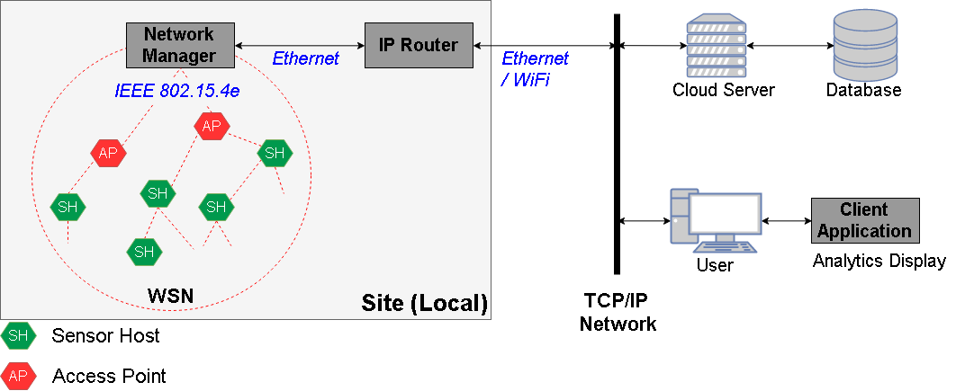

Figure . Proposed system architecture

# Project Stakeholders

The following stakeholders listed in Table 1 have been identified for this project. Based on their respective interests in the project and further analysis in Appendix A – Stakeholder Analysis, the communications management plan is outlined in Table 2.

Table : Project Stakeholders

|  |  |  |
| --- | --- | --- |
| Stakeholder | Role | Interest in Project |
| Mr Mark Callaghan  (ATAMO) | Project Sponsor | Receiving design documentation for networking and energy management of a duinoPRO-Dusty WSN with cloud integration that is well-tested of a high quality. A working prototype is also desired. |
| Cloud Seven Consultants (Team 14) | Design Team | Responsible for completing the design task and project management. |
| Project Manager | - | Manage progress on the design task, team meetings and communication with Project Sponsor. Learn and develop project management skills. |
| Mr Marcus Pham | Supervisor | Provide assistance and advice on teamwork and technical issues to the Design Team during weekly meetings. Contribute to a successful design project. Potential involvement in assessing project deliverables. |
| Dr Sally Male | Unit Coordinator | Provide assistance with ELEC5552 unit administration issues. |
| ATAMO’s clients | End users | Successful development and availability of a low-cost, reliable, low power and reconfigurable WSN for automated plant data acquisition. A relevant and intuitive user interface and cloud database is also desirable. |
| Original Equipment Manufacturers | Suppliers | Provide components required for the design and support for these if requested. No particular interest in output of design project per se. |

Table : Communications Management Plan

| Stakeholders | Information required by stakeholder | Frequency | Communication method | Owner |
| --- | --- | --- | --- | --- |
| Mr Mark Callaghan | Progress updates  Major design decisions  Project deliverables | Weekly  As required  As required | Email and/or Project Partner Meetings | Project Manager |
| Dr Sally Male | Escalation of issues | As required | Email and/or in-person meeting | Project Manager |
| Mr Marcus Pham | Progress updates  Individual notebook entries | Weekly | Supervisor meetings | Design Team members |
| ATAMO’s clients | Successful completion of prototype/development of new product | At completion | At the discretion of ATAMO | ATAMO |
| Original Equipment Manufacturers | Product orders, requests for advice | As needed | TBC | Design Team |

# Relevant Literature

## Background & Case Study

A WSN may consist of a potentially very large number of sensor nodes, each node comprising of sensing, data processing and communications equipment [5]. All nodes are capable of sending and receiving data and together form a connected network that may transfer data from any node to the network gateway [6]. The myriad applications for WSNs include transmission line monitoring, building management, military, structural health monitoring, intelligent traffic management and agriculture [5, 6, 7]. Given their versatility and cost, the International Electrotechnical Commission assert that WSNs are “*the* key technology for IoT” (emphasis added) [6, p. 3].

One WSN project with notable similarities to the current project was undertaken by researchers from the University of Western Australia in the early-to-mid 2000s [8]. The researchers desired to remotely measure the soil moisture content in a locality near Perth, Western Australia, over an extended time period in order to study local soil moisture dynamics [8]. To achieve this, a WSN was designed and constructed with three sensing nodes, four routing nodes and one base node, which acted as a gateway device [9].

Each node was based around a single Mica2 mote which managed communication and sensor data acquisition at sensing nodes [9]. The Mica2 mote itself contains an embedded microprocessor which runs a lightweight OS [10]. Two soil moisture sensors were connected to the Mica2 module at sensing nodes [9]. The gateway node was connected to a modem which relayed data to a database that was viewable from a web page [9].

Power was found to be a key factor for the reliability of this system. Multiple battery technologies were examined by the researches, however the longest system lifetime achieved was only 28 days [9]. This short lifetime can be attributed to inefficient sub-system sleep protocols. That is, during inactivity, the radio was set to sleep (where its current draw was only 5 µA), however the microprocessor could not be set to sleep using the chosen software [9]. As a result, the minimum current draw across all states was 8 mA, causing the lifetime to be short [9]. Notably, the cost-per-node for this system exceeded $1000 per node [8, 9].

## Hardware

### Key Technologies

#### ATmega328P and duinoPRO UNO

The ATmega328P is an 8-bit AVR reduced instruct set computer (RISC) based microcontroller produced by Microchip Technology [11]. Due to the increased need for rapid development and testing, ATAMO have developed a modular hardware platform based on the ATmega328P microcontroller, the duinoPRO UNO. Using standard 2.54mm pitch headers, up to seven modules can be designed to fit onto the duinoPRO for simple and rapid development cycles [12].

#### LTC5800 Printed Circuit Assembly

The LTC58000 printed circuit assembly (PCA) is Linear Technology’s system-on-chip (SoC) that provides SmartMesh-IP networking [13]. This PCA is designed with an integrated, low power radio for IEEE 802.15.4e communication, and uses an ARM Cortex-M3 32-bit microprocessor to handle the SmartMesh-IP networking embedded software. The LTC5800’s behaviour on the network depends on the choice of firmware loaded; variants in the firmware allows LTC5800 PCAs to act in different roles across the network [13].

IoTeam’s Dusty module implements Linear Technology’s LTC5800 SoC into a pre-packaged module; it features the necessary external (to the LTC5800) components such as crystal oscillators, radio-frequency (RF) antenna ports and other peripherals [14].

#### PCB Electromagnetic Interference

One of the major challenges to hardware PCB design is to minimise Electromagnetic Interference (EMI) which can disrupt any electronic devices in the vicinity of the electromagnetic field of another device [15, 16]. Factors that contribute to the level of EMI present in PCBs include the noise from integrated circuit input/output (I/O) pins, power-supply systems and oscillator circuits [16, 17]. Proper separation between the crystal and its circuits from other components, as well as designing loop areas to be small is vital to reducing EMI [17, 18, 19]. Components may also be surrounded by conductive or magnetic materials to shield them from other parts of the system [17].

#### Hardware Communication Protocols

Commonly used communication protocols are the Serial Peripheral Interface (SPI), Inter Integrated Circuit (I2C) and Universal Asynchronous Receiver/Transmitter (UART). The SPI protocol is a three-wired communication protocol also known as Master/Slave protocol [20, 21]. The I2C protocol allows one device to exchange data with one or more connected devices through the use of clock and data signals [21]. I2C is similar to Asynchronous Serial Interfaces, such as UART, in conjunction with Recommended Standard-232 (RS232) [21, 22, 23]. RS232 is an asynchronous serial communication protocol used in computers and digital systems as it only allows for one transmitter and one receiver on each line [24]. Asynchronous mode only requires data and there is no clock signal to synchronize the output of bits from the transmitting UART to the sampling of bits by the receiving UART [21, 22, 24, 25].

### Standards

#### Hardware Handling

The relevant EMI PCB standard is AS/NZS 6100.4.2:2002 Electromagnetic compatibility (EMC) – Testing and measurement techniques – electrostatic discharge immunity test [26]. This standard establishes common and reliable benchmarks for evaluating the performance of electrical and electronic equipment when subjected to electrostatic discharges. It also includes electrostatic discharges which may occur from personnel to objects near vital equipment.

#### Embedded Hardware Development

The Motor Industry Software Reliability Association (MISRA) provides standards and guidelines on best practices in developing embedded systems [27]. MISRA-C:2012 applies to the development process, system design and testing for the C programming in embedded systems to ensure operational safety, security, portability and reliability of embedded systems [27]. Despite being designed for automobile contexts, MISRA-C:2012 is applied to many safety-critical systems, due to its wide-spread success in preventing vulnerabilities in the C Language.

## Network

The main design goal when designing communications in a WSN should be to ensure that the network performance is high enough, reliable and has lower power consumption [28].

### Key Technologies

#### TCP/IP – The Internet Protocol Suite

The Internet Protocol (IP), developed by the Internet Engineering Taskforce (IETF), is a Network Layer protocol that provides an unreliable (does not attempt to recover lost data), connectionless (each ‘packet’ is handled independently) and best-effort (does not specify guarantees) delivery service [29, 30].

The protocol provides three core definitions: (1) the basic unit of data transfer and the addressing mechanism to label the source and destination information, (2) the routing functions, and (3) a set of rules for defining how hosts and routers should process data, detect errors, and the conditions for discarding data [30].

The IP has two versions, IP version 4 (IPv4) and IP version 6 (IPv6). The primary differences in the two versions is how addressing is implemented. The former version uses 32-bit address sizes, whilst the latter uses 128-bit address sizes, allowing for a far larger number of possible addresses [31].

The Transmission Control Protocol (TCP) is a Transport Layer protocol that compensates for IP’s deficiencies, providing reliable, stream-orientated connections [32]. To achieve this TCP organises data in streams and arranges the streams using sequencing for reliable delivery. Further, TCP implements flow control; managing data buffers and traffic end-to-end coordination [32].

TCP and IP are ubiquitously employed together to form the backbone of the internet; together they form the internet protocol suite known as TCP/IP. This suite follows the Open Systems Interconnection (OSI) model.

#### Smart Mesh IP

Some of the most prevalent networking solutions in WSNs include Dust Networks, ZigBee, ZigBee PRO, 802.15.4 and IPv6 over Lower Power Wireless Personal Area Network (6LoWPAN) [28]. In this project the client specified a development platform which uses the IoTeam “Dusty” module that runs Linear Technology’s SmartMesh-IP embedded networking software [33].

SmartMesh-IP products are based on the 802.15.4e and 6LoWPAN standards [34]. The SmartMesh networking software comes complete with an Application Programming Interfaces (API), example code and quick start library (QSL) [35].

In a SmartMesh network there are three devices, each of which use the LTC5800 SoC, differing only in the software loaded [36]:

* Motes (Wireless Nodes), using the SmartMesh-IP Mote software (LTC5800-IPM)
* Access Point Mote, using the SmartMesh-IP Access Point software (LTC5800-IPA)
* Network Manager, using the SmartMesh-IP EManager software (LTC5800-IPR) or using an external x86 platform with the SmartMesh-IP VManager software

As implied by the name, the network is in a mesh topology and all motes can both transmit and receive data [36]. A simple SmartMesh Network is shown below [36].

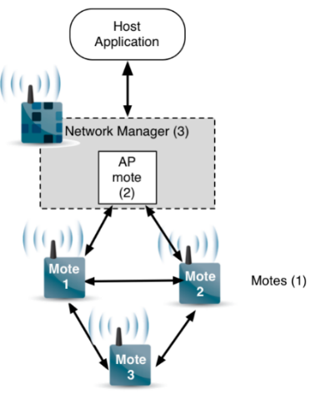

Figure : A Simple Network

### Standards

#### Communication Protocol – IEEE 802.15.4e

IEEE 802.15.4 is a communication protocol which aims to standardise the two lowest layers of the OSI model stack for applications that require low power consumption and low transmission rates, such as WSNs [37]. IEEE 802.15.4 specifies the utilization of the radio and the method of transmission and reception of the packets within three frequency bands (868 MHz, 925 MHz, and 2.4 GHz) [37]. Further, IEEE 802.15.4 specifies a Media Access Control (MAC) layer that provides access control and reliable data delivery by listening to the channel before sending data to minimise the likelihood of collisions with other transmissions in the network [37]. The “Dusty” module utilizes IEEE 892.15.4e for its wireless communication, using the 2.4 GHz RF band and communicating via Quadrature Phase Shift Keying (QPSK).

#### Internet Connection – 6LoWPAN

6LoWPAN is what makes it possible to connect computationally constrained WSN nodes to the internet. The 6LoWPAN standard was developed specifically for devices with constrained memory spaces and processing capabilities, whilst also ensuring the uniformity of packet structures; the implementation of WSNs should be no different to how Internet services are currently implemented [38]. Thus 6LoWPAN, to ensure uniformity of packet structures, enables transmission of IPv6 packets over an IEEE 802.15.4 network [38].

By communicating natively with IP, 6LoWPAN networks can be connected to other networks simply using IP routers as seen in the example in Figure 3 [38].

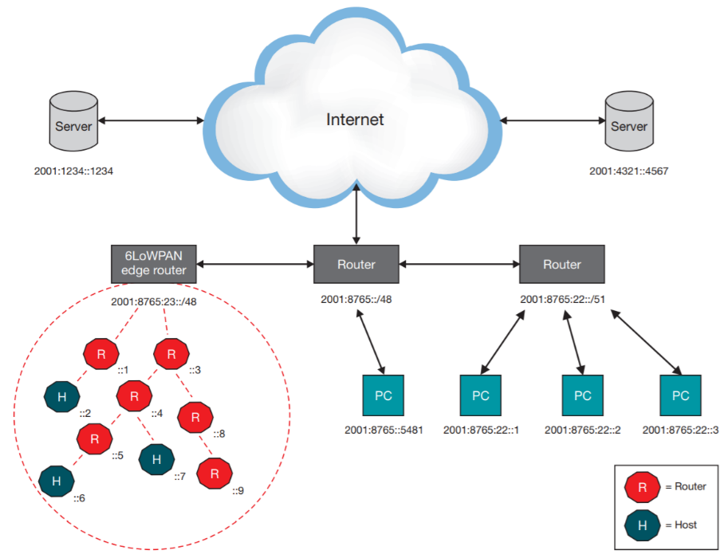

Figure . Example 6LoWPAN mesh network communicating with IPv6 Network

## Power Management

Many embedded systems – in particular WSNs – operate on battery power [7, 39, 40]. In this condition, “energy is considered as a scarce resource” [39, p. 1]. Manual battery replacement is also considered a challenging and undesirable task [7]. Therefore, power management is critical to WSN design [39, 40, 41, 42].

Power management has historically been limited to hardware design [43] and binary on/off control [40]. Today, most of the literature focuses on software-based power management [43]. Many techniques are available, including multiple low-power operation modes, dynamic voltage scaling (DVS), dynamic frequency scaling (DFS), power-aware compilers, low power bus encoding and sleep and wake-up protocols [39, 40, 44]. For WSNs, additional power management techniques include topology control protocols, data reduction schemes and mobile nodes [39]. Some standards exist for software-based power management, in particular ACPI [45]. However, these require the support of an operating system [42] and preclude case-specific tuning [40].

At the application level, Dynamic Power Management (DPM) is the primary avenue for software-based power management. DPM can be summarised as:

“putting system components into different states, each representing a certain performance and power consumption level. The [DPM] policy determines the type and timing of these transitions” [44, p. 2]

Some authors have proposed detailed DPM implementations, some of which include APIs [40, 42]. Two common DPM approaches for WSNs are DVS/DFS and sleep and wake-up protocols [7]. In DVS and DFS, supply voltage and clock speed are reduced when the power management software anticipates a lower workload [7].

Sleep and wake-up protocols, on the other hand, involve completely switching off subsystems when there is no activity and re-activating them on an event-driven or scheduled basis [39]. Event-driven protocols bring subsystems out of sleep when they are required to perform some function [39]. Scheduled protocols establish a pre-defined schedule of wake-up times and durations for subsystems to be active [39]. In designing sleep and wake-up protocols, transition energy cost associated with state changes must be considered [7]. The state transitions for the Dusty module are shown in Figure 4 [46].

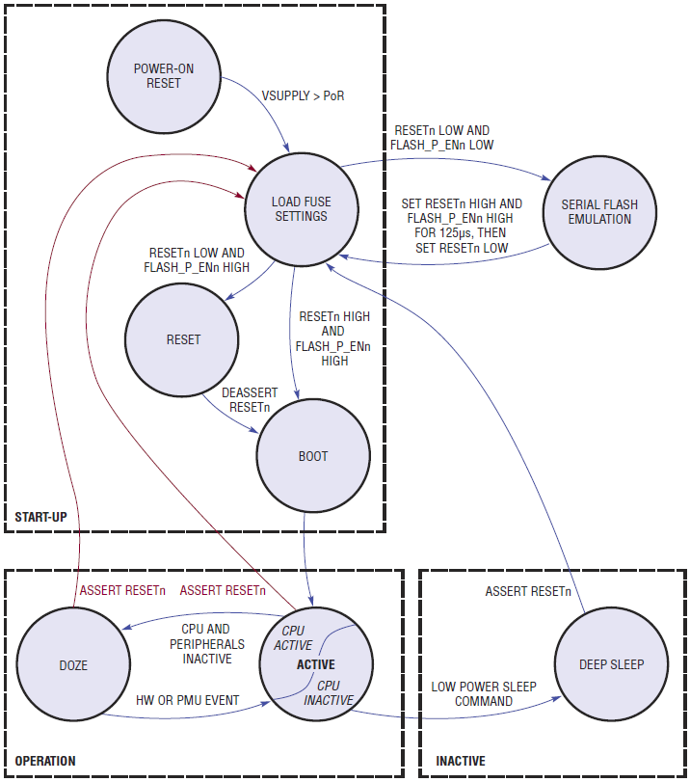

Figure : Dust Network LTC5800-IPM (Mote) State Transition Diagram

The development platform to be used in this project is produced by ATAMO and is known as the duinoPRO [47]. The duinoPRO (UNO) utilises an ATMega328P microprocessor [12]. This processor has various sleep modes available each with different power demands [48, 49]. Software available for controlling and interfacing the Dusty module includes the Quick Start Library [35] and SmartMesh C Library [50]. The duinoPRO can use standard Arduino software libraries [51] and/or the Atmel Software Framework [52].

## Front End

### Key Technologies

Once information has been successfully procured from the sensors, they must be uploaded into a cloud database. Cloud computing facilitates the mass processing of information using the internet as a medium for storage systems [53]. Consequently, the unified cloud-data has the potential to be accessible through any device providing that it is connected to the internet [54, 55]. The feasibility and success of cloud computing is immensely intertwined to the substantial advancements of the internet and the growing supply of data [53].

Cloud computing benefits significantly from economies of scale, elasticity and scalability [54, 55]. This is derived from the intrinsic nature of the cloud which enables it to dynamically modify the acquisition of computing resources to support variable workloads [53]. These benefits are indicative to the cloud industry’s bullish market and “hypergrowth” [56]. Despite this appeal, cloud services also have inherent trade-offs and drawbacks. Given that a business is signed to a cloud solution provider (CSP), the contract termination and data recollection is often an arduous task which may be costly or time consuming. Therefore, the difficulties which arise in CSP contract terminations creates a risk of vendor lock-in [53, 54]. In addition, the performance of cloud services is limited to the client’s network speed which can impose data transfer bottlenecks [53].

The National Institute of Standards and Technology have identified three main cloud delivery models, Software-as-a-Service (SaaS), Platform-as-a-Service (PaaS) and Infrastructure-as-a-Service (IaaS) [53, 54]. The underlying similarity in all these models is that the physical database and management is executed remotely at the CSP’s datacentres. However, the main difference in these delivery models is the degree to which the computing resources are outsourced which is reflected in Figure 5 [57].

|  |
| --- |
|  |

Figure 5: Comparison of CSP Delivery Models

In the SaaS model, the customer delegates all computing responsibility to the CSP. Consequently, the customer is not burdened by computing management but is limited to the CSP’s designated applications. The advantage to the SaaS model is that the end-users have easy access to specified applications and have proprietary ownership of the cloud-data. An example of a SaaS implementation would be Google Drive, where the end-users do not manage databases and are limited to Google Drive’s available features [54].

The PaaS model allows for the flexible deployment of applications. However, this delivery still inhibits the end-users control over the underlying cloud infrastructure which includes the network, servers, operating system and storage [53, 54]. Alternatively the IaaS model facilitates the provision of storage, networks, analytics and the freedom for the customer to deploy and run arbitrary software [53]. The IaaS delivery supports dynamic scaling and is particularly useful in circumstance where computing resource demand is volatile. This model is cost-effective for businesses that require multiple layers of control but cannot manage physical databases.

The cloud’s ability to store and process large datasets is highly valuable as the supply of data is currently growing at an unprecedented rate. Increasing in volume, variety and velocity, it brings forth a phenomenon called ‘Big Data’ [55, 58]. For IoT projects working in big data environments, the cloud offers the value through horizontal scaling. This allows the database to work in distributed environments and facilitates efficient processing [55].

Once procured, the sensor data must be presented to a user in an understandable format. Time spent developing an appealing user interface is often in trade-off with development of functionality [59]. Nevertheless, the user interface is an essential component to any computer system [60, 61].

User interface design is a subcategory of Human-Computer Interaction(HCI) – the study, planning, and design of how people and computers work together so that a user’s needs are satisfied in the most effective way [61]. This is governed by a myriad of influences: what abilities people possess (dictated by a defined target audience), their wants and expectations from the interaction, and what they perceive as visually attractive. Developers must consider this in parallel with the technical limitations of the given hardware and software.

A Graphical User Interface (GUI) is a type of interface that allows users to interact with electronic devices through graphical icons and visual indicators [59]. Gunerloy [61] defines a good user interface as *“one that lets the user accomplish the task that they want to accomplish, without putting obstacles in their way”.* To achieve this there must be enough control for the user to achieve what they want from an application, without the unnecessary clutter of additional controls. The complexity that is intrinsic to additional controls is illustrated in Figure 6.

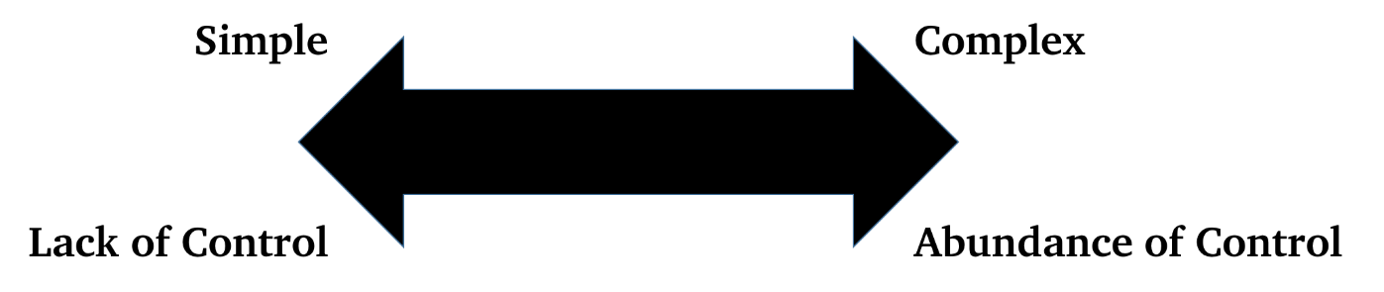

Figure : GUI complexity and control

### Standards

The importance of prudent GUI design is bolstered by the standards adopted and made publicly available by large corporations, including Microsoft [62], Apple [63] and Gnome [64]. These standards emphasise the importance of purposeful visual design, typography, and controls. These standards also include best practices for authentication. Users should only be asked to authenticate in exchange for value [63], such as personalizing the experience or accessing additional feature. The sign-in verification process should be quick and discreet to minimise its detraction from the application. Sign-in should be delayed for as long as practicable to avoid unnecessarily obstructing the user.

# Project Design Requirements

## Mandatory Design Requirements Matrix

All mandatory requirements must be accomplished for the project to be considered a success. In this regard, there are no trade-offs between the mandatory requirements, being the baseline level of quality defined by the client. These mandatory requirements have been explicitly spoken by the client or are expected through the necessary underlying tasks of spoken requirements. The mandatory requirements have been reviewed and verified by the client through email communication [65]. The following mandatory requirements in Table 3 span across expected, spoken, and unspoken requirements.

Table 3: Mandatory Requirements

| ID | Requirements | Business Need(s) |
| --- | --- | --- |
| M01 | Functional Operating Conditions   * Operational ambient temperature: -40 to 70°C [65] * Fully IP rated (IP68 or above) [66] * Input Battery Voltage 3.0 to 3.6 V [65] * Humidity: 10-90% [46] | Continual system functionality in expected operating environment |
| M02 | Safety:   * The system must be safe to operate, install, and maintain with necessary precautions taken to ensure the system will not cause injury or damage. | Reduce danger to human life to as low as reasonably practicable |
| M03 | Design strategy:   * A clear and defined strategy for implementation of the system must be provided. | Ease of implementation, maintenance and enhancement |
| M04 | Operational Lifetime:   * Sensor devices will operate for no less than 1 year for every 1000 mAh of battery capacity supplied. | Affordability of deploying large numbers of sensors and instrumentation |
| M05 | System Network:   * The system must be capable of receiving data remotely from at least 3 sensor devices, with each device separated by a maximum of 50m in open air * The sensor hosts must be discoverable and able to synchronise to the WSN given they are within 50 m (in open air) of another SmartMesh-IP enabled host (sensor host or network manager). | Provides additional data points to alleviate domain-based errors  Automates the process of data procurement |
| M06 | Internet Connectivity:   * The system must be capable of sending sensor data to a cloud-based database system from an internet-enabled gateway. | Continual data access |
| M07 | Data validity:   * Sensor data that is sent through the network (from sensor to gateway) must be valid, such that errors can be detected and stopped before transmission. | Reliable data integrity |
| M08 | Data Specification:   * Data that is transmitted from each host must contain the timestamp of the sensor data, the source of the sensor data, and the sensor data itself * The sensor data must be precise to at least 16-bits of resolution. | Provides value where the time and location of sensor data is of practical significance |
| M09 | Data currency and timeliness:   * The user must be able to view current data from the sensors from an internet-enabled gateway with a maximum of a two (2) minute delay | Provides near real-time access to monitored data |
| M10 | Client Application:   * A clear and relevant user interface that can access and interpret the cloud-based database must be provided for demonstration purposes. | Provide convenient and coherent access to monitored data |
| M11 | Portability:   * Capable of adapting any sensor module that is designed to the ATAMO duinoPRO specification. | Provide cross-functionality across a wide range of end-uses |
| M12 | Hardware Interface   * Interface between dusty module and duinoPRO must conform to ATAMO’s standard protocol | Provide cross-functionality across a wide range of end-uses |

## Aspirational Design Requirements Matrix

Upon realizing all mandatory requirements, CSC will pursue the delivery of additional requirements to further client satisfaction. These requirements have either been directly spoken as desirable additional features/functionality, or have been identified by CSC as exciter requirements. CSC has collectively defined these requirements as *aspirational requirements*. These aspirational requirements pursue a more optimised system, and have inherent trade-offs due to time restrictions imposed on CSC.

The client has reviewed the draft of the aspirational requirements in the meeting on 24/08/2017 [67] and dictated a priority rating from 1 to 5 (with 1 being of lowest importance and 5 being of highest importance). The client has verified the ranking of these requirements; the numerical priorities given by the client are listed in the column “Client Priority” (Table 4). CSC has bolstered this priority with a ‘Ranking’ column, which orders the aspirational requirements in descending order. Hence a ranking of one is the most important, being prioritised over all proceeding aspirational requirements.

Table : Aspirational Requirements

| ID | Ranking | Requirements | Business Need(s) | Client Priority |
| --- | --- | --- | --- | --- |
| A01 | 1 | Data Specification:   * In addition to sensor data of at least 16-bit resolution, diagnostic data of 16-bit resolution should be transmitted through the network | Provide critical data on the current condition of the system  Accommodate planned downtime and potential maintenance strategies | 5 |
| A02 | 2 | System Network:   * The system will be capable of receiving data remotely from at least 5 sensor devices, with each device separated by a maximum of 50m in open air | Increased network capacity enables improved data resolution across the monitored site | 5 |
| A03 | 3 | Synchronise Sensor Readings   * Ensure that sensor data readings occur at predictable and synchronised times at each node | Reliable and timely data acquisition | 4 |
| A04 | 4 | Adaptable Sampling Rate   * Enable users to configure the sensor sampling rate | Enables multifarious applications of the same system | 4 |
| A05 | 5 | Authentication   * Authentication will be provided to a minimum of two users on a single-tenant platform * The users will have identical permissions | Facilitates the procurement of confidential sensor data  Demonstrates the potential scalability of the system | 4 |
| A06 | 6 | Operational Lifetime   * Sensor devices will operate for no less than 2.5 years for every 1000 mAh of battery capacity supplied. | Low and infrequent system maintenance costs  High reliability sensing | 3 |
| A07 | 7 | Minimise System Cost   * Ensure total system cost is no more than $60 | Affordability of deploying large numbers of sensors and instrumentation | 2 |
| A08 | 8 | Amplified User Experience   * Graphical display of time series data * Consideration of colour theory, visual hierarchy, and typography | Ability to rapidly and easily discern trends and irregularities in sensor data | 2 |
| A09 | 9 | Virtual Manager   * The system should incorporate SmartMesh IP VManager-based network management to replace local embedded-based network management * A remote x86 based virtual machine with the SmartMesh-IP VManager installed should be capable of performing network management functions when connected to a SmartMesh-to-IP gateway that is local to the WSN site | Ability to more easily scale and reconfigure network | 1 |
| A10 | 10 | Database Scalability   * The database design may be capable of accommodating for data sent by hundreds of sensors * This scalable database design should be incorporated into the cloud system with considerations for the ‘Big Data’ movement | Ability to install extensive monitoring equipment throughout a plant and manage the associated data | 1 |

## Requirements Acceptance Criteria

It is important to CSC and the client that all mandatory requirements are achieved at a high standard. CSC has ensured that these requirements are met by providing the following acceptance criteria in Table 5. These criteria are derived from established standards in instrumentation, automation and project management from the engineering industry. It encompasses reporting and testing standards which are classified as good practice in the engineering industry. The acceptance criteria are further supplemented by statistical analysis of the mesh network where practicably. The statistical analysis is inclusive but not limited to null hypothesis testing using t-stats.

Table : Requirements Acceptance Criteria

| ID | Requirements | Associated deliverables | Acceptance Criteria |
| --- | --- | --- | --- |
| M01 | **Functional Operating Conditions** | The design and delivered prototype must be functionally operable at the extreme conditions specified by the client | The prototype will undertake a Site Acceptance Test (SAT) and is to be approved by the relevant stakeholders. This SAT will follow the frameworks, guidelines and guidance of the IEC 62381 [68]. |
| M02 | **Safety** | The design and delivered prototype must be safe in accordance to the relevant International or Australian Standards. | The prototype will undertake a Factory Acceptance Test (FAT) and is to be approved by the relevant stakeholders. This FAT will follow the safety frameworks, guidelines and guidance of the IEC 61511 [69]. |
| M03 | **Design Strategy** | Design report which discusses the architecture of the final design. This report will also explain how the code for each element of the system functions. | The client has highlighted the importance of a “layered approach” and so the design strategy will not be accepted until there is evidence of this in the final design report [33]. E.g. for the Networking this may follow the TCP/IP model which groups specific functions into a stack of layers. |
| M04 | **Operational Lifetime** | The design and delivered prototype must have a lifetime of 1 year per 1000 mAh. | The quality assurance (QA) test will measure the battery drainage and extrapolate the lifetime. An expected life of 1 year per 1000 mAh at a 1% significance level will be approved. |
| M05 | **System Network** | The design and delivered prototype must be capable of accommodating for 3 sensor devices. | The QA test will analyse the trade-offs associated to connecting 3 sensor devices. A system network which exhibits strong characteristics of reliability will be approved. |
| M06 | **Internet Connectivity** | The design and delivered prototype must be capable of sending sensor data to a cloud-based database system from an internet-enabled gateway. | Clear explanation of how the local mesh network connects to the internet via the gateway. The prototype will undergo a FAT to ensure successful connection to the gateway and the internet. |
| M07 | **Data Validity** | The design and delivered prototype must communicate valid data samples to a high degree of certainty. | The QA test will statistically determine the error rate within the database. An error rate of less than 0.01% will be approved [46]. |
| M08 | **Data Specification** | The design and delivered must allow 16-bits for sensor data and include a means for communicating the time stamp and location. | During a FAT data at the correct specification will be sent through the network to ensure the designed network protocol sends and receives the data in the correct format. |
| M09 | **Data Currency and Timeliness** | The user must be able to access current data from the sensors with a 2-minute tolerance from an internet-enabled gateway. | The QA test will statistically verify a delay of less than 2 minutes between sensor data generation and display of data via the online user interface |
| M10 | **Client Application** | The design and delivered prototype must encompass a user interface which is clear, relevant and easy to use. This user interface must be able to interface with the cloud system. | The client application will be reviewed and approved by the client, ensuring maximum user satisfaction. |
| M11 | **Portability** | Designed code that reads from sensor must be adaptable for other sensor types designed by ATAMO. | An explanation of how the code may be adapted for additional or different sensors must be included in the final design report. |
| M12 | **Hardware Interface** | Prototype and Design should be plug and play with ATAMO’s duinoPRO platform | At a FAT a real ATAMO sensor will be connected to the board to ensure data can be collected from the sensor correctly. |
| A01 | **Data Specification** | The final design and prototype must support the transmission of 16-bit diagnostic data. | This will be tested by passing both sensor data and diagnostic data through the network at the same time to ensure that both data sets are received by the end user and that sensor data and diagnostic data is correctly differentiated from each other. |
| A02 | **System Network** | The design and delivered prototype must be capable of accommodating for 5 sensor devices. | The QA test will analyse the trade-offs associated to connecting 5 sensor devices. A system network which exhibits strong characteristics of reliability will be approved. |
| A03 | **Synchronise Sensor Readings** | Networking, driver and power management software designed to operate synchronously across all WSN nodes | Successful code/design document walkthroughs  Successful system integration tests |
| A04 | **Adaptable Sampling Rate** | Sensor sampling rate will be user-configurable | Successful code/design document walkthroughs demonstrating its adaptability. |
| A05 | **Authentication** | GUI prompts a login screen with username and password to digitally authenticate user | Successful login with at least two user accounts |
| A06 | **Operational Lifetime** | The design and delivered prototype must have a lifetime of 2.5 years per 1000 mAh. | The QA test will measure the battery drainage and extrapolate the lifetime. An expected life of 2.5 years per 1000 mAh at a 1% significance level will be approved. |
| A07 | **Minimise System Cost** | Bill of materials for prototype/final product | Total manufacturing cost of all items in the bill of materials is less than $60 |
| A08 | **Amplified User Experience** | Aesthetically appealing GUI interface design | The user interface will be reviewed and approved by the client to ensure maximum user satisfaction. |
| A09 | **Virtual Manager** | SmartMesh-to-IP gateway device with x86 based platform installed with VManager | Gateway device can communicate to remote VManager for network functions |
| A10 | **Database Scalability** | The delivered cloud database should be scalable as data resolution increases. | Database scalability will be achieved upon the approval of a data scientist specialising in database architecture. |

## Description of Requirements

### Requirement A01: Data Specification

The addition of diagnostic data, such as mote battery levels, will add valuable for the end user of the WSN by enabling planned and targeted maintenance. This will reduce maintenance costs for the WSN.

Regarding design trade-offs, the increased usage of the network (more data, longer messages) may impinge on mote battery life (requirements M04 and A06). Therefore, the frequency at which diagnostic data is measured and reported will be chosen so as not to compromise mandatory requirement A04. However, as specified in Table 4, obtaining this diagnostic data is considered more valuable than the aspirational battery life in requirement A06.

### Requirement A02: System Network

Increasing the number of motes that the system can manage will enable the end user to monitor more parameters, increasing the value of the system to them. To achieve this, more motes may need to be designated as APs. Further testing of reliability will also be needed due to additional potential failure points.

Scaling up the network will incur costs on battery life and require more design time. As per the discussion in requirement A01, mandatory battery life requirement M04 will take precedence while aspirational requirement A06 is considered less valuable than this requirement.

### Requirement A03: Synchronise Sensor Readings

The SmartMesh-IP network uses Time Synchronised Channel Hopping to achieve clock synchronisation between motes [18]. The task for this requirement is to synchronise sensor data readings with this clock at each node. This will require either the Dusty module or microprocessor to monitor the clock and initiate sensor data requests and transmission at designated times. This requirement was initially requested by the Mr Mark Callaghan in an email on 7/08/2017 as a low priority requirement [54], however it was later revised to higher priority during the project partner meeting on 24/08/2017 [67].

With regard to trade-offs between requirements, completion of this requirement may result in a small impact on battery life. Mandatory requirement M04 will therefore take precedence over A03, however the aspirational battery life requirement A06 will not, given its lower priority.

### Requirement A04: Sampling Rate

Sensors will sample and report data back to the network gateway at two-minute intervals as described in the project brief [32]. Mr Mark Callaghan specified potential use cases needing a faster sampling rate in the second project partner meeting [68]. Whilst this will result in a tradeoff to the lifetime of the system, an option to adjust the sampling rate is deemed more important than the aspirational battery life.

### Requirement A05: Authentication

Authentication will be provided to a minimum of two users. This authentication touchstone is desired by the client to demonstrate the potential capabilities of the system when pursuing scalable proposals, as stated in the meeting with the client on the 10/08/2017 [66]. In addition, confidential sensor data will require authentication to maintain the privacy of potentially sensitive information. When accessing the user interface which contains the uploaded sensor data, users will be prompted to digitally authenticate themselves. This will be achieved via unique user credentials which will be generated and distributed to new users on an ad hoc basis.

### Requirement A06: Operational Lifetime

The final design must have an operational lifetime of at least 1 year per 1000mAh [53]. This serves to minimise replacement costs while also simplifying the maintenance schedule. Mr Mark Callaghan specified in the initial project partner meeting the motivation to extend the battery life up to 2.5 years per 1000mAh, however there is a tradeoff with requirements A01 through A04; more data transmitted at shorter intervals will decay the battery faster. Hence, operational lifetime will be optimised after these requirements.

### Requirement A07: Minimise System Cost

Cost elements for this design include hardware and software. The key hardware components, namely the duinoPRO and Dusty module, are fixed and will not be modified or changed by CSC. The only hardware component CSC are able to control is the interposer PCB for connecting the Dusty to the duinoPRO. The software CSC uses for this project will primarily be open source or developed internally, with the exception of any cloud database used. The choice of cloud system will therefore be the primary software-related cost.

Mr Mark Callaghan stated in the project partner meeting on 10/08/2017 that “cost reduction is important as it will facilitate for more instrumentation of the [end user’s] plant” [66]. However, as described above, most system components either will not contribute to cost or are outside CSC’s control. Consequently, cost reduction is not a highly ranked requirement. Since CSC does not have significant control over system cost, less effort will be directed toward this endeavour than most other requirements as per the rankings in Table 4. However, a total manufacture cost target of $60 has been set for the purpose of this requirement [67].

### Requirement A08: Amplified User Experience

Aspects of user interface design that serve mostly or completely to appeal to the user from a non-functional standpoint have been identified by CSC as an ‘exciter’ requirement for the project – a bonus feature that will enhance client satisfaction but is in no way mandatory. These elaborate aspects of the user experience include considerations of colour theory, visual hierarchy, and typography. CSC will pursue these considerations to front-end design once all functional requirements of the user interface have been implemented.

### Requirement A09: Virtual Manager

The Virtual Manager will replace the functions of the Gateway device and Embedded Network Manager located in the WSN. It must perform the necessary network management functions to build and maintain the WSN, whilst also forwarding data from the WSN to the cloud-database. Further, the Virtual Manager must be capable of being remote to the site. As with requirement A08, this is considered an ‘exciter’ requirement and will therefore not be pursued until all mandatory and higher priority functional requirements are met.

### Requirement A10: Data Scalability

There is spoken intention from the client for this system to be scalable in all aspects [33, 67]. To facilitate for larger mesh networks, a scalable cloud database would be an exciter for the client. In achieving this scalability, the database architecture should have the capability to store larger datasets with higher sampling rates. The data scalability will ensure that the mesh network can comfortably handle many more motes, generating additional value for the end user [66]. However, designing a scalable database architecture will require more time and research. Given the low priority of this requirement, this effort will be directed to other requirements first.

## List of Assumptions

To accelerate the progress of the project, CSC have derived and imposed assumptions. These assumptions were used as baseline to develop the conceptualisation phase of the project and are listed in Table 6. For absolute definitiveness, the majority of these assumptions were also verified and approved by the client [65]. These assumptions have aided in defining the project scope and the mandatory and aspirational requirements.

Table : Project Assumptions

|  |  |  |
| --- | --- | --- |
| Assumption | Affiliated Requirements | Client Verification |
| Input battery voltage range is 3.3 to 3.6V | M01 | Yes |
| Maximum inter-distance between motes is 50m in open-air (no physical barriers) | M05 | Yes |
| Devices should be operable at -40°C to 70°C | M01 | Yes |
| Aim to draw an average of 50uA for the microcontroller | M01, M04 | Yes |
| Aim to draw 50uA for the dust radio | M01, M04 | Yes |
| Minimum of 3 devices should be on the mesh network | M05 | Yes |
| Design does not need to account for security issues | M05 | Yes |
| The system does not need to perform network management, as the network management will be as provided by Dust tools. | M05 | Yes |
| Temperature data will be acquired | M08 | Yes |
| Sampling rate will be 2 minutes | M09 | Yes |
| All sensor connected to the duinoPRO board will be configured identically with respect to their pin functions, only with different meanings attached to the sensor data. | M05 | No |

# Project Constraints

CSC has identified the following constraints to the project:

1. Regulatory constraints covering the appropriately safe electronic equipment to be used in any electronic design.
2. Available space: the duinoPRO has a baseboard surface area of 99x99 mm with seven available solderable module areas. Each module has dimensions of 29.27x28.54 mm.
3. Access: The ATmega328P has a single Universal Asynchronous Receiver/Transmitter (UART) peripheral available and must multiplex devices that wish to share the peripheral. The duinoPRO platform only permits one module space to use the UART peripheral whilst also multiplexing the Serial-to-USB on-board device. The remaining modules can share the SPI peripheral as slaves to the ATmega328P.
4. Time: CSC are under assessment time constraints as outlined in the ELEC5552 Semester 2 2017 Unit Schedule. This predominantly entails the submission of: a “Preliminary Design” report before 4pm Friday 15/09/2017; a Final Report before 4pm Friday 27/10/2017; and a presentation on Friday 03/11/2017.

# Conclusion

Engineering a successful system starts by identifying the needs of the client. CSC has been engaged by ATAMO to design a distributed sensor system that enables users to monitor data such as temperature or vibration using a graphical interface. Through a review of relevant literature and consultations with Mr Mark Callaghan, CSC have identified the critical requirements which will be included in the design, as well as aspirational aspects of the system which will be included if sufficient resources are available.

The system must be capable of transmitting data from at least three sensors through a wireless network to a cloud-based database at two-minute intervals with any errors being detected before transmission. The design must be easily implemented and maintained with an operational lifetime of at least one year per 1000 mAh of battery capacity. Continuous functionality under the operating conditions outlined is required, and any safety hazard posed by the system will be engineered to be as low as reasonably practicable. Any sensor module that aligns with the ATAMO duinoPRO specification will be able to integrate with the system, and any communication channels between the hardware must conform to ATAMO’s standard protocol.

CSC’s philosophy will be to design a system that aligns with all of the critical requirements specified above. Trade-offs between aspirational requirements such as operational lifetime, data specification and sampling rate will then need to be analysed with reference to the rankings listed in Section 5.2. This document will be used as a reference in future consultation with Mr Mark Callaghan when undertaking future design decisions.

# References

[1] G. Levine. (2017). *Arduino* [Image]. Available: h<ttps://visualhunt.com/photo/126201/.>].

[2] K. Ellis, S. R. Mounce, B. Ryan, M. R. Templeton, and C. A. Biggs, "Use of on-line water quality monitoring data to predict bacteriological failures," (in English), *12th International Conference on Computing and Control for the Water Industry, Ccwi2013,* Proceedings Paper vol. 70, pp. 612-621, 2014. doi:10.1016/j.proeng.2014.02.067. Available: <Go to ISI>://WOS:000341500600067

[3] Y. Pang, G. Lodewijks, and Bindt, "Machinery maintenance prediction using pattern recognition of condition monitoring data," (in English), *8th International Conference on Condition Monitoring and Machinery Failure Prevention Technologies 2011, Vols 1 and 2,* Proceedings Paper pp. 772-781, 2011. Available: <Go to ISI>://WOS:000399622600078

[4] M. Yen, "Wireless sensor network monitors structural data and environmental contaminants," (in English), *Materials Performance,* Article vol. 47, no. 3, pp. 19-20, Mar 2008. Available: <Go to ISI>://WOS:000253665300005

[5] I. F. Akyildiz, W. Su, Y. Sankarasubramaniam, and E. Cayirci, "Wireless sensor networks: a survey," *Computer Networks,* vol. 38, no. 4, pp. 393-422, 2002.

[6] International Electrotechnical Commission, "Internet of Things: Wireless Sensor Networks," 2014, Available: h<ttp://www.iec.ch/whitepaper/pdf/iecWP-internetofthings-LR-en.pdf.> [Accessed: Aug. 21, 2017].

[7] W. Dargie, "Dynamic Power Management in Wireless Sensor Networks: State-of-the-Art," *IEEE Sensors Journal,* vol. 12, no. 5, pp. 1518-1528, 2012. doi:10.1109/JSEN.2011.2174149.

[8] R. Cardell-Oliver, "Software Engineering for Wireless Sensor Networks - A Case Study," The University of Western Australia, 2004, Available: h<ttp://www.csse.uwa.edu.au/adhocnets/WSNgroup/soil-water-proj/SEforWSNs.slides.pdf.> [Accessed: Aug. 23, 2017].

[9] R. Cardell-Oliver, K. Smettem, M. Kranz, and K. Mayer, "A Reactive Soil Moisture Sensor Network: Design and Field Evaluation," *International Journal of Distributed Sensor Networks,* vol. 1, no. 2, pp. 149-162, 2005.

[10] Crossbow Technology, "Mica2," n.d., Available: h<ttps://www.eol.ucar.edu/isf/facilities/isa/internal/CrossBow/DataSheets/mica2.pdf.> [Accessed: Aug. 24, 2017].

[11] Microchip Technology. (n.d.). *ATmega328P* [Online]. Available: h<ttps://www.microchip.com/wwwproducts/en/ATmega328P.> [Accessed: Aug. 25, 2017].

[12] ATAMO, "Close the gap with duinoPRO," n.d., Available: h<ttp://www.atamo.com.au/images/duinoPRO-ClosingtheGap-170109.pdf.> [Accessed: Aug. 10, 2017].

[13] Linear Technology. (2017). *LTC5800-IPM - SmartMesh IP Wireless 802.15.4e System-on-Chip* [Online]. Available: h<ttp://www.linear.com/product/LTC5800-IPM.>].

[14] M. Brianza, "IoTeam Dusty User Guide," Available: h<ttps://uploads.strikinglycdn.com/files/e6892882-b38a-49a0-b5a2-e78d664c8600/User%20Guide%20Dusty%20Rev%201.4.pdf>

[15] C. W. Sayre, *Complete Wireless Design*, 2 ed. New York: McGraw-Hill, 2008.

[16] Texas Instruments Incorporated, "PCB Design Guidelines For Reduced EMI," 1999, Available: h<ttp://www.ti.com/lit/an/szza009/szza009.pdf.>

[17] D. Bursky. (2013). *RF Shielding: The Art and Science of Eliminating Interference* [Online]. Available: h<ttps://www.digikey.com/en/articles/techzone/2013/jan/rf-shielding-the-art-and-science-of-eliminating-interference.> [Accessed: Aug. 20, 2017].

[18] B. Archambeault, C. Brench, and S. Connor, "Review of printed-circuit-board level EMI/EMC issues and tools," *IEEE Transactions on Electromagnetic Compatibility,* vol. 52, no. 2, pp. 455-461, 2010.

[19] A. Bhargava, D. Pommerenke, K. W. Kam, F. Centola, and C. W. Lam, "DC-DC buck converter EMI reduction using PCB layout modification," *IEEE Transactions on Electromagnetic Compatibility,* vol. 53, no. 3, pp. 806-813, 2011.

[20] M. Grusin. (2013). *Serial Peripheral Interface* [Online]. Available: h<ttps://learn.sparkfun.com/tutorials/serial-peripheral-interface-spi.> [Accessed: Aug. 21, 2017].

[21] Y. Tambi. (2013). *Serial Communication - Introduction* [Online]. Available: h<ttp://maxembedded.com/2013/09/serial-communication-introduction/#UARTnUSART.> [Accessed: Aug. 21, 2017].

[22] F. Durda. (2014). *Serial and UART Tutorial* [Online]. Available: h<ttps://www.freebsd.org/doc/en/articles/serial-uart/.> [Accessed: Aug. 2, 2017].

[23] B. Parikh. (2012). *RS232: Basics, Implementation & Specification* [Online]. Available: h<ttps://www.engineersgarage.com/articles/what-is-rs232.> [Accessed: Aug. 21, 2017].

[24] N. Instrument. (2016). *RS-232, RS-422, RS-485 Serial Communication General Concepts* [Online]. Available: h<ttp://www.ni.com/white-paper/11390/en/#toc3.> [Accessed: Aug. 22, 2017].

[25] J. Beningo. (2015). *USART vs UART: Know the difference* [Online]. Available: h<ttp://www.edn.com/electronics-blogs/embedded-basics/4440395/USART-vs-UART--Know-the-difference.> [Accessed: Aug. 20, 2017].

[26] A. N. Z. Standard, "AS/NZS 61000.4.2: 2002 Electromagnetic compatibility (EMC)," in "Testing and measurement techniques - Electrostatic discharge immunity test," 2002. [Accessed: Aug. 22, 2017].

[27] MISRA, "MISRA Compliance:2016," in "Achieving compliance with MISRA Coding Guidelines," 2016, Available: h<ttps://www.misra.org.uk/LinkClick.aspx?fileticket=w_Syhpkf7xA%3D&tabid=57.> [Accessed: Aug. 21, 2017].

[28] E. Gaura, M. Allen, L. Girod, J. Brusey, and G. Challen, "Wireless Sensor Networks Design For Deployment," in *Wireless Sensor Networks*Dordrecht: Springer, 2010, pp. 1-67.

[29] M. E. Zarki. *IP - The Internet Protocol* [Online]. Available: h<ttps://drive.google.com/drive/u/1/folders/0B0IcQ2oe_jR2WFdiV1JYM2pMYW8.>].

[30] K. Krishnan. (2005). *Internet Protocol* [Online]. Available: h<ttp://www4.ncsu.edu/~kksivara/sfwr4c03/lectures/se4c03lecture4.pdf.>].

[31] American Registery for Internet Numbers, "IPv4 and IPv6," Aug. 22, 2017, Available: h<ttp://biotech.law.lsu.edu/blog/ipv4_ipv6.pdf.>

[32] Stanford University. (2017). *Transmission Control Protocol (TCP)* [Online]. Available: h<ttps://cs.stanford.edu/people/eroberts/courses/soco/projects/1999-00/internet/tcp.html.>].

[33] S. Male, "Project 14: Energy Management in Low Power Wireless Sensor Networks," 2017, Available: ELEC5552 LMS Team 14 File Exchange.

[34] Linear Technology. (2017). *Smart Mesh IP*. Available: h<ttp://www.linear.com/products/SmartMesh_IP.> [Accessed: Aug. 2, 2017].

[35] J. Simon. (2017). *QuickStart Library Overview*. Available: h<ttps://dustcloud.atlassian.net/wiki/spaces/QSL/pages/80609284/QuickStart+Library+Overview.> [Accessed: Aug. 20, 2017].

[36] Linear Technology, Smart Mesh IP User's Guide, 2016. [Online]. Available: h<ttp://cds.linear.com/docs/en/user-guide/SmartMesh_IP_User_s_Guide.pdf.>

[37] C. Buratti, M. Martolo, G. Ferrari, and R. Verdone, "Fundamentals," in *Sensor Networks with IEEE 802.15.4 Systems*Berlin Heidelberg: Springer, 2011, pp. 3-28.

[38] J. Olsson, "6LoWPAN Demystified," 2014, Available: h<ttp://www.ti.com/lit/wp/swry013/swry013.pdf.> [Accessed: Aug. 22, 2017].

[39] J. A. Khan, H. K. Qureshi, and A. Iqbal, "Energy management in Wireless Sensor Networks: A Survey," *Computers and Electrical Engineering,* vol. 41, pp. 159-176, 2015.

[40] A. A. Fröhlich, "A Comprehensive Approach to Power Management in Embedded Systems," *International Journal of Distributed Sensor Networks,* vol. 7, no. 1, 2011.

[41] Microchip Technology. (2017) Going to Extremes. *Micro Solutions*, pp. 4-5. Available: h<ttp://ww1.microchip.com/downloads/en/Market_Communication/MicroSolutions-September-October-2017.pdf>

[42] A. S. Hoeller, L. F. Wanner, and A. A. Fröhlich, "A Hierarchical Approach for Power Management on Mobile Embedded Systems," in *From Model-Driven Design to Resource Management for Distributed Embedded Systems*, B. Kleinjohann, L. Kleinjohann, R. J. Machado, C. E. Pereira, and P. S. Thiagarajan, Eds. Braga, Portugal, 2006, pp. 265-274.

[43] C. Wells. (2015). *Power management in embedded software* [Online]. Available: h<ttp://www.embedded.com/design/power-optimization/4440195/Power-management-in-embedded-software.> [Accessed: Aug. 20, 2017].

[44] M. Pedram, "Power Optimization and Management in Embedded Systems," in *Proceedings of the Asia and South Pacific Design Automation Conference*, 2001, pp. 239-244. Available: h<ttp://gec.di.uminho.pt/Discip/MInf/ac0203/ICCA03/PowerOpt.pdf>

[45] Intel, Microsoft, and Toshiba, "Advanced Configuration and Power Interface Specification," 1996, Available: h<ttp://uefi.org/sites/default/files/resources/ACPI_1.pdf.> [Accessed: Aug. 20, 2017].

[46] Dust Networks, "LTC5800-IPM SmartMesh IP Node 2.4GHz 802.15.4e Wireless Mote-on-Chip," 2017, Available: h<ttp://cds.linear.com/docs/en/datasheet/5800ipmfa.pdf.> [Accessed: Aug. 16, 2017].

[47] ATAMO, "Getting Started Guide - duinoPRO UNO," 2016.

[48] Atmel, "ATmega328/P Datasheet," 2016, Available: h<ttp://www.atmel.com/Images/Atmel-42735-8-bit-AVR-Microcontroller-ATmega328-328P_Datasheet.pdf.> [Accessed: Aug. 22, 2017].

[49] N. Gammon. (2012). *Power saving techniques for microprocessors* [Online]. Available: h<ttp://www.gammon.com.au/power.> [Accessed: Aug. 20, 2017].

[50] T. Watteyne. (2016). *How to Use the C Library*. Available: h<ttps://dustcloud.atlassian.net/wiki/spaces/CLIB/pages/34308117/How+to+Use+the+C+Library.> [Accessed: Aug. 20, 2017].

[51] Arduino. (2017). *Libraries*. Available: h<ttps://www.arduino.cc/en/Reference/Libraries.> [Accessed: Aug. 22, 2017].

[52] Atmel. (n.d.). *Atmel Software Framework - Embedded Software Solution for Atmel Flash MCUs* [Online]. Available: h<ttp://asf.atmel.com/docs/latest/.> [Accessed: Aug. 22, 2017].

[53] D. C. Marinescu, *Cloud Computing Theory and Practice*. Elsevier, 2013.

[54] D. Rountree and I. Castrillo, H. Jiang, Ed. *The Basics of Cloud Computing*. Elsevier Inc, 2014.

[55] L. Jiang, L. D. Xu, H. Cai, Z. Jiang, F. Bu, and B. Xu, "An IoT-Oriented Data Storage Framework in Cloud Computing Platform," *IEEE TRANSACTIONS ON INDUSTRIAL INFORMATICS,* vol. 10, no. 2, pp. 1443-1452, 2014.

[56] International Trade Administration, "2016 Top Markets Report Cloud Computing," 2016.

[57] Cloud Standard Customer Council, "Practical Guide to Platform as a Service," ed, 2015.

[58] V. Varga, K. T. Janosi-Rancz, and B. Kalman, "Conceptual Design of Document NoSQL Database with Formal Concept Analysis," *Acta Polytechnica Hungarica,* vol. 13, no. 2, pp. 229-248, 2016.

[59] K. P. Lee and J. H. Lee, "Usability in Korea - From GUI to User Experience Design," in *Global Usability*, I. Douglas and Z. J. Liu, Eds. (Human-Computer Interaction Series, Dordrecht: Springer, 2011, pp. 309-331.

[60] W. O. Galitz, *The Essential Guide to User Interface Design: An Introduction to GUI Design Principles and Techniques*. John Wiley \\&amp; Sons, Inc., 2007.

[61] M. Gunderloy, *Developer to Designer: GUI Design for the Busy Developer*. Wiley, 2006.

[62] Microsoft. (2016). *Design applications for the Windows desktop*. Available: h<ttps://developer.microsoft.com/en-us/windows/desktop/design.> [Accessed: 21/08].

[63] Apple. (2017). *Human Interface Guidelines*. Available: h<ttps://developer.apple.com/design/.> [Accessed: Aug. 21, 2017].

[64] Gnome. (2017). *GNOME Human Interface Guidelines*. Available: <https://developer.gnome.org/hig/stable/>. [Accessed: 21/08].

[65] M. Callaghan, "ELEC5552 Technical Queries 1-6 Week 3 20170817," 2017, Available: ELEC5552 LMS Team 14 File Exchange.

[66] A. Ta, "ELEC5552 Team 14 Minutes 170810 Week 2," 2017, Available: ELEC5552 LMS Team 14 File Exchange.

[67] P. Bouvy, "ELEC5552 Team 14 Minutes 170824 Week 4," 2017, Available: ELEC5552 LMS Team 14 File Exchange.

[68] International Electrotechnical Commission, "IEC 62381 - Automation systems in the process industry," 2012. [Accessed: Aug. 24, 2017].

[69] International Electrotechnical Commission, "IEC 61511 - Functional safety - Safety instrumented systems for the process industry sector," 2016. [Accessed: Aug. 24, 2017].

# Appendices

## Appendix A – Stakeholder Analysis

Table : Stakeholder Prioritisation

|  |  |  |  |  |
| --- | --- | --- | --- | --- |
| Stakeholders | Interest (15) | Power (15) | Product (I x P) | Priority |
| Mr Mark Callaghan | 5 | 5 | 25 | Key |
| Cloud Seven Consultants  (including Project Manager) | 5 | 4 | 20 | Key |
| Dr Sally Male | 3 | 5 | 15 | High |
| Mr Marcus Pham | 4 | 3 | 12 | High |
| ATAMO’s clients | 4 | 2 | 8 | Moderate |
| Original Equipment Manufacturers | 1 | 2 | 2 | Low |

Table : Stakeholder Prioritisation Schedule

|  |  |
| --- | --- |
| Priority | Description |
| Key | Stakeholder is central to project execution. Frequent and detailed communication critical. |
| High | Stakeholder has significant involvement in the project and should be notified of important milestones and events. |
| Moderate | Stakeholder has some role in the project and may be notified of important milestones and events. |
| Low | Stakeholder is peripheral to the project and does not need to be notified about its progress or outcome. |