**LAB – 3**

Objective: Amazon SageMaker - Encoding Categorical Data

Procedure:

1. Accessing the AWS Management Console

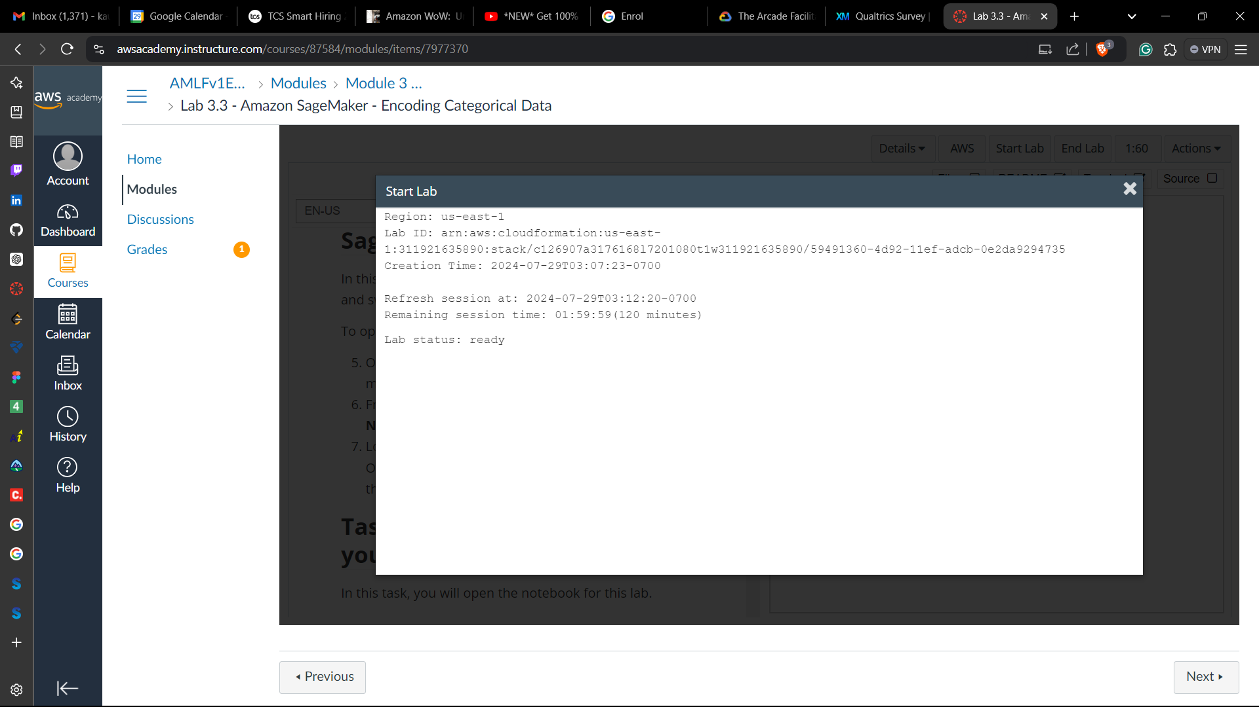

**Task 1: Accessing a notebook instance in Amazon SageMaker**

1. On the AWS Management Console, on the **Services** menu, choose **Amazon SageMaker**.
2. From the navigation menu on the left, expand the **Notebook** section and choose **Notebook instances**.
3. Look for the notebook instance named MyNotebook. Open the JupyterLab notebook instance by going to the end of the row and choosing **Open JupyterLab**.

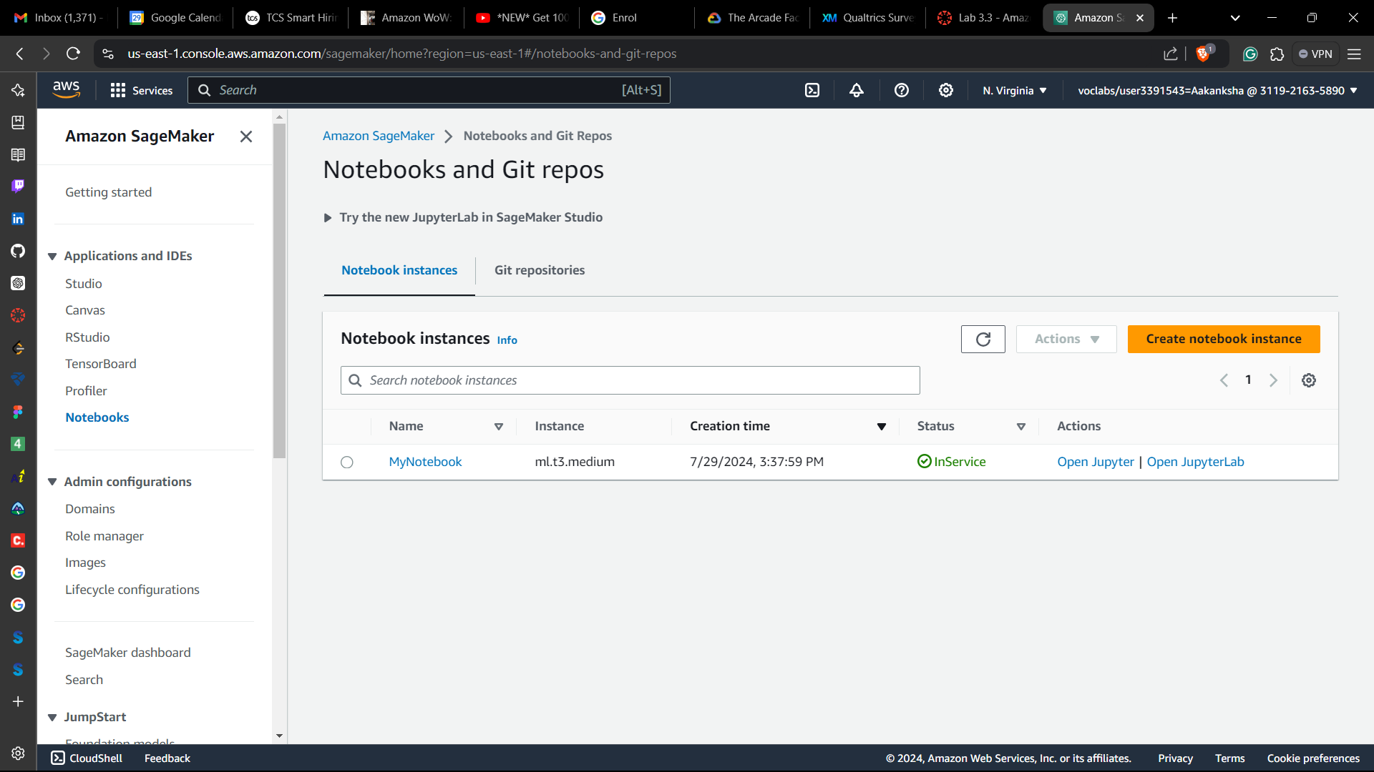

**Task 2: Opening a notebook in your notebook instance**

1. In your JupyterLab environment, go to the file browser in the left pane and locate the 3_3-machinelearning.jpynb file & open it.

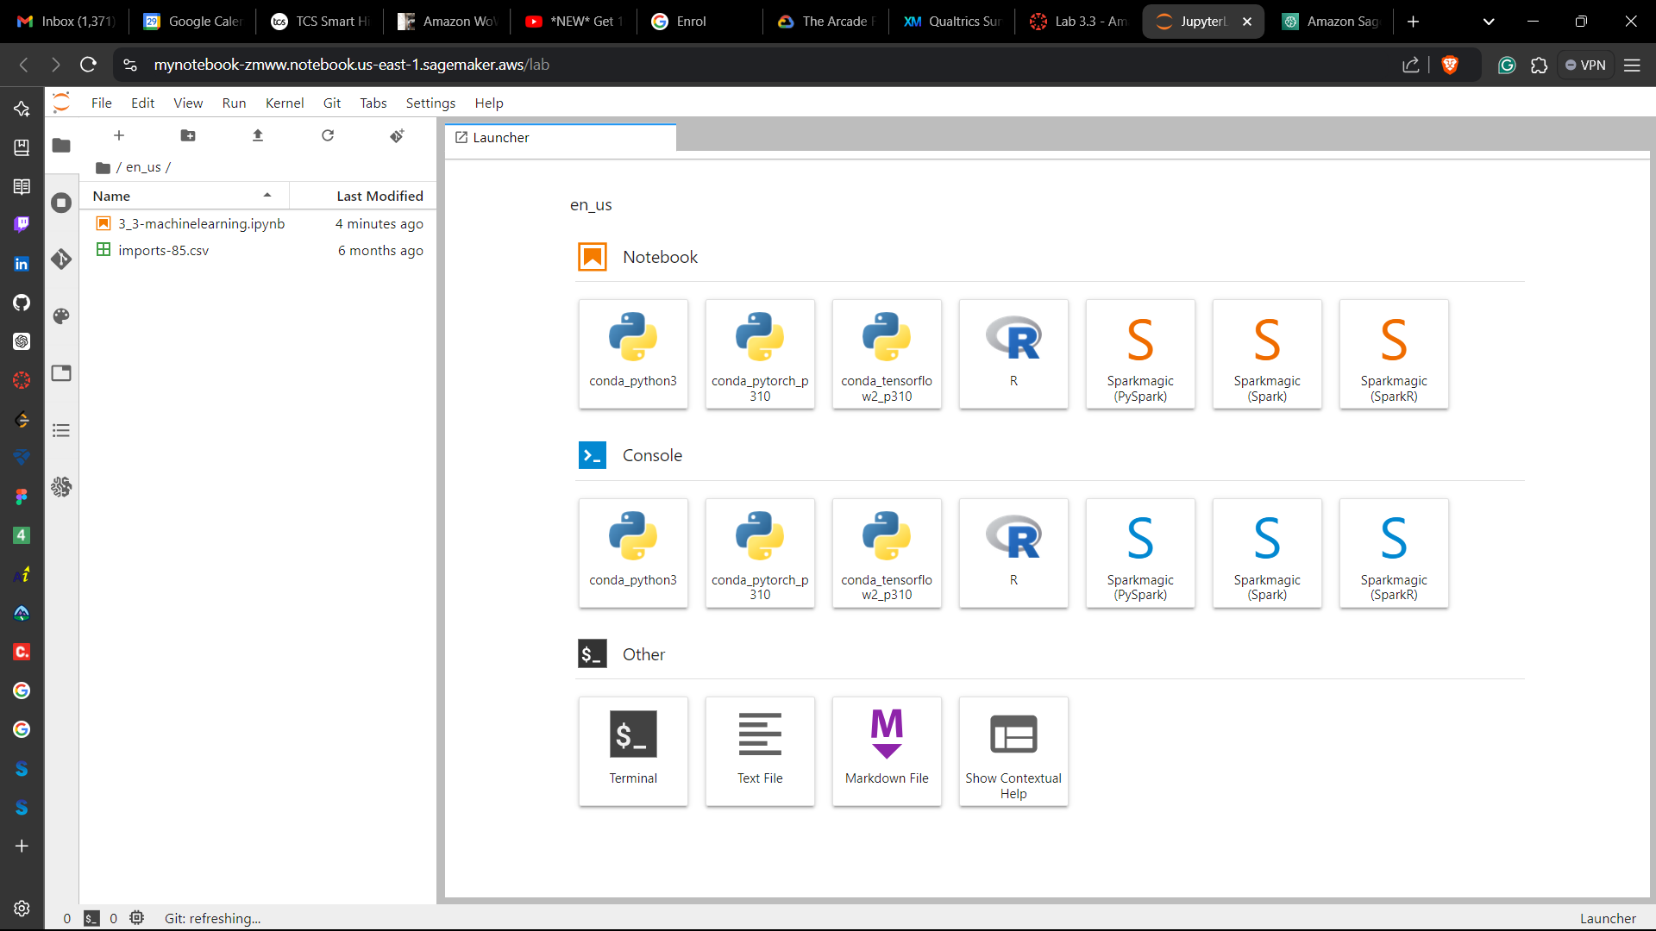

1. Follow the instructions in the notebook

**Step 1: Importing and exploring the data**

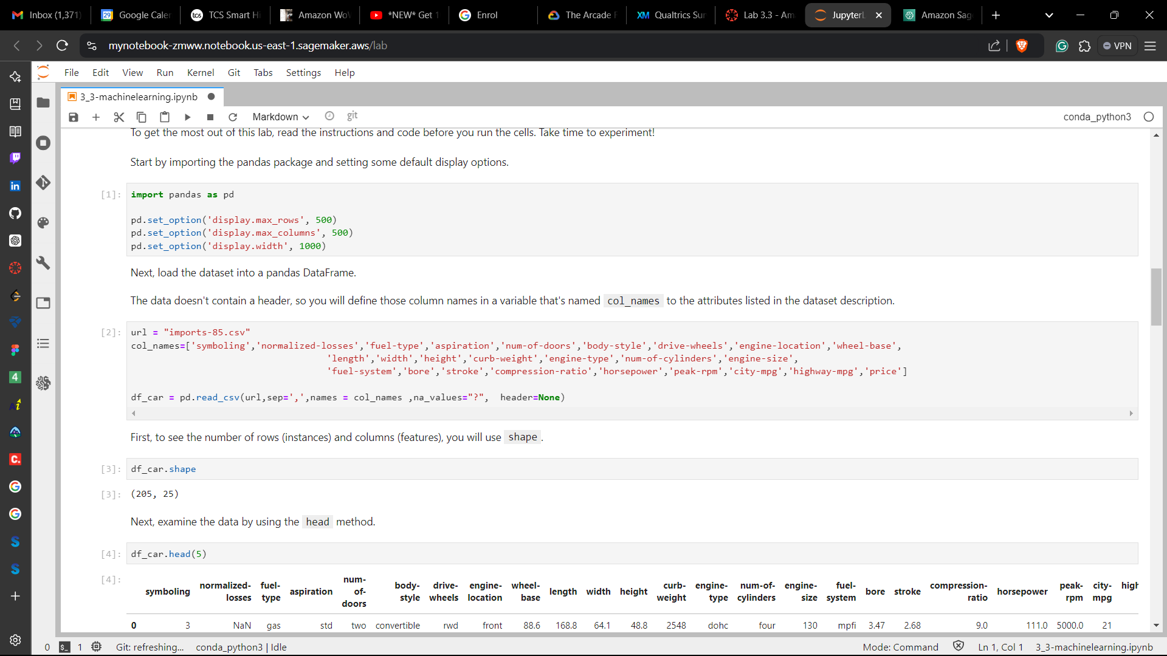

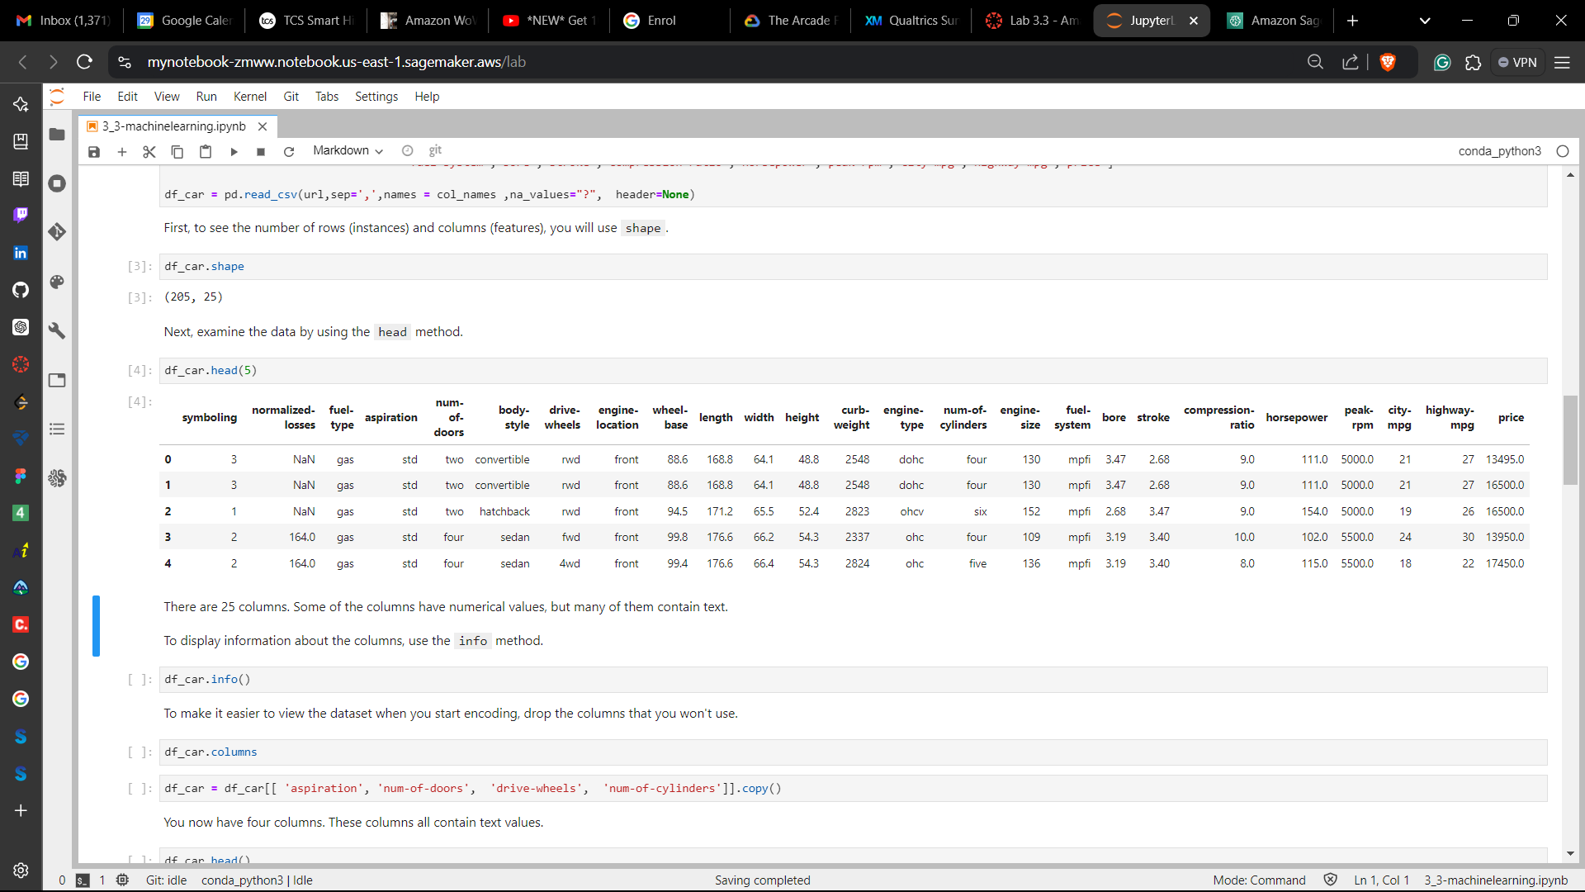

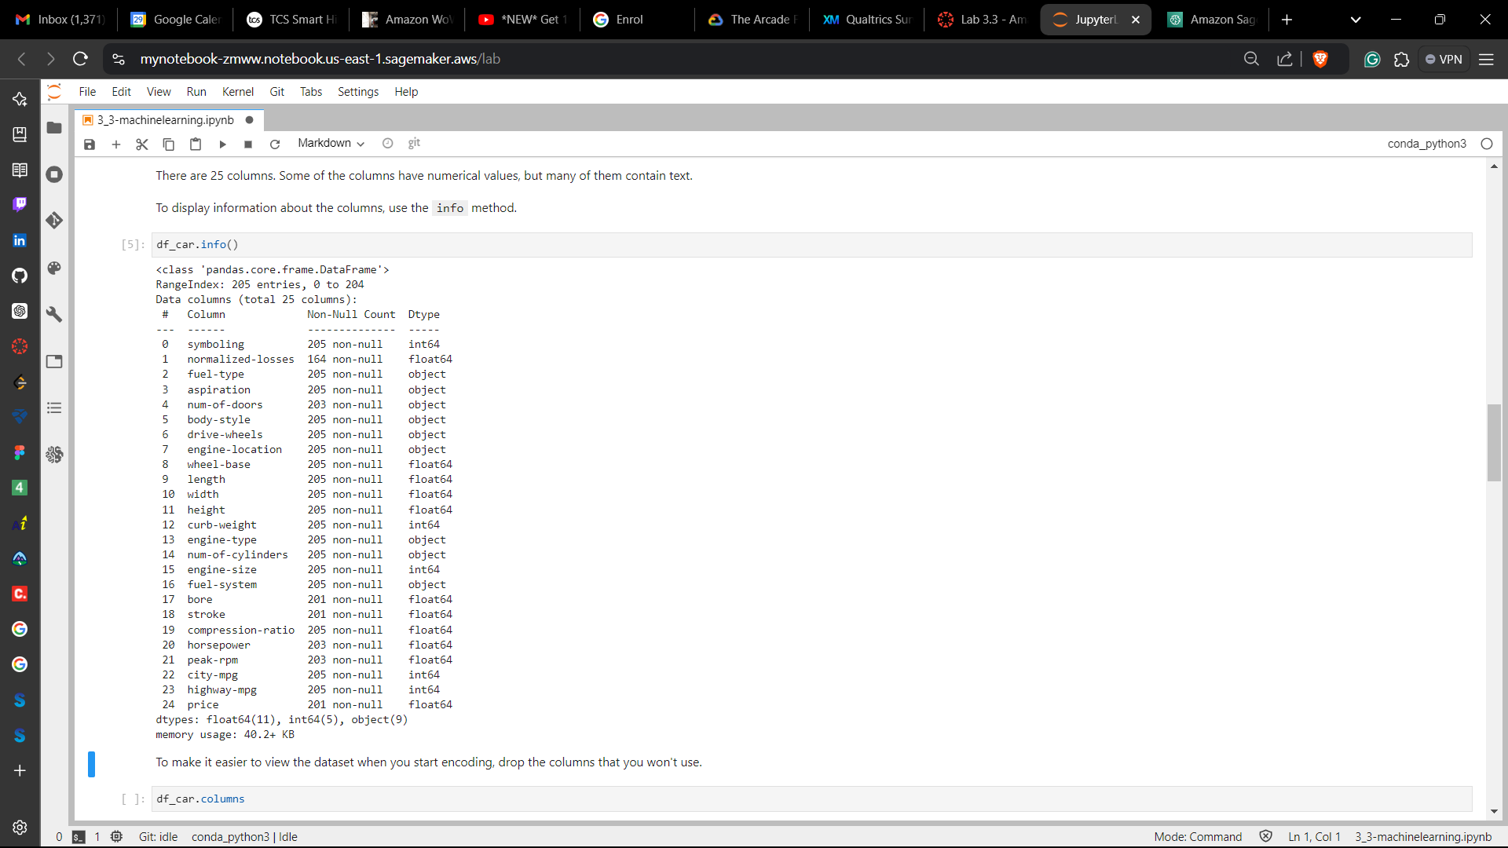 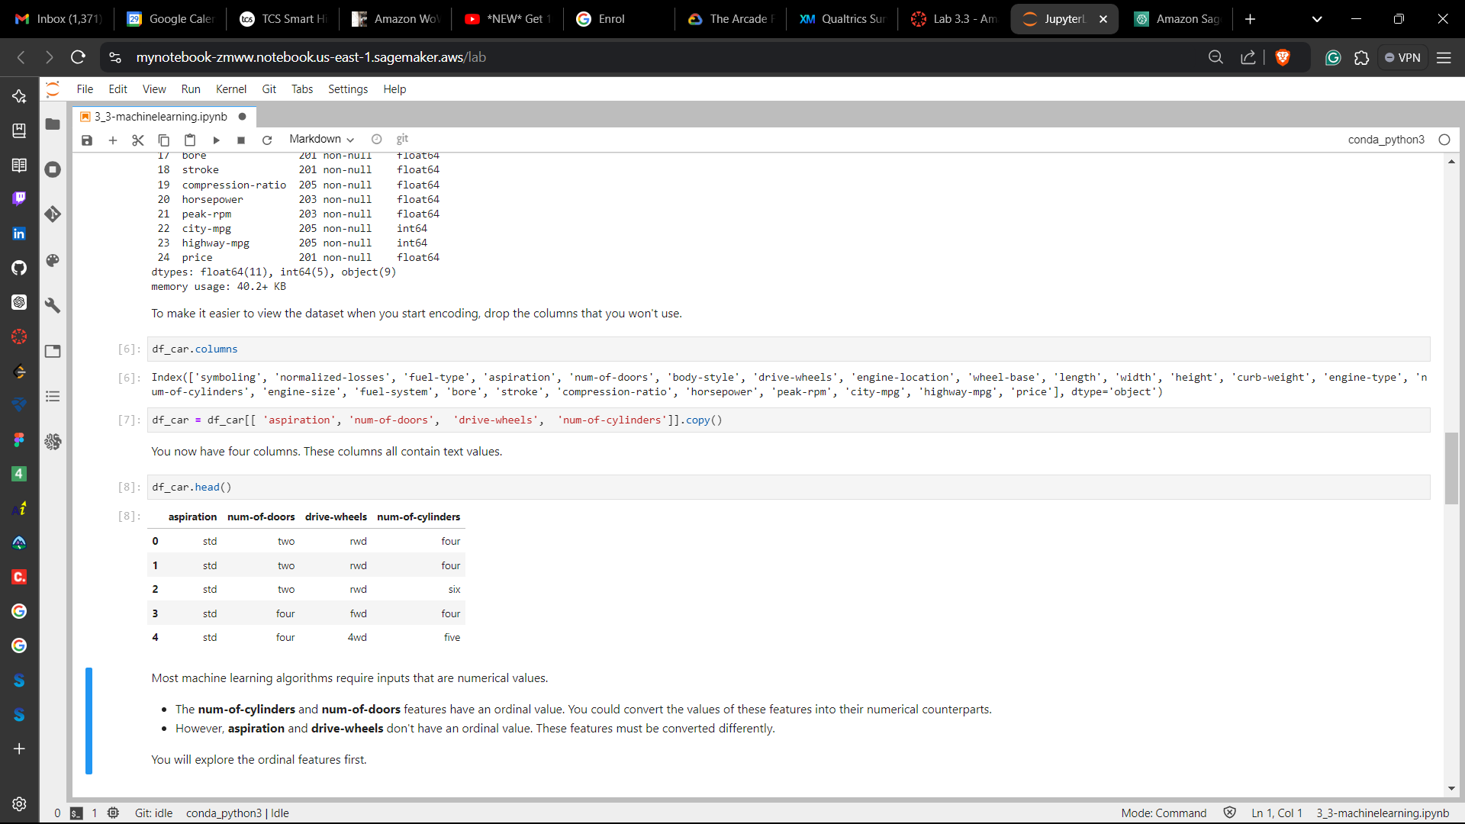

**Step 2: Encoding ordinal features**

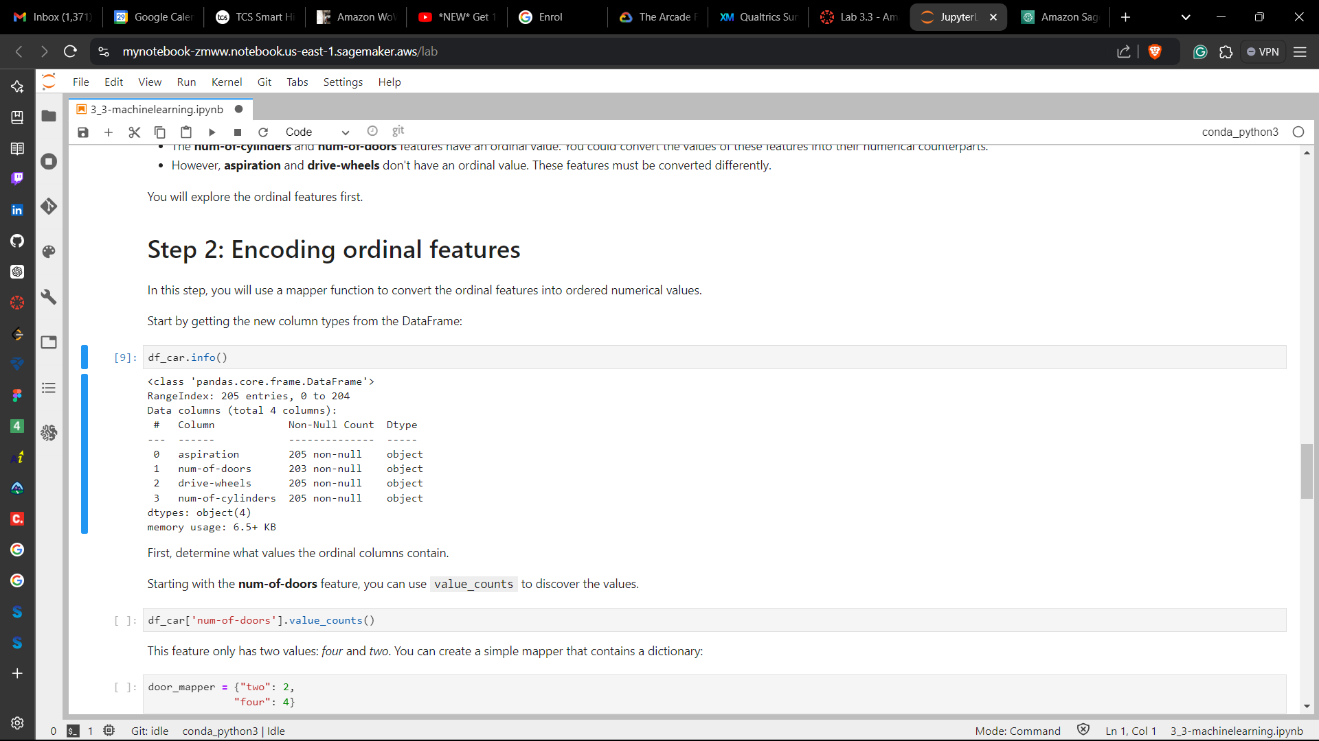 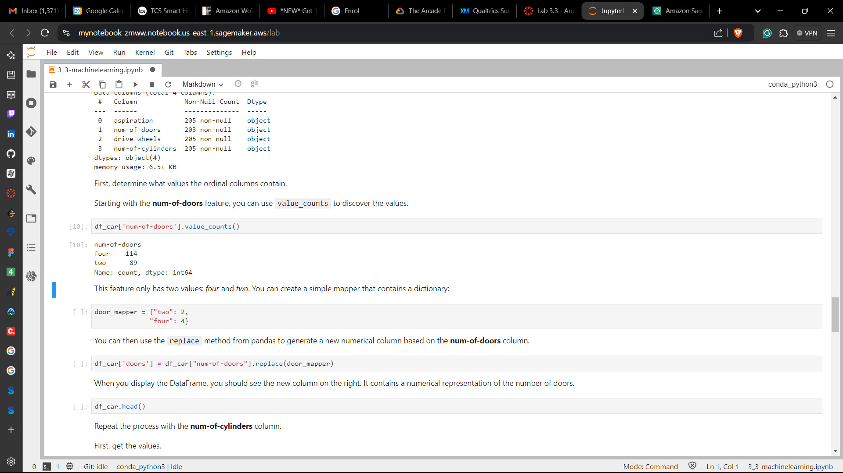

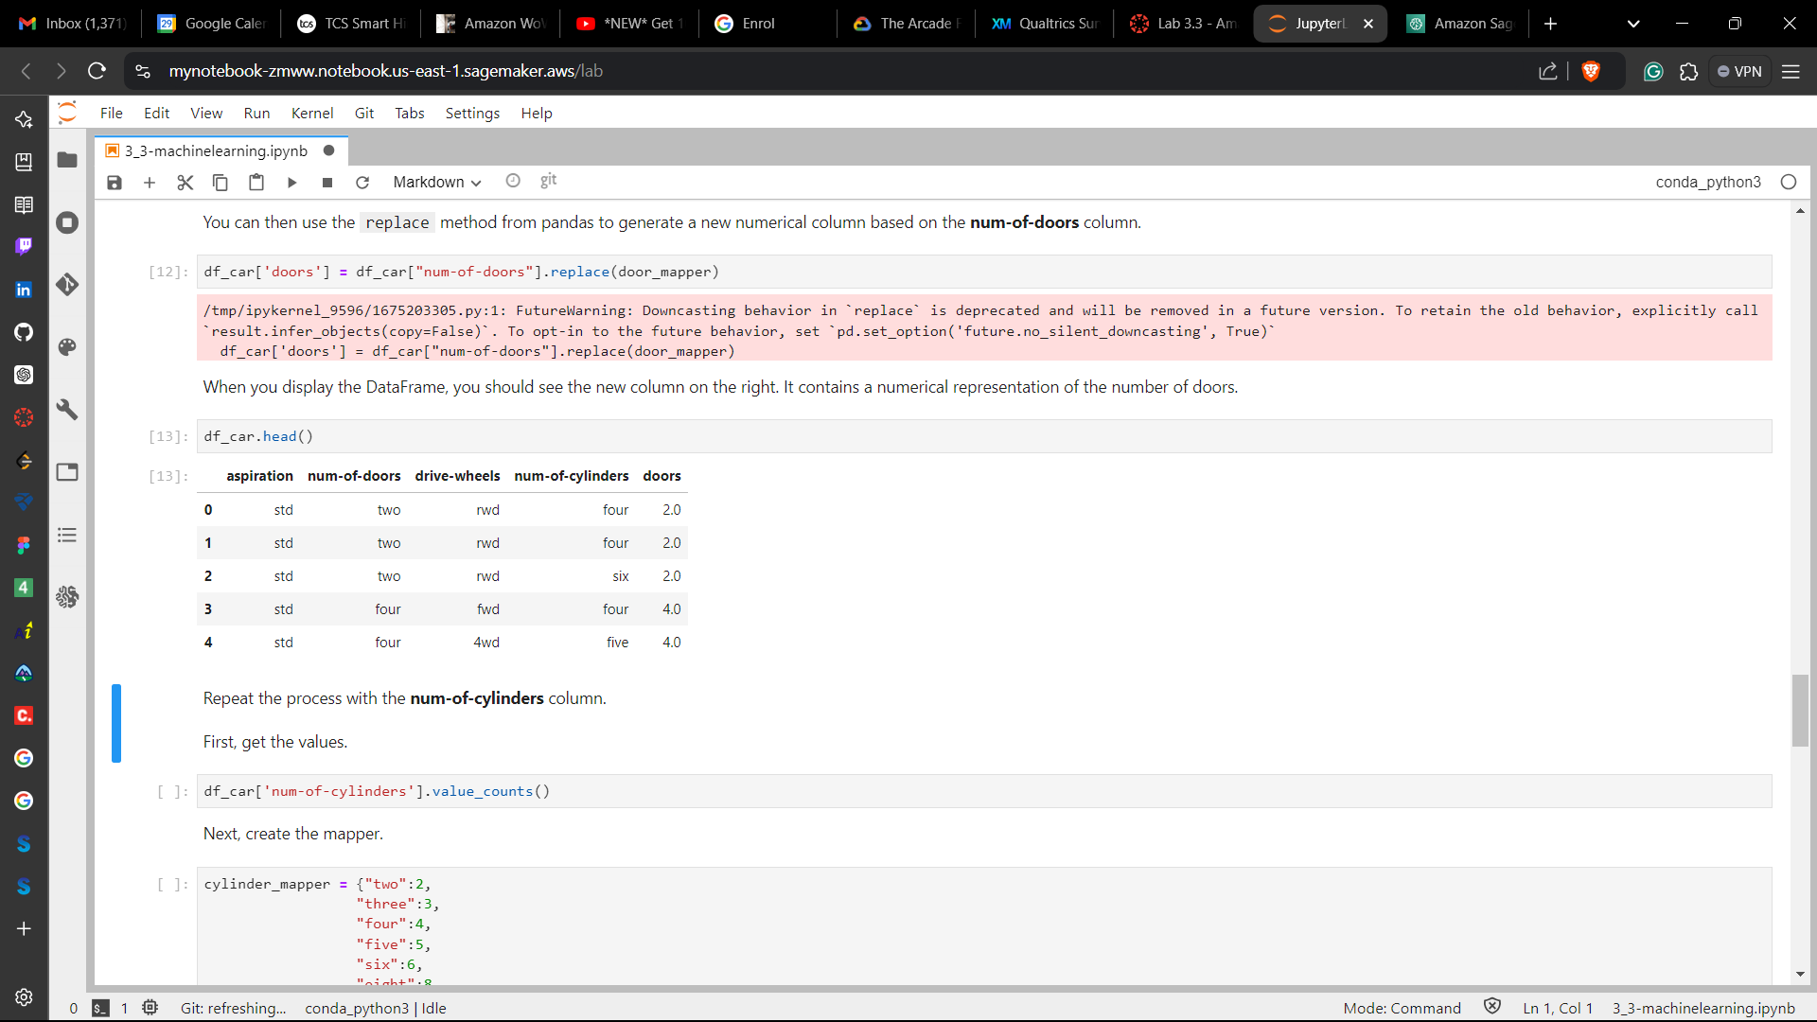 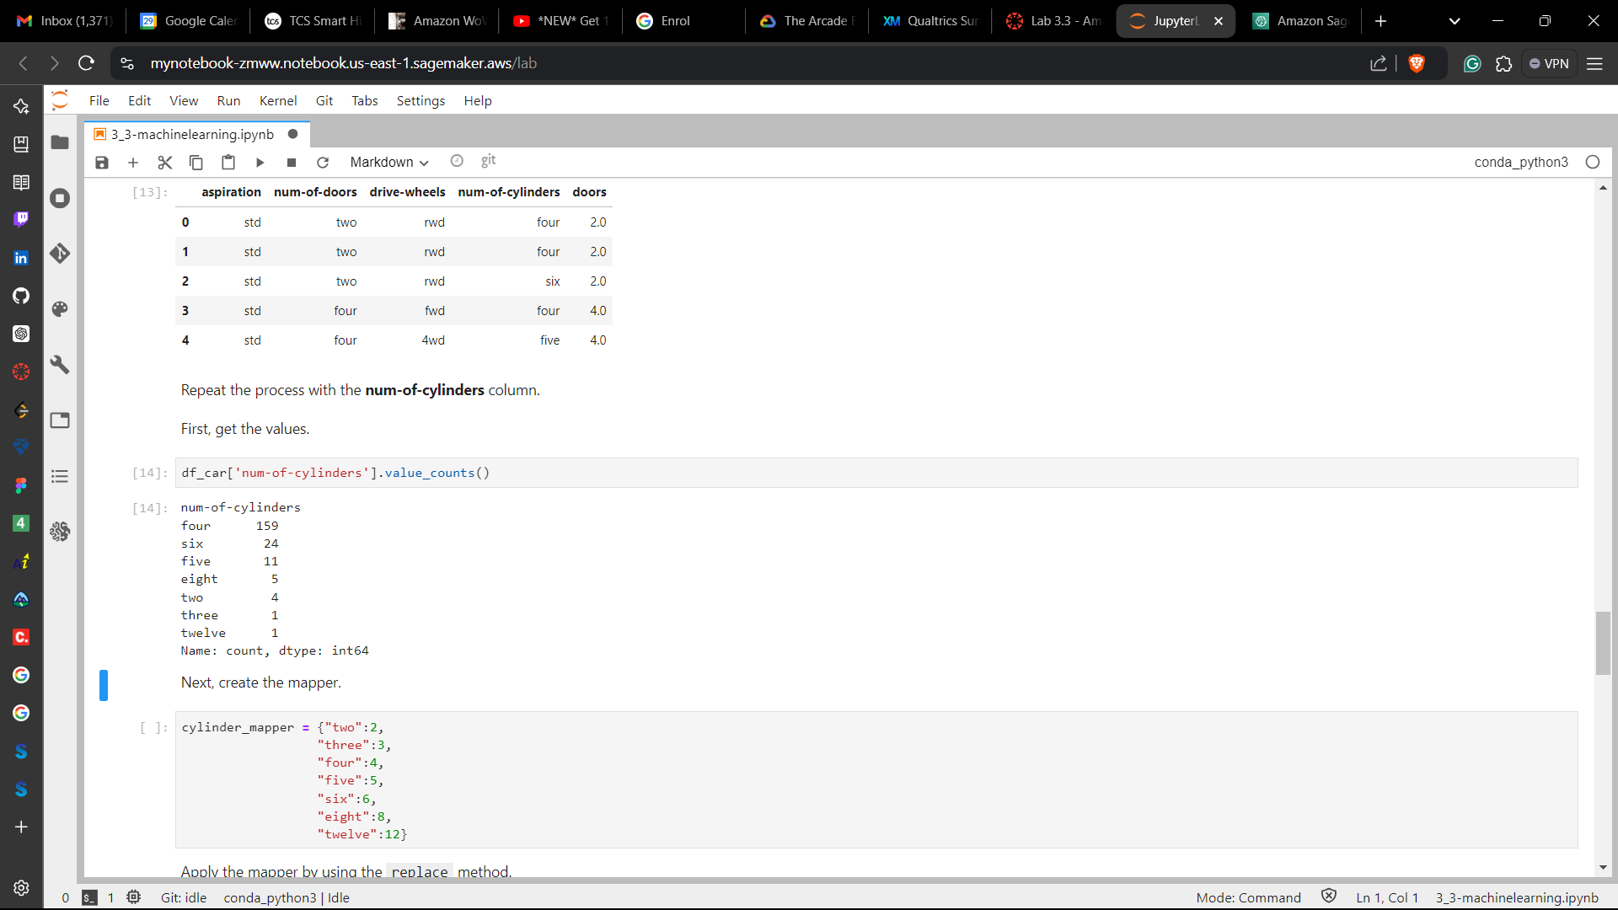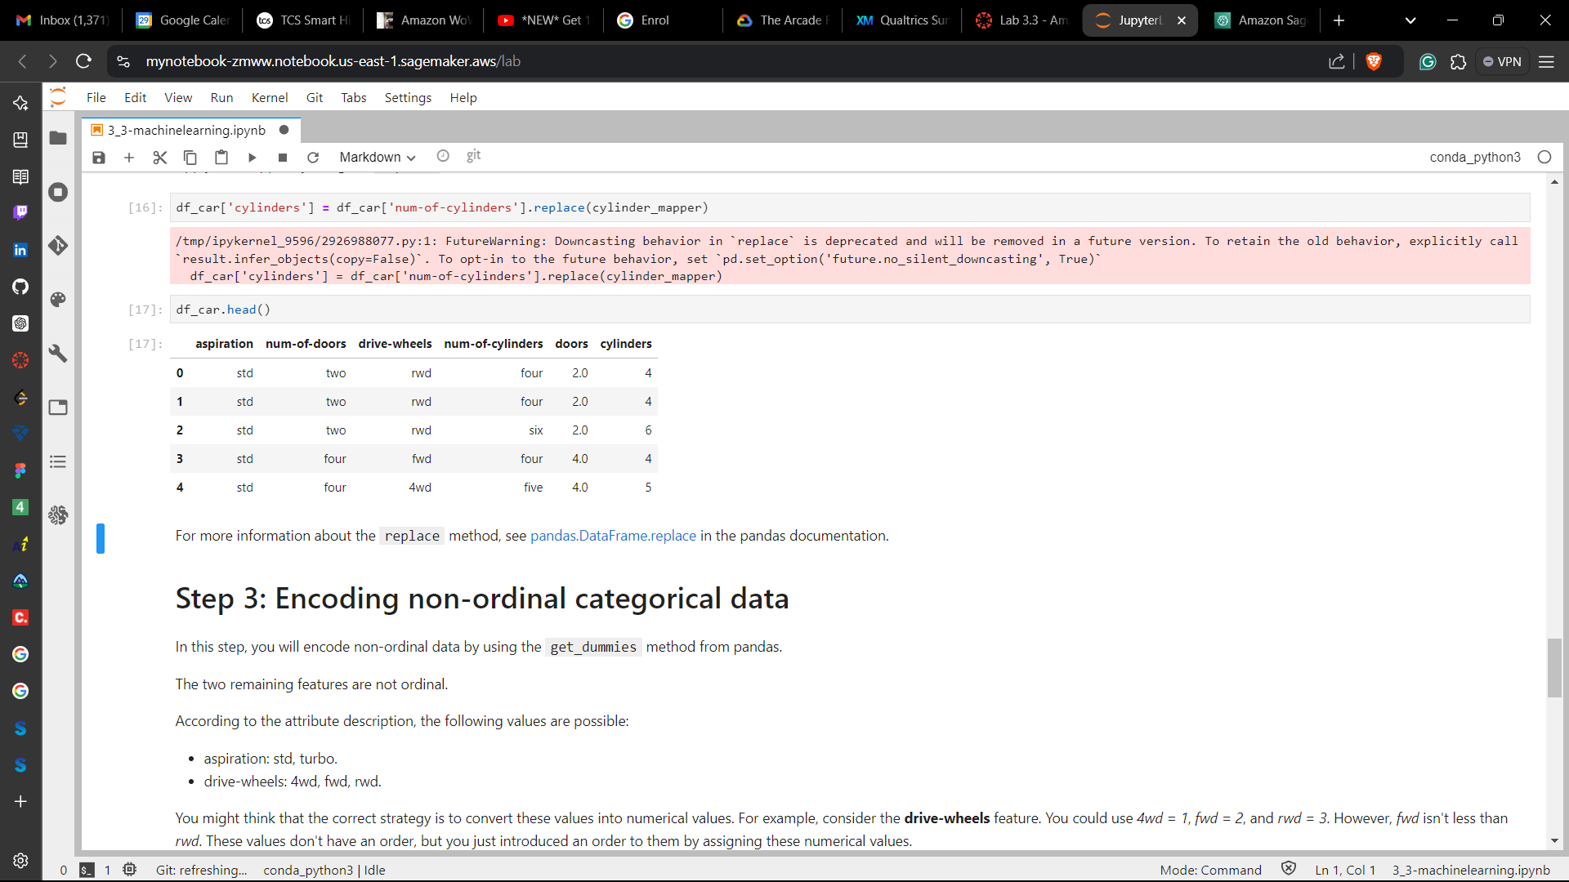

**Step 3: Encoding non-ordinal categorical data**

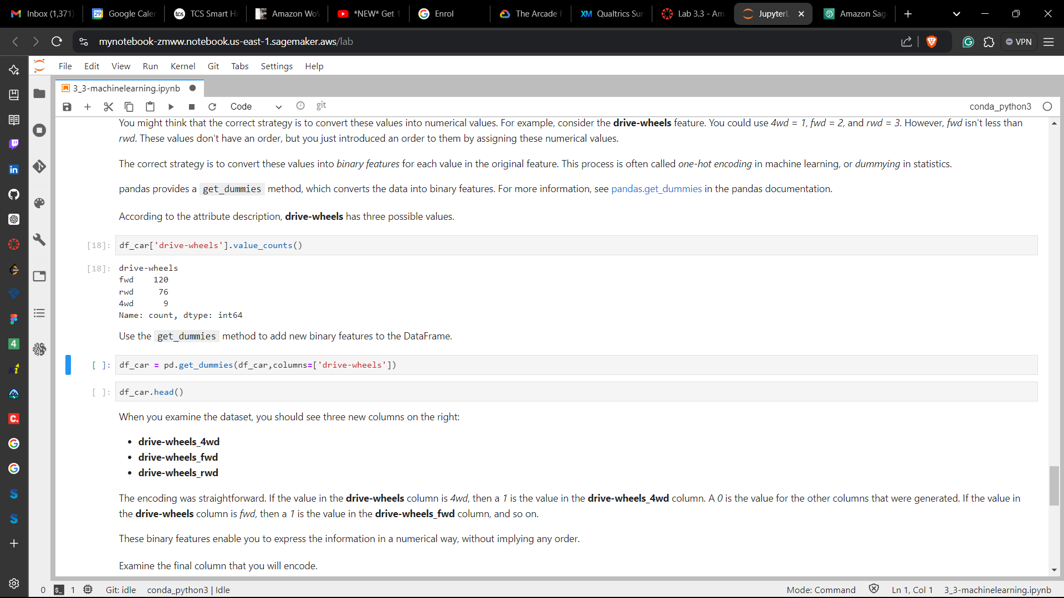

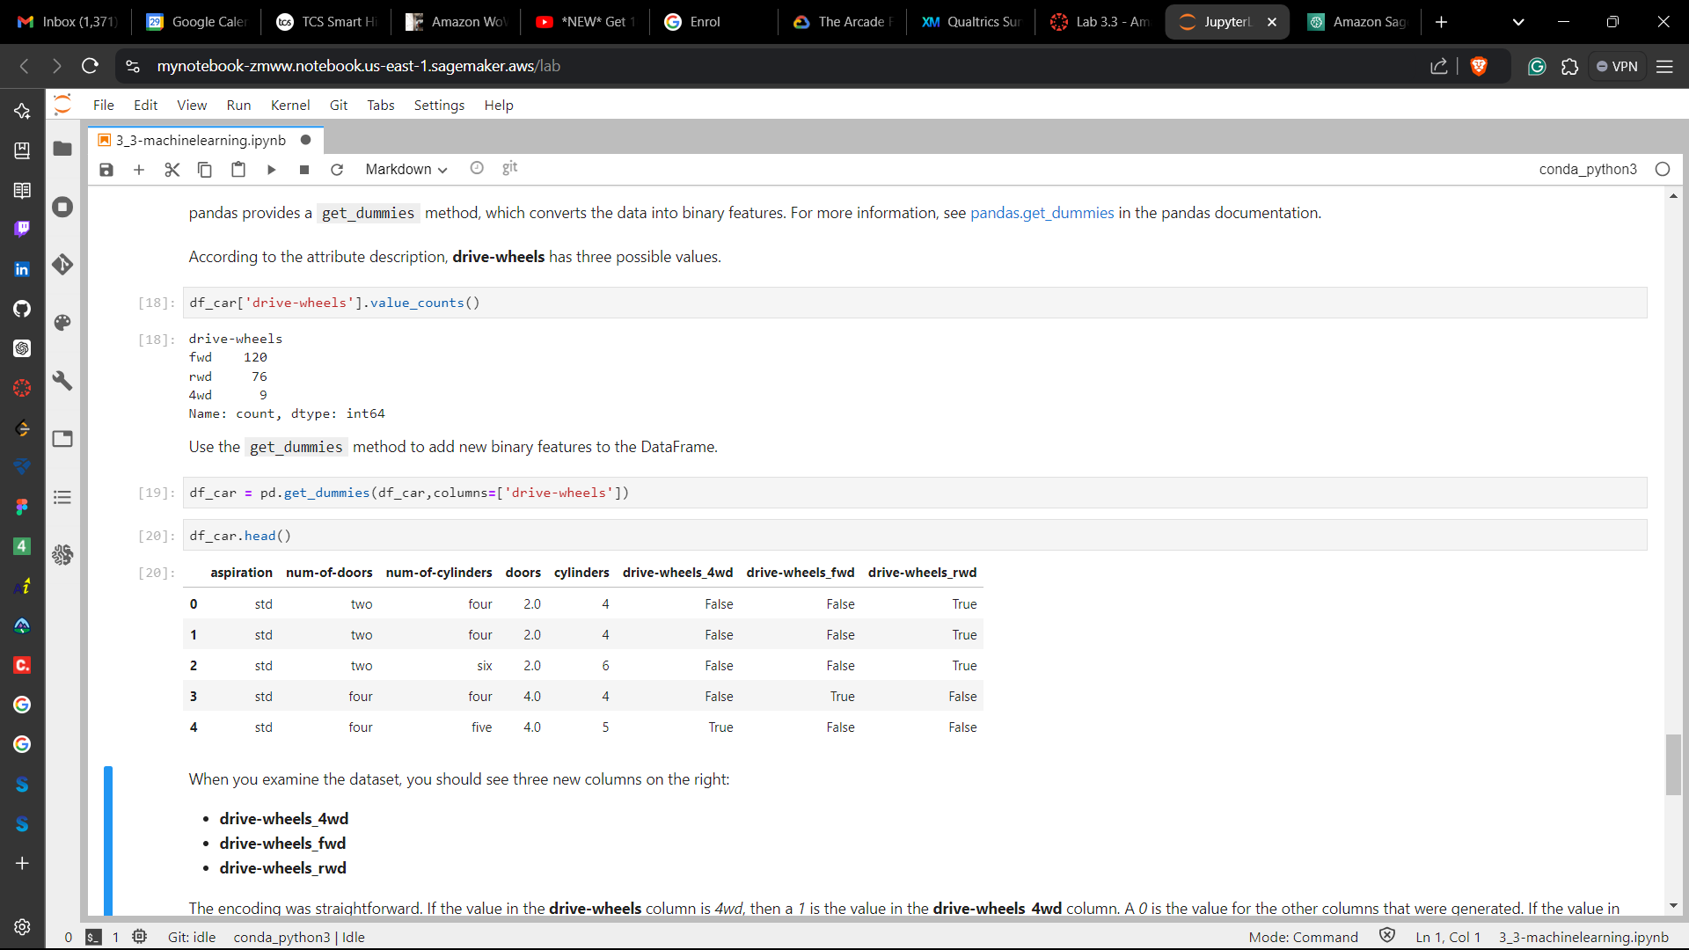

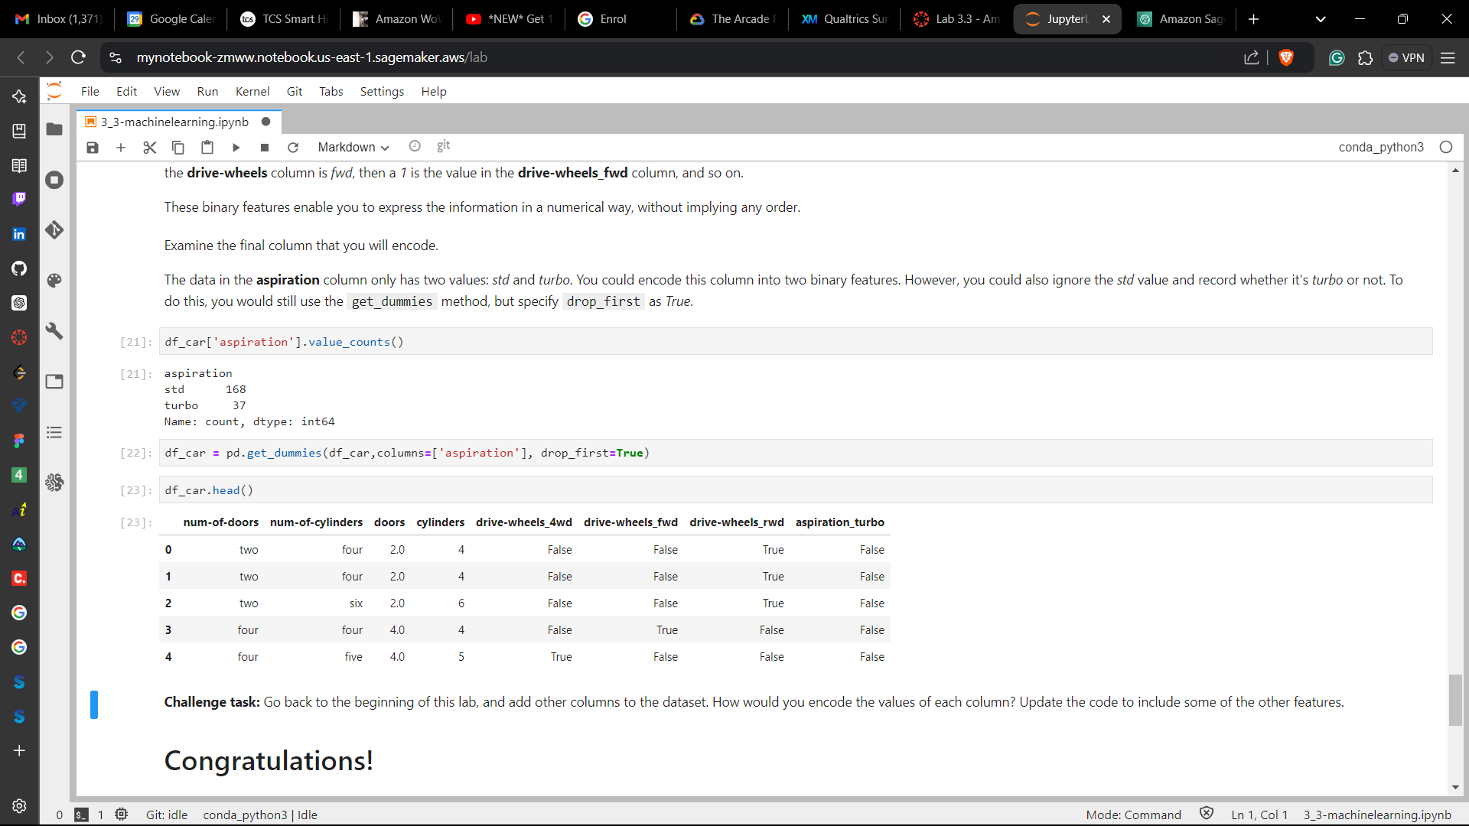

**Conclusion**

* Encoded ordinal categorical data
* Encoded non-ordinal categorical data

**Lab complete**

1. In order to end the lab, choose End Lab, and then choose **Yes**.

