**LAB – 4**

Objective: Amazon SageMaker - Training a model

Procedure:

1. Accessing the AWS Management Console

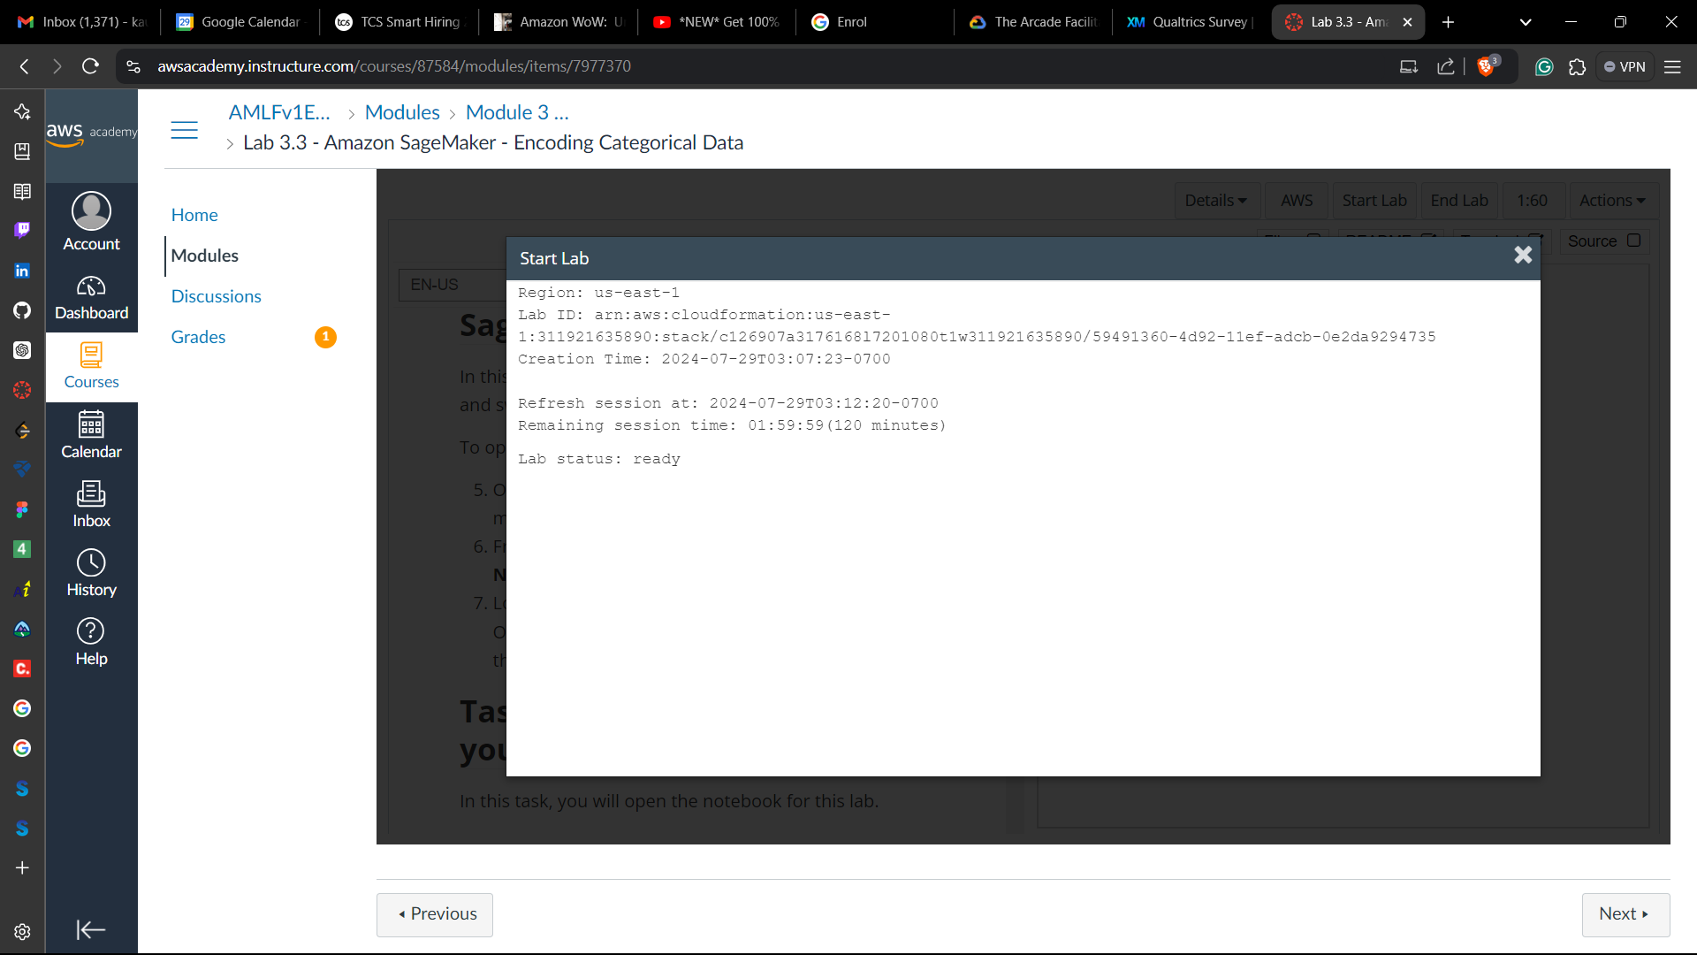

**Task 1: Accessing a notebook instance in Amazon SageMaker**

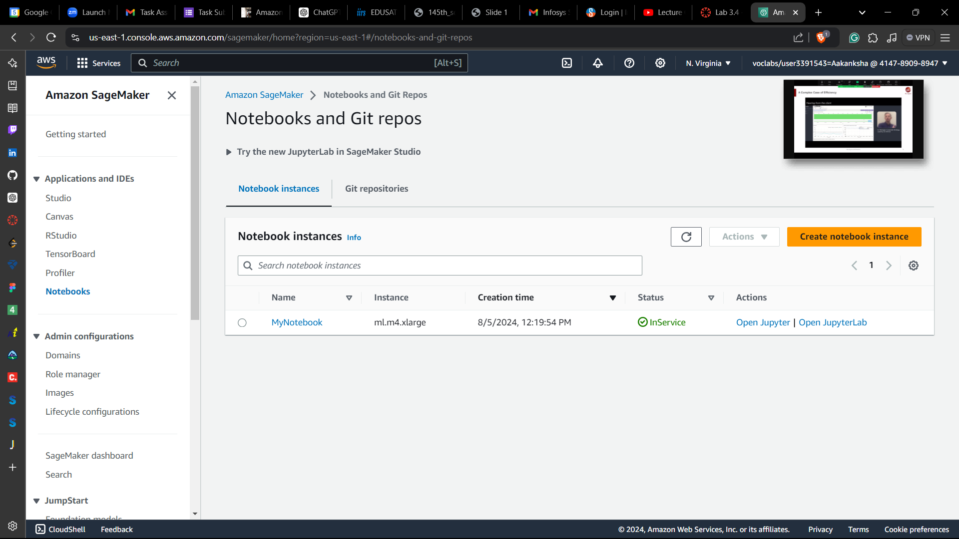

**Task 2: Opening a notebook in your notebook instance**

1. In your JupyterLab environment, go to the file browser in the left pane and locate the 3_4-machinelearning.jpynb file & open it.

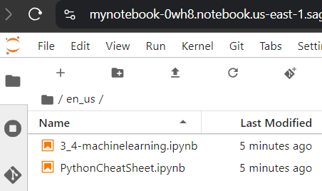

1. Follow the instructions in the notebook

**Importing the data**

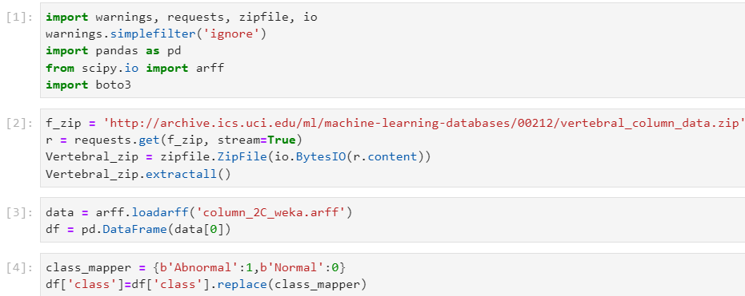

**Step 1: Exploring the data**

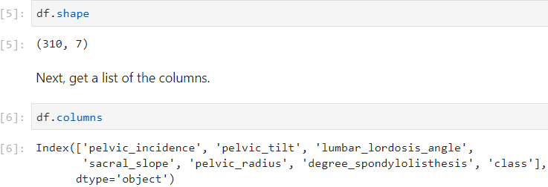

**Step 2: Preparing the data**

2.1 Moving the target column position

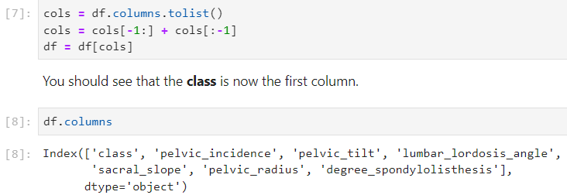

2.2 Splitting the data

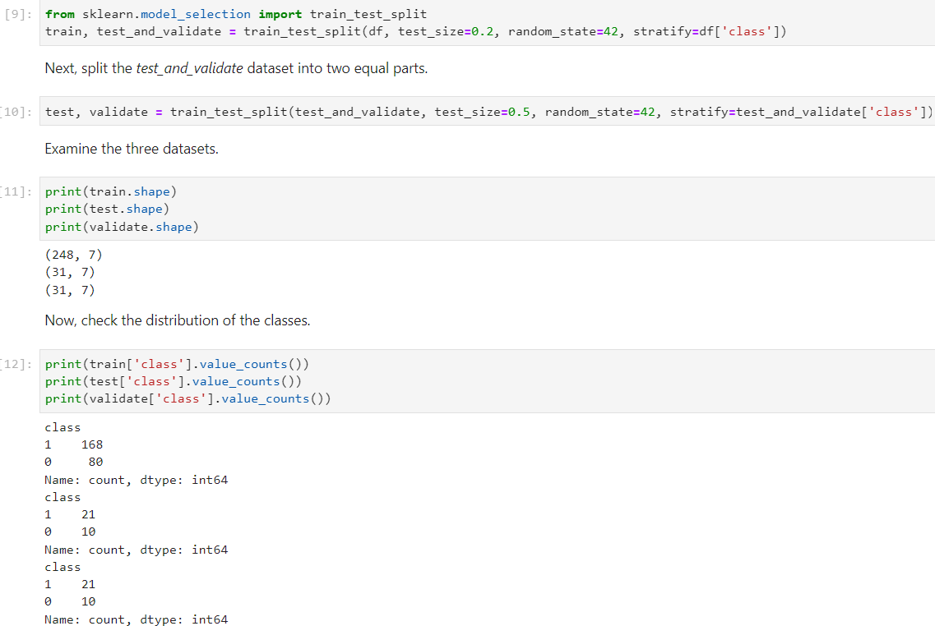

2.3 Uploading the data to Amazon S3

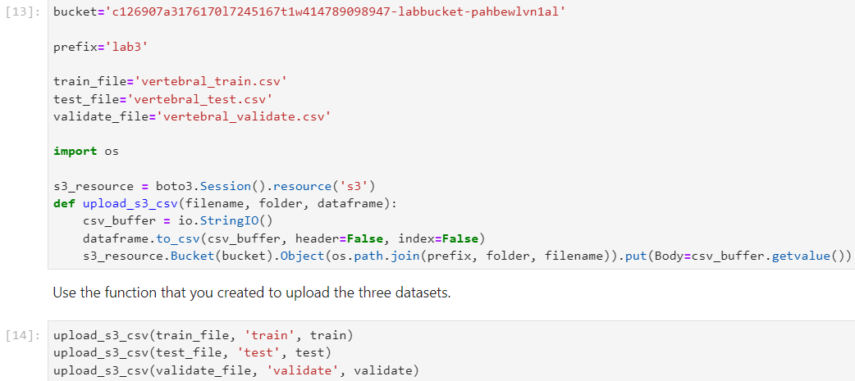

**Step 3: Training the model**

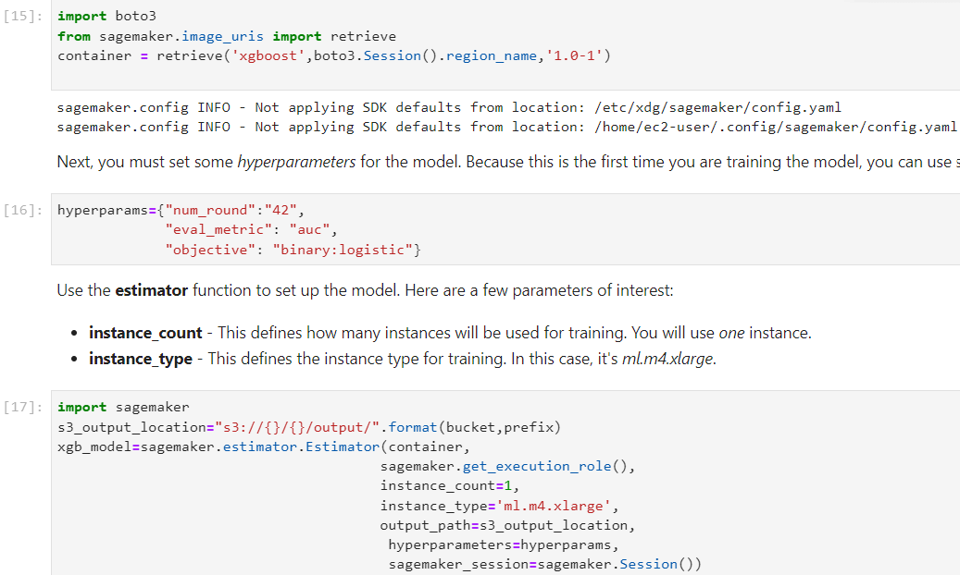

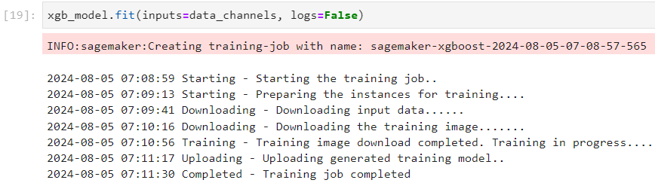

**Conclusion**

* Split data into training, validation, and test datasets
* Trained an XGBoost model in Amazon SageMaker

**Lab complete**

1. In order to end the lab, choose End Lab, and then choose **Yes**.

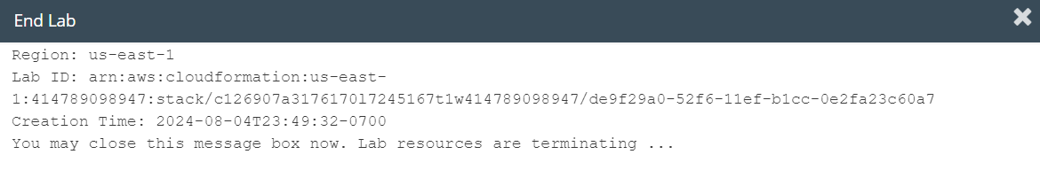

**LAB – 5**

Objective: Amazon SageMaker - Deploying a model

Procedure:

1. Accessing the AWS Management Console

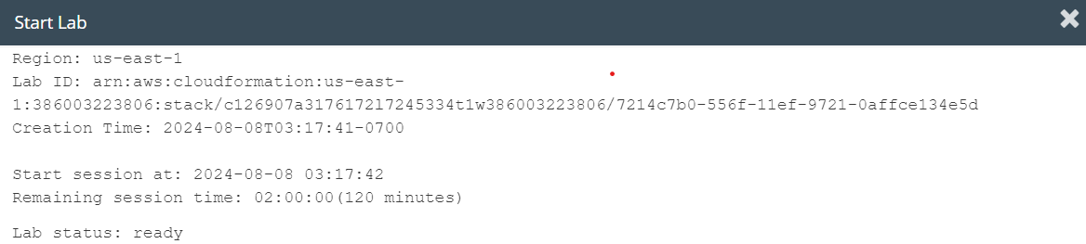

**Task 1: Accessing a notebook instance in Amazon SageMaker**

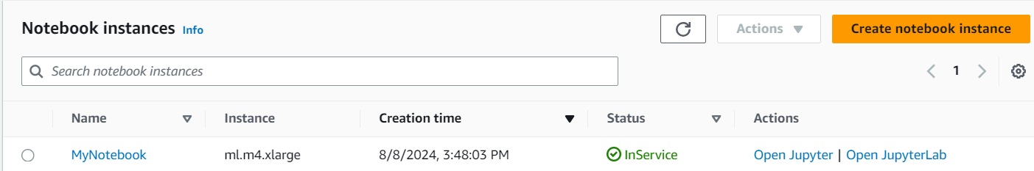

**Task 2: Opening a notebook in your notebook instance**

1. In your JupyterLab environment, go to the file browser in the left pane and locate the 3_5-machinelearning.jpynb file & open it.

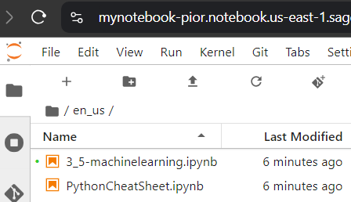

1. Follow the instructions in the notebook
   1. Importing the data

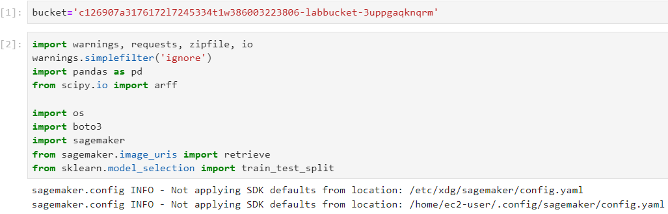

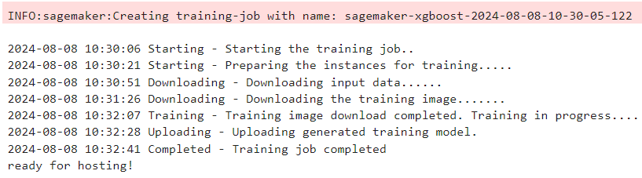

Step 1: Hosting the model

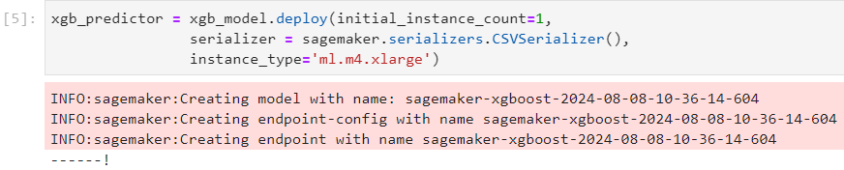

Step 2: Performing predictions

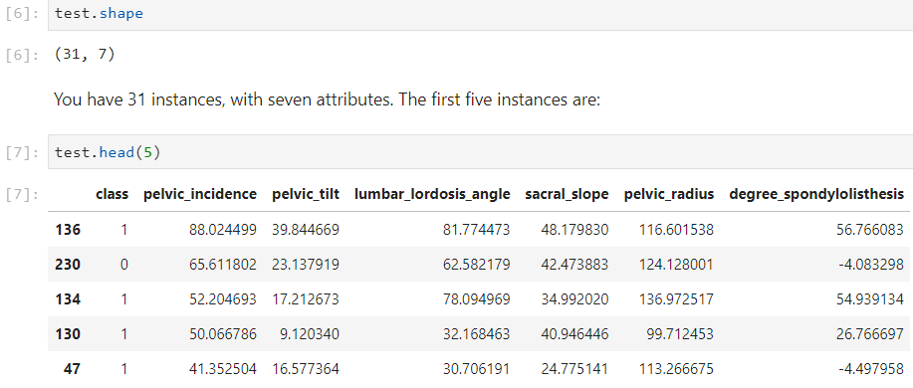

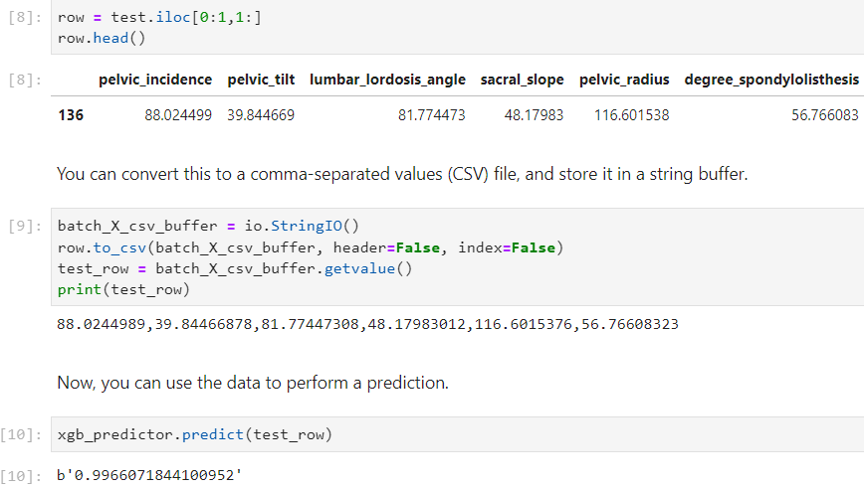

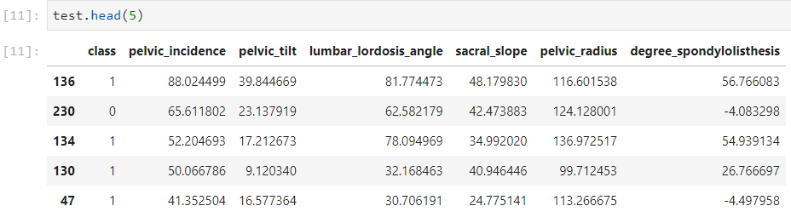

Step 3: Terminating the deployed model



Step 4: Performing a batch transform

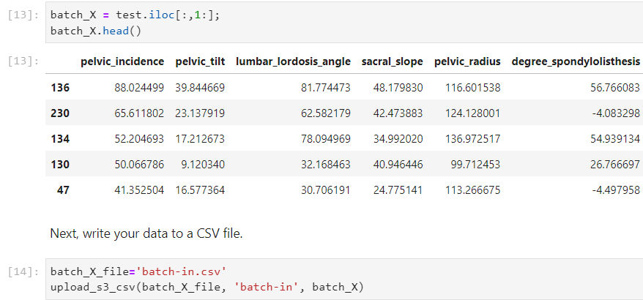

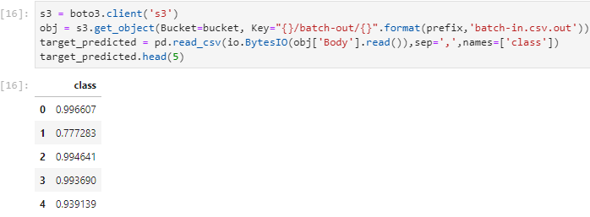

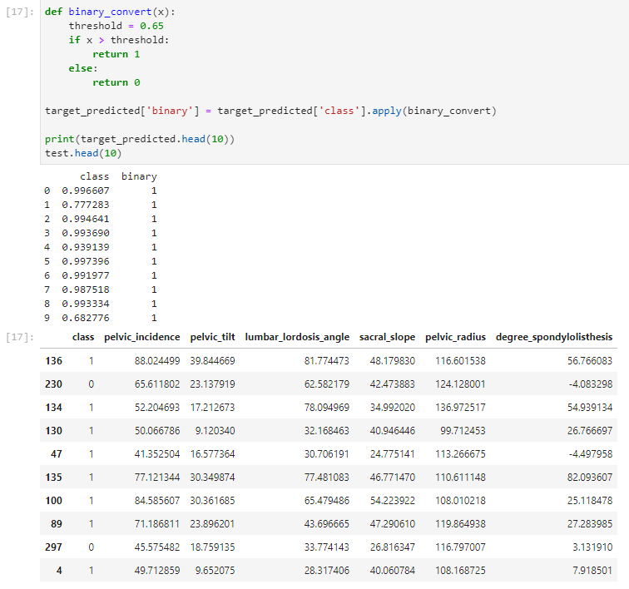

**Conclusion**

* Deployed a machine learning model
* Used the test dataset to perform a batch transformation with the model

**Lab complete**

1. In order to end the lab, choose End Lab, and then choose **Yes**.

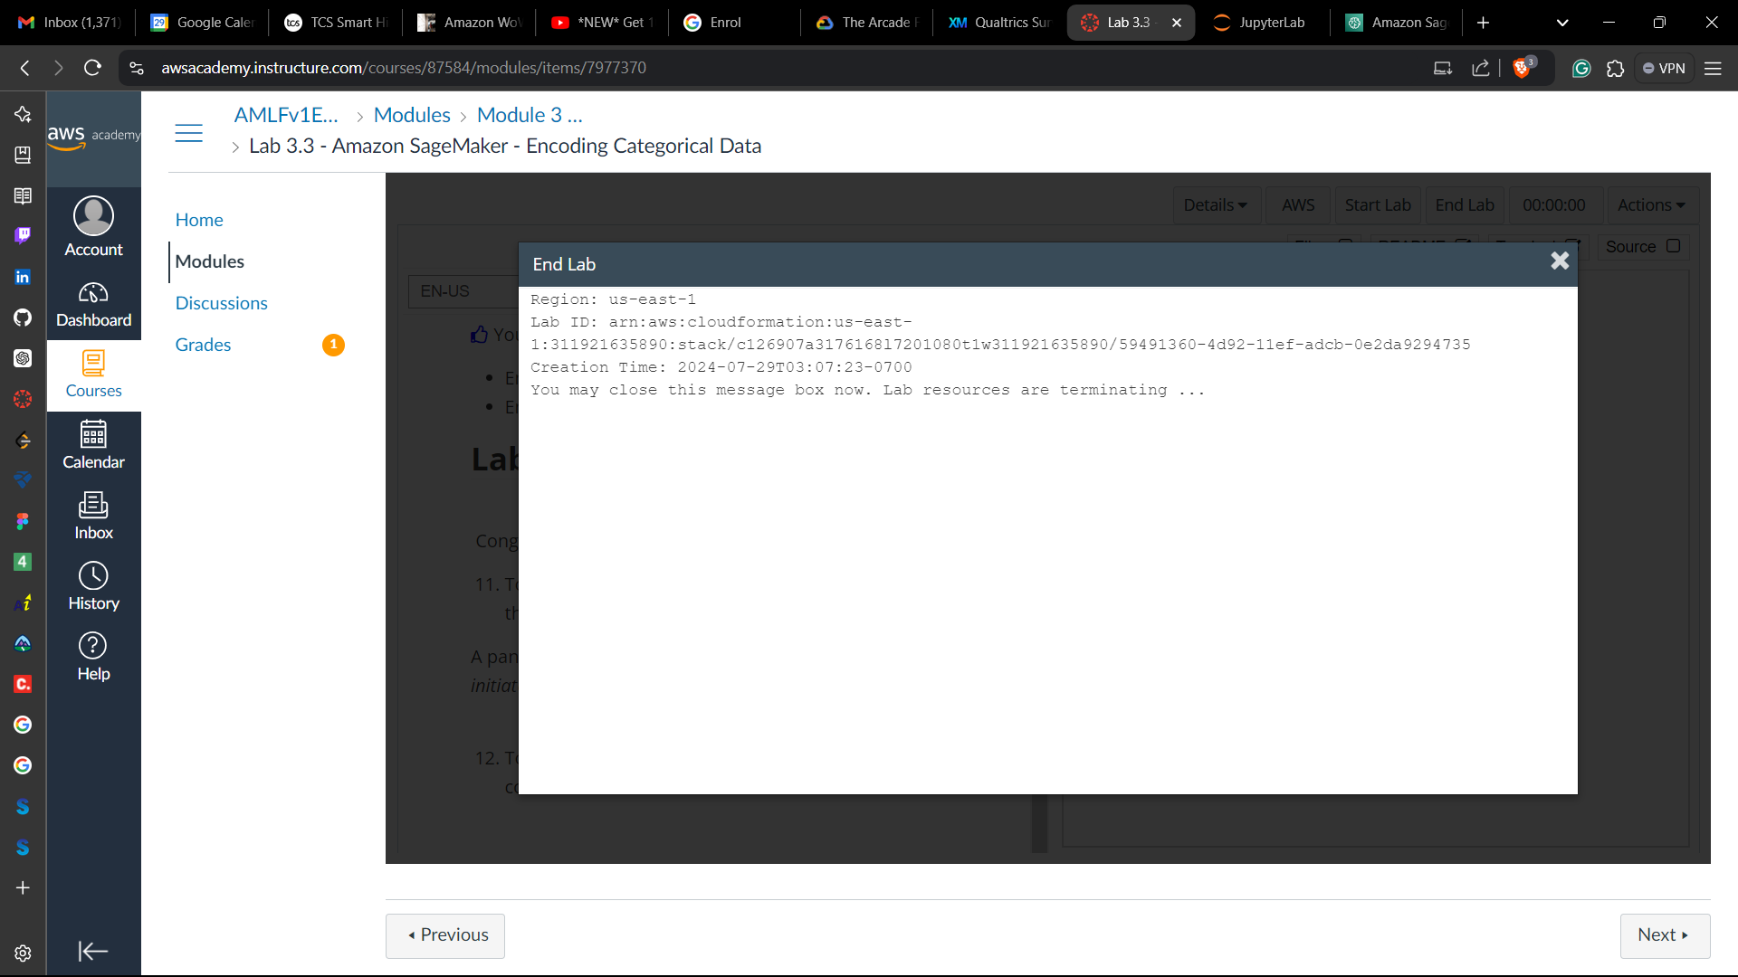

**LAB – 6**

Objective: Amazon SageMaker - Generating model performance metricsProcedure:

1. Accessing the AWS Management Console



**Task 1: Accessing a notebook instance in Amazon SageMaker**

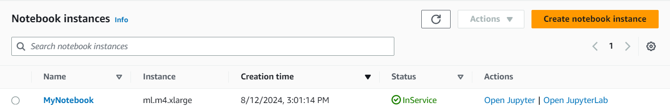

**Task 2: Opening a notebook in your notebook instance**

1. In your JupyterLab environment, go to the file browser in the left pane and locate the 3_6-machinelearning.jpynb file & open it.

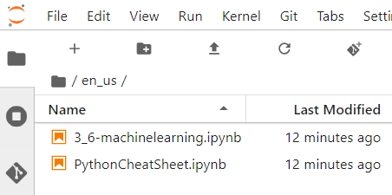

1. Follow the instructions in the notebook

Importing the data and training the model

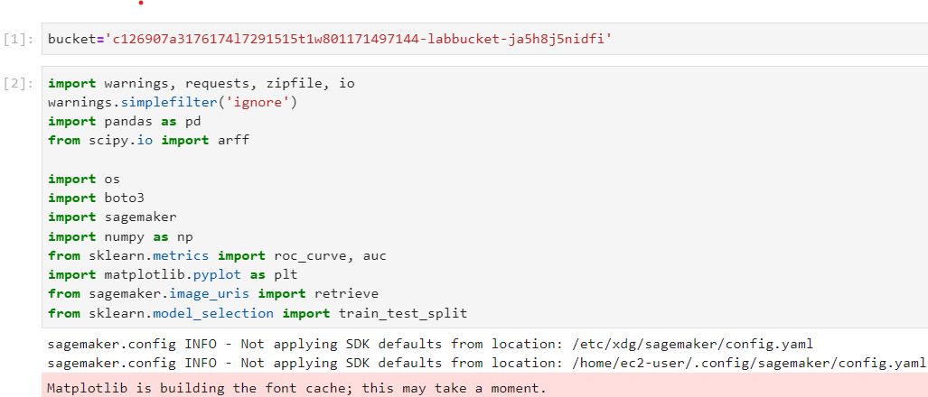

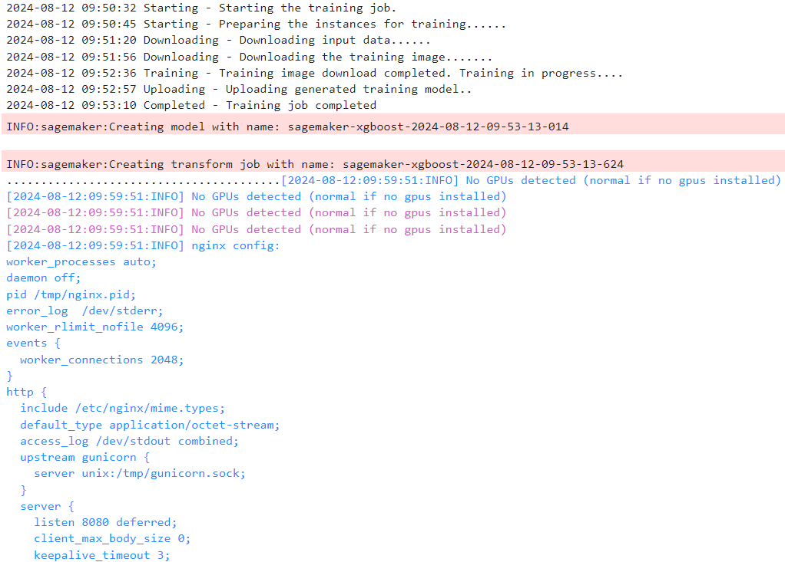

Step 1: Exploring the results

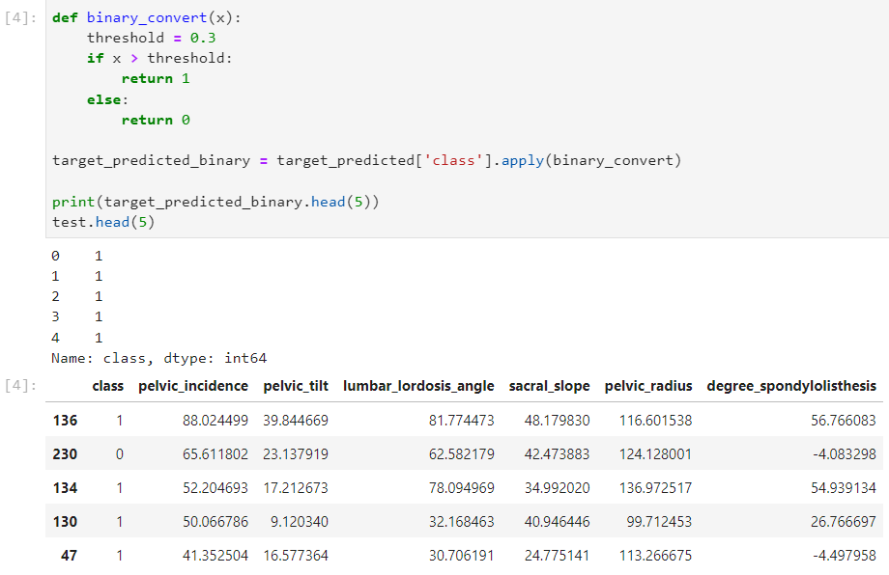

Step 2: Creating a confusion matrix

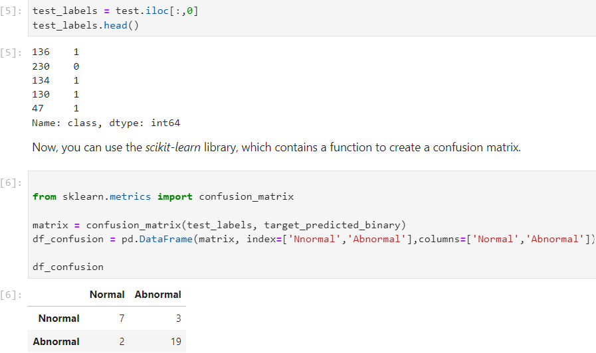

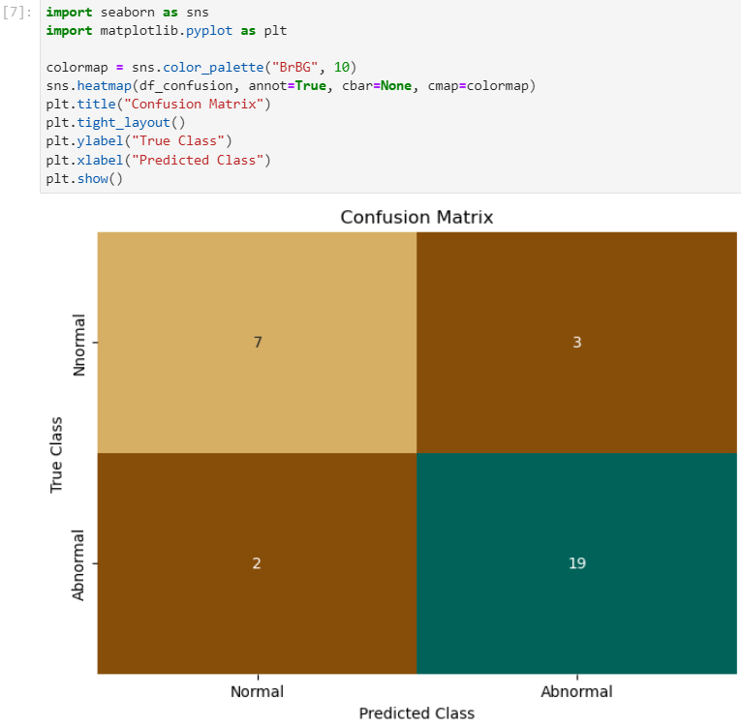

Step 3: Calculating performance statistics

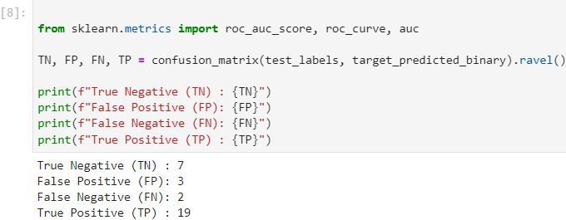

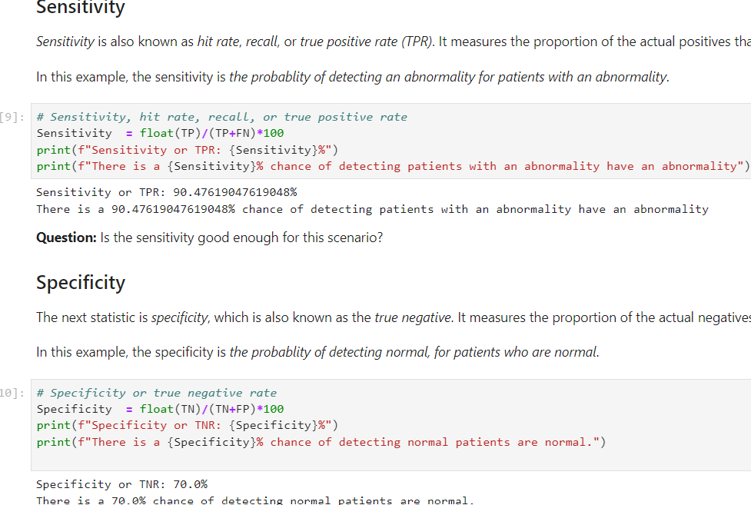

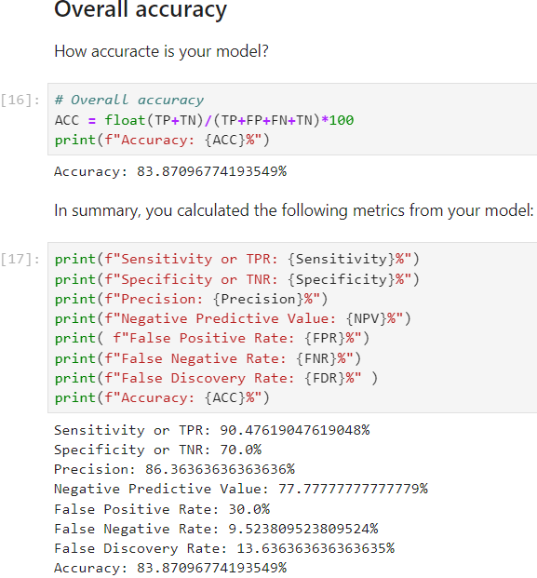

Step 4: Calculating the AUC-ROC Curve

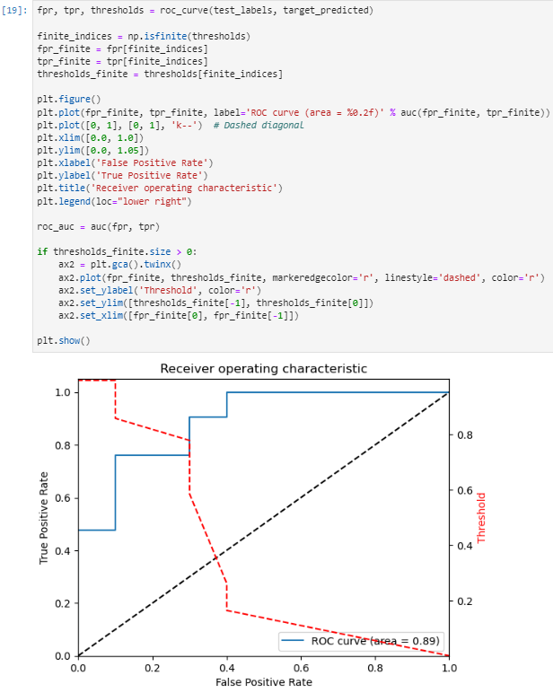

**Challenge task:** Update the previous code to use *target_predicted_binary* instead of *target_predicted*. How does that change the graph?

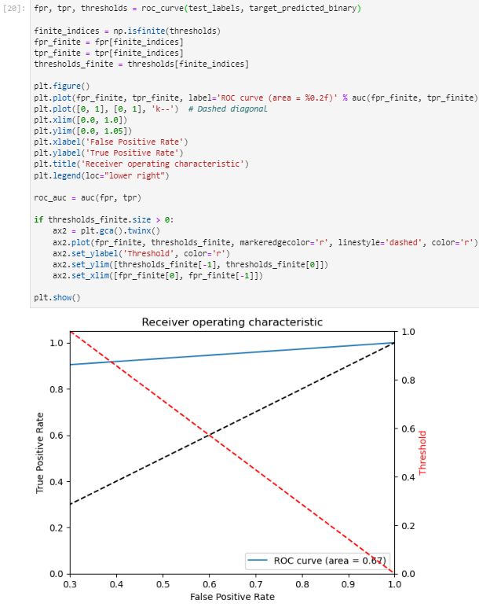

**Conclusion**

* Used the test data to generate predictions
* Generated a confusion matrix from the results
* Generated performance metrics for the model

**Lab complete**

1. In order to end the lab, choose End Lab, and then choose **Yes**.



**LAB – 7**

Objective: Amazon SageMaker - Hyperparameter Tuning

Procedure:

1. Accessing the AWS Management Console



**Task 1: Accessing a notebook instance in Amazon SageMaker**

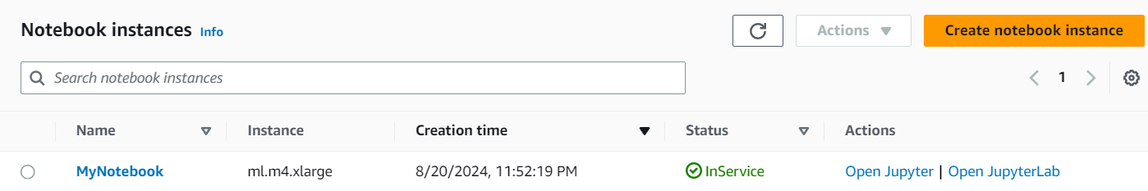

**Task 2: Opening a notebook in your notebook instance**

1. In your JupyterLab environment, go to the file browser in the left pane and locate the 3_7-machinelearning.jpynb file & open it.

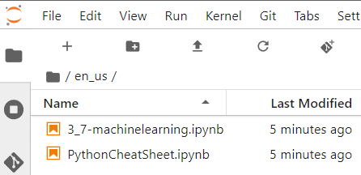

1. Follow the instructions in the notebook

**Importing the data, and training, testing and validating the model**

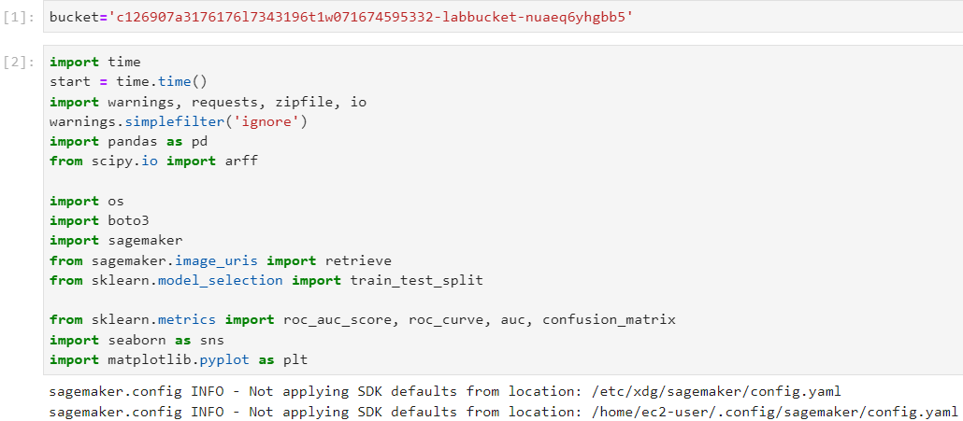

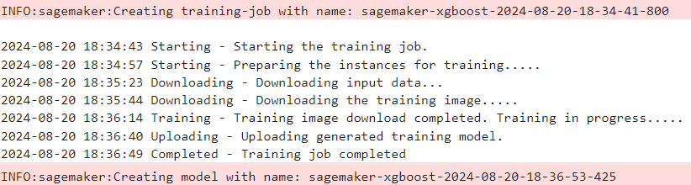

**Step 1: Getting model statistics**

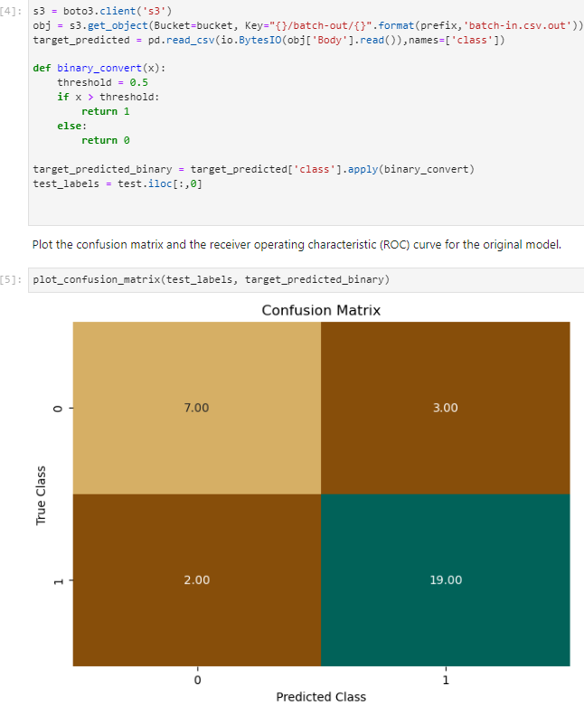

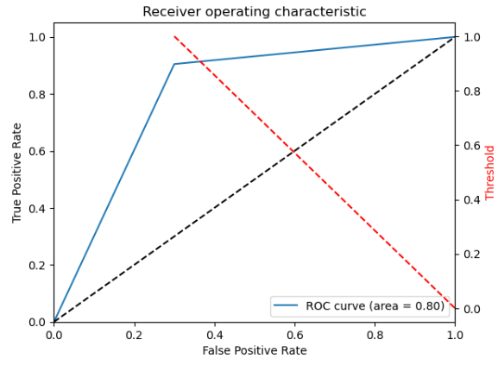

**Step 2: Creating a hyperparameter tuning job**

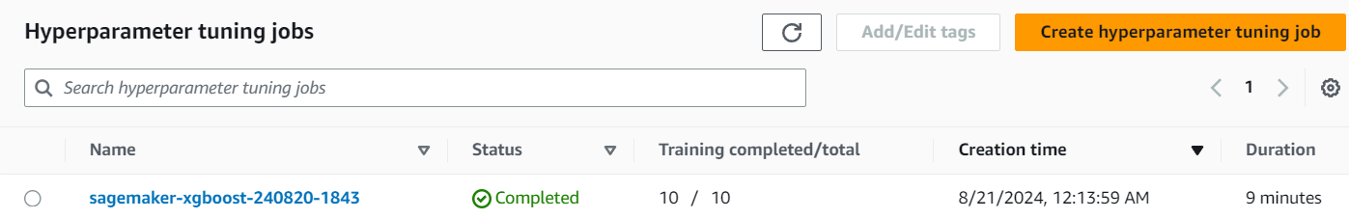

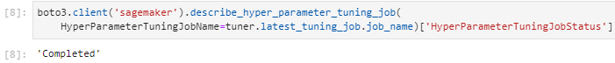

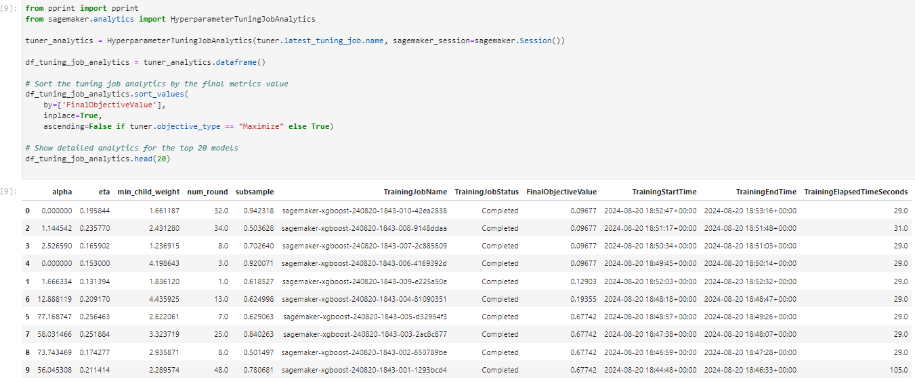

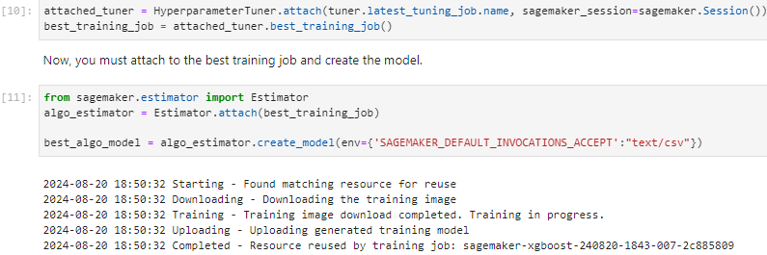

**Step 3: Investigating the tuning job results**

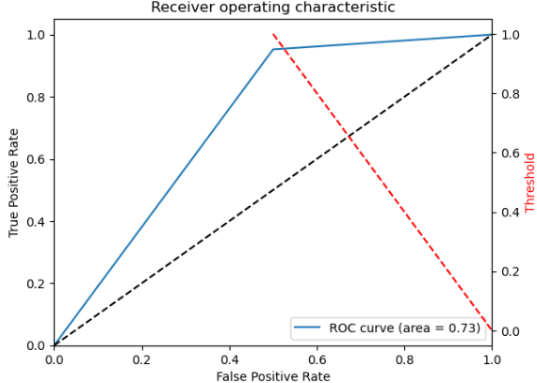

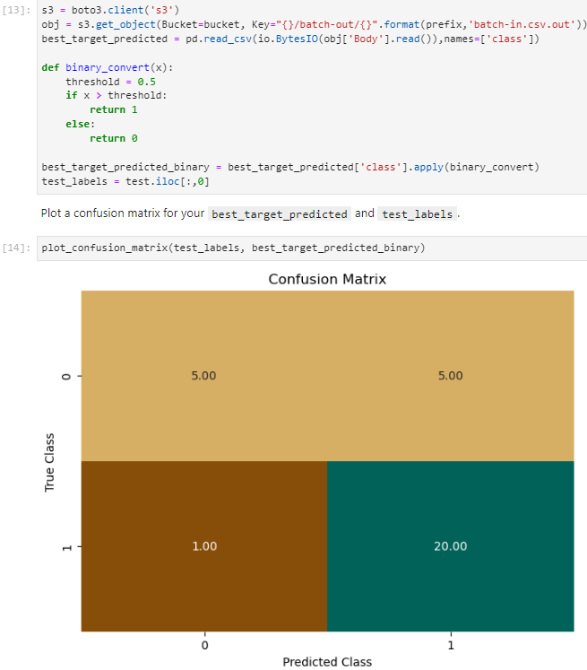

**Conclusion**

* Use Amazon SageMaker to create a hyperparameter training job
* Tune an XGBoost model by using Amazon SageMaker
* Test the tuned model by using performance metrics

**Lab complete**

1. In order to end the lab, choose End Lab, and then choose **Yes**.

