**SAVITRIBAI PHULE PUNE UNIVERSITY  
(Formely University of Pune)**

**JSPM’s JAYAWANTRAO SAWANT COLLEGE OF**

**ENGINEERING, PUNE-33**

**M.C.A. - I**

**PYTHON LAB ASSIGNMENT**

**Semester 1**

|  |  |
| --- | --- |
| **Name of Student:** | **Manish Shetty** |
| **Roll No.** | **(H) 2560** |
| **Email:** | **manishnshetty77@gmail.com** |
| **Phone:** | **8208618905** |

**Subject Teacher/ GFM HOD**

**Academic Year 2025-27**

**Index**

|  |  |  |  |
| --- | --- | --- | --- |
| **Sr. No** | **Assignment -2** | **Date** | **Sign** |
| 1. | 2.1 Function Basics – Scope, Nested Function, Non-local Statements  Case Study-1: Student Grading System |  |  |
| 2. | 2.2 Built-in Functions  Case Study-2: E-commerce Order Summary |  |  |
| 3. | 2.3 Topic: Types of Functions, Anonymous Function  Case Study-3: Student Data Management |  |  |
| 4. | 2.4 Decorators and Generators  Case Study-4: Banking Transactions |  |  |
| 5. | 2.5 Topic: Modules – Basic Usage, Creating & Importing Modules  Case Study-5: Scientific Calculator |  |  |
| 6. | 2.6 Importing Functions and Variables from Different Modules  Case Study-6: Travel Expense Calculator |  |  |
| 7. | 2.7 Python Built-in Modules – math, random, datetime  Case Study-7: Lucky Draw Contest |  |  |
| 8. | 2.8 Package: Import Basics  Case Study-8: Library Management System |  |  |
| 9. | 2.9**:** Python Namespace Packages  Case Study-9: University Departments System |  |  |
| 10. | 2.10 User Defined Modules and Packages  Case Study-10: Hospital Management System |  |  |
| 11. | 2.11.1 Avoiding Code Break using Exception Handling  **Case Study**: Online Payment Processing  2.11.2 Safeguarding File Operation using Exception Handling  **Case Study**: Student Record File System  2.11.3 Handling Multiple and User Defined Exceptions  **Case Study**: ATM Withdrawal  2.11.4 Handling and Helping Developer with Error Code  **Case Study**: Web Application Debugging  2.11.5 Programming using Exception Handling  **Case Study**: Web Application Debugging |  |  |

**Assignment No-2**

**Subject:** Python Programming (PP) **Subject Teacher:** Prof. Leena Deshmukh HOD

**Topic:** Python Lab Assignment-2

**Name:** Manish Narayan Shetty **Roll No:** (H25)60 **Class:** MCA – Semester-I

**College Name:** JSPM’s Jayawantrao Sawant College of Engineering (JSCOE)

**Submitted To:** **Submitted Date:**

**Case Study-1: Student Grading System** **Topic: Function Basics – Scope, Nested Function, Non-local Statements**

* Create a function calculate_grade() that takes marks as input.
* Inside it, define a nested function grade_category() that assigns a grade.
* Use a nonlocal variable to update and print remarks from the nested function (e.g., “Pass with Distinction”).

**Program/Code:**

def calculate_grade(marks):

remarks = "No remarks available."

def grade_category():

nonlocal remarks

if marks >= 75:

grade = 'A'

remarks = "Pass with Distiniction"

elif marks >= 60:

grade = 'B'

remarks = "First Class"

elif marks >= 50:

grade = 'C'

remarks = "Second Class"

elif marks >= 40:

grade = 'D'

remarks = "Pass"

else:

grade = 'F'

remarks = "Fail"

return grade

final_grade = grade_category()

print("Marks: ",marks)

print("Grade: ",final_grade)

print("Remarks: ",remarks)

print("-" * 20)

marks = int(input("Enter the Total Marks Obtained: "))

calculate_grade(marks)

**Output:**

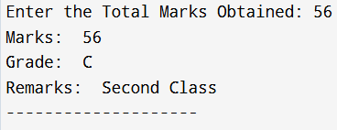

**Case Study-2:** **E-commerce Order Summary**  **Topic: Built-in Functions**

* Use built-in functions like len(), max(), min(), sum(), sorted() to:
* Find the total number of orders.
* Calculate the highest, lowest, and average order value.
* Sort the order values in ascending order.

**Program/Code:**

def summarize_orders(orders):

print("--- E-commerce Order Summary ---")

if not orders:

print("No orders to summarize.")

return

total_orders = len(orders)

print("Total number of orders: ",total_orders)

highest_order = max(orders)

lowest_order = min(orders)

print("Highest order value: ",highest_order)

print("Lowest order value: ",lowest_order)

total_value = sum(orders)

average_order = total_value / total_orders

print("Average order value: ",average_order)

sorted_orders = sorted(orders)

print("\nOrders sorted (ascending):")

value = [values for values in sorted_orders]

print(value)

print("-" * 32)

order_values = [150.75, 89.99, 245.50, 42.10, 150.75, 12.00, 305.00, 78.45]

summarize_orders(order_values)

**Output:**

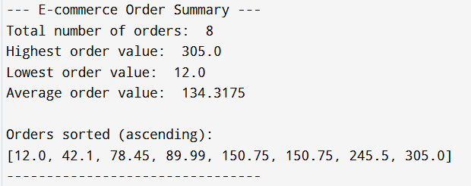

**Case Study-3: Employee Salary Slip**  **Topic: Types of Functions, Anonymous Function (lambda)**

* Define a normal function to calculate HRA, DA, PF.
* Define a lambda function to calculate net salary.
* Show difference between user-defined and lambda function usage.

**Program/Code:**

def calculate_allowances_deductions(basic_salary):

hra_percent = 0.30 # 30% of basic

da_percent = 0.20 # 20% of basic

pf_percent = 0.12 # 12% of basic

hra = basic_salary * hra_percent

da = basic_salary * da_percent

pf = basic_salary * pf_percent

return hra, da, pf

employee_basic_salary = int(input("Enter Employee Salary: "))

hra_amount, da_amount, pf_amount = calculate_allowances_deductions(employee_basic_salary)

calculate_net_salary = lambda basic, hra, da, pf: basic + hra + da - pf

net_salary = calculate_net_salary(employee_basic_salary, hra_amount, da_amount, pf_amount)

print("--- Employee Salary Slip ---")

print("Basic Salary : ",employee_basic_salary)

print("HRA (30%) : ",hra_amount)

print("DA (20%) : ",da_amount)

print("PF (12%) : ",pf_amount)

print("-" * 28)

print("Net Salary : ",net_salary)

print("=" * 28)

**Output:**

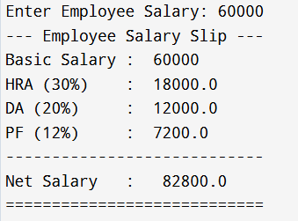

**Case Study 4: Online Banking System**  **Topic: Decorators and Generators**

* Create a decorator @authenticate_user to check if a user is logged in before performing a transaction.
* Implement a generator function transaction_history() that yields last 5 transactions of a user.

**Program/Code:**

# --- Decorator to check authentication ---

def authenticate_user(func):

def wrapper(user, *args, **kwargs):

if not user.get("is_logged_in"):

print("Access denied. Please log in first.")

return

return func(user, *args, **kwargs)

return wrapper

# --- Generator function for last 5 transactions ---

def transaction_history(transactions):

# Yield last 5 transactions

for txn in transactions[-5:]:

yield txn

# --- Function to perform a transaction (uses decorator) ---

@authenticate_user

def perform_transaction(user, amount):

print("Transaction of ₹ ”,amount,” successful for user: “,user['name'])

if __name__ == "__main__":

# User data

user = {"name": "Manish", "is_logged_in": True}

# Sample transaction list

transactions = [500, -200, 1000, -150, 300, -400, 700]

# Perform a transaction

perform_transaction(user, 250)

# Display last 5 transactions using generator

print("\nLast 5 Transactions:")

for txn in transaction_history(transactions):

print("₹”, txn)

**Output:**

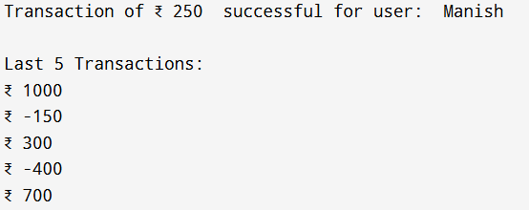

**Case Study 5: Scientific Calculator Topic: Modules – Basic Usage, Creating & Importing Modules**

* Create a module calculator.py with functions add, subtract, multiply, divide.
* Import the module in another file main.py and perform user-chosen operations.

**Program/Code:**

**Calculator.py (Module) Code:**

def add(a,b):

return a + b

def sub(a,b):

return a - b

def mul(a,b):

return a * b

def div(a,b):

if b == 0:

print("ERROR: Cannot divide by Zero!")

retursn a / b

**main.py Code:**

import calculator as cal

print("-"*25)

print("1. ADD\n2. Substract\n3. Multiply\n4. Divivde\n")

choice = int(input("Choose Operation from above by selecting the Option Number: "))

num1 = float(input("Enter Value 1: "))

num2 = float(input("Enter Value 2: "))

if choice == 1:

print("Addition of ",num1," & ",num2," is: ",cal.add(num1,num2))

elif choice == 2:

print("Substraction of ",num1," & ",num2," is: ",cal.sub(num1,num2))

elif choice == 3:

print("Multiplication of ",num1," & ",num2," is: ",cal.mul(num1,num2))

elif choice == 4:

print("Division of ",num1," & ",num2," is: ",cal.div(num1,num2))

else:

print("Enter Valid Choice!")

**Output:**

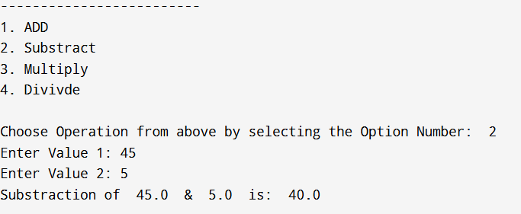

**Case Study 6: Travel Expense Calculator**

**Topic: Importing Functions and Variables from Different Modules**

* Create two modules:
* transport.py → contains bus/train/flight fare functions.
* stay.py → contains hotel/food expense functions.
* Import specific functions into main.py to calculate total trip cost.

**Program/Code:**

**Transport.py code:**

def get_bus_fare(distance_km):

return distance_km * 0.5 # $0.5 per km

def get_train_fare(distance_km):

rate = 0.75

return distance_km * rate

def get_flight_fare(destination):

fares = {'Pune': 5300, 'Mumbai': 3450, 'Mangalore': 7350}

return fares.get(destination, 500) # Default fare if not found

**stay.py Code:**

def calculate_hotel_cost(nights):

nightly_rate = 2000

return nights * nightly_rate

def calculate_food_expense(days):

avg_daily_cost = 500

return days * avg_daily_cost

**main.py Code:**

import transport as t

from stay import calculate_hotel_cost, calculate_food_expense

print("Enter your Travel and stay Details: ")

dest = input("Enter Destination Name: ")

distance = int(input("Enter the Total Distance from your Current Location to destination in km: "))

mode = input("Enter the mode of your transport: ")

nights = int(input("Enter Total no of nights you will stay: "))

days = int(input("Enter Total no of Days you will stay: "))

travel_cost = 0

if mode == "flight":

travel_cost = t.get_flight_fare(dest)

elif mode == "bus":

travel_cost = t.get_bus_fare(distance)

elif mode == "train":

travel_cost = t.get_train_fare(distance)

else:

print("Enter Correct mode of Transport!")

hotel_cost = calculate_hotel_cost(nights)

food_cost = calculate_food_expense(days)

total_trip_cost = travel_cost + hotel_cost + food_cost

# --- Display Results ---

print("Travel Cost to ",dest," : ",travel_cost)

print("Hotel Cost for ",nights," nights: ",hotel_cost)

print("Food Cost for ",days," days: ",food_cost)

print("-" * 30)

print("Total Trip Cost: ",total_trip_cost)

**Output:**

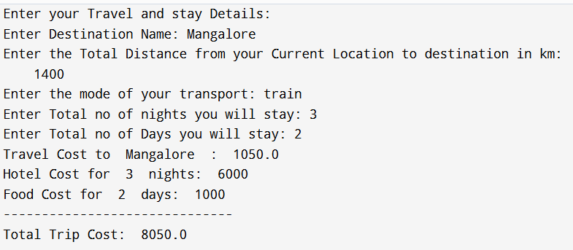

**Case Study 7: Lucky Draw Contest Topic: Python Built-in Modules – math, random, datetime**

* Use random to pick 5 winners from a list of participants.
* Use datetime to print the date & time of draw.
* Use math to calculate prize money distribution with percentage-based bonus.

**Program/Code:**

import random

import datetime

import math

participants = ["Manish", "Ganesh", "Deepak", "Kaushik", "Rohan", "Kaushal", "Shrinivas", "Maithili", "Rutuja"]

total_prize_pool = 50000

print("--- Lucky Draw Contest ---")

num_winners = 5

winners = random.sample(participants, num_winners)

print("The ",num_winners," Winners are: ",winners)

now = datetime.datetime.now()

print("Draw Date & Time: ",now.strftime('%Y-%m-%d %H:%M:%S'))

base_prize = total_prize_pool / num_winners

bonus_percentages = [0.40, 0.30, 0.10, 0.10, 0.10]

prizes = []

print("\n--- Prize Distribution ---")

for i, winner in enumerate(winners):

bonus_amount = base_prize * bonus_percentages[i]

total_prize = math.ceil(base_prize + bonus_amount)

prizes.append(total_prize)

print(winner," (Bonus: ",bonus_percentages[i]*100,"%): Base", base_prize + bonus_amount," = Total ",total_prize)

print("\nTotal Prize Pool: ",total_prize_pool)

print("Total Distributed (Rounded): ",sum(prizes))

**Output:**

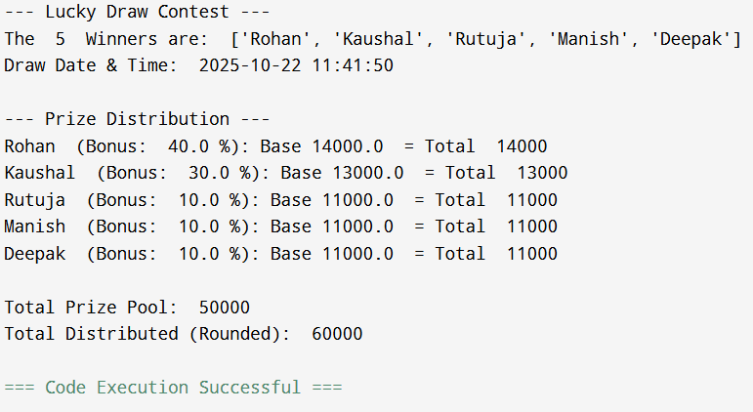

**Case Study 8: Library Management System Topic: Package: Import Basics**

* Create a package library with modules:
* books.py → add, remove, search books.
* members.py → register and update members.
* Import these modules inside main.py to simulate library operations.

**Program/Code:**

**# library/books.py**

book_list = []

def add_book(title, author):

book = {"title": title, "author": author, "status": "Available"}

book_list.append(book)

print("Book added: ",title," by ",author)

def remove_book(title):

global book_list

original_len = len(book_list)

book_list = [b for b in book_list if b['title'].lower() != title.lower()]

if len(book_list) < original_len:

print("Book removed: ",title)

else:

print("Book not found: ",title)

def search_book(title):

results = [b for b in book_list if title.lower() in b['title'].lower()]

print("--- Search Results for ",title," ---")

if results:

for book in results:

print("Title: ",book['title']," Author: ",book['author']," Status: ",book['status'])

else:

print("No books found matching the search criteria.")

**# library/members.py**

member_list = {}

member_id_counter = 1001

def register_member(name):

global member_id_counter

member_list[member_id_counter] = {"name": name, "status": "Active"}

print("Member registered: ",name," with ID ",member_id_counter)

member_id_counter += 1

return member_id_counter - 1

def update_member_status(member_id, new_status):

if member_id in member_list:

member_list[member_id]['status'] = new_status

print("Member ",member_id," status updated to ",new_status)

else:

print("Error: Member ID ",member_id," not found.")

def get_member_details(member_id):

return member_list.get(member_id, "Member not found.")

**main.py Code:**

import library.books

import library.members

def simulate_library_operations():

print("\n--- Welcome to the Library System ---")

library.books.add_book("Python Crash Course", "Eric Matthes")

library.books.add_book("The Lord of the Rings", "J.R.R. Tolkien")

library.members.register_member("System Admin")

print("\n(System initialized with a few books and one member.)")

print("-" * 40)

while True:

print("\n--- Main Menu ---")

print("1. Add a Book")

print("2. Search for a Book")

print("3. Register a New Member")

print("4. Update Member Status (e.g., Suspended)")

print("5. Display All Books and Members")

print("6. Exit")

choice = input("Enter your choice (1-6): ").strip()

if choice == '1':

title = input("Enter the book title: ").strip()

author = input("Enter the author's name: ").strip()

if title and author:

library.books.add_book(title, author)

else:

print("Title and Author cannot be empty.")

elif choice == '2':

search_term = input("Enter title/keyword to search: ").strip()

library.books.search_book(search_term)

elif choice == '3':

name = input("Enter the new member's name: ").strip()

if name:

library.members.register_member(name)

else:

print("Member name cannot be empty.")

elif choice == '4':

if not library.members.member_list:

print("No members registered yet.")

continue

print("\nCurrent Members:")

for mid, details in library.members.member_list.items():

print(" ID: ",mid," - Name: ",details['name']," (Status: ",details['status'],")")

try:

member_id = int(input("Enter the Member ID to update: ").strip())

new_status = input("Enter the new status (e.g., Active, Suspended, Lost): ").strip()

library.members.update_member_status(member_id, new_status)

except ValueError:

print("Invalid input. Please enter a valid number for the Member ID.")

elif choice == '5':

print("\n" + "=" * 40)

print("--- Current Library Status ---")

print("\nAll current books:")

if library.books.book_list:

for b in library.books.book_list:

print(" Title: ",b['title']," | Author: ",b['author']," | Status: ",b['status'])

else:

print(" (No books in the library.)")

print("\nAll current members:")

if library.members.member_list:

for mid, details in library.members.member_list.items():

print(" ID: ",mid," | Name: ",details['name']," | Status: ",details['status'])

else:

print(" (No members registered.)")

print("=" * 40)

elif choice == '6':

print("\nThank you for using the Library Management System. Goodbye! ")

break

else:

print("Invalid choice. Please enter a number between 1 and 6.")

simulate_library_operations()

**Output:**

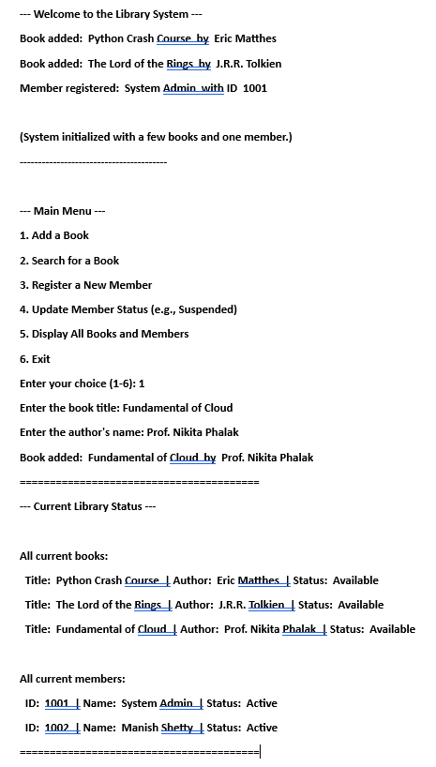

**Case Study 9: University Departments System Topic: Python Namespace Packages**

* Create a namespace package university with sub-packages:
* science → subjects list.
* arts → subjects list.
* commerce → subjects list.
* Import and display subjects from different namespaces.

**Program/Code:**

**# science/subjects.py**

SCIENCE_SUBJECTS = [

"Physics",

"Chemistry",

"Biology",

"Mathematics",

"Computer Science"

]

def get_science_subjects():

return SCIENCE_SUBJECTS

**# arts/subjects.py**

ARTS_SUBJECTS = [

"History",

"Literature",

"Philosophy",

"Sociology",

"Visual Arts"

]

def get_arts_subjects():

return ARTS_SUBJECTS

**# commerce/subjects.py**

COMMERCE_SUBJECTS = [

"Accounting",

"Economics",

"Business Studies",

"Finance",

"Marketing"

]

def get_commerce_subjects():

return COMMERCE_SUBJECTS

**main.py**

import Science.subjects as science_sub

import Arts.subjects as arts_sub

import commerce.subjects as commerce_sub

print("--- University Department Subjects ---")

# Import and display subjects from different namespaces

science_list = science_sub.get_science_subjects()

print("\nScience Subjects:")

for subject in science_list:

print("- ",subject)

arts_list = arts_sub.get_arts_subjects()

print("\nArts Subjects:")

for subject in arts_list:

print("- ",subject)

commerce_list = commerce_sub.get_commerce_subjects()

print("\nCommerce Subjects:")

for subject in commerce_list:

print("- ",subject)

**Output:**

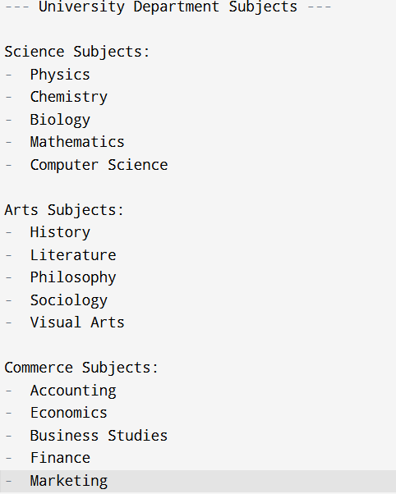

**Case Study 10: Hospital Management System Topic: User Defined Modules and Packages**

* Create a package hospital with modules:
  + patient.py → store patient details.
  + doctor.py → store doctor details.
  + appointment.py → book appointments.
* Import and combine all to simulate hospital operations.

**Program/Code:**

**# hospital/patient.py**

PATIENTS = {}

p_id_counter = 101

def register_patient(name, age, condition):

global p_id_counter

PATIENTS[p_id_counter] = {"name": name, "age": age, "condition": condition}

print("Patient ",name," registered with ID P",p_id_counter,".")

p_id_counter += 1

return p_id_counter - 1

def get_patient_details(patient_id):

return PATIENTS.get(patient_id)

**# hospital/doctor.py**

DOCTORS = {}

d_id_counter = 201

def add_doctor(name, specialty):

global d_id_counter

DOCTORS[d_id_counter] = {"name": name, "specialty": specialty}

print("Doctor ",name," (",specialty,") added with ID D",d_id_counter,".")

d_id_counter += 1

return d_id_counter - 1

def get_doctor_details(doctor_id):

return DOCTORS.get(doctor_id)

**# hospital/appointment.py**

APPOINTMENTS = []

def book_appointment(patient_id, doctor_id, date_time):

if not isinstance(patient_id, int) or not isinstance(doctor_id, int):

print("Error: Invalid ID type for booking.")

return False

appointment = {

"patient_id": patient_id,

"doctor_id": doctor_id,

"date_time": date_time

}

APPOINTMENTS.append(appointment)

print("Appointment booked for P",patient_id," with D",doctor_id," on ",date_time,".")

return True

def get_appointments_for_doctor(doctor_id):

return [app for app in APPOINTMENTS if app['doctor_id'] == doctor_id]

**# main.py**

import hospital

print("--- Hospital Management System Simulation ---")

p_id_jane = hospital.register_patient("Jane Doe", 35, "Fever")

p_id_john = hospital.register_patient("John Smith", 60, "Routine Checkup")

print("-" * 20)

d_id_dr_sam = hospital.add_doctor("Dr. Sam Wilson", "Cardiology")

d_id_dr_lily = hospital.add_doctor("Dr. Lily Chen", "General Practice")

print("-" * 20)

hospital.book_appointment(p_id_jane, d_id_dr_lily, "2025-10-25 10:00")

hospital.book_appointment(p_id_john, d_id_dr_sam, "2025-10-25 11:30")

hospital.book_appointment(p_id_jane, d_id_dr_lily, "2025-10-26 09:00") # Jane's second appointment

print("-" * 20)

dr_lily_schedule = hospital.get_appointments_for_doctor(d_id_dr_lily)

print("Dr. Lily Chen's Appointments (",len(dr_lily_schedule),"):")

for app in dr_lily_schedule:

print(" - Patient P",app['patient_id']," at ",app['date_time'])

**Output:**

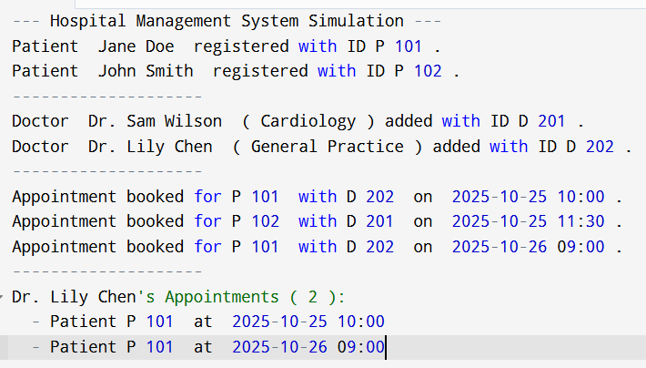

**Case Study 11.1: Online Payment Processing Topic: Exception Handling**

* Take payment input from user.
* Handle cases where user enters invalid amount (string instead of number) using try except.

**Program/Code:**

def process_payment():

print("--- Online Payment Processing ---")

try:

amount_str = input("Enter payment amount (e.g., 50.00): ")

amount = float(amount_str)

if amount <= 0:

print("Payment failed: Amount must be positive.")

else:

print("Payment of ",amount," processed successfully.")

except ValueError:

print("Payment failed: Invalid amount entered.")

print("Please enter a valid numeric value (e.g., 50.00).")

except Exception as e:

print("An unexpected error occurred: ",e)

process_payment()

**Output:**

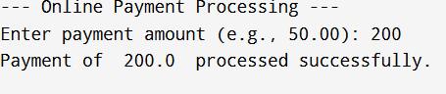

**Case Study 11.2: Student Record File System**

* Try to open a file students.txt.
* If the file is missing, handle exception and create a new file.

**Program/Code:**

import os

FILE_NAME = "students.txt"

def safeguard_file_operation():

print("--- Safeguarding File: ",FILE_NAME," ---")

try:

with open(FILE_NAME, 'r') as file:

print("File '",FILE_NAME,"' found and opened successfully.")

content = file.read().strip()

if content:

print("Content preview:\n" + content[:100] + ("..." if len(content) > 100 else ""))

else:

print("File is empty.")

except FileNotFoundError:

print("File '",FILE_NAME,"' is missing. Creating a new file...")

try:

with open(FILE_NAME, 'w') as file:

file.write("Student Records:\n")

file.write("Name, Age, Grade\n")

print("New file '",FILE_NAME,"' created successfully.")

except IOError as e:

print("Error creating file: ",e)

except Exception as e:

print("An unexpected error occurred: ",e)

if os.path.exists(FILE_NAME):

os.remove(FILE_NAME)

print("(Cleaned up previous '",FILE_NAME,"' for fresh demo)")

safeguard_file_operation()

print("\n--- Demonstration complete. Running again to show 'File found' case ---")

safeguard_file_operation()

**Output:**

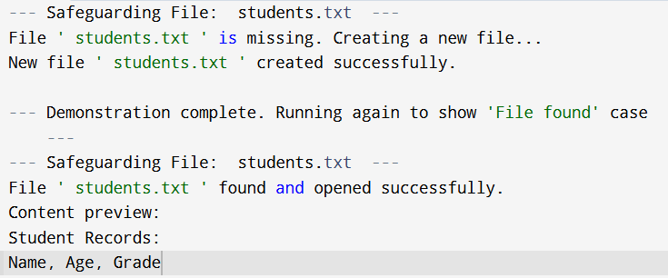

**Students.txt file:**



**Case Study 11.3: ATM Withdrawal**

* Raise a user-defined exception if withdrawal amount > balance.
* Handle multiple exceptions like: o Invalid input type. o Amount not multiple of 100.

**Program/Code:**

class InsufficientFundsError(Exception):

def __init__(self, requested, balance):

self.requested = requested

self.balance = balance

super().__init__("Withdrawal amount (",requested,") exceeds available balance (",balance,").")

class NotMultipleOfHundredError(Exception):

def __init__(self, amount):

self.amount = amount

super().__init__("Withdrawal amount (",amount,") must be a multiple of 100.")

def atm_withdrawal(current_balance):

print("\n--- ATM Withdrawal Simulation ---")

print("Current Balance: ",current_balance)

try:

amount_str = input("Enter withdrawal amount (multiple of 100): $")

withdrawal_amount = int(amount_str)

if withdrawal_amount % 100 != 0:

raise NotMultipleOfHundredError(withdrawal_amount)

if withdrawal_amount > current_balance:

raise InsufficientFundsError(withdrawal_amount, current_balance)

new_balance = current_balance - withdrawal_amount

print("Transaction successful! Withdrew ",withdrawal_amount)

print("New Balance: ",new_balance)

except ValueError:

print("Error: Invalid input. Please enter a whole number.")

except NotMultipleOfHundredError as e:

print("Error",e)

except InsufficientFundsError as e:

print("Transaction failed: ",e)

print("Please enter a lower amount.")

except Exception as e:

print(f"An unexpected system error occurred: {e}")

atm_withdrawal(current_balance=2500) # Valid transaction

atm_withdrawal(current_balance=2500) # Test InsufficientFundsError (e.g., enter 3000)

atm_withdrawal(current_balance=2500) # Test NotMultipleOfHundredError (e.g., enter 250)

atm_withdrawal(current_balance=2500) # Test ValueError (e.g., enter 'five hundred')

**Output:**

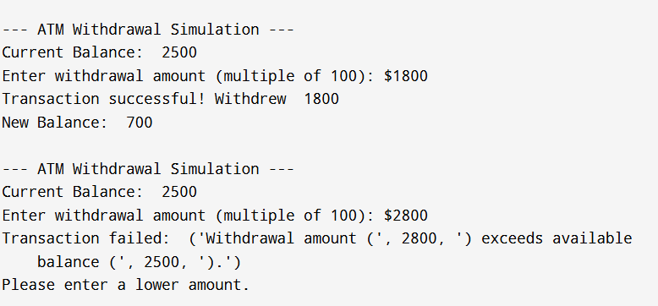

**Case Study 11.4: Web Application Debugging**

* Create a function that logs exceptions into an error file error_log.txt.
* Along with the exception, store an error code and timestamp.

**Program/Code:**

import datetime

ERROR_LOG_FILE = "error_log.txt"

def log_exception(error_code, exception_message):

timestamp = datetime.datetime.now().strftime("%Y-%m-%d %H:%M:%S")

log_entry = f"[{timestamp}] CODE: {error_code} | EXCEPTION: {exception_message}\n"

try:

with open(ERROR_LOG_FILE, 'a') as f:

f.write(log_entry)

print(f"Error logged successfully with code {error_code}.")

except Exception as e:

print(f"CRITICAL ERROR: Could not write to log file: {e}")

def process_user_data(data):

print(f"\n--- Processing data: {data} ---")

try:

user_id = data['user_id']

username = data['username']

result = 100 / data['settings']['divisor']

print(f"Data processed for User {user_id} ({username}). Result: {result}")

except KeyError as e:

error_msg = f"Missing dictionary key: {e}"

log_exception(error_code="4001_MISSING_KEY", exception_message=error_msg)

print("Processing failed. Check error log.")

except ZeroDivisionError as e:

error_msg = str(e)

log_exception(error_code="5002_ZERO_DIV", exception_message=error_msg)

print("Processing failed. Check error log.")

except Exception as e:

error_msg = str(e)

log_exception(error_code="9999_UNEXPECTED", exception_message=error_msg)

print("Processing failed. Check error log.")

# Test Case 1: Missing 'username' key (KeyError)

process_user_data({'user_id': 123, 'settings': {'divisor': 1}})

# Test Case 2: Division by zero (ZeroDivisionError)

process_user_data({'user_id': 456, 'username': 'testuser', 'settings': {'divisor': 0}})

# Test Case 3: Successful execution

process_user_data({'user_id': 789, 'username': 'success', 'settings': {'divisor': 5}})

print(f"\n--- Developer Note: Check '{ERROR_LOG_FILE}' for log details. ---")

**Output:**

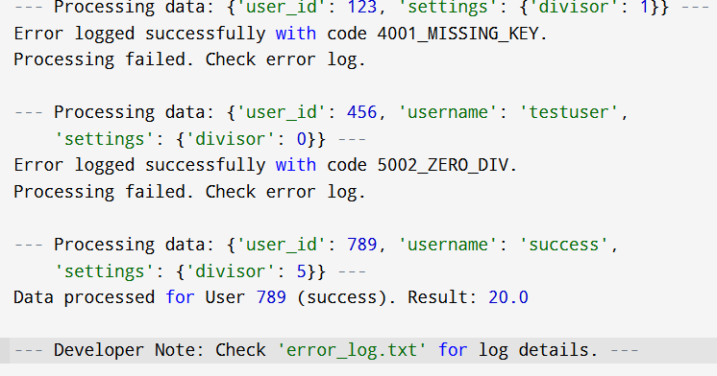

**Errorlog.txt File Created:**

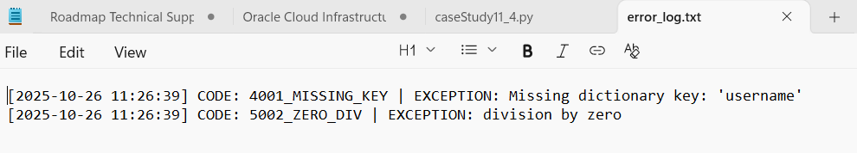

**Case Study 11.5: Airline Ticket Reservation**

* Implement ticket booking where:
* If seats are full → raise an exception.
* If user enters invalid passenger data → handle gracefully.
* Always close the file/logging resource using finally.

**Program/Code:**

class SeatsFullError(Exception):

def __init__(self, flight_id):

self.flight_id = flight_id

super().__init__("Flight flight_id is fully booked. No seats available.")

MAX_SEATS = 2

BOOKED_SEATS = 0

LOG_FILE = "reservation_log.txt"

def book_ticket(flight_id, passenger_data):

global BOOKED_SEATS

file_resource = None

print(f"\n--- Attempting to book for {flight_id} ---")

try:

if BOOKED_SEATS >= MAX_SEATS:

raise SeatsFullError(flight_id)

if not isinstance(passenger_data.get('name'), str) or len(passenger_data['name']) < 2:

print("Booking failed: Invalid or missing passenger name.")

return

if not isinstance(passenger_data.get('age'), int) or passenger_data['age'] <= 0:

print("Booking failed: Invalid passenger age.")

return

BOOKED_SEATS += 1

file_resource = open(LOG_FILE, 'a')

log_entry = f"BOOKED: Flight {flight_id}, Seat {BOOKED_SEATS}, Passenger: {passenger_data['name']}\n"

file_resource.write(log_entry)

print(f"Booking successful! Seat {BOOKED_SEATS} on {flight_id} for {passenger_data['name']}.")

except SeatsFullError as e:

print(f"Booking failed: {e}")

except Exception as e:

print(f"An unexpected error occurred during booking: {e}")

finally:

if file_resource:

file_resource.close()

print("--- Booking attempt finished. ---")

import os

if os.path.exists(LOG_FILE):

os.remove(LOG_FILE)

# Test Case 1: Successful booking

book_ticket("AI101", {'name': 'Alice Smith', 'age': 30})

# Test Case 2: Successful booking (max seats = 2)

book_ticket("AI101", {'name': 'Bob Johnson', 'age': 45})

# Test Case 3: Seats full (Raises SeatsFullError)

book_ticket("AI101", {'name': 'Charlie Brown', 'age': 22})

# Test Case 4: Invalid passenger data (Handled gracefully with return)

book_ticket("AI102", {'name': '', 'age': 25})

# Test Case 5: Invalid passenger data (Handled gracefully with return)

book_ticket("AI102", {'name': 'Eve', 'age': 'twenty'})

print(f"\nTotal seats booked on AI101: {BOOKED_SEATS}/{MAX_SEATS}")

print(f"Check '{LOG_FILE}' for successful booking records.")

**Output:**

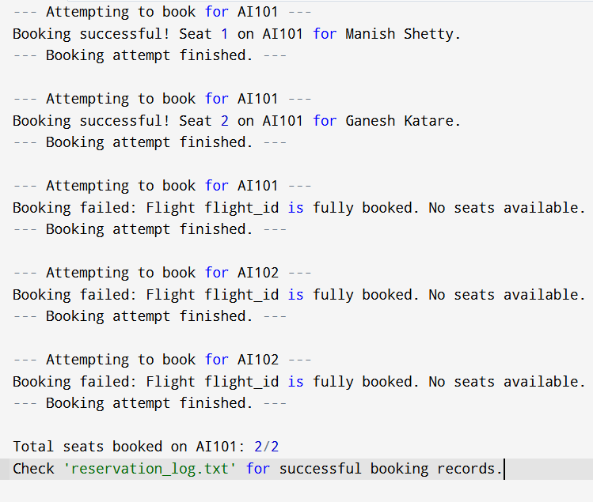

**Reservation_log.txt file:**

