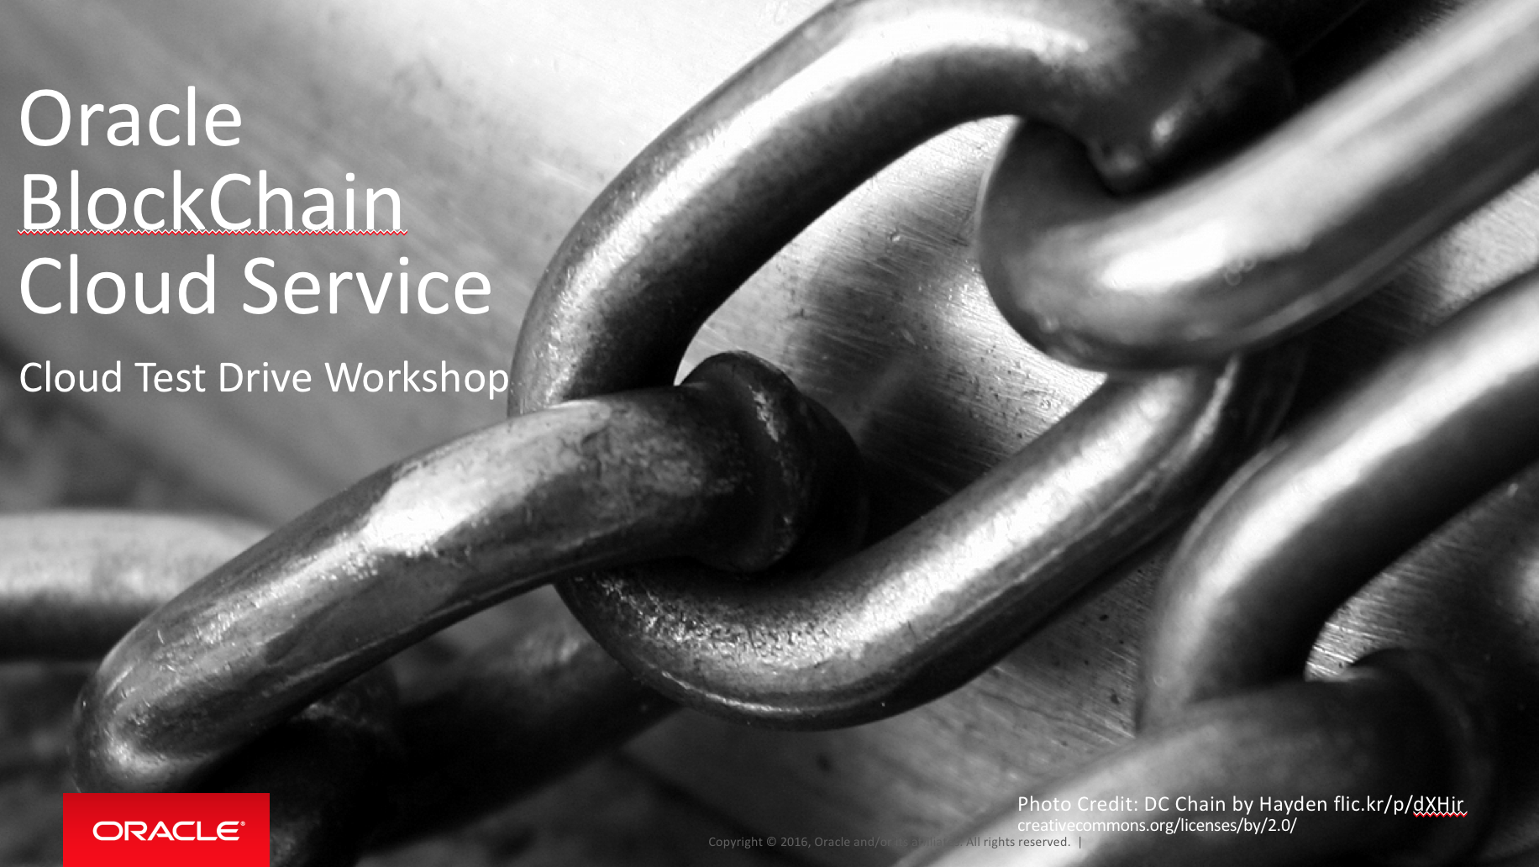

Oracle Content & Experience Cloud Service

Workshop

Contents:

Demo Attributes 2

Oracle Blockchain Cloud Service 2

Overview 3

Chapter 1: Create an OBCS course on Ravello Training platform 4

Chapter 2: Create an OBCS class from the course tempalte 9

Chapter 3: Manage access details for students. 11

## Demo Attributes

|  |  |
| --- | --- |
| **Product(s)** | Oracle BlockChain Cloud Service |
| **Date last updated** | December 2018 |
| **Author(s)** | Jens Lusebrink |
| **Demo Title(s)** | PaaS – Oracle BlockChain Cloud Service (OBCS) |

## Oracle Blockchain Cloud Service

Oracle Blockchain Cloud Service is a new offering that is part of Oracle’s comprehensive platform-as-a service (PaaS) portfolio. Delivered by the world’s most scalable, distributed transaction processing platform provider, Oracle Blockchain Cloud Service is the most comprehensive distributed ledger cloud platform.

A comprehensive distributed ledger cloud platform to provision Blockchain networks, join other organizations, and deploy & run smart contracts to update and query the ledger. Reliably share data and conduct trusted transactions with suppliers, banks, and other trade partners through integration with existing or new cloud-based or on-premises applications.

## Overview

* This document describes the steps necessary to setup the Oracle Blockchain Cloud Service HandsOn lab in a Oracle Ravello Training Platform environment.
* Within the Ravello Training platform, a class could be created and VM and participants can be managed.

| **S.No.** | **Action** | **Description** |
| --- | --- | --- |
| Chapter 1: Create an OBCS course on Ravello Training platform | | |
| 1.00 | Ravello Training platform | Log into Ravello with your Oracle user account. |
| 1.01 | Access Training platform | From there, access the ‘Training Platform’ link. |
| 1.02 | Create a course | Click on ‘Course’ in the left hand menu. Depending on your Ravello usage, you might already see a course.  Click on ‘Create Course’ in the upper right. |
| 1.04 | Enter course details | In the dialog, enter the course name, a description. |
| 1.05 | Select a OBCS blueprint | In order to provide an environment for your course you have to select an OBCS blueprint from Ravello and assign it to your course. A valid blueprint for the OBCS HOL can be identified by its name ‘OBCS_CloudTestDrive_Labxx’.  You might be provided with relevant Blueprint names upfront. Click on ‘Add Blueprint’ and select the relevant ones from the list. |
| 1.06 | Finish course creation | Once you have selected a blueprint you are back in the course creation dialog. Finish the creation by clicking ‘Create’. You have created a course and need to create a class now. |

|  |  |  |
| --- | --- | --- |
| Chapter 2: Create an OBCS class from the course tempalte | | |
| 2.00 | Create a class from the course template. | Click on ‘Create Class’ |
|  |  | Fill in the form. Provide a meaningful name, description, and pay attention to the Active from … Active until selection.  Leave **Cost Bucket** as is.  Select yourself as a trainer. Click Create to finish. |
| 2.02 | Add students to your class | After creating your class you will be taken to the form where you can add students for your class. Here you should enter the participants details as available beforehand. |
|  |  | Click on ‘Manage Students’. In the next screen, click on ‘Add student’.    Save your student and repeat for the remaining students. |

|  |  |  |
| --- | --- | --- |
| Chapter 3: Manage access details for students. | | |
| 3.00 | Provide students access to the environment | Once you have created the students, go to the ‘Application’ tab in the course overview page.    Here you can see the Application that has been assigned to the student based on the Ravello Blueprint.  ***NOTE: Each student has its own environment in Ravello during this class.*** |
| 3.01 | Collect and download ‘Student Portal Links’ | For each student a unique ‘Student Portal Link’ has been created.  You can distribute these links to your students for example via a Public Docs folder, assign a number to each student, and instruct them to select the corresponding link from the spreadsheet.. |
| 3.02 | Preparing the student’s images | To instantiate the VM’s before the start of you class, click the checkbox on the right (see red rectangle on the left on above screenshot). This allows you to select all images in one go.   * Now hit the “Start” button to start up all instances in one go. As starting up an instance can take up to 5 minutes, do this well in advance of the start of your lab. * Please be aware you are consuming actual budget when instantiating VM’s. So always set the appropriate “Stop Time” to automatically stop all VM’s. |
| 3.03 | Students accessing the Class | Each student can now access the class via his unique link. What the student has to do then is described in the **Lab0_BCS_Ravello_Participant_Setup document**. |