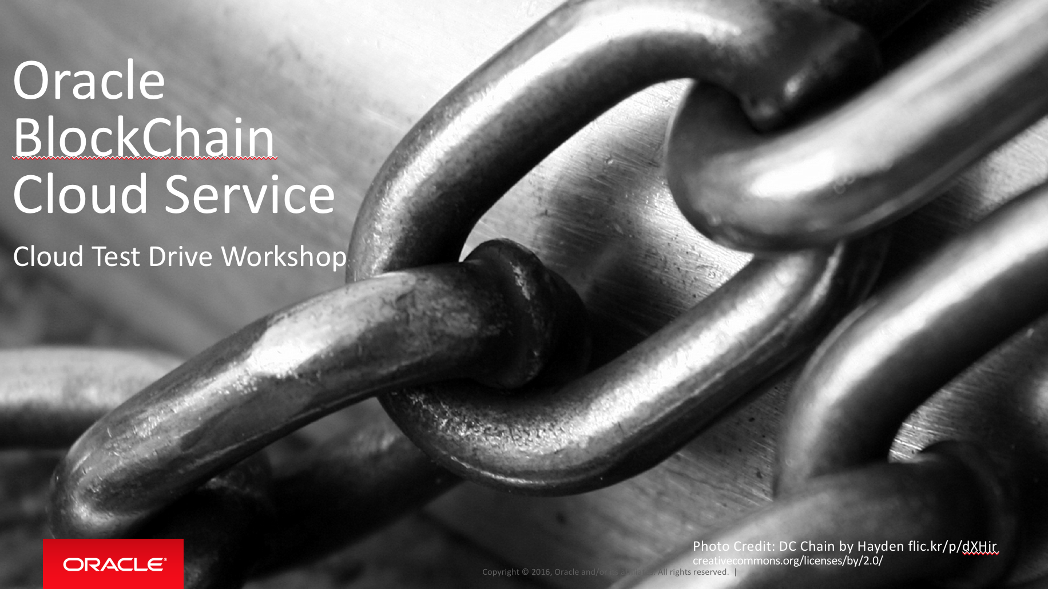

Oracle Content & Experience Cloud Service

Workshop

Contents:

Demo Attributes 2

Oracle Blockchain Cloud Service 2

Overview 3

Chapter 1: Accessing the Blockchain - basics 4

Chapter 2: Working with the Blockchain – view transactions 9

Chapter 3: Working with the Blockchain – executing transactions 11

## Demo Attributes

|  |  |
| --- | --- |
| **Product(s)** | Oracle BlockChain Cloud Service |
| **Date last updated** | March 2018 |
| **Author(s)** | Jens Lusebrink |
| **Demo Title(s)** | PaaS – BlockChain Cloud Service (BCS) |

## Oracle Blockchain Cloud Service

Oracle Blockchain Cloud Service is a new offering that is part of Oracle’s comprehensive platform-as-a service (PaaS) portfolio. Delivered by the world’s most scalable, distributed transaction processing platform provider, Oracle Blockchain Cloud Service is the most comprehensive distributed ledger cloud platform.

A comprehensive distributed ledger cloud platform to provision Blockchain networks, join other organizations, and deploy & run smart contracts to update and query the ledger. Reliably share data and conduct trusted transactions with suppliers, banks, and other trade partners through integration with existing or new cloud-based or on-premises applications.

## Overview

**End-to-End Application Flow**

This HandsOn Lab focusses on working on an existing Oracle Blockchain Cloud Service (OBCS) network and demonstrate how to query the Blockchain, verifying, and executing transactions via sample Business Applications.

The estimated duration of this HandsOn Lab is appr. 1 hour if used with the provided VM that contains an already created Blockchain network.

| **S.No.** | **Action** | **Description** |
| --- | --- | --- |
| Chapter 1: Accessing the Blockchain - basics | | |
| 1.00 | In this lab, we will work with an existing Blockchain network running on the Oracle Blockchain Cloud Service (OBCS).  The network already consists of 3 organizations:   * 1 founder (Detroit Auto) * 1 participant Jude Dealer * 1 participant Sam Dealer   ***NOTE: In the following steps will working with Detroit Auto and Jude Dealer*** |  |
| 1.01 | Let’s explore the existing Blockchain network  In order to work with the Blockchain network, all participants must be active   1. Right Mouse-Click in the line of the participants name and select ‘Start’ 2. Repeat for the 2nd participant 3. Wait until the Status has switched to ‘On’ |  |
| 1.02 | Now, we want to access the Dashboards for each participant.   1. Click on the participant’s name and the Dashboard will open in a new window. 2. Leave the Welcome Screen and click on ‘Dashboard’ |  |
| 1.03 | The Dashboard for each participant will tell us the overall status of the OBCS network.  For the Founder:  For the participant: |  |
| 1.04 | Now, let’s have a look into the transactions.  There are several ways to interact with OBCS network. While, for development and test reasons you might want to work from the command-line, in a Business scenario you will include the OBCS network in your Business Applications.  For the HandsOn Lab we have created some ‘dummy’ applications that will give you an easy and comfortable access to the OBCS network.   1. From the VM console, open the ‘Home’ directory and drill down to ‘Documents’ and then to ‘Environments’ 2. You should see 3 Folder as in the screenshot. 3. Open the ‘master’ folder and right mouse-click in to the folder background and select open Terminal. 4. In the terminal window type **npm start.** This will start the dummy application. 5. Back in your webbrowser, open a new tab and enter the following URL: <http://localhost:7050> 6. You should have access to the application for Detroit Auto |  |
| 1.05 | Repeat the same steps for the **companyb** folder. Take a note of the **different port number (7020)** when opening the application for Company B (=Jude Dealer) |  |
| 1.06 |  |  |
| Chapter 2: Working with the Blockchain – view transactions | | |
| 2.00 | We now have started the applications for the founder (Detroit Auto) and the participant (Jude Dealer).  We can see on the Dashboard for each organization that there has been some transaction created in the past.  The purpose of our sample application is to provide an easy access to the OBCS network.  We now want to examine the transaction between the founder and the participant. |  |
| 2.01 | We now want to examine the transaction between the founder and the participant.   1. Go to the Detroit Auto application and enter a value ‘whl1241’ 2. OBCS will be queried and the result displayed below. We can see all parameter that have been included in the transaction according to the chaincode. 3. Furthermore, the application also allows us to have a look at the raw result that we have received from OBCS. |  |
| 2.02 | It is also possible to query multiple part numbers.   1. Enter whl1241 and win1242 separated by comma. |  |
| Chapter 3: Working with the Blockchain – executing transactions | | |
| 3.00 |  | The application do not just give us the capability to query the status of transaction on OBCS but we can also execute transactions between the 2 participants. |
| 3.01 | 1. Open the Vehicle Trace Dashboard for Detroit Auto at localhost:7050 2. Select the ‘Transfer’ tab 3. Login with ‘DetroitAuto’ and NO password |  |
| 3.02 | Now we are going to transfer a vehicle part from Detroit Auto to Jude Dealer.   1. Select **jude.channel** 2. Enter ‘win1242 as the *Chassis number of a vehicle*. 3. Enter ‘Judes Dealership’ as the *Vehicle part new owner*. 4. Click ‘Transfer Vehicle part’ 5. 4 You receive a confirmation in the API box |  |
| 3.03 | Confirm the transfer.   1. Go to Jude’ Dealership Dashboard at localhost:7020 2. Enter ‘win1242’ in the Trace field and click enter. 3. Look at the API box to see the transaction history 4. Here you can see the original transaction and the recent one where the ownership of the car has changed. |  |
| 3.04 | Another way to visualize the OBCS transactions can be see when selecting the Query result and look at the Transfer history graph.  Mouse-over the entry reveals more details for this transaction. |  |
|  |  |  |
|  |  |  |
|  |  |  |
| **Congratulation**  **You completed the HandsOn Lab** | | |