

**webMethods CloudStreams Provider for AUTOPILOT**

Version 10.11 | January 2022

Contents

1 Document Change History 3

2 What is webMethods CloudStreams Provider for Autopilot? 4

3 Steps to create the connector connection 5

4 webMethods CloudStreams Provider for Autopilot Connector 6

4.1 Connector Details 6

4.1.1 Supported Resources 6

4.1.2 Usage Notes 6

# Document Change History

|  |  |
| --- | --- |
| **Document revision date** | **Summary of changes** |
| January 2022 | First release of this document. |

# What is webMethods CloudStreams Provider for Autopilot?

Autopilot is easy-to-use software for multi-channel marketing. The Autopilot REST API allows you to:

* Send contacts from Autopilot to your app
* Add contacts from your app into Autopilot
* Trigger Autopilot journeys from your app
* Keep unsubscribes in sync between Autopilot and your app
* Enhance contact profiles with custom fields and data from your app
* Get data from your app into and out of Salesforce using Autopilot's native integration

Authentication method used is **API keys**

# Steps to create the connector connection

**Pre-requisites**

Before creating a connection, ensure you have the API key generated from the Autopilot website.

Below link has the details of how to generate the API key:

([https://autopilot.docs.apiary.io/#reference/authentication](https://autopilot.docs.apiary.io/%23reference/authentication))

1. **Creating the connection On-Prem**
2. Login to the Integration server admin page and navigate to Solutions->CloudStreams

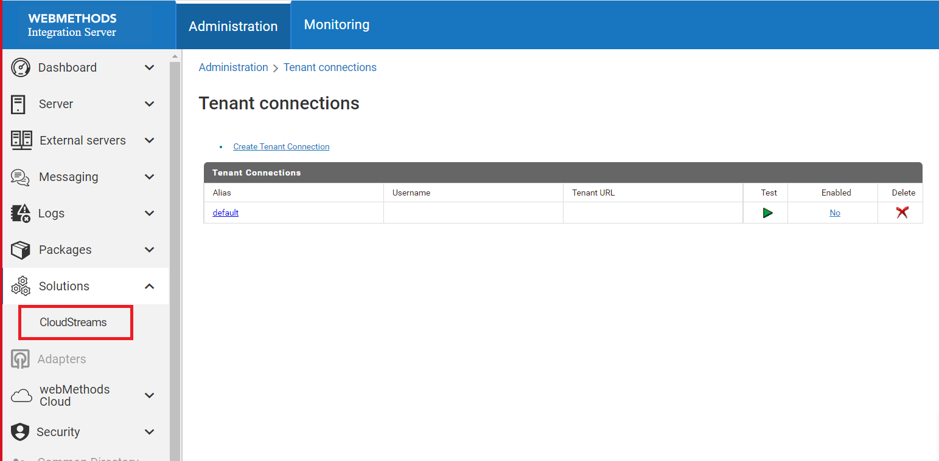

1. After navigating to CloudStreams tab, click on Providers->Autopilot and click on “WmAutopilotProvider” connector.

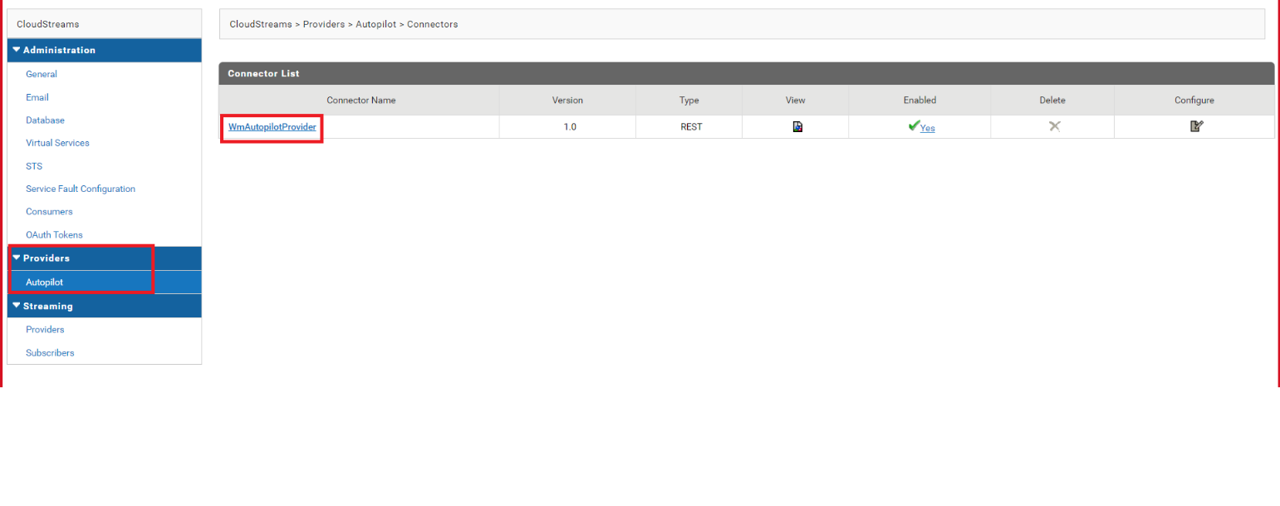

1. Click on “Configure New Connection” and provide the values as shown below:

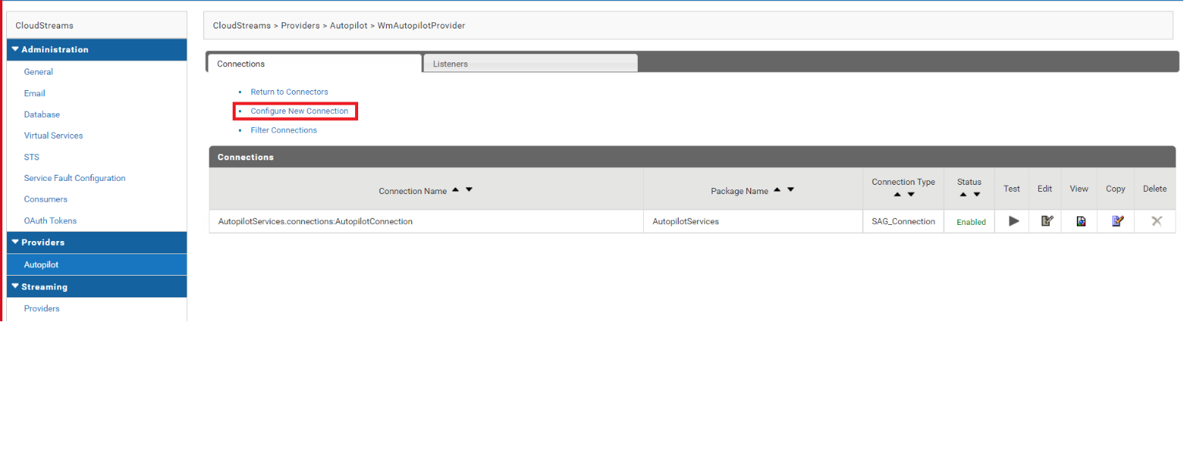

1. Enable the connection by clicking on “Disabled”(A popup asking for confirmation would appear, click “Ok” to proceed):

The connection will then be enabled as shown below:

1. **Creating the connection on webmethods.IO**
2. Login to https://wmioconnectorsdev.int-az-us.webmethods.io/#/ and navigate to the project - “ManualPilot”.Click on the project and navigate to “Flow Services” section in the “Integrations” tab as shown below:

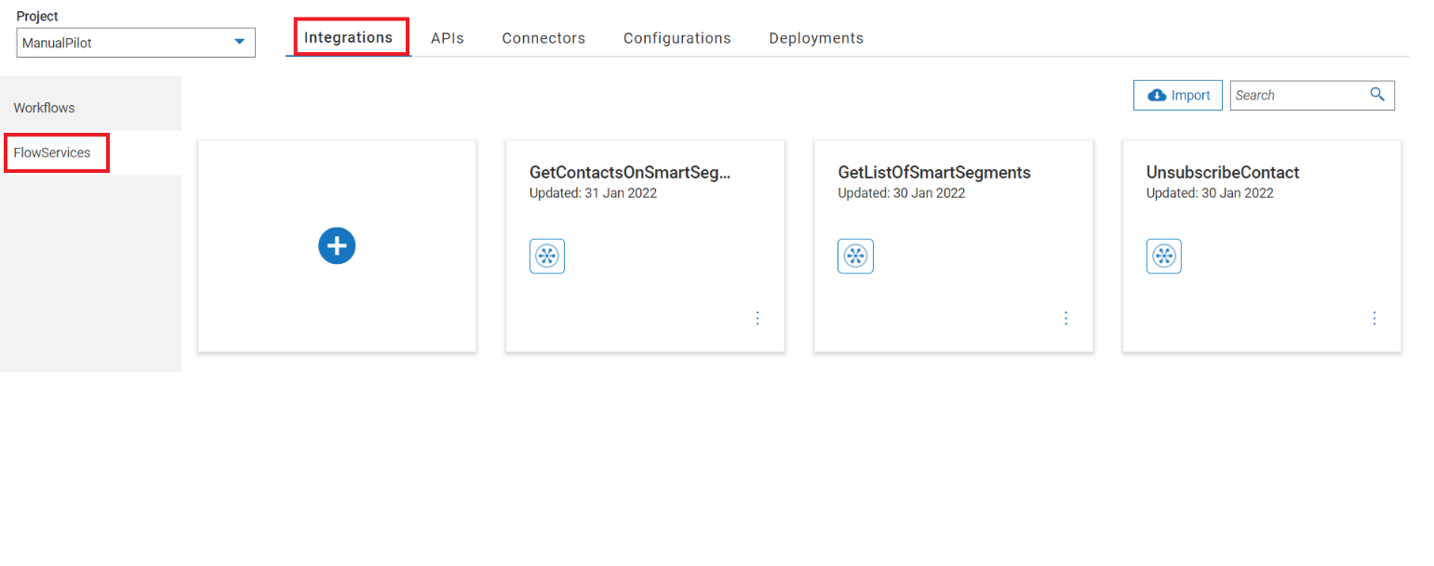

1. Click on “+” button to create a new flow service. In the 1st step of the flow service, search for the provider name i.e WmAutopilotProvider. Then click on “Add Custom Operation” in the drop down.

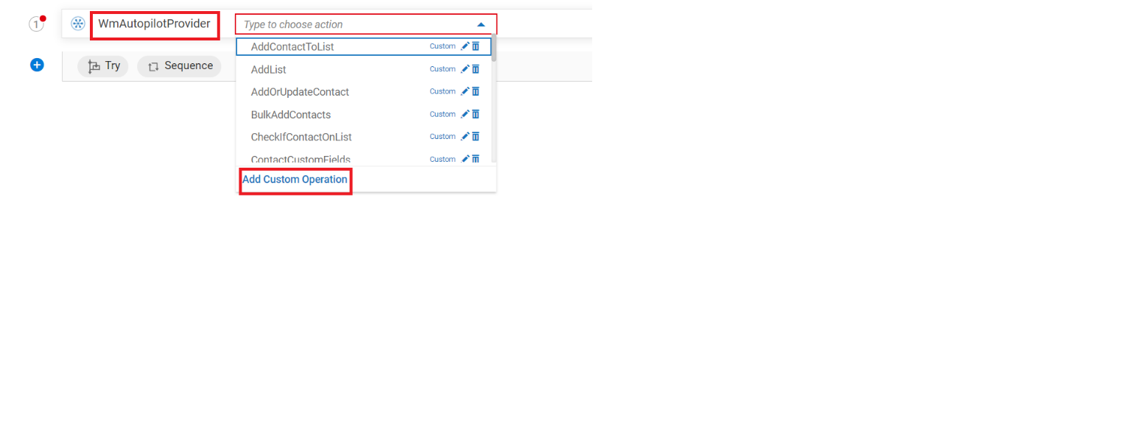

1. Click on the “+” button to create a new account as shown below:

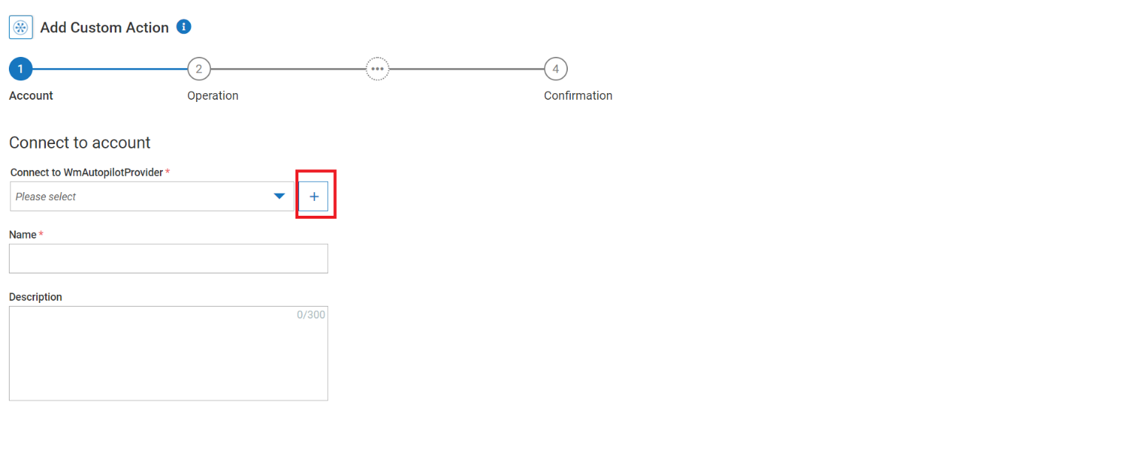

1. Provide the name of your connection, server URL and API key and click on “Add”

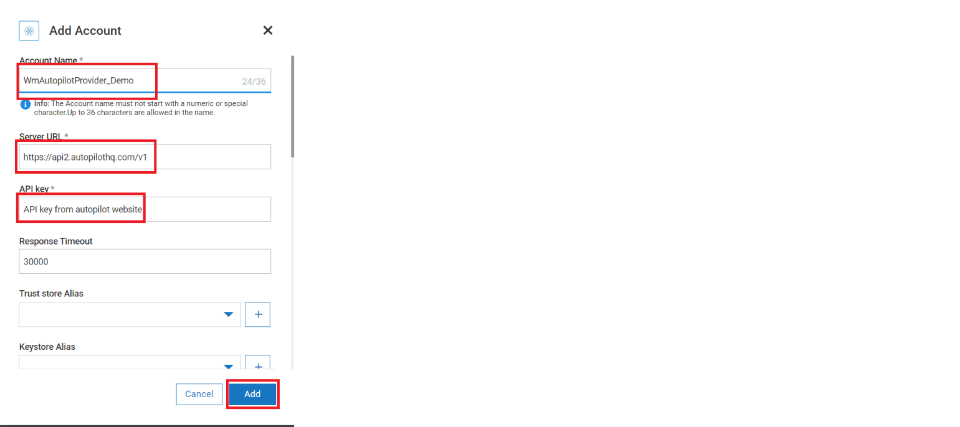

# webMethods CloudStreams Provider for Autopilot Connector

## Connector Details

The connector details include:

* **SaaS Provider**: Autopilot
* **API Version**: v1
* **API Type**: REST
* **Developers**: KS Pavithra, Prasanna SP
* **Group**: Autopilot
* **CloudStreams Minimum Version Compatibility**: 10.11
* **Provider Package Name**: WmAutopilotProvider

### Supported Resources

List down resources supported by the provider:

|  |  |  |  |  |
| --- | --- | --- | --- | --- |
| **Service: Bundle** | | | | |
|  | **Name** | **Path** | **Method** | **Description** |
| 1 | Add Or Update Contact | /v1/contact | POST | Autopilot has a standard set of fields which represent each contact. You are able to set any of these fields via this call. If a contact doesn't already exist, it will be created. If a contact with the same email address exists, it will be updated. |
| 2 | Bulk Add Contacts | /v1/contacts | POST | Autopilot has a standard set of fields which represent each contact. You are able to set any of these fields via this call. If a contact doesn't already exist, it will be created. If a contact with the same email address exists, it will be updated. |
| 3 | Get All Contacts | /v1/contacts/bookmark | GET | Get a list of all of the contacts for your account. You will be given a JSON object with 2 or 3 properties as a reply |
| 4 | Get Contact | /v1/contact/contact_id_or_email | GET | Retrieves the given contact record. |
| 5 | Delete Contact | /v1/contact/contact_id_or_email | DELETE | Remove the contact from database. Deleting a contact is permanent, and there is no way to undo it. |
| 6 | Unsubscribe Contact | /v1/contact/contact_id_or_email/unsubscribe | POST | This method will unsubscribe the contact from receiving emails from your Autopilot Journeys. |
| 7 | Add contact to journey | /v1/trigger/trigger_id/contact/contact_id_or_email | POST | Add a contact to a particular Autopilot journey. |
| 8 | Get List of Journeys containing API triggers | /v1/triggers | GET | Programmatically get a list of published journeys which contain an API trigger. |
| 9 | Get List of Lists | /v1/lists | GET | Get a list of all available lists which you can add contacts to, remove contacts from or get a list of contacts on. |
| 10 | Add List | /v1/list | POST | Lists are used in Autopilot to group contacts together. A contact can belong to as many lists as you like. This method allows you to add a new list. It will appear in the tree in the Contacts section of Autopilot |
| 11 | Get Contacts On List | /v1/list/list_id/contacts/bookmark | GET | Get a list of all of the contacts which are on this list. |
| 12 | Check If Contact On List | /v1/list/list_id/contact/contact_id_or_email | GET | This method checks if a contact belongs to a particular list. |
| 13 | Add Contact To List | /v1/list/list_id/contact/contact_id_or_email | POST | This method will add a contact to a list. |
| 14 | Remove Contact From List | /v1/list/list_id/contact/contact_id_or_email | DELETE | This method can be used to remove a contact from a list. |
| 15 | Get List of Smart Segments | /v1/smart_segments | GET | Get a list of all available smart segments. |
| 16 | Get Contacts On Smart Segment | /v1/smart_segments/smart_segment_id/contacts/bookmark | GET | This method will return a list of all of the contacts which are on this smart segment. It does not support lists. |
| 17 | Get Custom Fields | /v1/contacts/custom_fields | GET | Get a list of all custom fields. |
| 18 | Get Account | /v1/account | GET | This method retrieves the account information of the primary account holder of the Autopilot instance associated with the provided API key. |
| 19 | Get Email | /v1/email/email_id | GET | Retrieves an email campaign's data based on an ID received in the Autopilot Activity Stream. |
| 20 | Record Page Visit | /v1/pagevisit/visit | POST | This endpoint allows you to record a page visit programmatically using your own sessionId, which you can then use later with the /v1/pagevisit/associate endpoint to associate that session with a particular contact once you know who it is. |
| 21 | Associate Session | /v1/pagevisit/associate | POST | If you have been recording website visits with the /v1/pagevisit/visit endpoint then you need to also associate those sessionIds with an email address. This will allow the system to associate the recorded page visits with the correct contact in the system.  This is done by email address in Autopilot. |
| 22 | Delete Contact Activity Feed | /v1/contact/contact_id_or_email/activityfeed/type_of_activities | DELETE | Calling this method with the contact_id or email address of the customer will result in their entire activity feed being deleted. |
| 23 | Register REST Hook | /v1/hook | POST | Rather than having your system continuously poll to find out when there is new information to trigger from, we allow you to register a URL which we will call when these events occur, called a "REST Hook". Whenever an event you have registered for occurs, for example a new contact being added to Autopilot, we will send a HTTP POST to your URL with information about that event for your system to act upon. |
| 24 | Unregister REST Hook | /v1/hook/hook_id | DELETE | When you no longer wish your target_url to be POSTed to when the registered Autopilot event happens, you may unsubscribe an endpoint URL by providing the hook_id which was given to you when you registered. |
| 25 | List REST Hook | /v1/hooks | GET | Get a list of all REST Hooks registered in your Autopilot account |
| 26 | Delete All REST Hooks | /v1/hooks | DELETE | Calling this will delete all REST Hooks and we will stop hitting your end points when events occur. |

### Usage Notes

Usage has been covered in the document in “test” folder