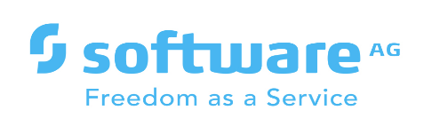

**webMethods CloudStreams Provider for MeisterTask**

Version <IS version> | January 2022

Contents

1 Document Change History 3

2 What is webMethods CloudStreams Provider for <SaaS Name>? 4

3 Steps to create the connector connection 5

4 webMethods CloudStreams Provider for <SaaS name> Connector 6

4.1 Connector Details 6

4.1.1 Supported Resources 6

4.1.2 Usage Notes 6

# Document Change History

|  |  |
| --- | --- |
| **Document revision date** | **Summary of changes** |
| January 2022 | First release of this document. |

# What is webMethods CloudStreams Provider for MeisterTask

[MeisterTask](https://www.meistertask.com/) is a flexible project management app that scales from personal project tracking to a full-blown project management tool for a large team. It's based on the Kanban task management system, but it can be adapted and customized based on the needs of your project or company

Some of the features available in MeisterTask :

**Projects**: Projects in MeisterTask are similar to boards in Trello—they're the top-level of organization within your account. MeisterTask's collaboration features work on a per-project basis, so you can use different projects to collaborate with different teams and co-workers.

**Tasks**: What Trello refers to as cards, MeisterTask calls tasks. And that's exactly what they are: to-do items.

MeisterTask Cloudstream connector has the capabilities to create new project/task as well as get all projects/tasks from MeisterTask application. Hence a webMethods.io application can interact with MeisterTask and can perform all functionalities through this connector for project management.

# Steps to create the connector connection

Authorization Method:

MeisterTask supports OAuth 2.0 for authentication

* Registered the application in MeisterTask to get the client ID and client secret
* Authorization code is obtained using client ID and client secret
* A non-expiring Access token is obtained from Meister Task using authorization code and other details
* This access token is used as **API key** for all our operation in wM.io

Connector creation in wM.io

* 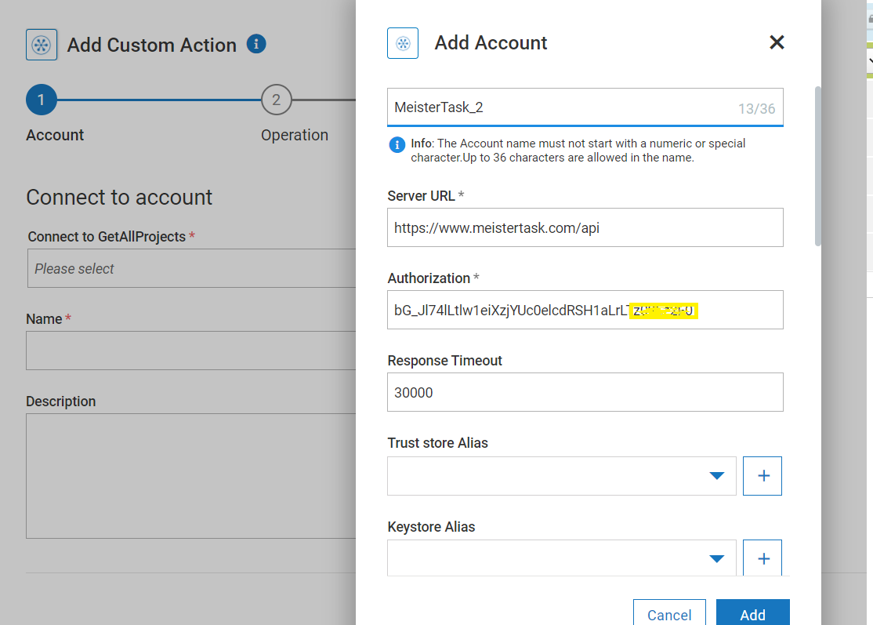

# webMethods CloudStreams Provider for MeisterTask Connector

## Connector Details

The connector details include:

* **SaaS Provider**: MeisterTask
* **API Version**: V2
* **API Type**: Rest
* **Developer**: Bharathipriya.TS , Udhaya Kumar S
* **Group**: MeisterTask
* **CloudStreams Minimum Version Compatibility**: 10.11
* **Provider Package Name**: MeisterTaskProvider

### Supported Resources

List down resources supported by the provider:

|  |  |  |  |  |
| --- | --- | --- | --- | --- |
| **Service: Bundle** | | | | |
|  | **Name** | **Path** | **Method** | **Description** |
| 1 | Get All Projects | https://www.meistertask.com/api/projects | GET | Get all active projects in MeisterTask. |
| 2 | Create New Projects | https://www.meistertask.com/api/projects? ?name=&notes= | POST | Create new project in MeisterTask |

[/projects/:project_id/tasks · MeisterTask](https://developers.meistertask.com/v1.0/docs/get-project-tasks)

### Usage Notes

Since API key is not available in list of authentication type in cloudStream connector, we have added custom authentication type and used it as header in operations.

