

**webMethods CloudStreams Provider for Recruitee**

Version <IS version> | January 2022

Contents

1 Document Change History 1

2 What is webMethods CloudStreams Provider for Recruitee? 1

3 Steps to create the connector connection 1

3.1. Creating provider 1

3.2. Creating connection 1

3.3. Creating resource and adding authentication 1

3.4. Publishing connector 1

3.5. Creating and testing Cloud connector service 1

3.6. Creating Workflow and testing in cloud tenant 1

4 webMethods CloudStreams Provider for Recruitee Connector 1

4.1 Connector Details 1

4.1.1 Supported Resources 1

4.1.2 Usage Notes 1

# Document Change History

|  |  |
| --- | --- |
| **Document revision date** | **Summary of changes** |
| January 2022 | First release of this document. |

# What is webMethods CloudStreams Provider for Recruitee?

Recruitee is a business producing or selling computer "software as a service"(Saas.) The software functions as an applicant tracking system for handling applications for jobs. It is the collaborative hiring software that delivers the complete solution to help internal HR teams work with the rest of their organization to hire better together.

It includes a careers site editing system for employer branding, a plugin for sourcing (personnel) (otherwise called recruitment), employment website integration, email and calendar synchronization.

With an easy-to-use interface, Recruiter and the Recruitee find it easy to navigate through intuitive UX to build custom pipelines, attract and source top talent, evaluate candidates, and hire future team members. Recruitee provider application allows create the connectors to perform various Recruitment related task like creating, updating, deleting, viewing job offers, candidates, departments along with scheduling the interviews, releasing the offers etc.

For more information about how to configure and use CloudStreams connectors with webMethods CloudStreams, see the Administering webMethods CloudStreams document available in the **webMethods** section of the [Software AG Documentation](http://documentation.softwareag.com) web page.

# Steps to create the connector connection

## Creating provider

In Software AG Designer, go to **Window > Perspective > Open Perspective > CloudStreams Providers**

Enter project name and connector details, endpoint of the API provider, authentication mode etc.

This will automatically create a package with provider name in development perspective with below structure

Open connection under the Recruitee REST service. Go to connection tab, select Authentication Type as ‘None’ and add Custom connection as below.

## Creating connection

Recruitee provider will get created in IS admin page. Navigate to IS 🡪 Solutions 🡪 CloudStreams. Under providers tab, we can view the created provider. Click on RecruiteeV2 connector.

Configure new connection as below. Create a package in local and provide the package path while configuring the connection. Enter the BearerToken value and click save. Enable the connection.

This will create connection in designer as well.

## Creating resource and adding authentication

Create the resource by right clicking on the Resources, fill the resource path and REST method.

Resource can be renamed under General tab.

Add the authorization for resource. Select the value as Assign from Connection parameters, so that the value mentioned in IS cloud stream connection page will be taken at run time.

If the resource needs any parameters to be passed, go to parameters tab, Add and select the style as URI context/Query paramter and enter the parameter fields name. click finish

Add request response document types along with response codes range.

Required documents can be created under Provider package 🡪 doctypes section, which can be used as document references in request response body.

## Publishing connector

For publishing the resource to cloud tenant. Add Cloud Tenant in designer under Preferences.

Right click on the provider and click publish. Select the targets where you want the resources to be published.

Enable the options as below for resource visibility in tenant cloud

Publish successful status on target servers will be shown

## Creating and testing Cloud connector service

Create Cloud connector services to test the resources in local server as below.

Select connector name and connection

Select the required resource and click Finish, Save.

Similarly create Connector services to test all CRUD resources created under Cloud stream perspective.

Run the service and test by passing required inputs

Success response with output

## Creating Workflow and testing in cloud tenant

Login to Cloud tenant to test cloud stream connector from wm.io using workflow.

Create new workflow by clicking on the ‘+’

In the search bar enter the connector name. Drag and drop the required connector in workflow.

Click on the settings of connector to configure the resource.

Create/Select the action of connector to be performed and the account for running that action.

Configure the action by adding Account to execute an operation/resource and confirm.

Test the action by passing Authorisation details and required parameters.

Connector is tested successfully

Connector can also be tested by clicking on Run button.

# webMethods CloudStreams Provider for Recruitee Connector

## Connector Details

The connector details include:

* **SaaS Provider**: Recruitee
* **API Version**: V2
* **API Type**: REST
* **Developer**: Neha Alladi
* **Group**:
* **CloudStreams Minimum Version Compatibility**: 10.11
* **Provider Package Name**: WmRecruiteeProviderV2

### Supported Resources

Resources supported by the provider:

|  |  |  |  |  |
| --- | --- | --- | --- | --- |
| **Service: Bundle** | | | | |
|  | **Name** | **Path** | **Method** | **Description** |
| 1 | createCandidate | https://api.recruitee.com/c/74497/candidates | POST | Create a new candidate |
| 2 | createOffer | https://api.recruitee.com/c/74497/offers | POST | Create new job opening |
| 3 | deleteCandidate | https://api.recruitee.com/c/74497/candidates/{id} | DELETE | Delete a candidate |
| 4 | deleteOffer | https://api.recruitee.com/c/74497/offers/{id} | DELETE | Delete job offer |
| 5 | getCandidates | https://api.recruitee.com/c/74497/candidates/{id} | GET | Get the list of candidates |
| 6 | getDepartments | https://api.recruitee.com/c/74497/departments | GET | Get the list of departments |
| 7 | getOffers | https://api.recruitee.com/c/74497/offers/{id} | GET | Gets the list job offers |
| 8 | updateCandidate | https://api.recruitee.com/c/74497/candidates/{id} | PATCH | Update the candidate info |
| 9 | updateOffer | https://api.recruitee.com/c/74497/offers/{id} | PATCH | Update job offer info |
| 10 | attachFile | https://api.recruitee.com/c/74497/attachments | POST | Attach a file to job offer or candidate |

### Usage Notes

**SAAS provider site**

<https://recruitee.com/>

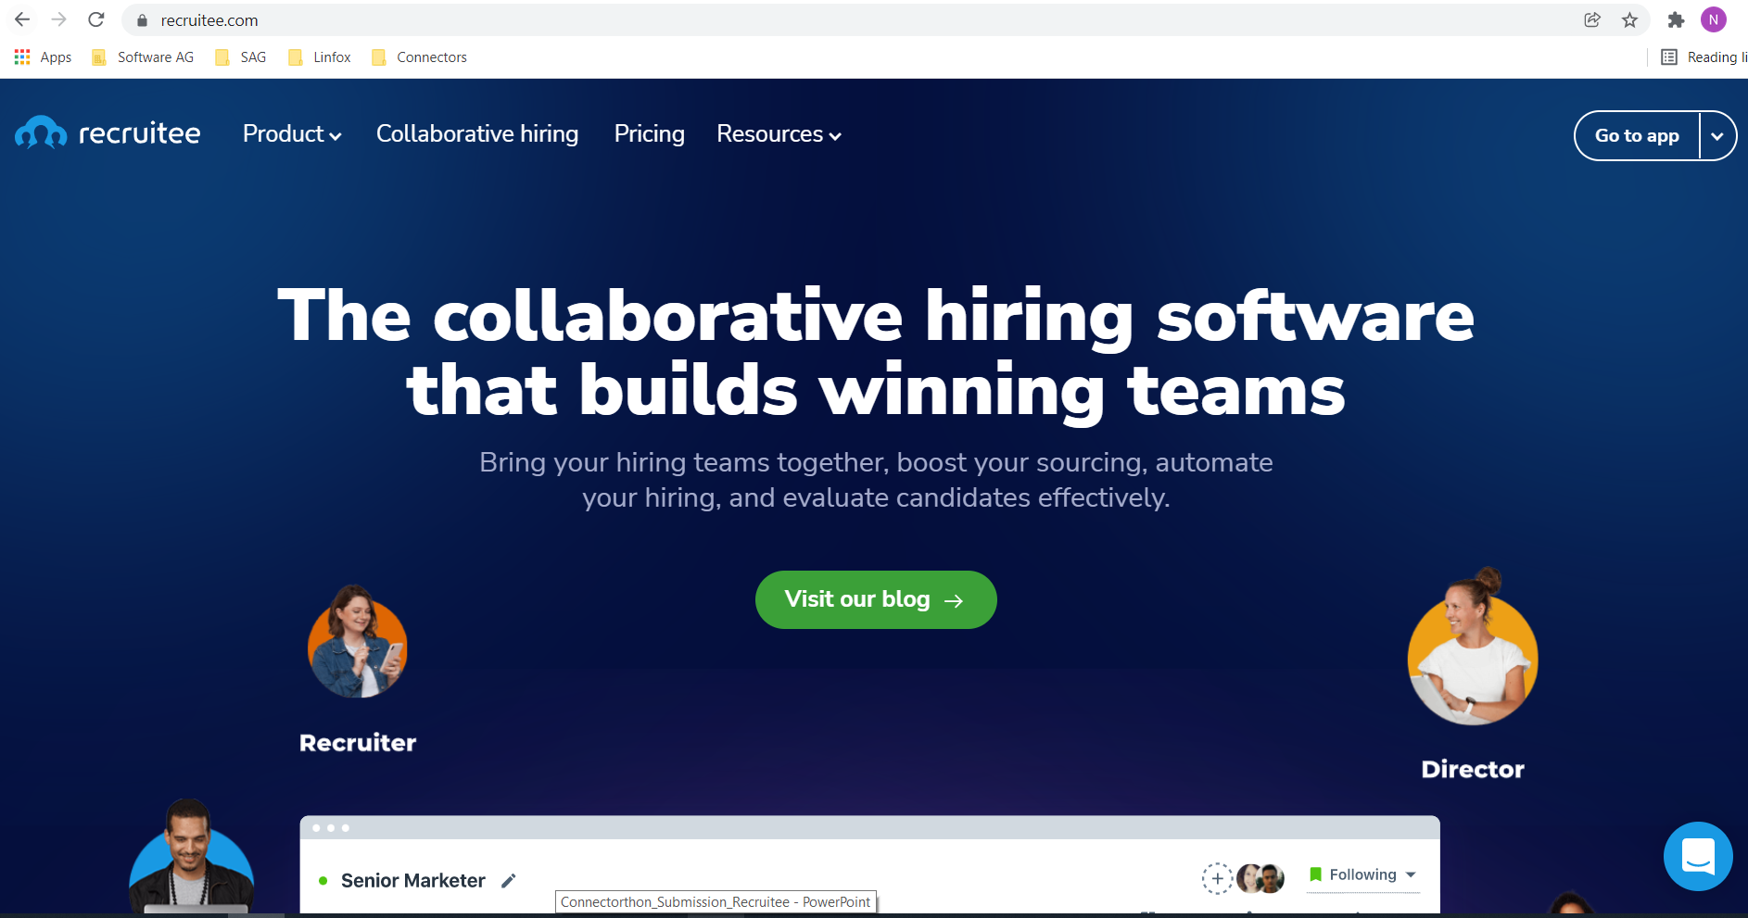

**SAAS provider Developers API reference page**

<https://docs.recruitee.com/reference/intro-to-careers-site-api>

**Token generation steps**

<https://docs.recruitee.com/reference/getting-started>

