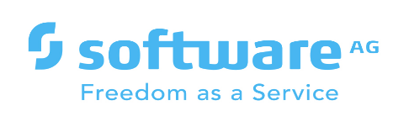

**webMethods CloudStreams Provider for AirTable**

Version 10.11 | January 2022

Contents

1 Document Change History 3

2 What is webMethods CloudStreams Provider for <SaaS Name>? 4

3 Steps to create the connector connection 5

4 webMethods CloudStreams Provider for <SaaS name> Connector 6

4.1 Connector Details 6

4.1.1 Supported Resources 6

4.1.2 Usage Notes 6

# Document Change History

|  |  |
| --- | --- |
| **Document revision date** | **Summary of changes** |
| January 2022 | First release of this document. |

# What is webMethods CloudStreams Provider for AirTable?

Airtable is a relational database tool that's also an [online collaboration tool](https://in.pcmag.com/software/94860/the-best-online-collaboration-software-for-2020), it is easy to use and extremely versatile. User can use it to manage work, track and organize inventories, plan an event, and much more.

Airtable is an online system where a group of collaborators can store, share, and collaboratively edit information. The information might be ideas, inventory, tasks, or something else.

Airtable comes with a helpful selection of templates, which may give you more ideas about how you can use it. For example, there are templates called Social Media Calendar, Wedding Planning, Nonprofit Grant Tracker, Employee Onboarding, Bug Tracker, Product Launch, and many others

# Steps to create the connector connection

Write down the steps to create the connection.

* To Create a connector connection, create a custom action by selecting setting option

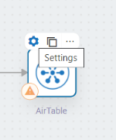

* create a custom action by clicking '+' for this connector.
* create a connection by clicking '+' for this custom action.
* Enter below values.
  + Account Name : Airtable_2
  + Server URL : https://api.airtable.com/v0
  + Authorization : API KEY (Bearer Token)
  + Keep rest all values as default.

* After creating connection, select the operation and click Next.

* Click Done.

# webMethods CloudStreams Provider for AirTable Connector

## Connector Details

The connector details include:

* **SaaS Provider**: AirTable
* **API Version**: 1.0
* **API Type**: Rest
* **Developer**: Niveed Kumar Reddy Bollapally, Sumanth Lakshman
* **Group**: sagmaze
* **CloudStreams Minimum Version Compatibility**: 10.11
* **Provider Package Name**: airTable

### Supported Resources

List down resources supported by the provider:

|  |  |  |  |  |
| --- | --- | --- | --- | --- |
| **Service: Bundle** | | | | |
|  | **Name** | **Path** | **Method** | **Description** |
| 1 | getProjects | /{base}/Projects/{id} | GET | To retrieve an existing record in Projects table |
| 2 | getProjectsList | /{base}/Projects?maxRecords=&view=&api_key= | GET | To list records in Project Table |
| 3 | createProjects | /{base}/Projects | POST | To create new records |
| 4 | deleteProject | /{base}/Projects/{records} | Delete | To delete Projects records |
| 5 | updateProjects | /{base}/Projects | PATCH | To update Projects records. |

### Usage Notes

Any special notes