Installation Guide

for

App Transformation

Document Version No.: 1.0
Release Date:

REVISION HISTORY

Date | Version No. | Prepared By | Reviewed By | Approved By | Summary of Changes
29/10/2020 | 1.0 | S.Latha

TABLE OF CONTENTS
Introduction 4
Purpose of this document 4
Recommended Hardware Requirements 4
Recommended Software Requirements 4
Prerequisites: 5
Azure Account 5
PowerShell 5
Install App Transformation using Package Script 5
Folder Structure of Executable Package: 7
Configure after installation 8
GitHub Account Configuration: 8
Configure Environment variables 8
Setup Path for 7 zip 9
Setup Path for Java and Maven 9
Login into Azure 10
PostgreSQL Server 10
Running Java API 10
Configuration 11
Running Server 11
Configuration 12
Running Client 13
Configuration: 13

Introduction

In this Installation Guide, we have included the installation of Server API, Java API, Portal, and dependent packages to run the application transformation tool. Once it is installed successfully, end-user can transform their monolithic applications to microservices. Server API act as a backend of Portal and used to transform DotNet Application (ASP.Net MVC, ASPX) to DotNet Micro services. Java API is used to transform Java Spring Boot application to Java Micro services. Apptrans Portal helps the end user to transform their monolithic applications to Micro services and deploy into multi-cloud.

Purpose of this document
This document explains how to install the services and configure the monolithic application to transform into micro services.

Recommended Hardware Requirements
- Windows OS

Recommended Software Requirements
- Dotnet Core 3.1
- Git Bash
- Java JDK
- PostgreSQL
- Node JS NPM V12.18.4
- Azure Functions Core Tools
- Azure CLI and Azure DevOps CLI
  - azure-cli-2.12.0.msi
  - az extension add --name azure-devops
- AWS Lambda Tools and Templates for Dotnet
  - dotnet new -i Amazon.Lambda.Templates
  - dotnet tool install --global Amazon.Lambda.Tools

- MVN
- Gradle
- 7 Zip

Prerequisites:

Azure Account
Account in Azure for the following setup
  - Azure pipeline.
  - Host APP Trans Server.
  - Create a Service Connection in azure pipeline for APP Trans Server.
  - Host PostgreSQL Server.

PowerShell
  - Run Windows PowerShell as administrator
  - Type Set-ExecutionPolicy RemoteSigned to set the policy to RemoteSigned.
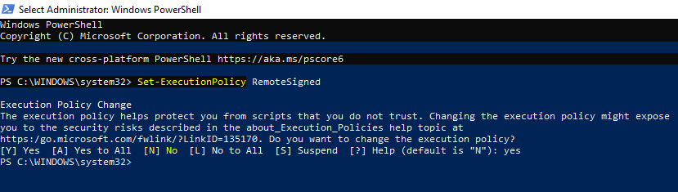

Install App Transformation using Package Script

App Transformation Packaged Zip has following PowerShell Scripts:
- Install-AppTrans.ps1
- Config-AppTrans.ps1

Note: First run the script Install-AppTrans.ps1 - To install all the dependent package.
Second run the script Config-AppTrans.ps1 - To download App Trans Executable Package and setting the required configuration.

Open the PowerShell as an administrator always to run the scripts.

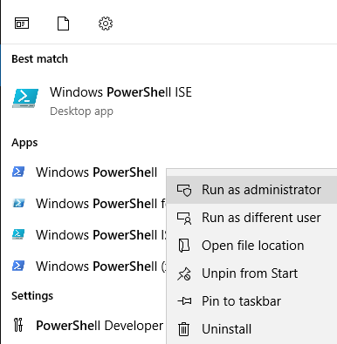

First run the script Install-AppTrans.ps1 and close the PowerShell window after the installation of software.

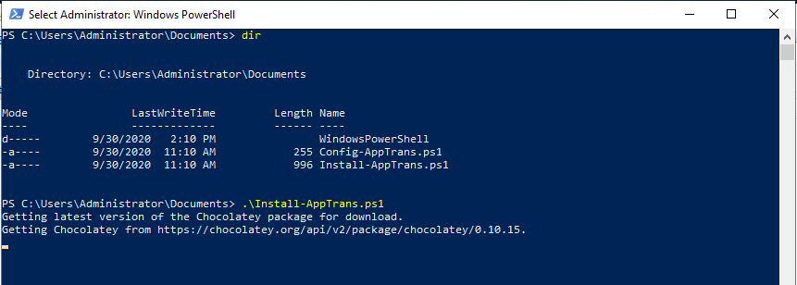

Open the new Power Shell window as an administrator and run the script Config-AppTrans.ps1 script to Install the Executable Package of App Transformation.

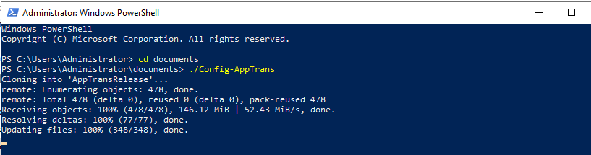

Specify the given GitHub credential to clone the executables. Below GitHub credential can be used to download the Executable Package.
Username: cloudifyhexa
Password: Hexaware00@

Folder Structure of Executable Package:

After running the scripts, “AppTransRelease” folder will be available in the path C:\AppTransRelease.

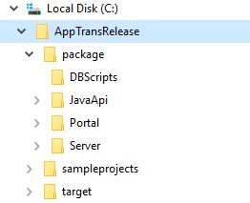

Details of each folder:
- C:\AppTransRelease\package\Server => Holds the executable files for App Trans Server.
- C:\AppTransRelease\package\Portal => Holds the executable files for App Trans Portal.

- C:\AppTransRelease\package\JavaAPI => Holds the executable file for Java API
- C:\AppTransRelease\package\DBScripts => Holds schema for tables.
- C:\AppTransRelease\package\target => Holds the template for Azure Pipeline which is used to create the Azure Pipeline automatically.

Configure after installation

GitHub Account Configuration:

This is the GitHub configuration used to push the extracted microservices into the GitHub Repository. Hence, end user can configure their own GitHub credentials.

Configure GitHub credentials in the system by giving the below command in the command prompt.
git config --global user.email <<GitHub Mail Id>>
git config --global user.name <<GitHub User Id>>
Note:
If any git user is configured in the local system, it can also be deleted by going to Control Panel\User Accounts\Credential Manager

Configure Environment variables

Setup PAT for GitHub-Azure Pipeline:
The Personal Access Token (PAT) is required to create the service connection for the GitHub Repo in Azure pipeline. For automation purpose set the GitHub PAT token using the AZURE_DEVOPS_EXT_GITHUB_PAT environment.
Steps are as follows:

- Create PAT in GitHub which is used to give the access to create Pipeline in Azure. PAT should be created in the same GitHub where the extracted microservices are pushed from App Transformation.

The Access for personal token is as follows
admin:repo_hook, delete_repo, repo

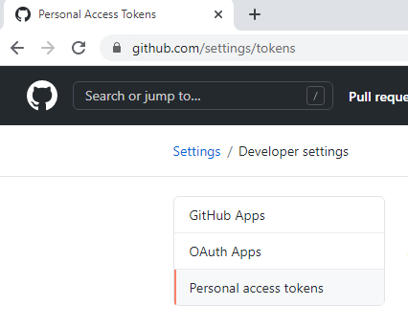

- Add the PAT to User Environment variable.
Variable Name: AZURE_DEVOPS_EXT_GITHUB_PAT
Value: PAT (which is created in GitHub)
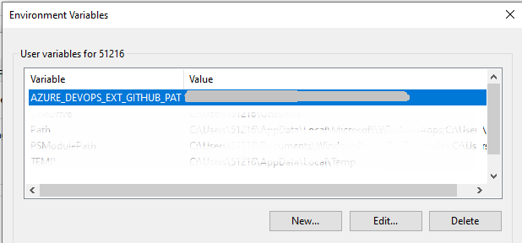

Setup Path for 7 zip

Set Environment variables for User

C:\Program files\7-Zip

Setup Path for Java and Maven

C:\Program Files\Java\jre1.8.0_261\bin
C:\apache-maven-3.6.3-bin\bin

Login into Azure
Initiate the Azure by login using below command in command prompt

Az Login

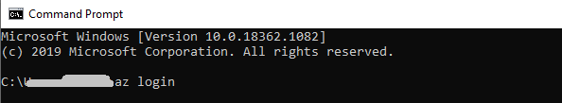

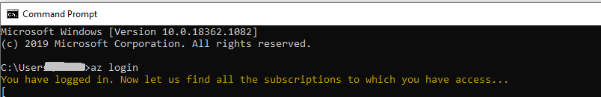

PostgreSQL Server

Schema is used to create the following tables.
- Servicestatus
- Sourceapp

Running Java API

Below command is used to run the App Trans Java API from the Executable Package folder path C:\AppTransRelease\package\JavaAPI

java -Xmx4028m -Dusr.name=<<username>> -Dtarget.folder=<<target folder>> Apptrans-0.0.1-SNAPSHOT.jar

Sample screen shot:

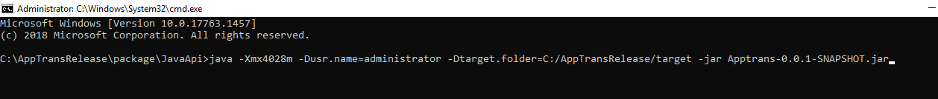

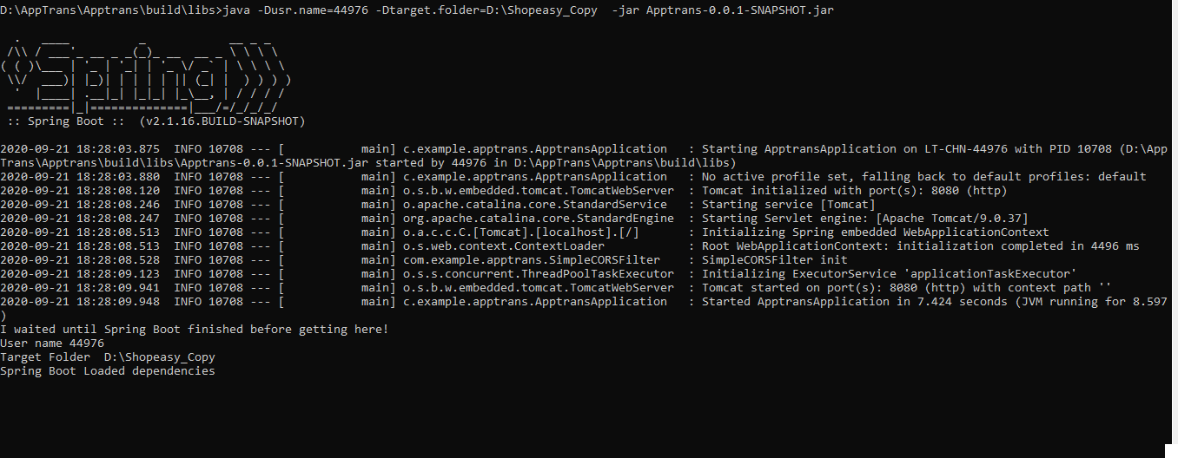

Configuration
Command argument holds the below configuration:

- System Username
  - Holds the username of the system.
-Dusr.name = << UserName>>

- Target Folder
  - The default value is C:\AppTransRelease\target which holds the template for Azure Pipeline.

-Dtarget.folder = <<Target Path>>

Running Server
Below command is used to run the App Trans Server from the Executable Package folder path C:\AppTransRelease\package\Server.

transwebapi

The default host is https://localhost:5001/api

Sample screen shot:

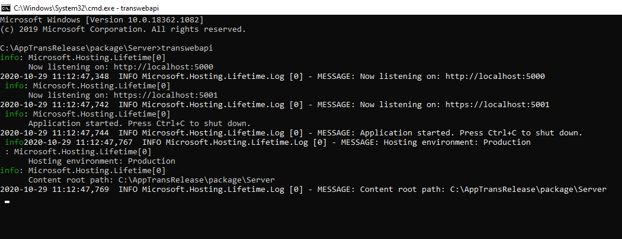

Configuration
Appsettings.json holds the configurations. Below values can be configured.

- Database connection string:
  - Holds the connection string of PostgreSQL server.

"ConnectionStrings": {

"transdb": << Connection String >>
},
- Configure JavaApi:
  - Holds the URL of Java API. The default URL is http://localhost:8080 after running Java API.
"javaapibaseurl": << Java API URL >>

- Target Folder:
  - The default value is C:\AppTransRelease\target which holds the template for Azure Pipeline.
"targetpath": << Target Folder Path>>

Running Client

This is a User Interface to help the end-user for the Application Transformation.

Below command is used to run the App Trans Portal from the Executable Package folder path C:\AppTransRelease\package\Portal.
npm start

Sample Screen shot:

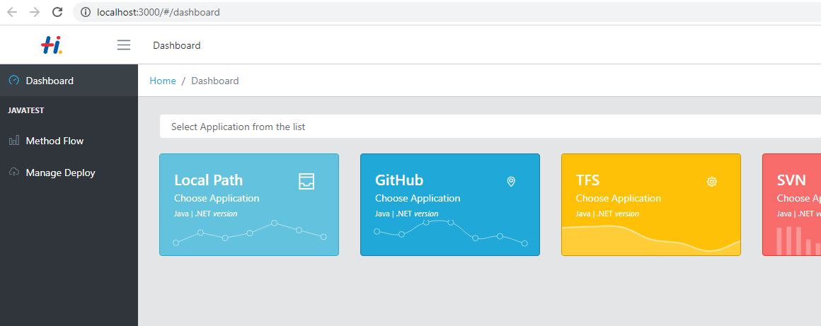

Configuration:
Configure the Server URL. The default value is https://localhost:5001/api

