Differentiation point of CloudKibo:
- File Transfer with unlimited size
- Screen sharing which is rarely found in other communication apps
- CloudKibo initially started as R&D product and its deployed in any country as enterprise or Telco (Telecommunication company)
- CloudKibo is not a short term product to be marketed but it is built as an application which yet has to explore many features in its long term destination
- Main objective of CloudKibo is to provide long term advantage and build stable customer base

Finding of critical gaps of CloudKibo:
- The biggest gap of CloudKibo in terms of marketing is that it didn’t build up an android/IOS app in the very beginning. People these days usually prefer using apps on their mobile phones rather web-based communication
- Due to weak website/interface content, it couldn’t build up an attractive marketing campaign
- Usage of testimonials on the website would have provided credibility and reliability factor to the target audience but CloudKibo has not worked in these areas yet
- Also, in comparison with other communication apps, CloudKibo does not have Online tutorials on its website.
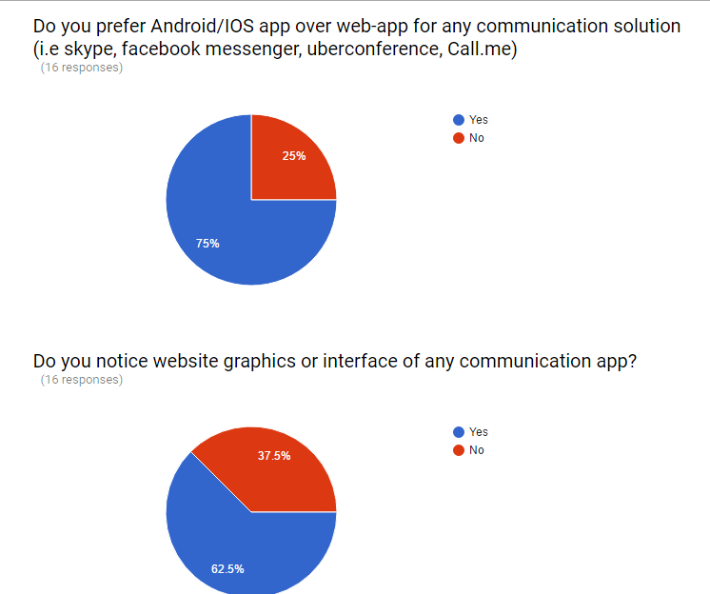

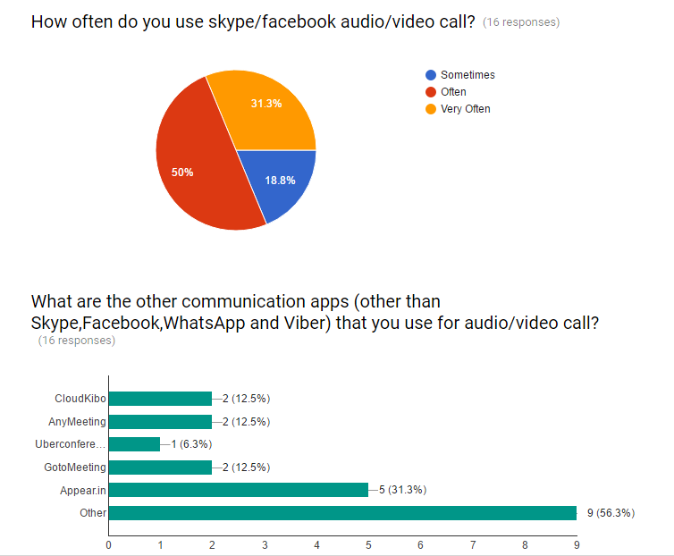
Surprisingly many people prefer IMO, Tango, Appear.in and WebEx over the competitor vendors of CloudKibo

Questions.
How is N2N solution connected with CloudKibo?
What are the opportunities for CloudKibo in terms of technological areas? Need for SWOT analysis.
Can we expand CloudKibo’s target audience to the public?
Next Week Task
1) I will be working on the remaining sections of SWOT analysis i.e opportunities and threats
2) I will compile all of the marketing strategies necessary for CloudKibo
3) I will also try to write some content for the website homepage.
.

