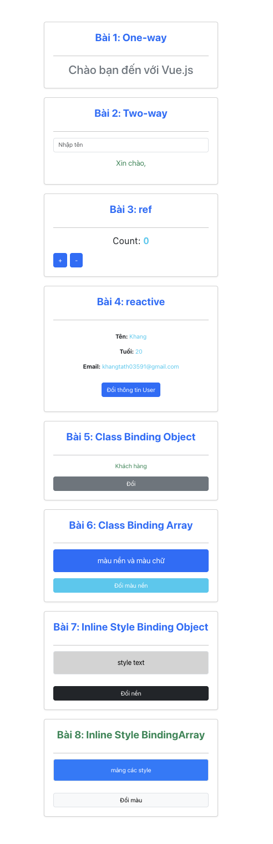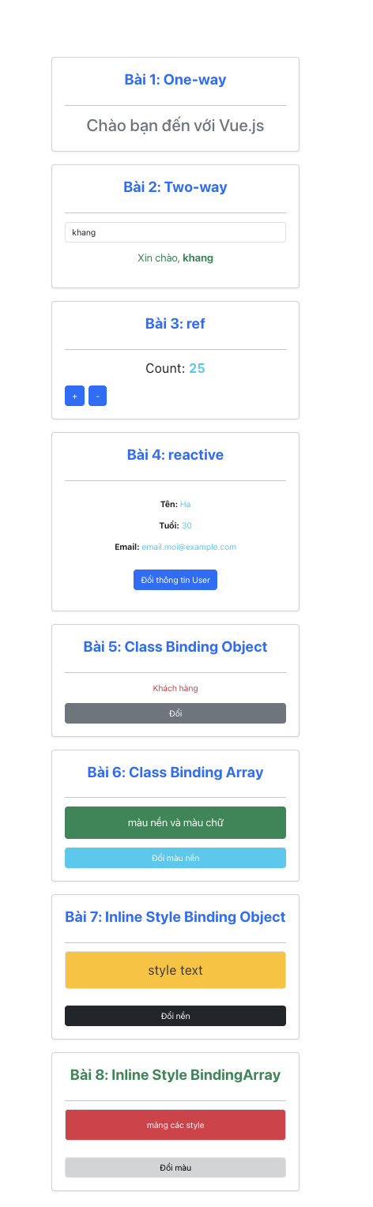

<script setup>

import { reactive, ref } from 'vue';

const title = ref('Chào bạn đến với Vue.js');

const name = ref('');

const count = ref(0);

const cong = () => {

count.value++;

};

const tru = () => {

count.value--;

};

const user = reactive({

name: 'Khang',

age: 20,

email: 'khangtath03591@gmail.com'

});

const changeUserAge = () => {

user.age = 30;

user.name = 'Ha';

user.email = 'email.moi@example.com'

};

const isVip = ref(true);

const doiVip = () => {

isVip.value = !isVip.value;

};

const mainClass = ref('bg-primary');

const textClass = ref('text-white');

const toggleClass = () => {

mainClass.value = mainClass.value === 'bg-primary' ? 'bg-success' : 'bg-primary';

};

const styleObject = ref({

backgroundColor: 'lightgray',

fontSize: '18px',

padding: '10px',

borderRadius: '5px',

color: 'black'

});

const changeStyle = () => {

styleObject.value.backgroundColor = '#ffc107';

styleObject.value.fontSize = '24px';

styleObject.value.color = '#343a40';

};

const style1 = reactive({ backgroundColor: '#007bff', padding: '10px', color: 'white', borderRadius: '5px' });

const style2 = reactive({ border: '2px solid #28a745' });

const toggleStyle = () => {

style1.backgroundColor = style1.backgroundColor === '#007bff' ? '#dc3545' : '#007bff';

style1.color = style1.backgroundColor === '#007bff' ? 'white' : 'white';

};

</script>

<template>

<div class="container my-5">

<div class="card p-4 mb-4 shadow-sm">

<h3 class="card-title text-primary mb-3">Bài 1: One-way</h3>

<hr>

<h2 class="text-secondary">{{ title }}</h2>

</div>

<div class="card p-4 mb-4 shadow-sm">

<h3 class="card-title text-primary mb-3">Bài 2: Two-way</h3>

<hr>

<div class="mb-3">

<input type="text" id="nameInput" v-model="name" placeholder="Nhập tên" class="form-control">

</div>

<p class="text-success fs-5">Xin chào, <span class="fw-bold">{{ name }}</span></p>

</div>

<div class="card p-4 mb-4 shadow-sm">

<h3 class="card-title text-primary mb-3">Bài 3: ref</h3>

<hr>

<p class="fs-4 mb-3">Count: <span class="fw-bold text-info">{{ count }}</span></p>

<div class="d-flex gap-2">

<button class="btn btn-primary" @click="cong">+</button>

<button class="btn btn-primary" @click="tru">-</button>

</div>

</div>

<div class="card p-4 mb-4 shadow-sm">

<h3 class="card-title text-primary mb-3">Bài 4: reactive</h3>

<hr>

<div class="card-body">

<p><strong>Tên:</strong> <span class="text-info">{{ user.name }}</span></p>

<p><strong>Tuổi:</strong> <span class="text-info">{{ user.age }}</span></p>

<p><strong>Email:</strong> <span class="text-info">{{ user.email }}</span></p>

<button class="btn btn-primary text-white mt-3" @click="changeUserAge">Đổi thông tin User</button>

</div>

</div>

<div class="card p-4 mb-4 shadow-sm">

<h3 class="card-title text-primary mb-3">Bài 5: Class Binding Object</h3>

<hr>

<div :class="{'text-success':isVip ,'text-danger':!isVip}"> Khách hàng</div>

<button class="btn btn-secondary mt-3" @click="doiVip">Đổi</button>

</div>

<div class="card p-4 mb-4 shadow-sm">

<h3 class="card-title text-primary mb-3">Bài 6: Class Binding Array</h3>

<hr>

<div :class="[mainClass, textClass, 'p-3', 'rounded', 'mb-3', 'fs-5']">

màu nền và màu chữ

</div>

<button class="btn btn-info text-white" @click="toggleClass">Đổi màu nền</button>

</div>

<div class="card p-4 mb-4 shadow-sm">

<h3 class="card-title text-primary mb-3">Bài 7: Inline Style Binding Object</h3>

<hr>

<div :style="styleObject" class="p-3 mb-3 border rounded d-inline-block">

style text

</div>

<button class="btn btn-dark mt-3" @click="changeStyle">Đổi nền</button>

</div>

<div class="card p-4 mb-4 shadow-sm">

<h3 class="card-title text-success mb-3">Bài 8: Inline Style BindingArray</h3>

<hr>

<div :style="[style1, style2]" class="p-3 mb-3 border rounded d-inline-block">

mảng các style

</div>

<button class="btn btn-light border mt-3" @click="toggleStyle">Đổi màu</button>

</div>

</div>

</template>

<style scoped>

.card-title {

font-weight: bold;

}

</style>