Cloud-Ready PostgreSQL Production Platform
Complete Project Documentation
PostgreSQL • Azure • Terraform • GitHub Actions • OIDC • RBAC • Backup & Recovery

Purpose of this document
This document consolidates the original 13-page Azure screenshot documentation with the completed project implementation record. It is intended to provide a single, employer-facing technical narrative covering the project from database foundation through Azure deployment, security hardening, infrastructure as code, CI/CD, cost management, troubleshooting, and final operating state.

Documentation status: Core implementation and documentation complete
September 2026

How to Read This Document
The original Azure Documentation PDF is primarily a screenshot log: many pages contain screenshots with short labels such as "Azure Resource Group," "Terraform import," "Terraform validate, format, and plan," and "Using bastion to download psql." Those screenshots are preserved in this document. The surrounding narrative expands them into an end-to-end engineering record.
Where a screenshot alone does not establish a technical fact, the narrative does not treat the image as proof. Implementation details in the expanded sections reflect the completed project record developed during the project.

Contents
1. Executive Summary
2. Project Objectives and Scope
3. Final Architecture
4. PostgreSQL Foundation and Data Platform
5. Database Performance Engineering
6. Security and Access Controls
7. Azure Infrastructure Deployment
8. Azure PostgreSQL and Private Networking
9. Linux VM and Administrative Access
10. Azure Bastion and Connectivity
11. Terraform Infrastructure as Code
12. Remote Terraform State
13. GitHub Actions and Entra OIDC
14. RBAC and Least-Privilege Review
15. Backup, Restore, and Disaster Recovery
16. Monitoring and Operational Visibility
17. Azure Cost Management and Optimization
18. Troubleshooting and Lessons Learned
19. Final Project State
20. Production Evolution
Appendix A. Original Screenshot Evidence Index

1. Executive Summary
The Cloud-Ready PostgreSQL Production Platform is an end-to-end infrastructure and database engineering project designed to demonstrate how a production-style PostgreSQL workload can be built, secured, optimized, deployed to Azure, automated with Terraform and GitHub Actions, and operated with cost awareness.
The database workload contains more than one million transaction records and was used to demonstrate indexing, query investigation, partitioning, security controls, backup/restore, and performance analysis. The cloud environment uses Azure Virtual Network networking, Azure Database for PostgreSQL Flexible Server, an Ubuntu Linux VM, Azure Bastion, private DNS, network security controls, Terraform remote state, and GitHub Actions authenticated through Microsoft Entra ID OIDC.
The project also deliberately documents limitations. It does not claim formal production RTO/RPO measurements, cross-region database replication, automated failover, or a complete Azure Monitor/Log Analytics implementation.

Core Technology Stack
- PostgreSQL 16.15 and SQL
- Python for data generation and supporting automation
- Docker and Linux
- Microsoft Azure Virtual Network and subnets
- Azure Database for PostgreSQL Flexible Server
- Ubuntu Linux virtual machine
- Azure Bastion and private DNS
- Terraform 1.16.1 with the AzureRM provider
- Azure Storage remote Terraform state
- GitHub Actions CI/CD
- Microsoft Entra ID federated OIDC authentication
- Azure RBAC and least-privilege controls

2. Project Objectives and Scope
The project was structured as a sequence of engineering phases:
- Phase 1 — PostgreSQL Foundation
- Phase 2 — Schema and Data
- Phase 3 — Security
- Phase 4 — Performance
- Phase 5 — Partitioning
- Phase 6 — Azure Deployment
- Phase 7 — Cloud Monitoring
- Phase 8 — Backup and Recovery
- Phase 9 — Terraform and CI/CD
- Phase 10 — Hardening, Cost Optimization, Documentation, and Final Audit

Primary learning objectives
- Build a realistic relational workload rather than a minimal demonstration database.
- Investigate database performance using indexes and EXPLAIN ANALYZE.
- Understand how partitioning changes the physical organization of a large transaction table.
- Implement secure administrative access and reduce unnecessary network exposure.
- Deploy and reconcile existing Azure resources with Terraform.
- Use remote state rather than committing Terraform state to source control.
- Authenticate GitHub Actions to Azure with short-lived OIDC tokens instead of long-lived client secrets.
- Apply RBAC at appropriate scopes and review excessive permissions.
- Measure and control cloud spending instead of treating cloud resources as free.

3. Final Architecture
The final environment separates database services, application/administration infrastructure, and the CI/CD control plane. The Azure network uses a 10.0.0.0/16 VNet with dedicated application, PostgreSQL, and Bastion subnets.
GitHub Repository
|
| GitHub Actions + OIDC
v
Microsoft Entra ID
|
v
Azure RBAC
|
+-------------------------------+
| rg-cloud-postgres-platform |
| |
| VNet 10.0.0.0/16 |
| | |
| +-- snet-application |
| | +-- az-linux-vm |
| | |
| +-- snet-PostgreSQL |
| | +-- PostgreSQL |
| | Flexible Server |
| | |
| +-- AzureBastionSubnet |
| +-- Bastion |
| |
+--------------------------------+
|
+-- Private DNS
The main infrastructure region is centralus. The primary project resource group is rg-cloud-postgres-platform. A separate eastus resource group is used for Terraform remote-state storage.
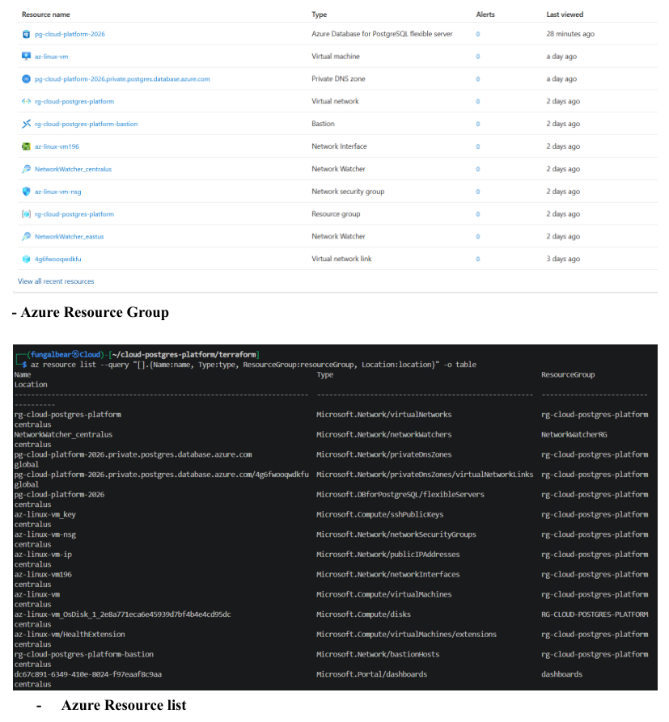
Figure 1 — Azure resource-group and resource-list evidence. [Source screenshot: original Azure Documentation, page 3]

4. PostgreSQL Foundation and Data Platform
The database was developed locally first, using PostgreSQL 16.15 in Docker. A Python/Faker-based data-generation workflow populated a production-style relational schema. The completed dataset includes 10,000 customers, 100 accounts, 100 merchants, and 1,001,001 transactions.
The transactions table became the primary workload for performance engineering. Its size reached roughly 162 MB, while the overall database was later reported at approximately 172 MB.

Core database objects
- customers — 10,000 rows
- accounts — 100 rows
- addresses — 0 rows in the completed dataset
- merchants — 100 rows
- transactions — 1,001,001 rows
- transactions_partitioned — partitioned table created for partitioning work
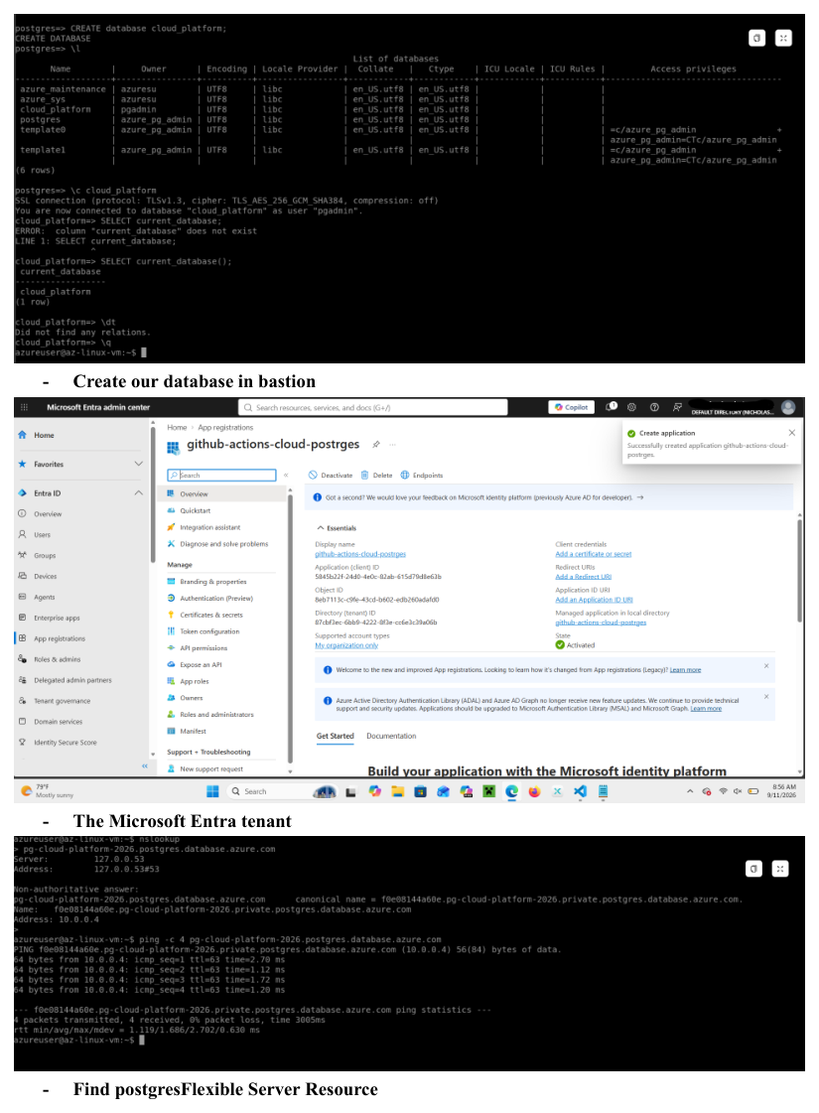
Figure 2 — Database creation and verification work through the Azure/Bastion workflow. [Source screenshot: original Azure Documentation, page 7]

5. Database Performance Engineering
Performance work focused on using database-native evidence rather than assuming that an index or partitioning scheme would help. Indexes were evaluated with query plans and EXPLAIN ANALYZE, including account/status access patterns and combined account/timestamp access.
Partitioning was used as a physical data-management technique. The partitioned transaction structure was created to explore how a large transaction workload could be organized for scalable maintenance and query access patterns.
- EXPLAIN ANALYZE was used to investigate query execution.
- Indexes were created around common filtering and join patterns.
- The project tracked table and index sizes.
- The workload contained more than one million transactions to make performance behavior meaningful.
- Performance observations are specific to the project environment and workload.

6. Security and Access Controls
Security was treated as an architecture concern rather than a final checklist. The completed project removed the broad public TCP/22 NSG rule, used SSH key authentication, disabled password authentication on the Linux VM, and relied on Bastion/private administration for management access.
- SSH key-based authentication
- Password authentication disabled on the Linux VM
- Secure Boot enabled
- vTPM enabled
- Network Security Group retained without the broad public SSH rule
- Private PostgreSQL networking
- Private DNS for PostgreSQL name resolution
- GitHub Actions OIDC instead of a stored Azure client secret
- Scoped Azure RBAC
- Credential cleanup from tracked project files
- Terraform state excluded from source control
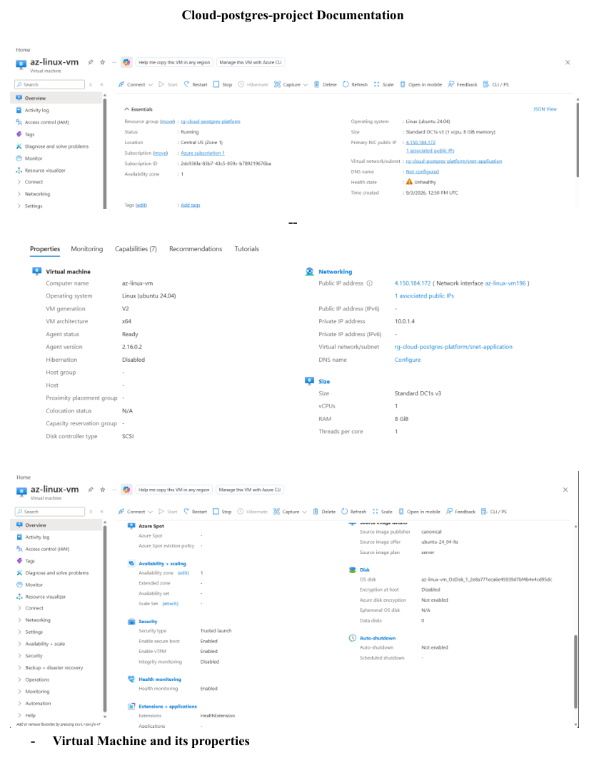
Figure 3 — Original Azure VM/property evidence. [Source screenshot: original Azure Documentation, page 1]
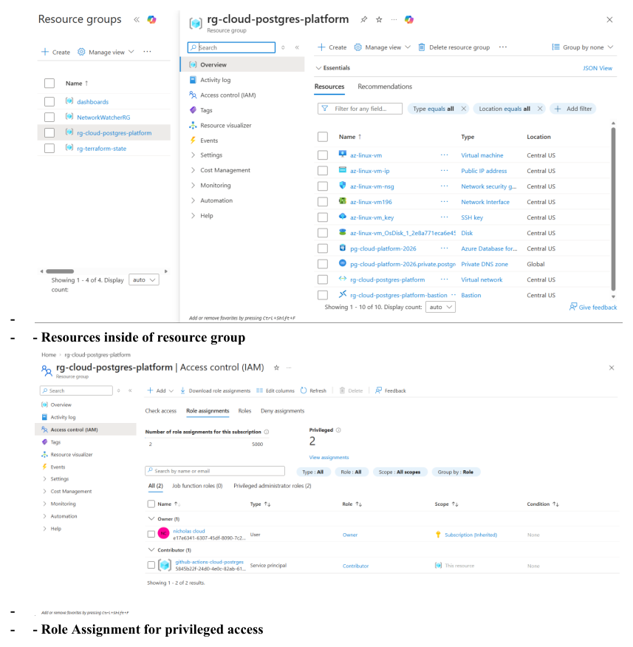
Figure 4 — Original resource-group and privileged-access evidence. [Source screenshot: original Azure Documentation, page 9]

7. Azure Infrastructure Deployment
The Azure deployment established the cloud environment around the database workload. The main resource group is rg-cloud-postgres-platform and the infrastructure region is centralus.

Network layout
- VNet: rg-cloud-postgres-platform — 10.0.0.0/16
- snet-application — 10.0.1.0/24
- snet-PostgreSQL — 10.0.2.0/24
- default — 10.0.0.0/24, delegated to PostgreSQL Flexible Server/storage endpoint
- AzureBastionSubnet — 10.0.3.0/24
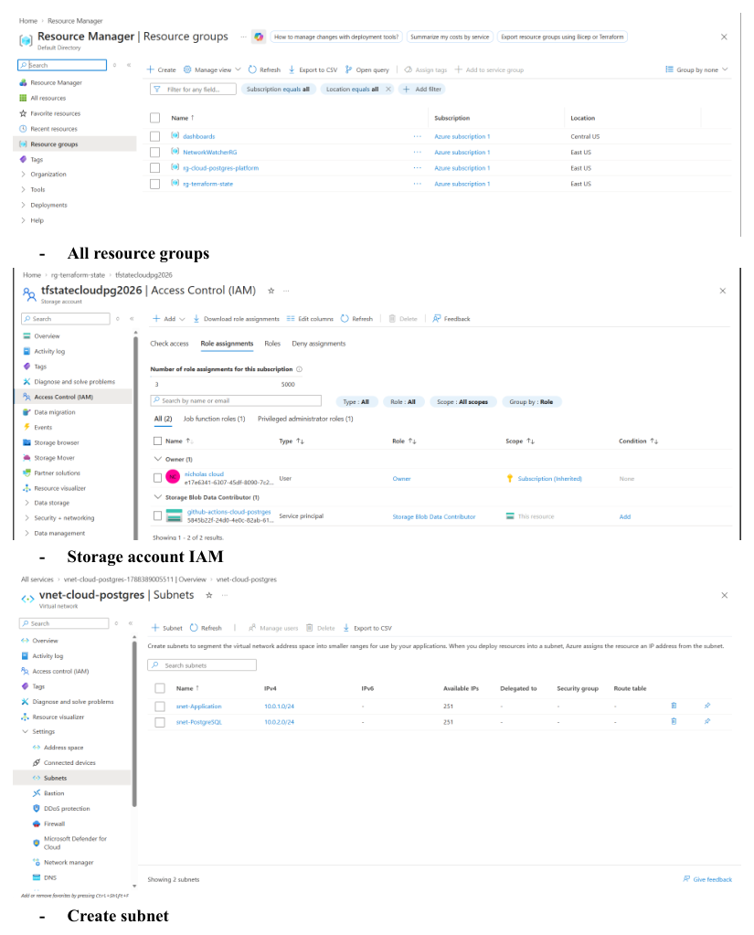
Figure 5 — Original evidence showing resource groups, storage IAM, and subnet creation. [Source screenshot: original Azure Documentation, page 10]
Figure 6 — Original evidence showing resources inside the project resource group. [Source screenshot: original Azure Documentation, page 9]

8. Azure PostgreSQL and Private Networking
The managed database service is Azure Database for PostgreSQL Flexible Server named pg-cloud-platform-2026. The selected compute configuration is the Burstable Standard_B2s SKU. Private DNS was created for the server so the database could be accessed through the private Azure network rather than exposing PostgreSQL directly to the public internet.
- PostgreSQL Flexible Server deployment
- Private DNS zone: pg-cloud-platform-2026.private.postgres.database.azure.com
- Database access through the project VNet
- Bastion-based administrative workflow
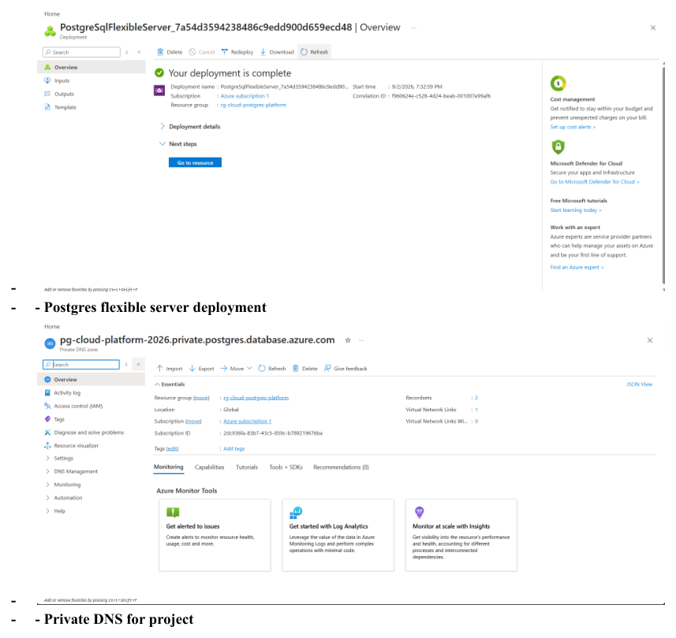
Figure 7 — PostgreSQL Flexible Server deployment and private DNS evidence. [Source screenshot: original Azure Documentation, page 8]
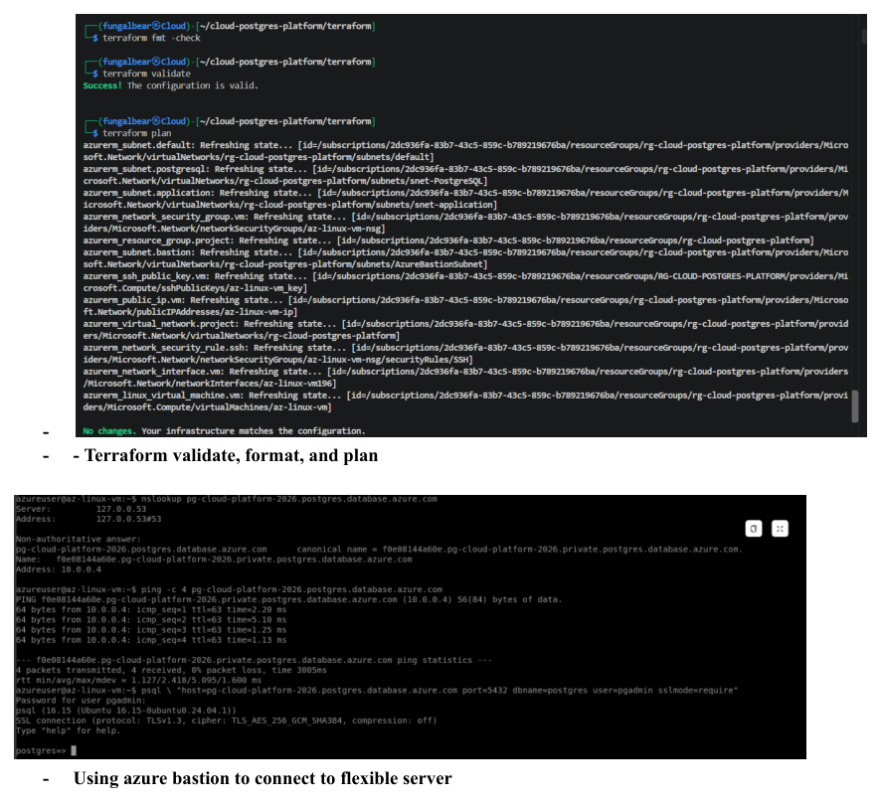
Figure 8 — Original evidence for using Azure Bastion to connect to the Flexible Server. [Source screenshot: original Azure Documentation, page 12]

9. Linux VM and Administrative Access
The Linux VM az-linux-vm provides an application/administration host inside the application subnet. It uses Ubuntu 24.04, a Standard_DC1s_v3 VM size, a static public IP resource, and hardened SSH configuration. The public IP existed as an Azure resource, but the broad inbound TCP/22 rule was removed during the final hardening phase.
The VM was configured with Secure Boot, vTPM, boot diagnostics, and password authentication disabled. Administrative access was shifted toward Bastion/private access after the public SSH rule was removed.
Figure 9 — Original VM properties evidence. [Source screenshot: original Azure Documentation, page 1]

10. Azure Bastion and Connectivity
Azure Bastion was used as the private administrative path for the VM/database environment. The project documentation captures Bastion connections to the PostgreSQL environment and the use of Bastion to obtain PostgreSQL client tooling.
The Bastion workflow also exposed real troubleshooting issues. Azure CLI commands encountered resource-model/dependency problems, while portal-based Bastion access worked under the appropriate conditions. These issues were recorded rather than hidden.
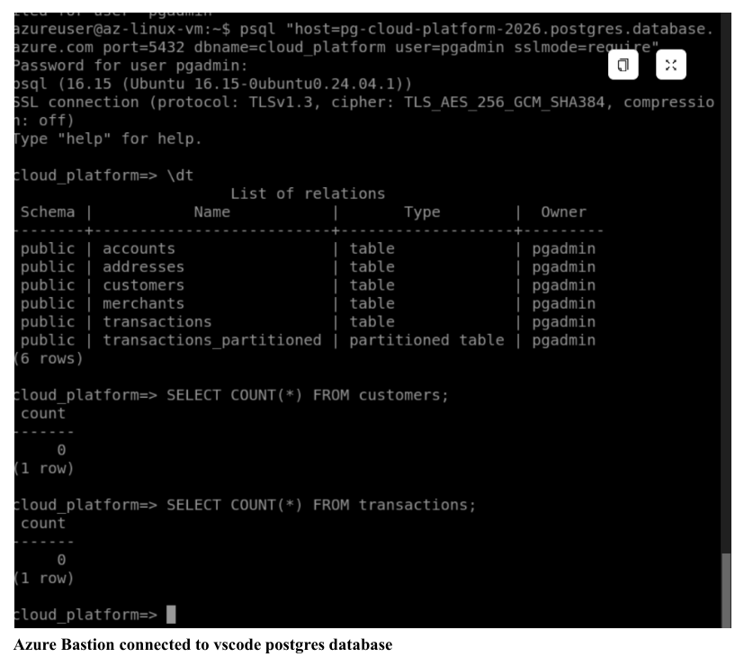
Figure 10 — Azure Bastion connected to the PostgreSQL environment. [Source screenshot: original Azure Documentation, page 4]
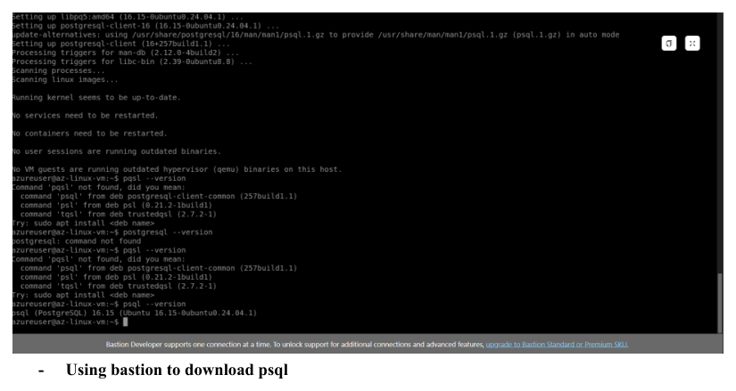
Figure 11 — Original evidence showing the Bastion workflow for obtaining psql. [Source screenshot: original Azure Documentation, page 13]

11. Terraform Infrastructure as Code
Terraform was introduced after the Azure environment existed so the project could demonstrate import, reconciliation, and controlled infrastructure management rather than simply provisioning everything from an empty subscription.

Terraform structure
- providers.tf — Terraform/Azure provider and remote backend configuration
- variables.tf — configurable project inputs
- compute.tf — VM, NIC, and public IP
- networking.tf — VNet/subnet/networking resources
- security.tf — NSG and SSH public key resource
- outputs.tf — useful resource outputs
- terraform.tfvars.example — safe configuration template

Core workflow
terraform init
terraform fmt -check -recursive
terraform validate
terraform plan
terraform apply
terraform import <resource-address> <azure-resource-id>
A key provider-registration issue was handled by setting resource_provider_registrations = "none" so Terraform would not attempt unwanted subscription-wide provider registration behavior. Existing Azure resources were imported and reconciled into the intended configuration.
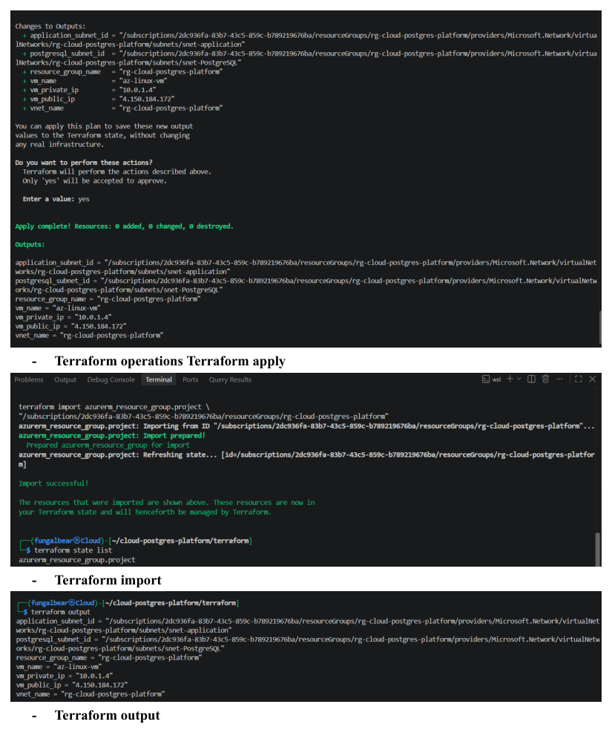
Figure 12 — Original Terraform apply, import, and output evidence. [Source screenshot: original Azure Documentation, page 11]
Figure 13 — Original Terraform validate, format, and plan evidence. [Source screenshot: original Azure Documentation, page 12]

12. Remote Terraform State
The project uses a separate bootstrap configuration to create the remote state infrastructure. This avoids placing the state-storage resources inside the main project state before that backend exists.
- State resource group: rg-terraform-state
- Storage account: tfstatecloudpg2026
- Container: tfstate
- Replication: LRS
- Minimum TLS version: TLS 1.2
- Public blob/container access disabled
- Blob versioning enabled
- Main Terraform state key: cloud-postgres-platform.tfstate
The bootstrap configuration was applied successfully, after which the main Terraform state was migrated to the Azure Storage backend. Local state files remain excluded from source control.
Figure 14 — Original storage-account IAM and Azure resource evidence. [Source screenshot: original Azure Documentation, page 10]

13. GitHub Actions and Entra OIDC
GitHub Actions provides automated Terraform validation and planning. The workflow checks formatting, initializes Terraform, validates the configuration, and produces a plan. Azure authentication uses Microsoft Entra ID federated OIDC.
GitHub Actions
|
| OIDC token
v
Microsoft Entra ID
|
| Federated credential
v
Azure service principal
|
+-- Contributor on project resource group
|
+-- Storage Blob Data Contributor on Terraform state storage
The repository workflow grants id-token: write and contents: read. Azure client, tenant, and subscription identifiers are supplied as GitHub repository variables, while the VM public key is supplied as a non-secret variable. No long-lived Azure client secret is required by the workflow.

14. RBAC and Least-Privilege Review
The final RBAC model scopes GitHub Actions to the project resource group and Terraform state storage rather than giving it subscription-wide Owner access.
- GitHub Actions service principal: Contributor on rg-cloud-postgres-platform
- GitHub Actions service principal: Storage Blob Data Contributor on tfstatecloudpg2026
- Personal administrative access: Contributor on rg-cloud-postgres-platform
- Temporary root-level User Access Administrator access used for recovery was removed after normal access was restored
- Subscription-level Owner access for the automation identity was removed during hardening
An important troubleshooting lesson occurred when broad permissions were removed before confirming that appropriate human administrative access remained. Temporary recovery access restored the user's project-level Contributor role, and the temporary elevation was then removed.
Figure 15 — Original privileged-access/role-assignment evidence. [Source screenshot: original Azure Documentation, page 9]
Figure 16 — Original storage IAM evidence. [Source screenshot: original Azure Documentation, page 10]

15. Backup, Restore, and Disaster Recovery
The database backup workflow uses PostgreSQL's custom dump format followed by pg_restore into a dedicated restore-test database. The restore test was completed successfully and row counts were compared against the source database.
cloud_platform
|
| pg_dump (custom format)
v
cloud_platform.dump
|
| pg_restore
v
cloud_platform_restore_test
|
+-- row-count validation
+-- schema/object validation
The project deliberately does not claim a formal RTO/RPO because those values were not measured. The current implementation also does not include cross-region PostgreSQL replication or automated failover.

16. Monitoring and Operational Visibility
Monitoring was approached at both the database and Azure-resource levels. PostgreSQL performance investigation used query plans, index behavior, table/index sizing, and workload observations. Azure-side visibility included resource status and cost/utilization review.
A full Azure Monitor/Log Analytics implementation was not completed. The documentation intentionally distinguishes the monitoring that was actually performed from a future centralized observability architecture.

17. Azure Cost Management and Optimization
Cost awareness was an explicit project objective. The documented Azure cost baseline as of September 14, 2026 was $54.06, leaving $145.94 of a $200 project credit.
Resource | Accumulated Cost
az-linux-vm | $28.96
pg-cloud-platform-2026 | $21.59
OS disk | $1.97
Public IP | $1.35
Private DNS | $0.19
The VM and PostgreSQL service together accounted for approximately 93.5% of the accumulated spend. The final cost-control action was to deallocate the VM and stop the PostgreSQL Flexible Server while preserving the resources for future demonstrations.
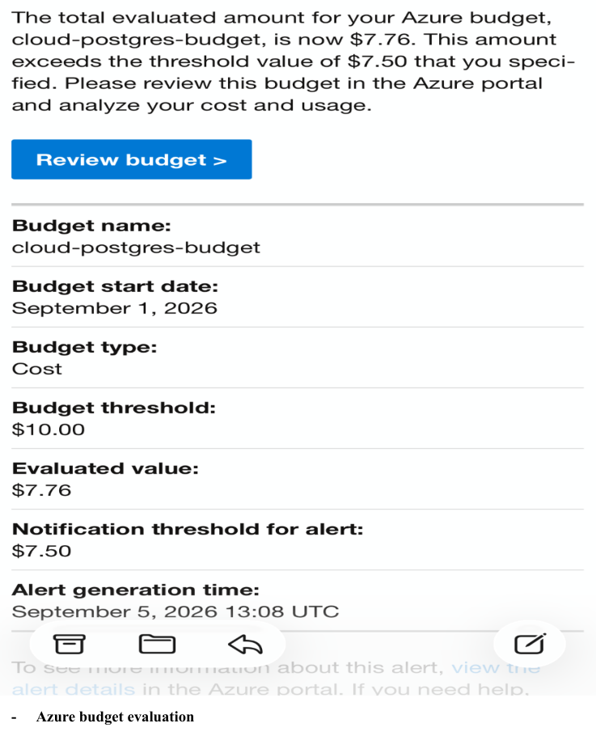
Figure 17 — Original Azure budget evaluation evidence. [Source screenshot: original Azure Documentation, page 2]
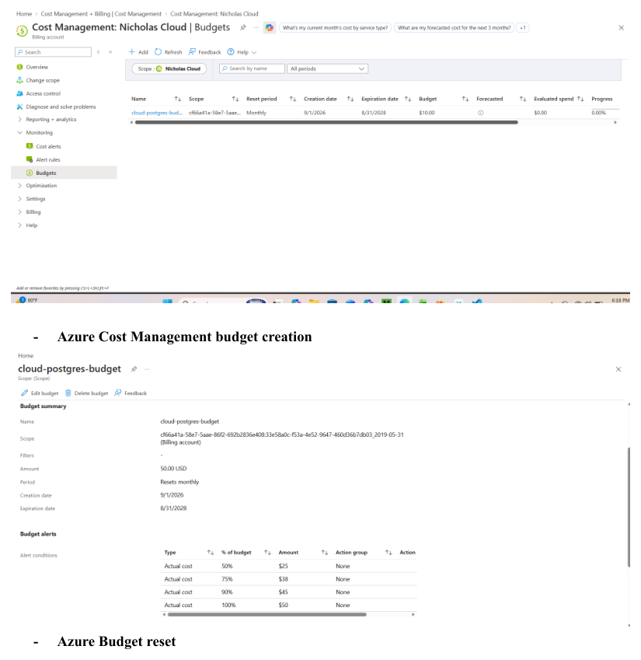
Figure 18 — Original Azure Cost Management budget creation/reset evidence. [Source screenshot: original Azure Documentation, page 5]
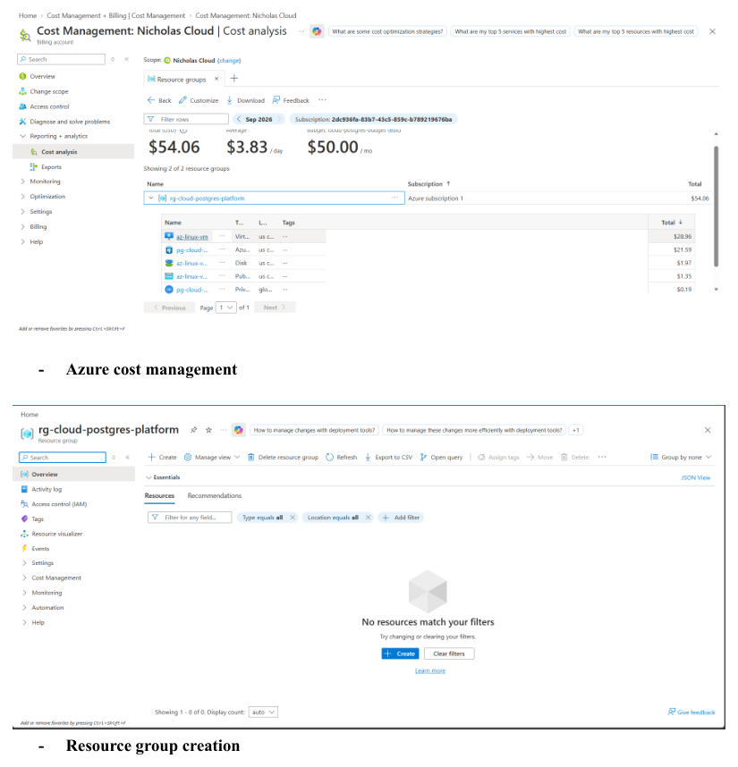
Figure 19 — Original Azure Cost Management and resource-group evidence. [Source screenshot: original Azure Documentation, page 6]
Figure 20 — Original Azure cost-management evidence. [Source screenshot: original Azure Documentation, page 12]

18. Troubleshooting and Lessons Learned
A major goal of this project was to document the engineering process, including failures and recovery. The following incidents are part of the project record.

Azure Bastion CLI issues
Azure CLI commands encountered resource-model/dependency problems. Portal-based access was used where appropriate, and the final architecture retained Bastion/private administration.

Terraform provider registration behavior
Terraform attempted provider registration that was undesirable for the project. The AzureRM provider was configured with resource_provider_registrations = "none" and the environment was reconciled deliberately.

Terraform import/reconciliation
Existing Azure resources were brought under Terraform management rather than being destroyed and recreated solely to fit the code.

GitHub OIDC federation mismatch
The federated credential was corrected to match the repository/branch assertion, after which the GitHub Actions workflow authenticated successfully.

RBAC access incident
Removing broad automation permissions exposed the need for a retained human administrative path. Temporary recovery access restored the user's project-level Contributor role, then the temporary elevation was removed.

Credential cleanup
A development database password had existed in tracked files. It was removed, the project moved to environment-based password handling, and the credential was excluded from version control.

GitHub HTTPS timeout
Git push intermittently timed out even though curl and Git verbose diagnostics later demonstrated successful DNS, TLS, HTTP/2, and Git protocol connectivity. A retry completed the push successfully.

19. Final Project State
The core implementation and documentation are complete. The final Git history includes the documentation and Terraform-polish commits, and the master branch was synchronized with origin/master.
- PostgreSQL workload: 1M+ transactions
- Azure deployment documented
- Private PostgreSQL networking documented
- SSH public-access rule removed
- RBAC hardened and temporary recovery access removed
- Terraform configuration organized and validated
- Remote Terraform state implemented
- GitHub Actions CI/CD implemented
- Entra OIDC authentication implemented
- Backup/restore test completed
- Cost baseline documented
- VM deallocated and PostgreSQL stopped to reduce ongoing compute charges
- Core project documentation completed and pushed to GitHub
Final portfolio narrative
The project demonstrates more than individual Azure or PostgreSQL commands. It shows the progression from a database workload to a cloud architecture, then to repeatable infrastructure, automated authentication, security hardening, operational validation, cost management, and documented troubleshooting.

20. Production Evolution
If this platform were advanced from a portfolio implementation into a production environment, the following capabilities would be evaluated:
- Formal RTO/RPO definitions and measured recovery procedures
- Cross-region disaster recovery or replication
- High-availability PostgreSQL configuration
- Automated backup retention and restore testing
- Azure Monitor and Log Analytics integration
- Centralized alerting and operational dashboards
- Azure Key Vault or equivalent managed secret storage
- Managed identities where appropriate
- Stronger private-endpoint/network-isolation patterns
- Separate development, staging, and production environments
- Pull-request approval and deployment gates
- More granular custom RBAC roles if required by organizational policy
- Automated infrastructure drift detection
These are future-state design considerations, not claims about capabilities already implemented in this project.

Appendix A. Original Screenshot Evidence Index
Original Page | Evidence
1 | Virtual Machine and its properties
2 | Azure budget evaluation
3 | Azure Resource Group / Azure Resource list
4 | Azure Bastion connected to VS Code PostgreSQL database
5 | Azure Cost Management budget creation / Azure Budget reset
6 | Azure Cost Management / Resource group creation
7 | Create database in Bastion / Microsoft Entra tenant / PostgreSQL Flexible Server resource
8 | PostgreSQL Flexible Server deployment / Private DNS for project
9 | Resources inside resource group / Role Assignment for privileged access
10 | All resource groups / Storage account IAM / Create subnet
11 | Terraform apply / Terraform import / Terraform output
12 | Terraform validate, format, and plan / Bastion connection / cost-management evidence
13 | Using Bastion to download psql

Source document reviewed: Azure Documentation.pdf (13 pages). The original screenshot evidence is preserved throughout this expanded document.

