marp: true paginate: true theme: default size: 16:9
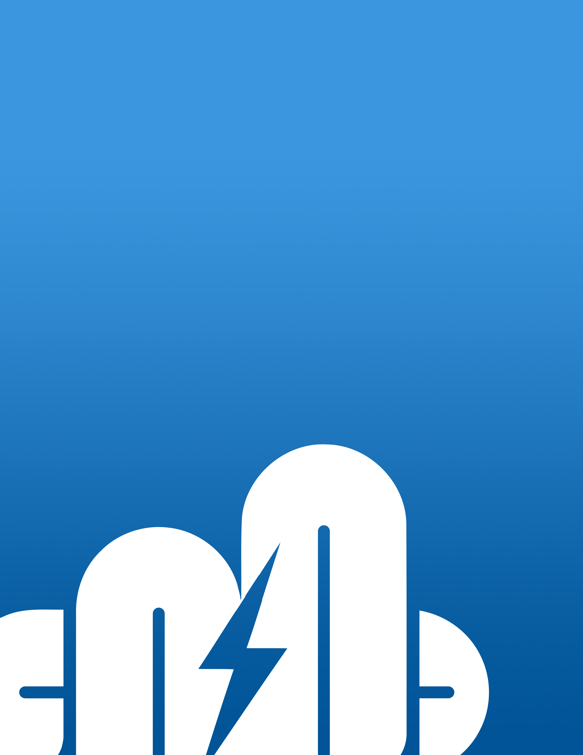

Proposal: Microsoft Teams & OneDrive Security Hardening

For Leonardo Company - Canada

Prepared by Cloudstrucc Inc.

🛍️ Executive Summary
Leonardo Company Canada, a leading defence contractor and critical service provider for the naval electronics segment, operates under the stringent requirements of the Controlled Goods Program (CGP) governed by Public Services and Procurement Canada (PSPC), as well as other government and international compliance frameworks.
To continue delivering secure, compliant, and mission-critical capabilities, Leonardo Company must ensure its internal collaboration platforms align with:
- Government of Canada cybersecurity standards (e.g., ITSG-33, ITSG-22)
- International frameworks such as ISO/IEC 27001, NIST 800-171
- Controlled Unclassified Information (CUI) guidelines
- Defense Industrial Base Cybersecurity Program (DIB CS)
- NATO Security Standards for classified and restricted information
This proposal outlines how Cloudstrucc will implement a Microsoft Teams security hardening initiative that transforms Teams into a fully end-to-end encrypted, CGP-, NIST-, and NATO-aligned collaboration environment. This includes integration of multi-factor authentication, advanced threat protection, data loss prevention, customer-managed encryption keys, and network isolation using Azure Private Endpoints and Microsoft Teams service tags.
These enhancements prevent data from traversing the public internet and allow for strict control over Microsoft 365 traffic by restricting access to approved IPs and virtual networks — a critical control mechanism for defence sector compliance.
The end state will position Leonardo Company Canada with a secure, modern, and scalable Teams collaboration platform — aligned with its goals of standardizing digital communication while ensuring end-to-end compliance with both national and international security regulations.

🔐 Scope of Work
- ✅ Enable secure OneDrive for Business integration, with sync from file system
- ✅ Apply Microsoft Purview policies to OneDrive (DLP, auto-labeling, encryption)
- ✅ Configure Conditional Access and session control for OneDrive access
- ✅ Restrict OneDrive access to managed devices via compliant endpoints
- ✅ Enforce MFA for guest/external access (Entra ID)
- ✅ Prevent meeting link forwarding abuse
- ✅ Configure Sensitivity Labels, DLP, and Information Barriers
- ✅ Integrate Customer Key (CMK) and private DNS endpoints
- ✅ Enable Safe Links/Attachments in Teams
- ✅ Configure Azure Private Endpoints with Microsoft 365 service tags
- ✅ Isolate Teams traffic from the public internet
- ✅ Implement Purview audit and retention policies
- ✅ Setup Defender for O365 & XDR dashboards
- ✅ Deliver internal documentation and run KT sessions
- ✅ 60-day support period + optional support extension

🧰 Pre-Requisites and Deployment Approach
To perform the activities outlined in this proposal, the following pre-requisites and operating model must be established:

🔑 Access and Privileged Roles
Cloudstrucc will require:
- A dedicated privileged administrative account (e.g., teams-sec-admin@leonardoCompany.com) or membership in a privileged role group within Microsoft Entra ID.
- The following roles or equivalent custom RBAC assignments:
  - Global Reader (for assessments and baselining)
  - Security Administrator (for configuring Defender, alerts, Purview)
  - Compliance Administrator (for DLP, Sensitivity Labels, eDiscovery)
  - Teams Administrator
  - SharePoint Administrator (for OneDrive-related policies)
  - Privileged Role Administrator (for scoped conditional access configuration)
  - Azure Network Contributor (if private endpoint provisioning is required)
Access must be granted by the Leonardo Company Entra administrator prior to work commencing (for prodcuction launch as the work commences in 2 lab enviornments described in the next section).

🏗️ Cloudstrucc Build & Staging Subscription Model
To support structured, low-risk implementation:
- Cloudstrucc will use its own Azure subscription and M365 tenant for initial build, configuration, and templating.
- This isolated tenant will mirror Leonardo Company’s compliance needs and baseline.
- Once complete:
  - Configuration will be validated and staged via Bicep/ARM templates or PowerShell scripts.
  - These artifacts will be deployed to a client-staging environment (test tenant or sandbox).
  - Following successful review, the solution will be deployed to the primary Leonardo tenant using a change-controlled (DevOps/GIT pipeline), and documented process in collaboration with the IT administrators.
This model ensures:
- Minimal disruption to existing Leonardo Company services
- Clean separation between development and production
- Reproducible security posture across environments
This is reflected in the project schedule.

⏳ Duration and Phasing

Project Duration: 30 to 60 Calendar Days
Phase | Duration | Milestone | Outcome
Phase 1 | Week 1 | Kickoff & Assessment | Identify gaps and current posture
Phase 2 | Weeks 2–3 | MFA + Meeting Policy Hardening | Guest MFA, Meeting Access Restrictions live
Phase 3 | Weeks 3–4 | Security Layering (CMK, DLP, Labels) | Policies and encryption applied
Phase 4 | Weeks 5–6 | Audit, Testing, and Training | Audit setup, team trained, docs delivered
Final | Day 60 | Handover & Review | All systems in place, support begins

💸 Implementation Cost Estimate (CAD)
Starting from the week of September 2, 2025, estimated due dates are projected based on a 60-day delivery schedule.
Item | Description | Estimated Cost (CAD) | Estimated Due Date
Discovery & Assessment | Initial audit, kickoff, stakeholder alignment & lab setup | $4,500 | September 10, 2025
Conditional Access & MFA Setup | Configure policies, guest restrictions | $5,500 | October 6, 2025
Meeting & Collaboration Hardening | Meeting options, lobby, link lockdown | $5,000 | October 10, 2025
DLP, Sensitivity Labels, IBs | Purview config, segmenting | $6,500 | November 13, 2025
CMK & Private Endpoint Support | Azure setup, encryption config | $7,000 | October 22, 2025
Audit, Defender XDR Integration | Logging, detection, incident setup | $4,000 | November 13, 2025
Documentation & Knowledge Transfer | Wiki + live walkthroughs / training | $3,500 | November 16, 2025
Rollout | Apply policies to company staff (all),  post production test run | N/A | November 17-20, 2025
Support (60 days) | Response, tuning, questions | $2,500 | Start: November 6, 2025)
Subtotal |  | $38,500 CAD
HST (13%) |  | $5,005 CAD
Total with HST |  | $43,505 CAD

Payment Terms The total amount indicated in this proposal, including applicable taxes, shall become payable upon completion of the scope of work as outlined herein. Final payment shall be due within thirty (30) days of the client’s written confirmation of acceptance and sign-off of the completed deliverables. For greater certainty, such acceptance shall not be unreasonably withheld. This agreement shall be governed by the laws of the Province of Ontario and the federal laws of Canada applicable therein.
Optional extension at $125/hr support block (min. 10 hrs)

📦 Licensing Requirements (CAD Pricing)
To implement the described security hardening, Leonardo Company Canada will require the following licensing tiers:

Microsoft 365 Licensing (CAD)
License Tier | Features Required | Estimated Monthly Cost (CAD/user)
Microsoft 365 E5 | DLP, Sensitivity Labels, Defender, CMK support | ~$57
Microsoft Teams Premium | Advanced meeting protection, watermarking, lobby control | ~$12

Notes
- E5 licensing is required for full Purview and Defender integration.
- Teams Premium enables advanced meeting security such as watermarking, lobby isolation, and end-to-end encryption policy enforcement.
- Minimum quantity and enterprise agreements may affect pricing.

📄 Appendices

Appendix C: OneDrive Security Hardening Overview
- Apply Microsoft Purview DLP rules and auto-classification labels to OneDrive
- Enforce compliance-based access controls (only compliant devices)
- Enable OneDrive sync policy for work files from corporate desktops/laptops only
- Restrict download/sharing from untrusted sessions using Defender & Purview
- Enable logging and retention policies for OneDrive access and edits

Appendix A: Detailed Microsoft Teams Security Checklist
- MFA enforcement for guests/internal staff
- Meeting policies & Teams Premium configurations
- Teams DLP and sensitivity label mappings
- CMK encryption and key rotation policy
- Azure Private Endpoint and DNS integration
- Use of Microsoft 365 Service Tags for Teams isolation
- Compliance test criteria (CGP/NIST/ITSG/NATO)

Appendix D: Compliance References (Expanded)
- Government of Canada ITSG-33 / ITSG-22
- Controlled Goods Program (CGP)
- ISO/IEC 27001
- NIST 800-171 / CUI
- NATO Restricted Information Protection Standards
- Microsoft Compliance Center (Purview)
