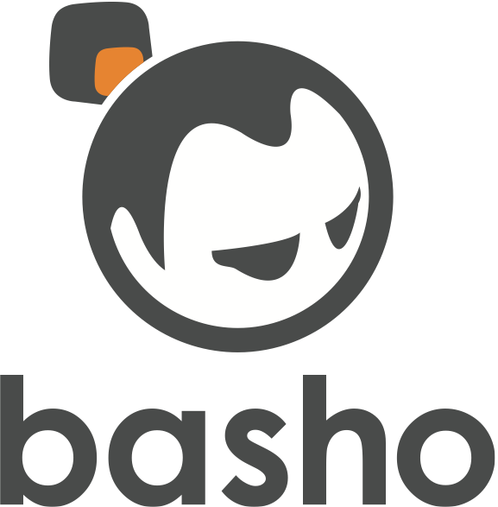

**Riak 101 - Intro To Riak**

2013/08

Core Fact: Riak is ***the*** ops-friendly database.

Provide a very-high-level overview of Riak’s primary features, not properties, and the methods by which a developer and/or application can interface with Riak.