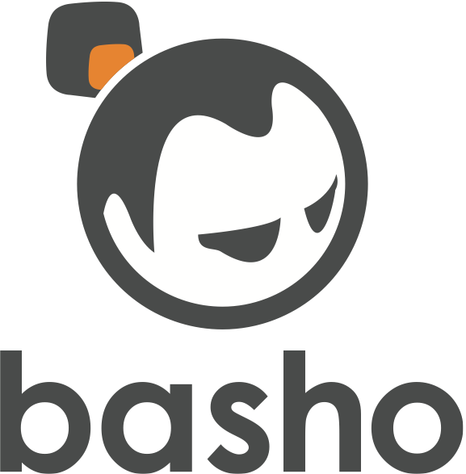

**RiakCS 101 - Intro To RiakCS**

2013/08

Core Fact: RiakCS lets you bring S3 in-house, gives you safety, flexibility and control.

Provide a high level overview of RiakCS. What it is, its main value proposition and outline the primary features providing context with example use cases.