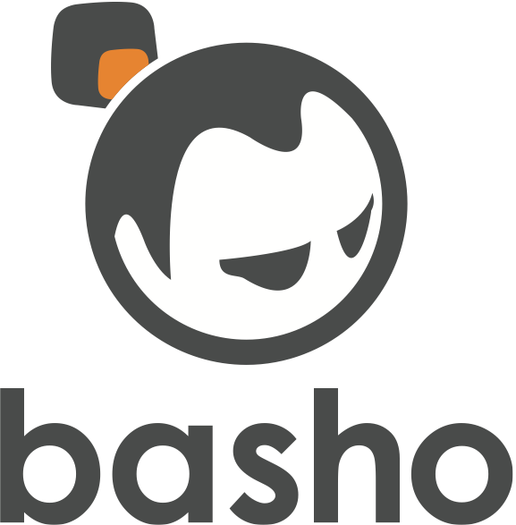

**Riak 103 - Standard Operating Procedure**

2013/10

Core Fact: Riak is A DATABASE, if you keep that in mind you might not setup something optimal, but you won’t set up something horrible.

Provide a very-high-level overview of Riak operations. Basic tuning guidelines, capacity planning, storage backends, backup strategies, and and common errors and problems.