**COMP9517: Computer Vision**

**2022 Term 3**

**Assignment 1 Report**

**Wanqing Yang – z5325987**

**Task 1: Background Estimation**

**Description:** The goal of the assignment was to remove background shading from the images and make the stars and nuclei clear in the images to enhance relevant features and prepare the images for quantitative analysis.

**Approach**:

For image with a black background:

Firstly, we create an image A that is the same size as the input image (image I).

Secondly, perform min-filter on image I, that is, traverse every pixel (x, y) in image I, and obtain minimum value in its N×N neighborhood as the pixel (x, y) of imageA. After that, we try different N values and find the minimum N that makes all the stars disappear. By observe all the images in Figure1.1, when N = 11, the stars just disappear. Similarly, by observing Figure 1.1, we can know that when N is too small, it will leads to the disappearance of part of the foreground in the output image. When N is too large, the resulting background will be distorted.

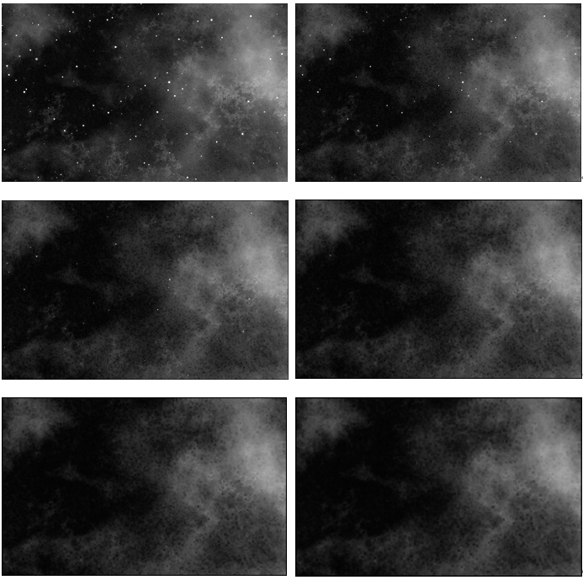

Figure1.1: N = 3, 5, 7, 9, 11, 13

Thirdly, create an image B of the same size as the input image (image I).

Then perform max-filter on image A, that is, traverse every pixel (x, y) in image A, and obtain maximum value in its N×N neighborhood as the pixel (x, y) of image B. After that, we generate image B (Figure 1.2).

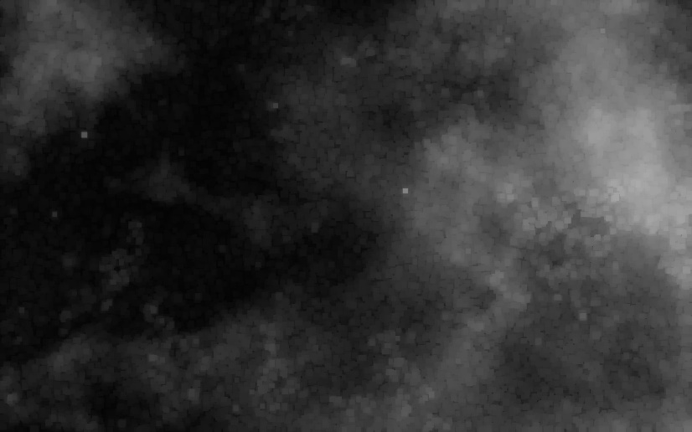

Figure1.2: image B, N = 11

**Task 2: Background Subtraction**

Finally, subtract image B pixel by pixel from image I to get image O with the background removed. After that, we generated the final image B with the background shading removed (Figure2.1).

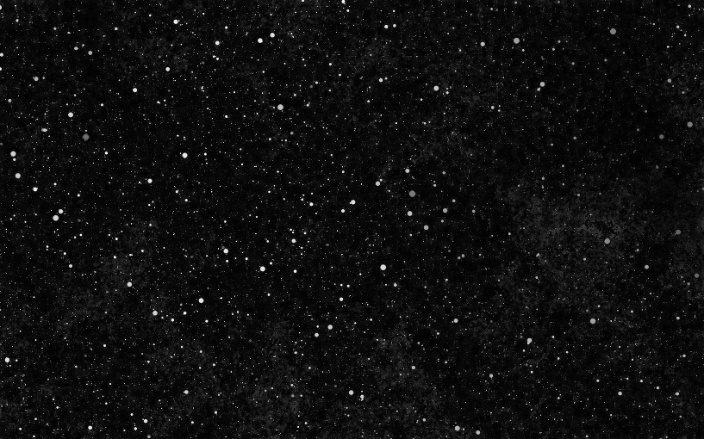

Figure2.1: image O, N = 11

**Task 3: Algorithm Extensions**

Algorithm extensions:

1. Ensure that the algorithm can handle images of any size, and calculate the row and col of the image at the beginning of the algorithm.
2. Make sure the algorithm can handle different N’s so that users can test different N values.
3. At the beginning of the algorithm, variable M is introduced.

When M = 0, min-filtering first, then max-filtering is performed, and subtraction is performed (O = I - B) finally.

When M = 1, max-filtering first, then min-filtering is performed, and finally subtraction (O = I – A + 255).

For Stars.png, it requires M = 0, but for Nulcei.png, it requires M = 1. By observing the Figure3.1, we can know that the color of the star in Stars.png is white. To get the background of the picture, the star needs to be covered. Therefore, min-filter should be performed first. For Figure3.2 (Nuclei.png), the color of nuclei is black. To obtain the background of the image, the nuclei need to be covered. Therefore, max-filter should be performed first.

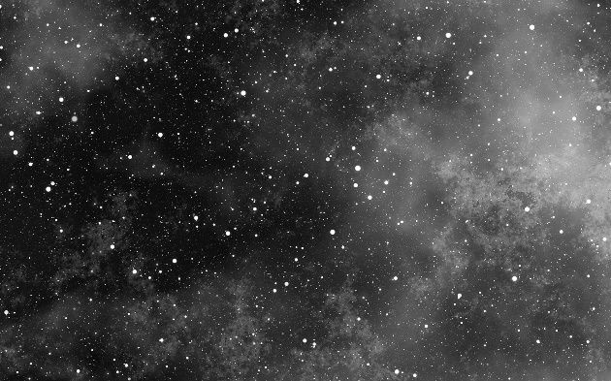 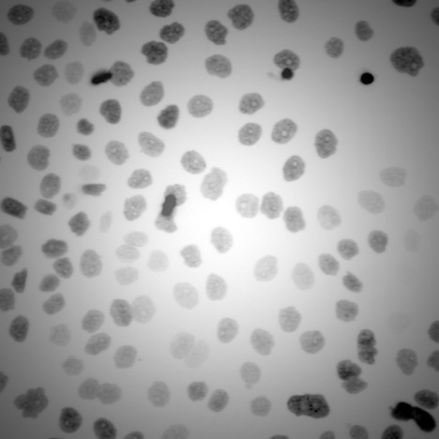 Figure3.1: input image Figure3.2 input image

After that, we try different N values and find the minimum N that makes all the Nuclei disappear. By observe all the images in Figure1.1, when N = 25, the stars just disappear.

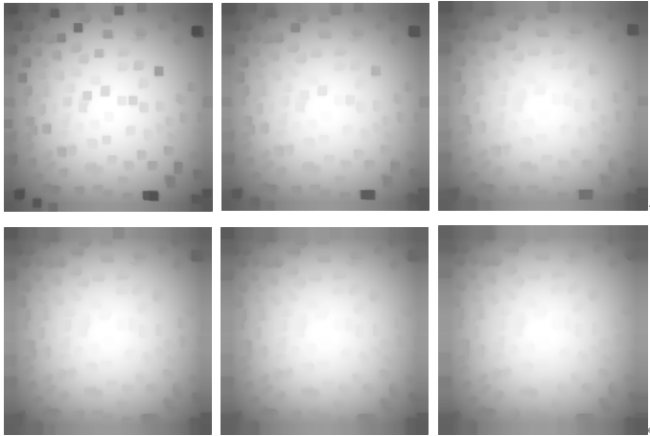

Figure3.3: image B, N = 19, 21, 23, 25, 27, 29

After two filters, we need to subtract image I from image A and add 255 (O = I – A + 255). This is because white has a gray value of 255 and black has a gray value of 0. If 255 is not added, the black nucleus minus the white background will have a negative value, and beyond the gray value range (0-255) and the color will be displayed incorrectly. The incorrect image is shown in Figure3.3.

Finally, we generate the image O with N = 25, as shown in Figure 3.5.

 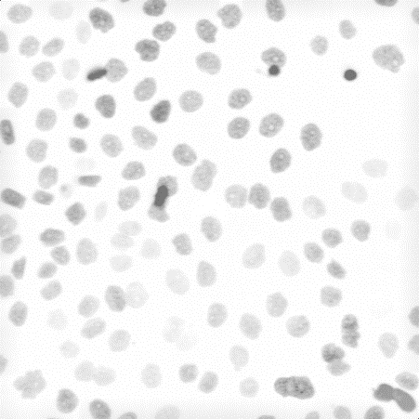

Figure3.4: incorrect image without 255 Figure 3.5 image O, N = 25