CMPSC122 Lab Section 002

Lab 12
Algorithm Analysis

Prepared By
Ian Clowes
Email: icc5102@psu.edu

Instructor: Professor Liaw
Date: 04/15/2025
Table of Contents
1 Objective (or Abstract) 3
2 Introduction 3
3 Procedure 3
4 Discussion 4
5 Conclusion 6
6 Appendix 7

1 Objective
The objective of this lab is to analyze, compare, and evaluate three different algorithms designed to solve the maximum contiguous subsequence sum problem. Through both theoretical analysis and empirical testing, the goal is to determine the computational efficiency of each method.

2 Introduction
The maximum contiguous subsequence sum problem involves finding a contiguous portion of a given integer sequence that returns the largest possible sum. For example, given the sequence: [-2, 11, -4, 13, -5, 2], the maximum subsequence is [11, -4, 13], which sums to 20.
Three algorithms were tested:
- Algorithm Blue: Brute-force approach.
- Algorithm Green: Divide-and-conquer method.
- Algorithm Red: Linear-time scan using dynamic programming.
The running of tests involved analyzing the theoretical time function of each algorithm and comparing it to observed runtime data using random arrays of integers of varying sizes.

3 Procedure
- These test runs were conducted on a Windows 11 laptop equipped with an Intel Core i7 processor and 16 GB RAM.
- The driver program was compiled using Microsoft Visual Studios and is also ran in the same software.
- A random sequence of integers was generated for each trial.
- Each algorithm was executed across increasing input sizes: 500, 1000, 2000, 4000, 8000, 16000, 32000, 64000.
- Execution time was measured using the custom timer.h header file, which contains a timer class. Providing member functions which allowed the run time of each trial to be precisely measured
- Maximum subsequence sum values are recorded under each trial.

4 Discussion
Analysis of Algorithm #1 (Blue Function):
The Blue function uses a brute-force technique to explore all possible contiguous subarrays. For each starting index, it computes all possible sums by extending to the right.
- Time Complexity: $O(n^{2})$
- Reasoning: For each element in the array, the algorithm performs a nested loop, resulting in operations in the worst case.
- Results:
Array Size | Max Sum | Time (s)
500 | 851 | 0.0010
1000 | 1158 | 0.0020
2000 | 1158 | 0.0080
4000 | 1958 | 0.0320

Analysis of Algorithm #2 (Green Function):
The Green function implements a recursive divide-and-conquer strategy. It breaks the problem into left, right, and crossing subarrays.
- Time Complexity: O(nlogn)
- Reasoning: The algorithm splits the array in half each time.
- Results:
Array Size | Max Sum | Time (s)
500 | 675 | 0.010
1000 | 761 | 0.010
2000 | 1052 | 0.010
4000 | 2429 | 0.020

Analysis of Algorithm #3 (Red Function):
The Red function uses dynamic programming, scanning the array linearly while keeping track of the maximum sum ending at each position.
- Time Complexity: O(n)
- Reasoning: Each element is processed once, with constant-time updates per iteration.
- Results:
Array Size | Max Sum | Time (s)
500 | 337 | 0.010
1000 | 731 | 0.010
2000 | 1108 | 0.010
4000 | 1165 | 0.010

Conclusion
Based on both theoretical and empirical analysis. Red is the most efficient algorithm due to its linear time function, O(n). Green provides a good middle ground but is still significantly slower than Red as the arrays become larger. Blue, being quadratic O($n^{2}$), quickly becomes a bad competitor when dealing with large datasets due to its logarithmic function (logn). The theoretical expectations correspond accurately with the observed results. This lab reinforced the importance of choosing proper algorithms in real-world applications, especially when dealing with large inputs of data.

6 Appendix
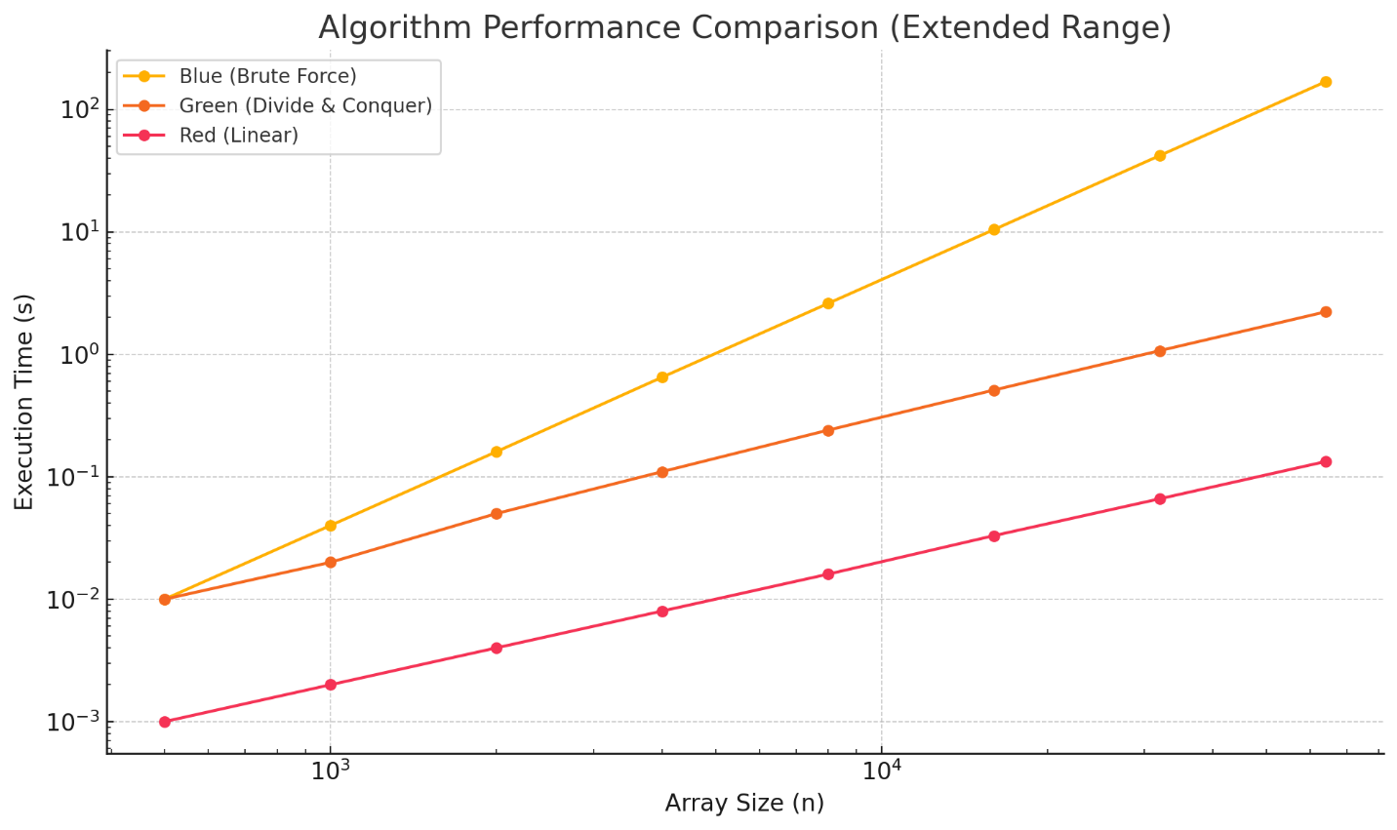
Using the data, a graph was constructed to show the runtime of each algorithm for increasing array sizes. It can be seen that the third line, representing the red (Linear) algorithm, continues to compute sums for larger datasets in less the time than the other two algorithms.

