CMPSC122 In-Lab 12 – Trees and Binary Search Trees (BST)

Part I. In-Lab Exercise (10 points)
Submit the solution files of the Exercises online before the due date/time. For exercises 1 and 2, upload your solution in a filled-in InLab11.docx file. For Exercise 2, you may use the template drawing of a tree for your answer (or draw your solution on paper, take a picture), and insert it into the docx file. For exercise 3, upload the filled-in InLab12.cpp file.

Exercise 1 (Non-Programming Exercise)
Show the preorder, inorder, and postorder traversals of the following binary tree.

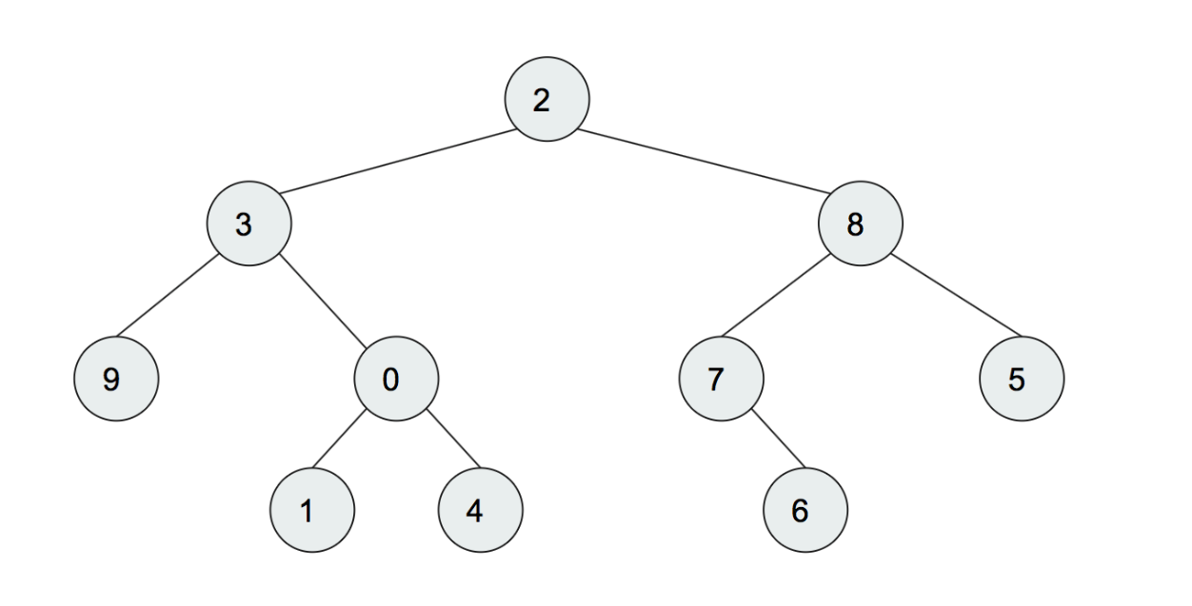

Pre-order: 2 3 9 0 1 4 8 7 6 5
Inorder: 9 3 1 0 4 2 7 6 8 5
Postorder: 9 1 4 0 3 6 7 8 5 2

Exercise 2 (Non-Programming Exercise)
Consider the following binary search tree with the key values of the nodes shown.

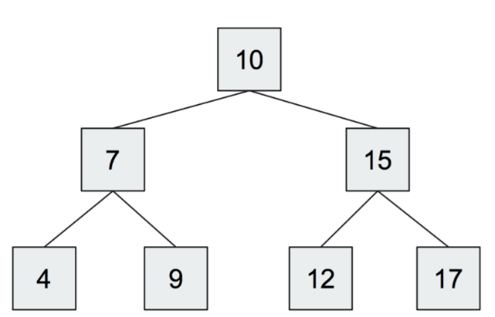

- After insertion of new a key value 5, what would the tree look like? Draw the tree after the insertion.
17
12
15
7
9
4
10

5

(2) After the above insertion, suppose we insert another node with key 11. Draw the tree after the insertion.

10
7
15
4
9
12
17
5

11

Exercise 3
In this exercise, you are asked to write 3 functions for Binary trees/BSTs. Download the skeleton file InLab12.cpp from Canvas. Fill in your function definition at the beginning of this file and submit the filled-in file.

The first function has the following prototype:

int CountLeaves(BinNode* root);

Given a binary tree (not necessarily a BST), this function counts the number of leaves of the tree.

The second function has the following prototype:

int CountSmaller5(BinNode* root);

Given a binary tree (not necessarily a BST), this function counts the number of nodes whose data value is <= 5.

The third function has the following prototype:

int FindMin(BinNode* root);

Given a BST, this function should return the smallest key value in the BST. Note you must make use of the property of a BST and implement an efficient algorithm. If no node in the tree (i.e. if the root begins with a NULL value), then return the INT_MIN named constant.

Submission:
- InLab12.cpp

Assignment Guidelines:
Assignment criteria | Penalty points
Missing affidavit header | -1
The source code has bad indentations or poor variable naming or using global variables (i.e. avoid using global variables in the program) | -1
The program failed to compile | -3
For Exercise 1 and Exercise 2, each mistake | -1
The function does not produce the result expected | -2
Missing program run output(s) is attached at the end of the source code. | -1
The program does not follow the function prototypes specified | -2

